First Congregational Church of Monroe United Church of Christ
(AKA Monroe Congregational Church) Monroe WA

Pastor – Full Time

Pacific Northwest Conference Validation Date
July 7, 2026

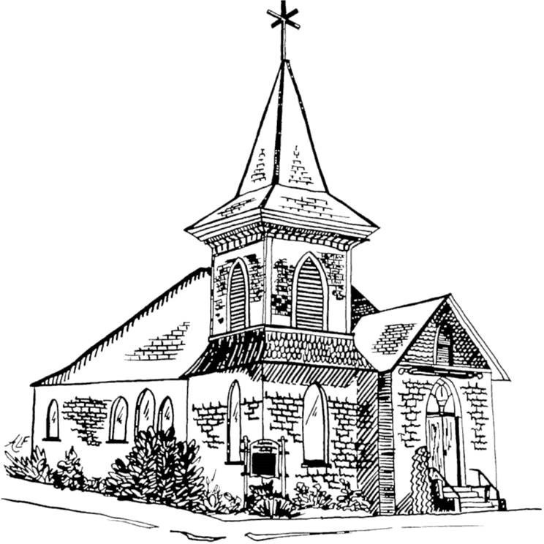

“God is able to provide you with every blessing, so that having all sufficiency in all things at all times,
you may abound in every good work.”(2 Corinthians 9:8)

Contents

- POSITION POSTING 4
1a. LISTING INFORMATION 4
1b. SCOPE OF WORK 6
UCC Required Activities 7
Core Competencies 7
1c. COMPENSATION AND SUPPORT 8
1d. WHO IS GOD CALLING TO MINISTER WITH US? 8
- WHO IS GOD CALLING US TO BECOME? 9
- WHO ARE WE NOW? 10
3a. CONGREGATIONAL REFLECTIONS 10
3a.1 Our Congregation’s Life Of Faith 10
3a.2 Strengths and Positive Qualities of Our Congregation 10
3a.3 What Worship Is Like When We Gather 10
3a.4 Our Vision for Our Educational Program/Faith of Your Church 11
3a.5 Our Congregation Organization for Ministry and Mission 11
3b. 11-YEAR REPORT 12
3c. CONGREGATIONAL DEMOGRAPHICS 14
3d. PARTICIPATION AND STAFFING 18
REFLECTION 21
3e. CHURCH FINANCES 21
REFLECTION 24
3f. HISTORICAL INFORMATION 25
- WHO IS OUR NEIGHBOR? 26
4A. COMMUNITY VISION 26
4b. MISSION InSite 27
- REFERENCES 29
REFERENCE 1 29
REFERENCE 2 29
REFERENCE 3 29
6 CLOSING THOUGHTS 30
6a CLOSING PRAYER 30
6b. STATEMENT OF CONSENT 30
6c VALIDATION BY CONFERENCE/ASSOCIATION 31
Attachments 33

POSITION POSTING

1a. LISTING INFORMATION
Church name: First Congregational Church of Monroe, UCC (AKA Monroe Congregational Church)
301 South Lewis
Monroe WA 98272 Supplemental web links:
https://www.monroeucc.org Conference:
Pacific Northwest Conference
Beth Astarte - Executive Administrator 206-725-8383
office@pncucc.org
Summary Ministry Description:
Monroe Congregational church is a small, open and affirming church located within easy distance from both Seattle and the mountains in the beautiful Pacific Northwest. We are extravagantly welcoming; we take our faith seriously, but we are not a serious people. We envision a vibrant congregation that reflects our community - families, young adults, the confused and misfits - all God has called to be a part of our family. Our music will be eclectic, drawing on the beauty and wisdom of the old and the liveliness of the new.
We seek a pastor who can join and lead us on this journey; a pastor who can attend to the pastoral needs of the congregation and work with us as we develop new outreach to the community and new ministries to those in need; a pastor who can preach heartfelt sermons that engage both our souls and our minds, and call us to a deeper relationship to our Creator and to loving service to our neighbor.
We are committed to this vision of our future and are willing to spend down our available assets to support a full-time or part-time pastor who shares this vision. We believe God is calling us to bigger things - not to save ourselves, but to serve others.

Photographs of the Sanctuary and Fellowship Hall
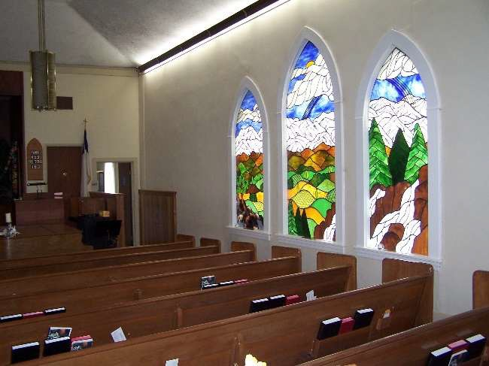
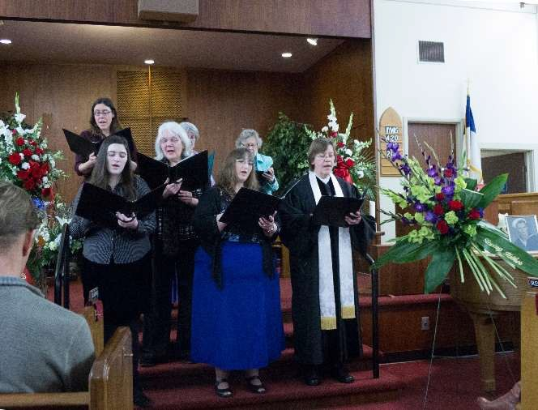
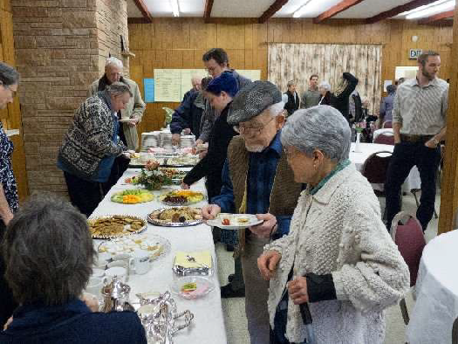

What we value about living in our area:
Monroe has a small town, semi-rural feeling while still maintaining easy access to the larger metropolitan Seattle area. We are surrounded by mountains, forests, and rivers and within an hour’s drive of Puget Sound. Our location affords us access to both the best of urban life (concerts, shopping, opera, museums, etc.) and the riches of the Northwest (hiking, snowshoeing, fishing, camping, skiing, etc.). The size of Monroe means that one often runs into neighbors and friends at the gym, the store or the post office and a sense of community is easier to maintain than in a larger urban environment.
Current size of active participants:
Active participants are around 54, average size of worship is 40
Languages used in ministry: English, however, we have a significant population of Spanish speakers in the Monroe area.
Position Title: Pastor Position Duration:
Designated-Term – a called position for a three-year term with the possibility to move to settled if goals are achieved, see 1b - Scope of Work.

Compensation Level: Full Time
Does the total support package meet conference compensation guidelines? Yes, see below.

1b. SCOPE OF WORK
Full-Time PASTORAL POSITION (40-50 hours weekly / 10-12 units)
- Preparation and leadership for Sunday worship including scripture study crafting liturgy & preparation of bulletin, sermon preparation, preaching, overseeing lay liturgists, planning of music in coordination with musical staff or volunteers, and offering of prayers.
- Faith formation of the congregation through Bible study and service opportunities.
- Pastoral Care in collaboration with lay people to those who are sick, elderly or grieving.
- Leadership development of congregants for ministry and programs both within and outside the church.
- Community engagement as a witness of God’s love for the world.
- Conduct weddings and funerals for participants in the worshipping community.
- Strategic planning for current and new directions in ministry.
- Attend meetings and give leadership as needed to church programs.
- Participate in wider church activities such as conference and association meetings.
- Administration responsibilities such as emails, the website, church supply purchasing,
- Faithful financial development and stewardship.
- Supervision of staff.
- Availability to wider community for funerals, weddings, special worship programs, and as a representative of the church to local organizations
- Counseling, listening and referrals as appropriate.
- Study and prayer to increase faith and to improve skills so as to lead, teach, and preach.
- Energizing and deepening the spiritual connections and faith understandings of others in all they do.
- Create events which have two foci:
  - Fellowship
  - Helping outside orgs raise funds/donations: or education.

Goals to move to SETTLED
  - Greater visibility within the larger community
  - The church is attracting visitors and new members.

UCC Required Activities
- Boundary Training every 3 years.
- Attend the Conference Annual Meeting
- Follow the Ethics of Ministry as outlined in the Manual on Ministry
- Other requirements that may be assigned by the Conference.

Core Competencies:
- We are looking for an energetic Pastor who will help us grow and reach out to our community.
- Someone able to provide uplifting, thoughtful and heartfelt sermons.
- A good listener, willing to collaborate with the congregation.

1c. COMPENSATION AND SUPPORT

Salary Basis:
Up to $70,000, depending on years of service per UCC guidelines.

Benefits:
Standard benefits will be provided. We will negotiate a salary & benefits balance that is agreeable to both parties.

Expected Living Conditions
There will be a housing allowance offered as part of the Salary Basis.

Comment on the residential/commuting expectations for your next minister.
Ideally, we would like the minister to live within a half hour or so of the church to be able to commute easily to work, this is negotiable. There are several smaller towns in the area with lower living costs than the Seattle suburbs.

Describe peer and professional support available for ministers in your association/conference:
Communities of Practice through the Pacific Northwest Conference UCC.
Additionally, our sister congregation, the local United in Grace church aka the combined Methodist and Lutherans, with whom we have worked in the past.

1d. WHO IS GOD CALLING TO MINISTER WITH US?
We are looking for a pastor who believes in a loving God who welcomes everyone. We need someone who believes in the power of prayer and feels a true call to serve God, the congregation and the wider community.
This pastor will express care and compassion for God’s creation, understand and promote mental health and wellness while also remembering their own self-care and life balance. They should be a good steward of the church finances and keep up with appropriate administrative duties.
We are looking for the right person to assist us in confronting injustice and oppression as we see it around us. We hope to become more involved with our community through mission and outreach. Our congregation has a strong foundation of mutual trust and independence. We would welcome a pastor to aid us in earning the trust of those who are spiritually hurting, alienated or seeking a new church home.
Our future pastor will be a person of strong moral character with personal integrity, respecting the dignity of all God’s people. Excellent communication skills will aid them in understanding and ministering to human development across all ages.

WHO IS GOD CALLING US TO BECOME?
“You shall love the Lord your God with all your heart, and with all your soul, and with all your mind.” (Matthew 22:37 NRSV)
Who is God calling us to become as a congregation?
We are looking for a pastor who will work with our congregation to raise our visibility and reach out to our immediate and wider community. There is clearly a need for a progressive voice of faith in the Monroe area, as most churches are conservative. We are called to be a place that welcomes all, and this includes non-traditional families, those in recovery, the elderly and the empty nesters. Part of the attendance goal would be home visits for the homebound and those who are no longer attending as they once did.
A growing attendance would help us reach out to youth who have few activities in the area; once again do food drives; possibly become involved in the Cold Weather Shelter program; have more involvement with our neighborhood churches and seek other ways to serve our community. We would like to continue the many AA groups that use our Fellowship Hall and expand our outreach by a larger social media presence.
Our new minister will work with us to achieve these goals by offering guidance and wisdom and encouraging us when our spirits and bodies lag. We believe that together we will be a visible, vital presence that shows the love of God to our community.

WHO ARE WE NOW?
“You shall love your neighbor as yourself.” (Matthew 22:39 NRSV)

3a. CONGREGATIONAL REFLECTIONS

3a.1 Our Congregation’s Life Of Faith.
We come from many different Christian traditions, but what unites us is our commitment to a pilgrimage of faith, a faith which is as ancient as the hymns we sing, and as joyful as the laughter we share. The most important words we hear each Sunday are that “we are all God’s beloved children.”
We are nurtured in our faith through good preaching and good music, provided by a small but mighty choir.
We are invited to come, as we are, to the Lord’s (or Communion) table. Even with our doubts and our questions we celebrate God’s loving presence in our household of faith.
Our faith is evident in our love for each other and for our neighbor. We support each other on our spiritual journeys, encouraging questions, honoring the faithfulness of our traditions, and seeking God's word through the life and teaching of Jesus Christ.

3a.2 Strengths and Positive Qualities of Our Congregation.
The fellowship and relationships within the congregation are important. People genuinely care about each other and enjoy each other’s company. We are welcoming, cooperative, and open to compromise.
We have beautiful and joyful music with a weekly choir anthem led by a very talented music director. There is occasionally special music which can include bells, guitar, or ukulele players and solos.
“Though we take our faith seriously, our hope is to share our spiritual home with others, with no pressure but many opportunities. Our congregation seems like a large happy family, willing to help those in need. Most pitch-in and help in some way.”

3a.3 What Worship Is Like When We Gather.
We are a friendly group that likes to interact with each other before, during and after service. We truly care for each other, are a very supportive group and are quick to welcome and include visitors and new members.
The main worship service is held in the sanctuary featuring lots of beautiful music. It always includes scripture, prayer, and thoughtful heartfelt sermons delivered with humor and compassion. The sermons reflect the congregation’s belief in social justice, being open and affirming, and welcoming to all, regardless of where they are on their spiritual journey. We offer Zoom for those unable to attend.

Services ARE usually in the sanctuary but occasionally in the fellowship hall such as Maundy Thursday dinner.

3a.4 Our Vision for Our Educational Program/Faith of Your Church.
We would like to have more younger families with children who come on a regular basis. There are between 2-9 children per week, ages ranging from 5-17. The Sunday School teachers held a meeting in February; it was attended by the parents and students to gauge interest in various activities and service projects as well as a possible youth group. The meeting was very helpful and will help guide our planning. This year we will evaluate different materials for instruction and determine what will best fit our needs. We will also re-evaluate using the Fellowship Hall for class instead of the nursery to help lessen the distractions.
One section of the weekly service is “A Time with the Children”. While our pastor often takes this on, we do have lay leaders who enjoy sharing stories, barn yard animals, pets and other items with the children.
All our children have been encouraged to participate in the activities of the church: candle lighting, collecting offerings, Fellowship Hour after services, grounds maintenance, music program, Christmas pageants, food drives and so forth. The UCC Conference has summer camps for grade school children, and we encourage the children to attend. The members have provided grants for those who could not afford to pay for the camp.
For adult education, classes are held on Sunday morning prior to church. One of our members has been leading a class on World Religions. Our pastor has also lead classes where we study books of the Bible, books on theology, and different faith disciplines. The pastor has provided “Cliff Notes” to help stimulate discussion. The students enjoy the opportunity to ask questions, make comments, and learn something new about our faith.

3a.5 Our Congregation Organization for Ministry and Mission.
Cabinet and Trustees are the two governing bodies of our church. Other committees are Pastor Parish, Outreach, Christian Ed, and Worship and Music. These committees average 1-2 hours per month.
Church communication channels are our weekly bulletin, weekly email, and snail mail, which are sent by our Pastor. Our annual report and budget are mailed or distributed to members shortly before our annual meeting. If there is a hot issue that needs to be addressed immediately, there will be a meeting of the appropriate committee, or a new ad hoc committee would be formed to address the issue
Our overall church vision is reflected in our Mission Statement, which is a powerful statement. We want to be a vibrant part of our larger community, a voice of truth and a promoter of justice for all our neighbors.
.

3b. 11-YEAR REPORT
Over the years our church has not been very consistent in sending our finances to the UCC so the published 11-year report was not as accurate as it should be. We have reconstructed the last 11 years using our church’s historical documents. The report is still not as accurate as it should be and has highlighted some of our reporting shortcomings. There is enough financial information to show the trends over the last 11 years.
Membership:
In work Financials:
Year | Current Expenses | Capital Payments | Basic Support | Tot Other UCC  Giving | Total OCWM | Other Gifts | Wider Mission | Basic Supp% Curr Local | Total Expend | Pledges and Offerings
2013 | 125,997 | 0 | 840 | 195 | 840 | 0 | 1417 | 1.16 | 127,612 | 98,924
2014 | 126,636 | 0 | 1245 | 822 | 2067 | 0 | 2067 | 1.16 | 133,131 | 96,169
2015 |  | 0 | 55 | 120 | 175 | 0 | 175 | 0.05 | 112,541 | 86,887
2016 | 122,591 | 0 | 0 | 0 | 568 | 0 | 595 | 0.00 | 123,159 | 77,615
2017 | 144,830 | 01qwq | 2340 | 0 | 2340 | 0 | 2340 | 2.18
2018 | 145,100 | 47,773 | 840 | 133 | 973 | 608 | 1581 | 0.82 | 145,730 | 75,959
2019 | 113,833 | 0 | 830 | 955 | 1785 | 0 | 1785 | 0.81 | 115,173 | 84,433
2020 |  | 0 | 1125 | 165 | 1290 | 0 | 1290 | 1.10

Year | Current Expenses | Capital Payments | Basic Support | Tot Other UCC  Giving | Total OCWM | Other Gifts | Wider Mission | Basic Supp% Curr Local | Total Expend | Pledges and Offerings
2021 | 100,805 | 0 | 955 | 0 | 955 | 0 | 955 | 0.94 | 102,026 | 73,032
2022 |  | 0 | 1150 | 75 | 1225 | 1429 | 2654 | 0.97
2023 | 100,023 | 0 | 2090 |  | 840 | 0 |  |  | 100,863 | 75,505
2024 | 101,246 | 0 | 3795 | 0 | 1000 | 0 |  | 0 | 101,246 | 82,288
2025 | 107,058 | 0 |  | 278 | 1000 |  | 870 |  | 100,347 | 93,113

3c. CONGREGATIONAL DEMOGRAPHICS
Who Participates in Our Church.
 |  | Is this number an estimate? (check if yes)
Number of active members: | 31
Number of active non-members: | 20
Total of church participants (sum of the numbers above): | 51

Percentage of total participants who have been in the church:
 | Qty/% | Is this number an estimate? (check if yes)
More than 10 years: | 18/37.25
Less than 10, more than 5 years: | 9/17.65
Less than 5 years: | 24/47.06

Number of total participants by age:
0-11 | 12-17 | 18-24 | 25-34 | 35-44 | 45-54 | 55-64 | 65-74 | 75+ | Are these numbers an estimate? (check if yes)
5 | 1 | 1 | 0 | 5 | 2 | 11 | 10 | 26

Percentage of adults in various household types: | qty | Is this number an estimate? (check if yes)
Single adults under 35: | 0
Households with minors: | 6
Single adults age 35-65: | 3
Joint households with no minors: | 18
Single adults over 65: | 11

Education level of adult participants by percentage: | % | Is this number an estimate? (check if yes)
High school: | 15
College: | 75

Education level of adult participants by percentage: | % | Is this number an estimate? (check if yes)
Graduate School: | 45
Specialty Training: | 20
Other (please specify):

Percentage of adults in various employment types | qty | Is this number an estimate? (check if yes)
Adults who are employed: | 11
Adults who are retired: | 29
Adults who are not fully employed: | 4

Page 16 of 35
Local Church Profile: Monroe Washington Congregational, UCC

The Range of Occupations of Working and Retired Adults in the Congregation:
We are a well-educated congregation, covering many disciplines. Some of our members have job experience in more than one field.
In the medical field, we have a retired doctor, nurses, physical therapists, and EMTs.
Teachers have found a home with us over the years. There are mathematicians, chemists, music teachers, and a college professor.
Technology has also shown up as electrical engineers, software engineers, and technicians.
There are entrepreneurs, accountants, home makers, and those who love to play in the dirt.
We have two individuals with Master of Divinity degrees which we have used as back up for times when our current pastor was not available, or if they wanted to practice giving sermons.
Ethnic Diversity
While our present make-up is predominantly white, we have been and wish to be a congregation comprised of a rich and diverse gathering of people from many ethnic backgrounds.
Diversity Conversation:
Early in the 2000s, we went through the discernment process and voted to become Open and Affirming. Since then, we have been blessed with a steady growth in the LGBTQIA+ demographic; they contribute many talents to our worship service, leadership and other community events.

All are welcome here and are given an opportunity to fully partake in any position.

3d. PARTICIPATION AND STAFFING

Ways of Gathering | Estimated number of people involved in attendance | Who plans each of the listed gatherings? (list any and all worship planners, such as various lay leaders, pastors, musicians, and other staff)
Adult Groups or Classes | 23 | Lay leaders
Baptisms (1) | 40 | Pastor
Children’s Groups or Classes | Variable | Our one Christian Ed teacher
Christmas Eve and Easter Worship | 22,40 | Pastor, Music Director
Church-wide Meals (8) | 30-40 | Lay Leaders, Pastor
Choirs and Music Groups | 8 | Music Director
Church-based Bible Study | 6 | Pastor
Communion (Monthly) | 30-40 | Pastor
Community Meals | 0
Confirmation (0) | 0
Drama or Dance Program | 0

Ways of Gathering | Estimated number of people involved in attendance | Who plans each of the listed gatherings? (list any and all worship planners, such as various lay leaders, pastors, musicians, and other staff)
Funerals (4) | Varies | Pastor, Music Director, Women’s Fellowship generally handles the reception if needed.
Intergenerational Groups | 30-40 | Pastor, Lay Leaders
Outdoor Worship | 0
Prayer or Meditation Groups | 0
Public Advocacy Work | 7 | Lay Leader
Retreats (2) | 15 | Pastor, Lay Leaders
Theology or Bible Programs in the Community | 0
Weddings (0) | 0
Worship (time slot: 10:30 – 11:30) | 30-40 | Pastor, Music Director
Worship (time slot: ) | NA | NA
Young Adult Groups or Classes | 0

Ways of Gathering | Estimated number of people involved in attendance | Who plans each of the listed gatherings? (list any and all worship planners, such as various lay leaders, pastors, musicians, and other staff)
Youth Groups or Classes | 0

List all members or regular participants in your congregation who are ordained, licensed, or commissioned ministers.
NA
If one or more previous pastors or retired ministers currently hold membership in the church, describe their role(s) in the life of the congregation:
NA
List all current staff, including ministers. Exclude the position you are seeking to fill. Indicate which staff person serves as head of staff.

Staff Position | Head of Staff? | Compensation (full time, part time, volunteer) | Supervised by | Length of Tenure for current person in this position
Pastor(retiring) Head of Staff | Yes | Part time | Trustees/Cabinet | 14 years
Music Director | No | Part time | Pastor/Trustees | 23 years
Custodian | No | Part time | Pastor/Trustees. | 20 years

REFLECTION
For a small church, we do a lot. We’re just not satisfied with the little we do. Homelessness and hunger are present in our community. Youth are underserved. LGBTQIA+ face discrimination or are invisible. If we are focused on only our own survival, we will dwindle away and cease to exist. Our faith calls us to service.

3e. CHURCH FINANCES
Current annual income - 2025

Source | Amount
Annual Offerings and Pledged Giving | $93,112
Endowment Proceeds (as permitted within spending policy, such as a cap of typically 4.5%-5% on total return) | $0
Endowment Draw (beyond what is permitted by spending policy, “drawing down the principal”) | $0
Fundraising Events | $3,800
Gifts Designated for a Specific Purpose (Giving Tree, Brown Bag, Youth, Sunday School, etc.) | $3,018
Grants | $0
Rentals of Church Building | $3,931
Rentals of Church Parsonage | N/A
Support from Related Organizations  (e.g. Women’s Group) | $500
Transfers from Special Accounts: Parsonage Sale account | $9,900
Other (specify): UCF interest | $9,452
Other (specify): Memorial Account Interest | $25.33
TOTAL | $123,738

Current annual expenses (dollars budgeted for most recent fiscal year): $112,199.
- A copy of 2025 EOY report and the 2026 budget can be requested when submitting application and interview is scheduled.
Page 21 of 35
Local Church Profile Monroe WA Congregational Church

Considering total budgeted expenses for the year, compare total ministerial support. What is the percentage?
- 2025 Part-time minister, Medicare eligible, and on sabbatical. Includes pulpit supply cost. 38%
Has the church ever failed to pay its financial obligations to a minister of the church?
- No.
Is your church 5-for-5, i.e. does it include each of the following contributions during the church year?
- Our Church’s Wider Mission (OCWM – Basic Support), Local Food Banks, Take the Next Step, Benevolence Fund, Christmas Fund
In what way is OCWM (Basic Support) gathered? If calculated as a percentage of operating budget, what is that percentage?
  - The donation is determined through the budget process. It has been budgeted 2026 at $1200.
  - There are also donations from congregants. What is the church’s current indebtedness?
  - None
If a building program is projected or underway, describe it, including the projected start/end date of the building project and the total project budget.
  - N/A
If the church has had capital campaigns in the last ten years, describe:

Year(s) | Purpose | Goal | Result | Impact
2018 | Solar Panels | $31,28 | $36,904 | Reduced electric bills
2021 | New HVAC for sanctuary | $4,672 | $10,000 | COVID safety.

If a capital campaign is underway or anticipated, describe: N/A
Describe the prominent mission component(s) involved in the most recent (or current) capital campaign.
N/A
Does your church have an endowment?

  - Yes
What is the value of the Endowment?
  - $78,253
Are funds drawn as needed, regularly, or under certain circumstances?
  - We do not currently draw funds from the Endowment
What is the percentage rate of draw (last year, compared to 5 years ago)?
  - N/A
Describe draw on endowment, if any, to meet operating budget expenses for the most recent year and the past five years:
  - N/A
At the current rate of draw, how long might the endowment last?
  - N/A
Please comment on the above calculations or estimates:
  - N/A Other Assets Reserves (savings):
  - $ 39,742 Total Money Market Fund savings account
Are funds drawn as needed, regularly, or under certain circumstances?
    - If the checking account drops below $5,000, we draw from the Money Market Fund. In 2025, $9,900 was withdrawn.
Investments (other than endowment):
  - $229,131 CD’s
  - $138,283 UCF Investment Account
Are funds drawn as needed, regularly, or under certain circumstances?
    - In 2025 we did not draw out any principal or interest. Does your church have a parsonage?
  - No
Describe all buildings owned by the church:
  - Church Hall, (full kitchen, Sunday School rooms, a large gathering room, nursery, large office/meeting area and 2 restrooms)

  - Church Sanctuary (a music room, entry area from the Hall, a Narthex). Our sanctuary was built in 1906 with some updates through the years. One upgrade is our beautiful, stained-glass windows featuring our Northwest environment of mountains, forest, rivers, and flora.
Describe non-owned buildings or space used or rented by the church:
  - N/A
Which spaces are accessible to wheelchairs?
  - Both buildings are wheelchair accessible.

REFLECTION
After reviewing the church’s finances and assets described above, what does this information reflect about your congregation’s mission and ministry?
The Trustees of our church begin working on our budget in November, the draft budget is then presented to the Cabinet prior to the Annual Meeting for their approval and then presented to the congregation during our annual meeting in February. The budget is discussed in detail, modified and voted upon. The Trustee’s build the budget based upon last year’s actuals and several previous years actual financial data.
In November 2023, our current part-time pastor recommended that we call for an all-congregation meeting to review our financial standing, our options for leadership and decide how to proceed with our church and ministry. Through an open discussion we reviewed the options of 1) stay with part-time pastorship, 2) hire a full-time pastor, 3) begin the process of shutting down our church and donating the remaining funds to charities, and lastly 4) join forces with another church. The decision was to seek a full-time minister who can help us grow our congregation. Our pastor also informed us of her desire to retire, but in 2025 was satisfied with a 5-month sabbatical and continued as our minister.
In 2024 the congregation agreed to let the Search Committee include part-time applications since we hadn’t been successful in our search to date.
In 6/2025 the Search Committee decided to take a break during the pastor’s sabbatical. We would question our minister about longevity upon their return
In 12/2025, Our pastor informed us they still have a desire to retire in a few years and has agreed to stay until we find a new minister.
In 3/2026 the Search Committee restarted the search process. We will utilize all our non-endowment funds to make this happen. As a conservative estimate, our funds can support and sustain the hiring of a new full-time minister for 3 years while we build our attendance and further our community outreach. Also, as a conservative estimate, our funds can support and sustain the hiring of a part-time minister for 5+ years.

3f. HISTORICAL INFORMATION

Ministerial History (all previous ministerial staff for the past 30 years)

Staff member’s name | Years of service | UCC Standing (Y/N)
Jane Sorenson | 2012 | present
Tom Sorenson | 2002 | 2014
Diane Schmitz | 2000 | 2001
Mary Olney | 1997 | 2000
*Jack Smith-St-Cyr | 1995 | 1997
Larry Baker | 1974 | 1995
*Interim

Church Conflict
We have experienced conflict when our clergy and congregation were not working in a collaborative manor. This win or lose relationship resulted in the loss of membership. We value a consultative relationship between clergy and congregation so that we can find our way through disagreements amicably and achieve positive results in ministry together.
What we learned about ourselves and our relationship with people who provided ministerial leadership:
We do best when we are being guided by warm, open, honest, and non-controlling people. We are at our heart an independent and strong congregation. Over time, responsibilities were given and taken over by the many pastors our church employed.
Has any past leader left under pressure or by involuntary termination?
Yes
Has your church been involved in a Situational Support Consultation?
No
Has a past pastor been the subject of a Fitness Review while at your church?
No

WHO IS OUR NEIGHBOR?
“You shall love your neighbor as yourself.” (Matthew 22:39 NRSV)

4A. COMMUNITY VISION
  - The local community of Monroe has many needs available for churches and other organizations to help individuals in the community and to provide fun and safe activities during the year. The following is a list of those activities in which we participate.
    - Take the Next Step: an organization helping at risk youth and families. As an organization, our church has donated cash to help purchase food, clothing and other services. As individuals, members of the church have attended fundraising functions that Take the Next Step has organized.
    - Brown Bag Lunches: This was started as part of the Four Faith Choice Churches to provide at least one lunch for the homeless during the week. The group meets in our kitchen to prepare the lunch bags.
    - Trunk or Treat Halloween celebrations: For many years we participated in the Trunk or Treat activity on South Lewis as a part of the larger downtown Monroe festivities. We feel that a safe and fun venue for kids to trick or treat is important. Members of the church also enjoy participating in the event.
    - Chili Cook Off or Soup and Stew Cook Off: This is an activity that typically takes place in February or March. The Cook Off is a fun event and introduces everyone to a variety of recipes and earns the church some extra cash which in turn we share with one of the local food banks. Participation has been variable over the years with both church and wider Monroe community joining the cook off.
    - Christmas Giving Tree: Each year at the beginning of Advent, gift cards are hung on the Christmas Tree. There are different local organizations for church members to choose from. The organizations represented are the Women’s Shelter, Take the Next Step, Monroe & Sultan Foodbanks, Brown Bag Lunches and our own church.
    - 12 Step: We are the main venue for several 12-step community meetings each week (currently 4 AA groups and one OA group).
    - Fall backpacks for school kids: Backpacks are collected and stuffed with supplies for the local schools.
    - Cold Weather Shelter: Our building is not suitable for a shelter, but we have supported those who have sheltering facilities and we are hopeful to participate in other ways with this program in the future.
Among the UCC sponsored programs we participate in the following:
    - Accessible to All (A2A)

    - God Is Still Speaking (GISS)
    - Open and Affirming (ONA)
  - Our congregation’s participation in ecumenical and interfaith activities (with other denominations and religious groups, local and regional).
A few years ago, four of the five churches on South Lewis Street formed a coalition called the Faith Choices Churches. This included the Methodist, Lutheran, Episcopal and our church. We had been combining the High Church services around Christmas and Easter prior to this, but now we have combined other activities which included the Trunk or Treat and Brown Bag Lunches. Due to changes in clergy, this coalition has fallen apart. The Episcopal church has closed its doors, and the Lutheran and Methodist churches now use the same facility and pastor (United in Grace Church).
We have been actively joining the United in Grace church in social activities recently.
The local Mosque has had an open house to the community and some of our members have participated.
  - How does our mission statement compare to the actual time spent engaging in different activities?
Our mission statement says that we endeavor to be a “vital and vibrant part of our larger community…as we interact with others and are of service to those who are in need.” In our limited way we do endeavor to live up to this, albeit it is limited by the size and age of our church members. Our biggest asset is our church building, and we make that available for community groups, including twelve step groups and a food program. We support individual members as they work and volunteer for a variety of social justice and environmental organizations both local and global.
  - Reflect on the scope of work assigned to your pastor.
Since our pastor is part-time, her time is by and large dedicated to the pastoral care of the congregation, preparation for worship on Sundays and on-going administrative duties. The new full-time pastor would be expected to have time for more community outreach.
See Scope of Work for additional information.

4b. MISSION InSite
- Comment on your congregation’s Mission InSite report with data for your neighborhood(s) or area. What trends and opportunities are shown?
The Pacific Northwest Conference does not subscribe to Mission InSite; thus, data has been drawn from the US census and the local Chamber of Commerce. Snohomish County continues to grow as a bedroom community for Seattle and King County, with a 2023 population of just under 850,000. Twenty-two percent of residents are under the age of 18 and 15% are sixty-five and older. Nearly three quarters are white

(64%), with Asian making up 14%, Hispanic 11.6% and African American 4%. Median household income in 2022 dollars is $104,000, but 8.5% of county residences are considered ‘persons in poverty.
- Our internal demographics compared to the local demographics
Our congregation is older and whiter than the county population in general. We probably represent the larger community economically, with many congregants now on fixed retirement income. Our church is located in an older part of town, with smaller houses, and lower income base.
- How the demographics of the community are currently shaping ministry.
It is expensive to live in the area, with the median value of houses at over $500,000. Rent in the county averages nearly $1800/month and over 30% of the population are renters. Our local food bank has seen a surge of need over the last few years and Monroe UCC has donated funds and operated food drives to contribute to this ongoing need. Some in the congregation are volunteering at the food banks.
- What do you hear when you talk to community leaders and ask them what your church is known for?
Our church is known as a center for AA meetings in the community; we hold six 12-step meetings a week in our fellowship hall. In addition, the church hosts both regional meetings and social gatherings for AA. The church is also known as being an open and affirming place for LGBTQIA+ individuals and families, as we proudly fly a rainbow flag in front of the church and host a booth at the annual Pride Fair in town.
- What do new people in the church say when asked what got them involved?
A number of people have commented that they were warmly welcomed and included in the fellowship hour after church. They knew they had found a church home after coming their first time. No one needs to remain a stranger.

REFERENCES
The following three references are all acquainted with our church but are not members.

REFERENCE 1
Kathleen Sallee Brown Bag Supervisor 425-387-2638
The Brown Bag Lunch Group uses our kitchen facilities to construct lunches for those in need. There are volunteers from three churches working in the group, ours, Methodists and Lutherans. Kathleen Sallee manages the group.

REFERENCE 2
Deb Ashly
Brown Bag Worker 206-719-3756I
A letter from Debbie is attached

REFERENCE 3
Marci Scott-Weis
Pastor of Magnolia United Church of Christ in Seattle WA 425-681-0909
Marci Scott-Weis is a former member of the Monroe United Church of Christ who still lives in the area and has stayed in touch with members here in Monroe.

6 CLOSING THOUGHTS

6a CLOSING PRAYER
God, our Creator, our Father and Mother,
We thank you for Monroe Congregational Church, this church that you have entrusted to us. Give us the wisdom and faith we need to embody our mission to be a welcoming presence and spiritual home for all.
May your Spirit guide the right person to lead us and prepare our hearts to receive them. May we find joy in working together in outreach to our neighbors and community.
In the name of Jesus, who walks with us on this journey, Amen

6b. STATEMENT OF CONSENT
The covenantal relationship between a church and those called by that church to serve as pastors and teachers and in other ministerial positions is strengthened when vital information is openly shared by covenantal partners. To that end, we attest that, to the best of our abilities, we have provided information in this profile that accurately represents our church. We have not knowingly withheld any information that would be helpful to candidates.
As the committee charged with the responsibility for identifying and recommending suitable new minister for our church, we have been authorized to share the information herein with potential candidates. We understand that a candidate may wish to secure further knowledge, information, and opinions about our church. We encourage a candidate to do so, recognizing that an open exchange of relevant information builds the foundation for continuing and healthy relationships between calling bodies and persons seeking a ministry position.
Contributors to the Local Church Profile
The volunteer group who are the official “Search” committee used all of the church as a source of information and input for this Profile. Our current Pastor offered information on history, Trustees contributed financial data, the local government website was an excellent source for area demographics. Our local church neighbors provided insight on how the community views us.

Signed:

Name / Title / Date
Sue Bell, Search Committee Chairperson, July 7, 2026

6c VALIDATION BY CONFERENCE/ASSOCIATION
The congregation is currently in good standing with the association / conference named.
Staff Comment: Yes

To the best of my knowledge, ministerial history information is complete.
Staff Comment: Yes

To the best of my knowledge, available church financial information is presented thoroughly.
Staff Comment: Yes

My signature below attests to the above three items.


Signature:

Name / Title: Rev. Dr. Lorraine Ceniceros, Acting Conference Minister
Email: lceniceros@pncucc.org
Phone: 909-2472-1742
Date: July 7, 2026

This document is created through support to Our Church’s Wider Mission (OCWM) and is only possible through the covenantal relationships of all settings of the United Church of Christ.

“Jesus answered them, ‘Have faith in God!’” – Mark 11:22



Attachments
- Reference Letters

Kathleen Sallee
Monroe Congregational/UCC has asked me to write a letter to assist in their search for a new pastor. I am a member of Morning Star Lutheran Church in Monroe, have lived in the Monroe area for over 50 years, and have seen many ways that Monroe UCC engages with the community.
About17 years ago, several Monroe churches (Monroe UCC, Our Saviour Episcopal, Monroe United Methodist, and Morning Star Lutheran) began a joint project called Faith Choices, with the mission to benefit our local community. One very successful project has been the Brown Bag Brigade, a group that provides lunches and snacks to be distributed to areas of need. Monroe UCC has allowed that group to use their kitchen for preparation and storage and continues to collect donations from church members to support the program.
Another area of cooperation among the Faith Choices churches has been participation in the annual Monroe Pride Festival. The churches have had adjacent booths, showing the LGBTQIA+ community that they are welcome and accepted.
As in many churches of traditional denominations, Monroe UCC members tend to be older adults. Efforts to attract participation by younger people and families would strengthen the congregation. It is my belief that more joint projects among our local churches would allow us to increase our beneficial impact in the local community and would increase visibility among people who might choose to join.

Kathleen Sallee April 5, 2024

Debbie Ashley

Thank you for the opportunity to respond to your query of my experiences with your church. I have observed the following strengths in your congregation 1) you provide an open and safe place for AA meetings, 2) you are supportive of Brown Bag Brigade by offering a place to store supplies and prepare meals and lunches for those in need in the Monroe community, 3) a year after the 9-11 attack in New York your church opened its doors to those who wanted to remember the loss of life and property. I had my son and his friends with me and the idea of being at Monroe High School to remember those lost was overwhelming. I saw a sign outside your church building about a memorial service. We attended the service at your church which was peaceful, low key, and reassuring.
The rays of the setting sun filtered through the stained-glass windows created a spiritual effect. The musical background pleasantly augmented the spiritual message of hope and healing. We all felt God's love, peace and reassurance.
As to how your church ministry may be improved, may I suggest the following: determine the level of involvement that you are able to provide including time, money and effort. Then perform an assessment of the needs of the community based on age, and ability of the clients. Based on these results, prayerfully develop realistic solutions. Remember, when you are in service of God's children, He will lead, bless and guide you.

Your friend Debbie Ashley

