Church Profile
2024
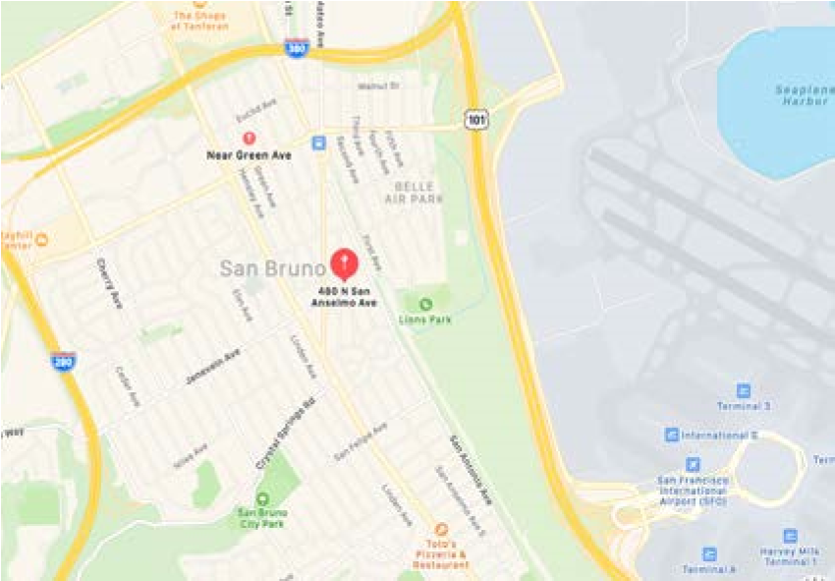
Saint John’s United Church of Christ
4 8 0 N S a n A n s e l m o a v e n u e , S a n B r u n o C a 9 4 0 6 6
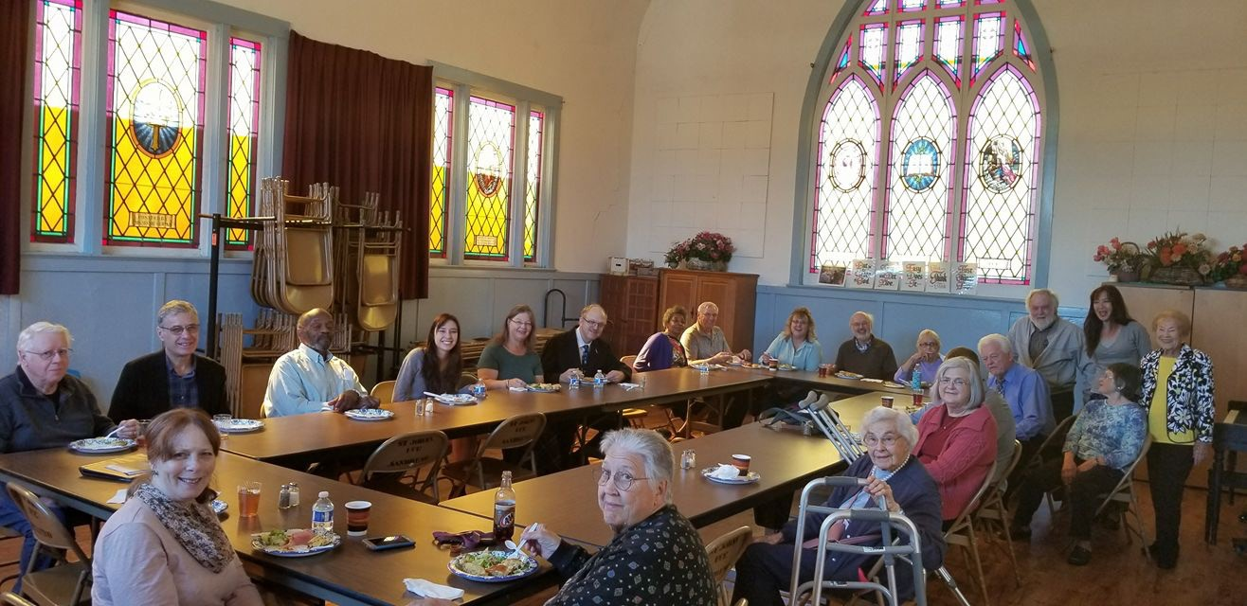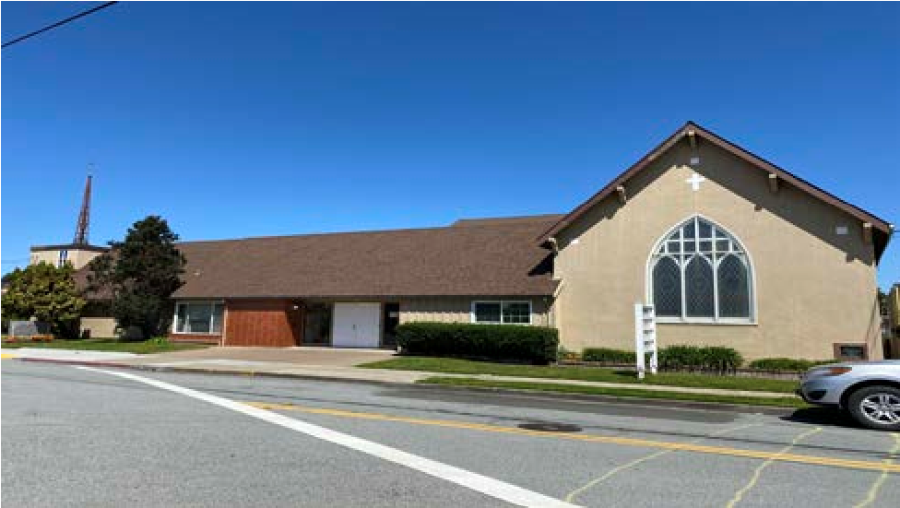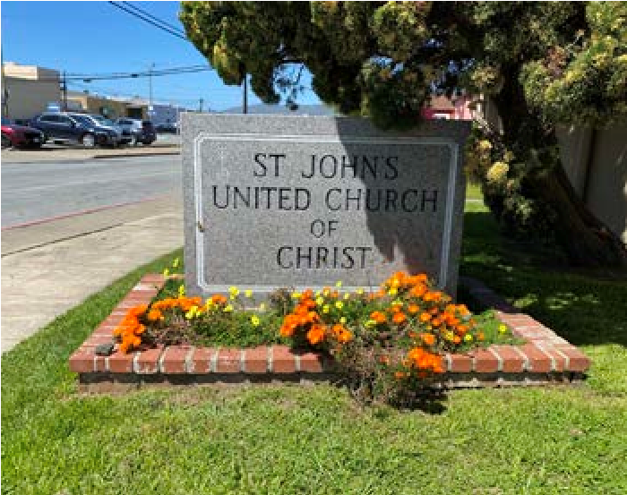
Who is God Calling Us to Become?

Our Mission
Together we are learning to live life the way Jesus did: to love one another, to forgive our enemies, understanding the Father’s love, and being empowered by the Holy Spirit. We care for each other, celebrating creativity, and embracing adventure in our faith. By reaching out to those around us and living honestly, peacefully, and faithfully in God the Father, we follow the example set by Jesus.

Our Vision
To be guided by the Holy Spirit will give us the wisdom to navigate through our daily lives. Each and every step we take, following the path of Jesus Christ, will lead us to rise above all troubles to fully understand how to have peace in our hearts, enabling us to encounter eternal happiness.
St. John’s United Church of Christ is an active church that believes our faith should not be just reserved for a couple of hours on a Sunday but lived out every day! We believe that all humans, regardless of who they are, are children of God deserving of His love and care. We as Christians should value all people as made in God’s image.
The Kingdom of Heaven welcome those with pure hearts. We may become daily disciples of Jesus teaching and live our lives with pure hearts. We may become living examples of God’s unconditional love.
St. John’s United Church of Christ is the house of the Lord where all who enter will find nourishmnet for the soul and warmth for the heart.
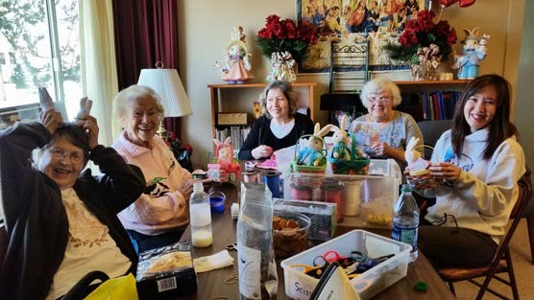
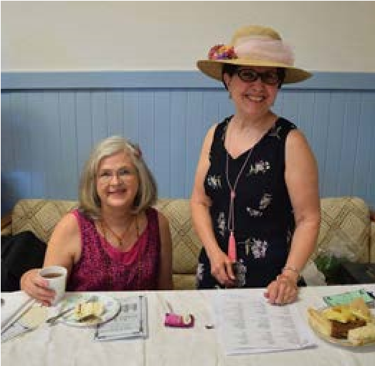
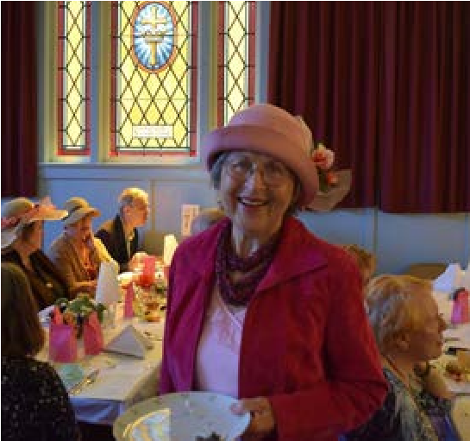
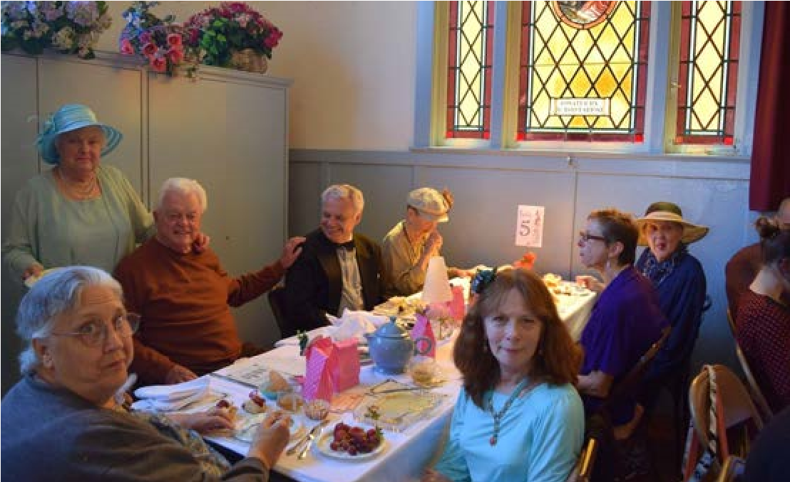
Who are We?
St. John’s United Church of Christ is currently a small congregation of under 20 people who have been long-time members of this church. We share the same values, beliefs, and strong faith in God our Father. Our beloved pastor, Champ Traylor, has instilled in us, for the past 50 years, the importance of focusing on what truly matters in life and striving to be the best we can be every day as God has created us.
We celebrate the gift of talent present in each and every one of us to do God’s work, to spread joy, share our blessings in our community, and radiate the qualities of Christianity to those around us: to love one another, to be humble, slow to anger, to seek knowledge, to forgive, and to reflect upon ourselves, living life as Jesus taught us. Under his leadership, we have developed a very strong bond among our members, becoming a body of Christ where each of us is an important part of the whole church.
Though we are small in numbers, it does not diminish our ability to worship the Lord and do God’s work. We are blessed with many talented individuals in our congregation, and with encouragement from our minister to remain positive and see challenges as blessings, we are able to evolve through many tough times.
Where groups of people gather, disagreements are inevitable. Over the course of our ministry spanning over a hundred years, we have encountered a proportionate amount and successfully overcome them. We resolve these conflicts through open communication, empathy, and compromise to find common ground. Such exercises are essential for Christians to seek God’s guidance and grow in faith through these experiences.
Like many churches in recent times, we have faced a significant decline in membership following the pandemic. Our community has dispersed for various reasons: some members relocated, others passed away, and our youth have grown up and moved away. Additionally, some aging members have chosen to be closer to their families. Furthermore, both our music director and organist have retired, and now we face the impending retirement of our pastor. Despite this exodus, our spiritual unity has strengthened, drawing our congregation closer together.
Our worship structure remains unchanged, whether we have nearly 100 members or barely 20. Sunday worship commences at 11:00 AM and concludes at 12:00 PM, followed by a cherished coffee hour where members take turns providing refreshments for all to enjoy. Communion is observed on the first Sunday of every month, and we maintain a flower calendar to commemorate life events and remember loved ones. We hold an annual church picnic service in the local park and diligently fundraise, collect offerings, and gather supplies to support local charities. Additionally, we offer our facilities at a discounted rate to various community groups, including AA meetings, the Korean Presbyterian Church, Pentecostal Church, Catholic Church, and a Montessori preschool.
Our church council convenes every third Sunday of the month to address governance matters, while the Women’s Guild meets weekly for fellowship, crafting and to organize day-to-day operations, including housekeeping, fundraising, and planning events and church activities throughout the year. Biannually, we host two major fundraising events well-known in the community: a Themed Tea and Christmas Boutique with breakfast and lunch.
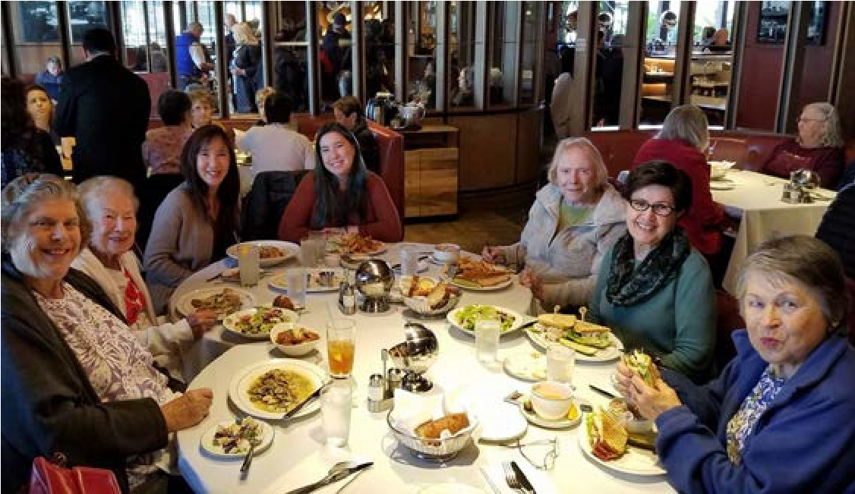
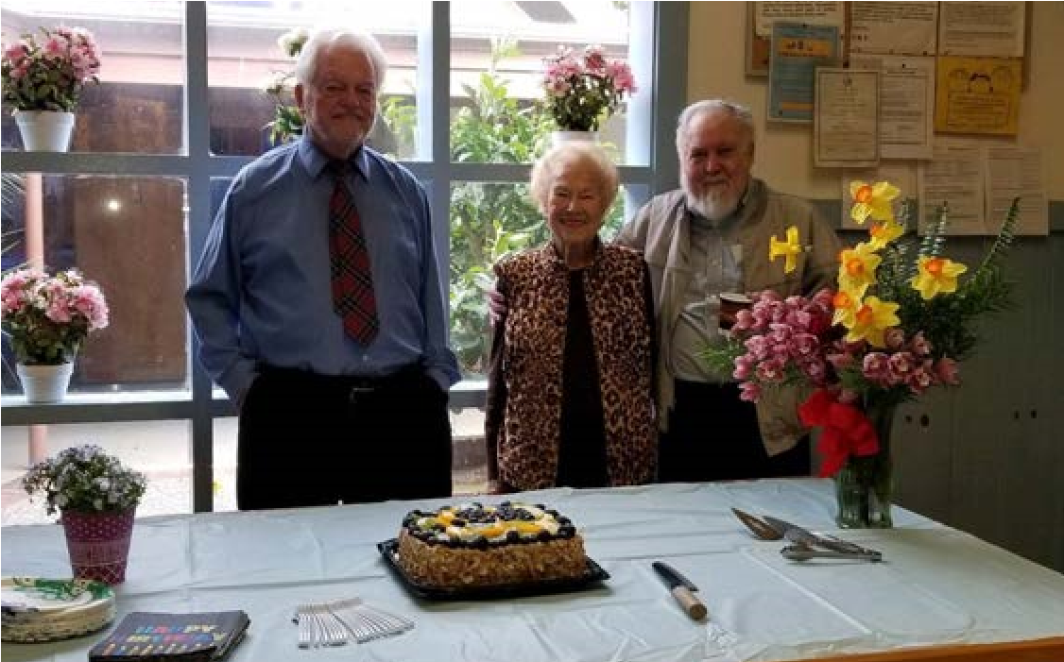
Prior to the pandemic, we regularly organized social gatherings, such as "Dinner on the Grounds" every other month, Maundy Thursday soup suppers, choir rehearsals, Bible studies, mystery trips, and outings for dinner. However, due to the high-risk nature of the majority of our congregation, we had to pause these activities. Unfortunately, we have not yet resumed our pre-pandemic structure. Many of our members are seniors living alone, and their social interaction relies heavily on church activities.
Recognizing the profound impact of purpose on mental and physical health, we take pride in the active participation of seniors in their 90s. As we look ahead, we eagerly anticipate welcoming a new pastor who is prepared to embrace the challenges ahead and lead our church into the future.
Where are We?
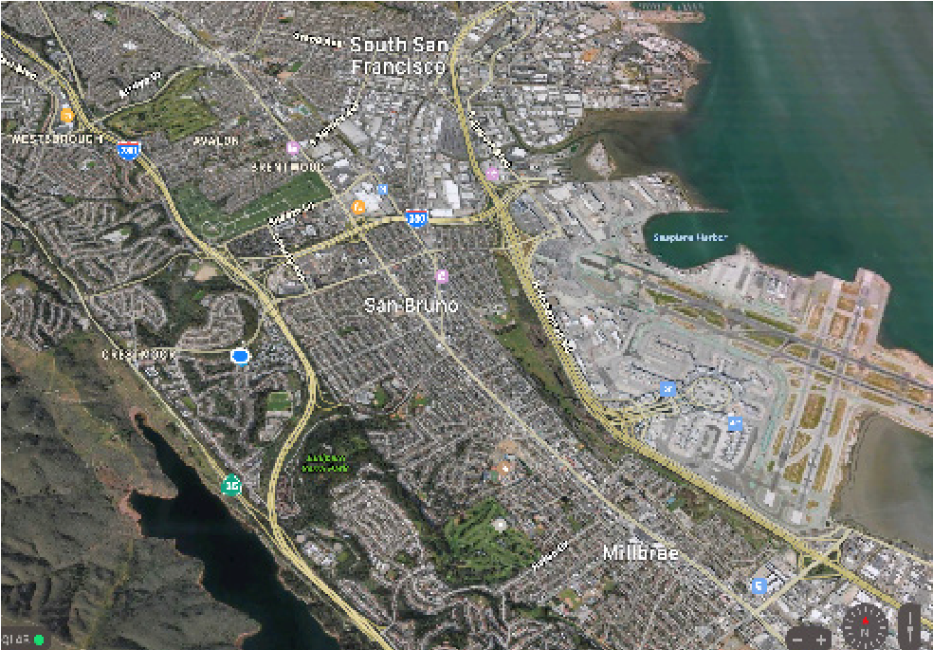
St John’s United Church of Christ is located in the heart of the downtown of the City of San
Bruno. Nestled in the northern part of California's
Silicon Valley, just 12 miles south of San Francisco, San Bruno is a charming city with a unique blend of suburban tranquility and urban vibrancy. Its proximity to San Francisco International Airport and transportation links, makes it a convenient hub, yet it maintains a peaceful atmosphere with tree-lined streets and welcoming neighborhoods.
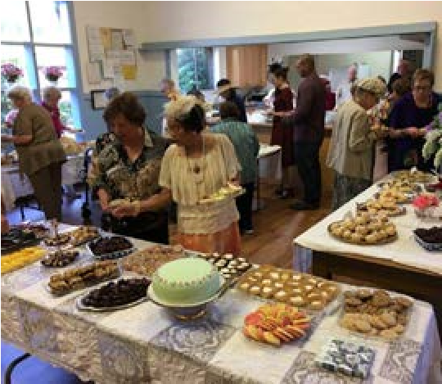
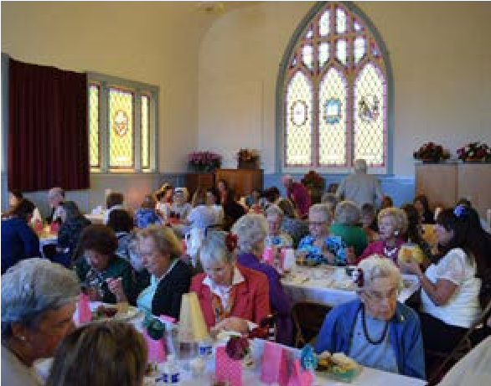
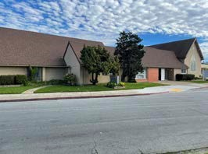
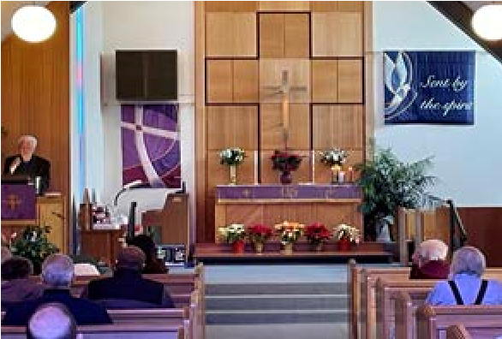
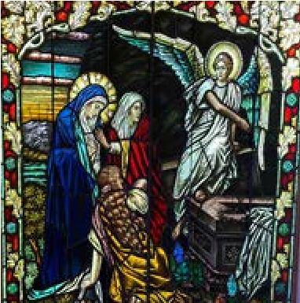
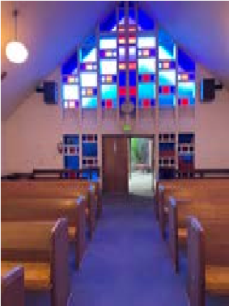
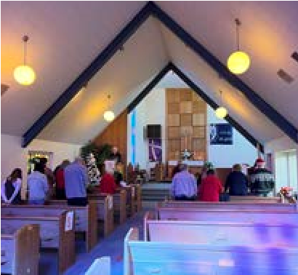
The city is home to the YouTube headquarters, showcasing its role in the technology industry and fostering innovation. The dining scene reflects the city's diversity, with restaurants serving everything from international cuisine to classic comfort food. Outdoor enthusiasts appreciate San Bruno for its parks and open spaces, including San Bruno Mountain State Park, offering miles of hiking trails and stunning vistas. San Bruno offers a delightful mix of small-town charm, cultural richness, technological innovation, and low crime rate making it an ideal location to raise a family in the heart of the Bay Area. Our Facilities
Our facilities consist of:
- 0.34 acre of land
- A modern sanctuary that seats 224 people
- A social hall with a large kitchen
- An original sanctuary that can be used for a fellowship hall, seating up to 238 people
- A parlor
- A craft room
- A nursery school facility
- Two classrooms
- Pastor's office
Our History
After meeting in members’ homes for a number of years, the church we know as St.
John’s United Church of Christ was founded on June 8, 1918, as the Evangelical St.
Johannes Society. The members of the congregation were primarily of German heritage. St. John’s was originally part of the German Evangelical Synod of North America.
By the 1920s, the congregation was meeting in Carpenters’ Hall. In 1921, the cornerstone of the old church sanctuary was laid, and a home for the small congregation was established.
In the 1930s, the Evangelical Synod of North America and the Reformed Churches merged to form the Evangelical and Reformed Church. However, even after the merger, St. John’s was occasionally referred to as St. John’s Evangelical Lutheran Church.
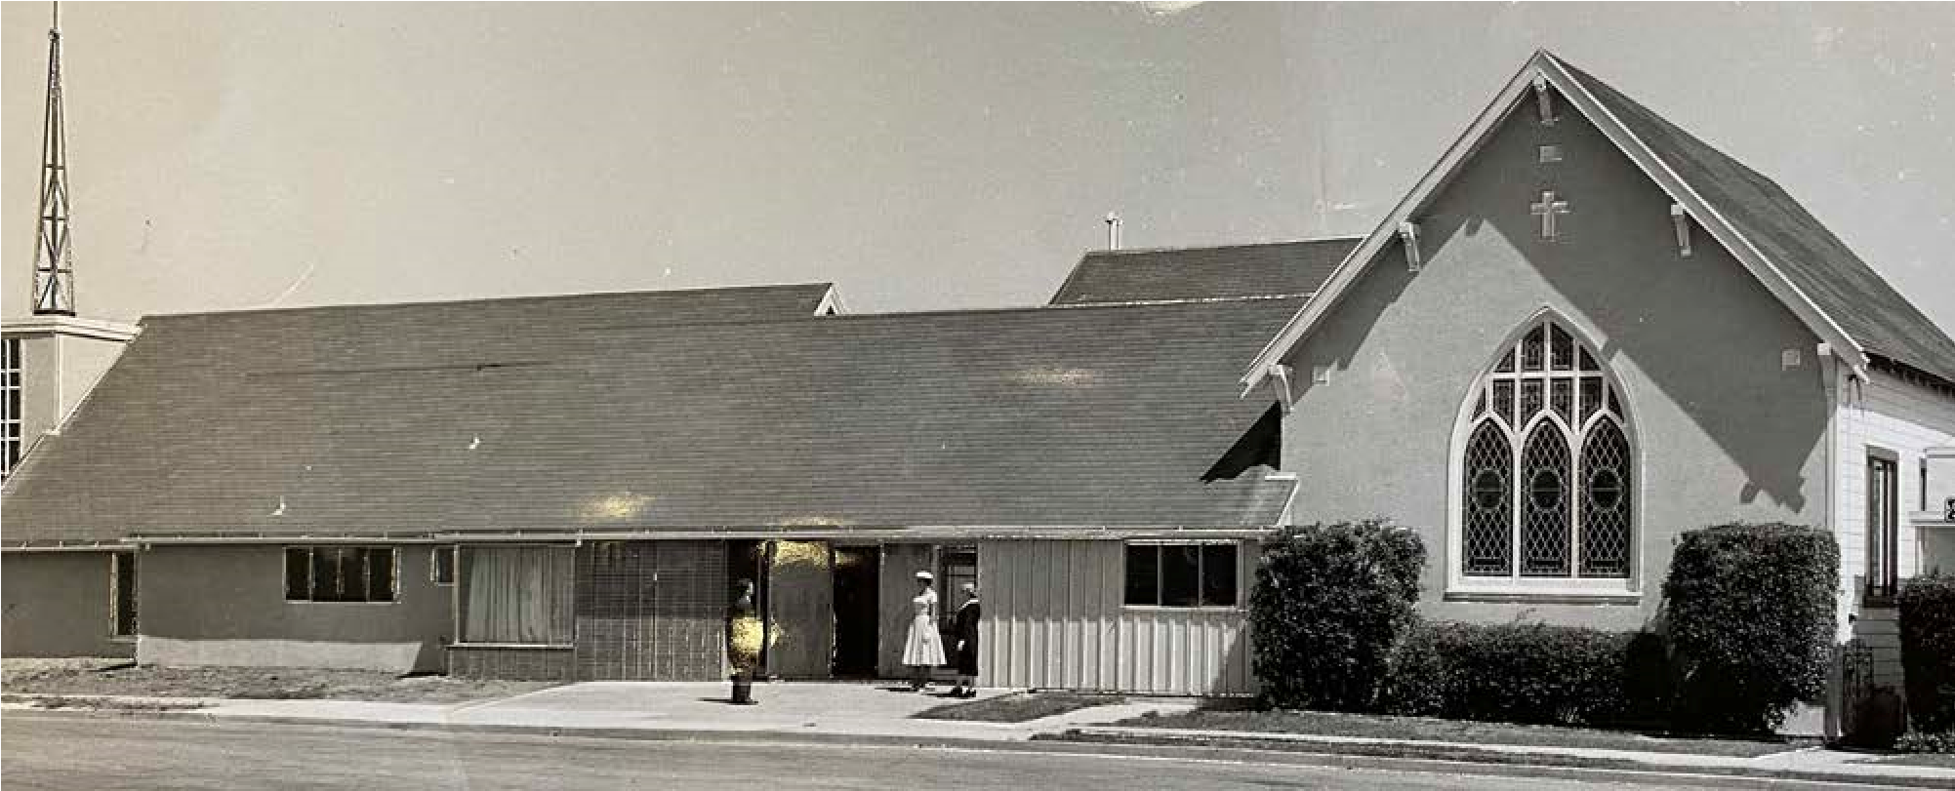
In June 1957, the Evangelical and Reformed denomination merged with the Congregational Christian Churches to form the United Church of Christ. The motto of this new denomination was “That They May All Be One”.
St. John’s is part of the United Church of Christ, and the congregation today has a diverse ethnic background. While we honor our German beginnings, we are blessed today with people who come from different denominations and cultural backgrounds.
On September 9, 2018, St. John’s celebrated the 100th anniversary of its formal incorporation on June 8, 1918. The resolutions recognizing St. John’s contribution and legacy in the community were received from the Conference of the Northern California Nevada United Church of Christ, the United States House of Representatives, the Senate of the State of California, and the City of San Bruno. In the resolution issued by the House of Representatives, Representative Jackie Spear noted that the church has been “... a rock of comfort and hope for the entire community ... allowing all who enter to be encouraged in their spiritual quest and thus allowing America to become a more perfect union.”
Mayor Rico Medina presented the resolution from the City of San Bruno noting that only a handful of institutions could claim such an achievement in the history of the city.
St. John’s has weathered the times, helping to instill values of faith, love, inclusion, and care for every person, no matter how mean their station in life. It has contributed to the fabric of the community, the state, and the nation with men and women who were taught the value and importance of every person.
Whenever possible, St. John’s has tried to contribute to the community needs. Support has always been provided for disaster relief as well as programs for the less fortunate, such as St. Anthony’s Dining Room, the Catholic Worker Hospitality House, and the San Francisco Night Ministry.
Pastor Champion Traylor and his late wife, Pat, have served St. John’s with great dedication for more than 50 years. They have helped its members to make the church a meaningful part of the community.
We may be small, but we believe in our future and the future of our community. We hope and pray for another 100 years of service.
Pastors who have served at St. John’s Church
1918 Pastor Meyer  - Pastor Limper  - Pastor Saenger  - Pastor Struckmeyer  - Pastor John Dipple  1927 Pastor Benjamin J. Koehler  1929 Pastor W.H. Pieper  1929 Pastor J.F.W. Helkamp  1929 Pastor W. Frazee  1931 Pastor Bahnson  1933 Pastor Theodore Tillmans | 1936 Dr. Ira W. Burnett  1938 Pastor Horst Jeschke  1943 Dr Ira W. Burnett  1945 Pastor Henry C. Warber  - Dr. Frankenfeld  - Dr. Saegner  1951 Reverend John W. Frank  - Pastor Victor Morgan  - Pastor John F. Flucke  - Pastor Hubert Dukes  - Pastor Samuel Foos
1973 -present Pastor Champion Traylor
Our Financials
St. John’s United Church is on a sound financial footing, with total cash assets exceeding $105,000. Our annual operating expenses amount to approximately $75,000, with an additional reserve of approximately $43,500. Over the past 11 years, with only three exceptions, our expenditures have consistently remained below our income, demonstrating our commitment to fiscal responsibility. Our primary aim is to maintain a balanced budget.
For the current financial year, we have projected a budgeted income of $80,200, sourced from donations (50%), facility rental fees (40%), and Gift Aid contributions (10%). Additionally, our fundraising efforts, led by the dedicated members of the St. John’s Women’s Guild, occur biannually, providing crucial support for our day-to-day operational expenses and charitable initiatives.
We proudly offer our facilities for hire to various organizations, and thanks to our prudent financial management, we hold no long-term debt, owning the entirety of our property outright. Please find below a summary table detailing our income and expenses over the past 11 years. Comprehensive financial statements are available upon request.
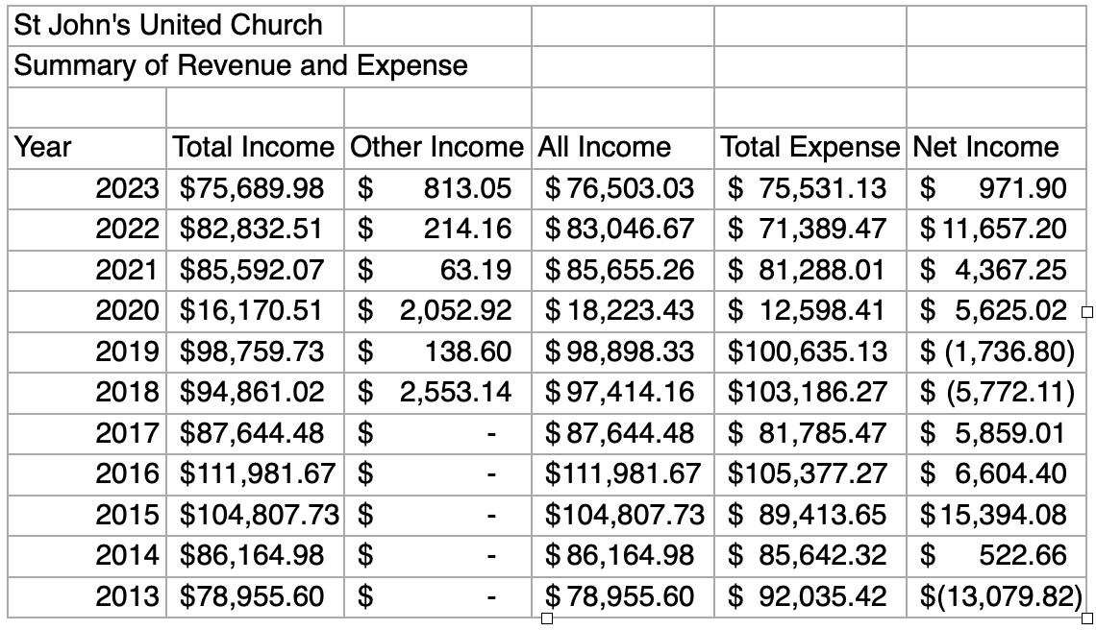
Who is Our Next Pastor
We bellieve that we require a minister who will assist us in nurturing our collective life in this manner. Specifically, we seek someone who:
- Possesses a profound reverence for the Bible in their personal life and possesses the ability to effectively convey this to others, while empowering fellow church members to do the same.
- Will inspire, challenge, encourage and work innovatively with the whole church to move us forward together into the future that God has prepared for us.
- Embraces a collaborative leadership approach, facilitating effective teamwork with our current and prospective ministry team.
- Will motivate, empower, and equip church members to utilize and enhance their God-given talents both within and beyond the church.
- Has the experience and passion to effectively integrate the people we have connected with, into the church community.

Spirituality
- Knows the Bible
- Strong Prayer Life
- Preaches the Gospel and can apply God’s Word to today’s issues
- A Pastoral Heart - loves and deeply cares for people
- Spiritually alive – Christ-like, strong faith, genuine, sincere, experienced in sharing the Gospel

Interpersonal Skills
- Friendly / People-Person / Caring and loving personality.
- Sense of Humor / Informal/ Casual/ Approachable.
- Enthusiastic / Outgoing / Self-confident / Optimistic.
- Patient / Compassionate/ Empathetic / Thoughtful / Genuine.
- Great Communicator.

Personal Qualities
- Willing to visit members, shut-ins and people in hospital.
- Administration skills / Organized / Sets goals / Proactive / Leads by example.
- Great public speaker.
- Experience with youth.
- Good with social media in ministry.
- Clear vision for the church and can articulate it.
- Dedicated to church growth.
- Non anxious presence in crisis situations
- Experience in working with people in need/crisis
- Group facilitator
- Able to keep high level of confidentiality
- Outstanding organizational and time-management skills
- Good active listening and willingness to help.
- Strong communication skills both verbal and written.
- Flexible

Oversight Ministries
- Oversee/coordinate congregation services
- The pastor shall serve as one of the Elders
- Give pastoral input to the various church commissions
- The pastor shall be responsible to the counsel of the church for his ministry

People Ministries
- Weddings and funerals
- Counseling (pre-marital, marriage, family, personal)
- Baptism and orientation of new converts or members
- Visitation (newcomer, hospital, congregational)
- Maintain regular communication with the congregation

Required Education and Experience
- Religious degree and credentialing
- Pastoral experience

Compensation Part-time
- $30,000 plus benefits annually, negotiable.
- Paid time off - 14 days per calendar year

Contact: stjohnssanbruno@gmail.com
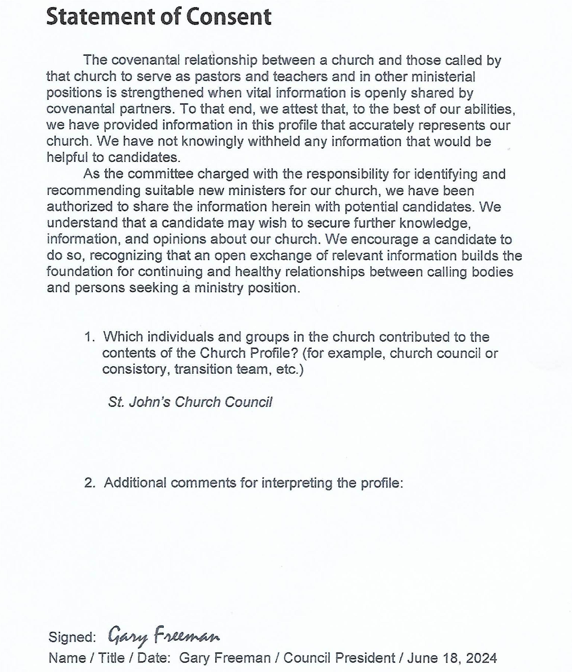
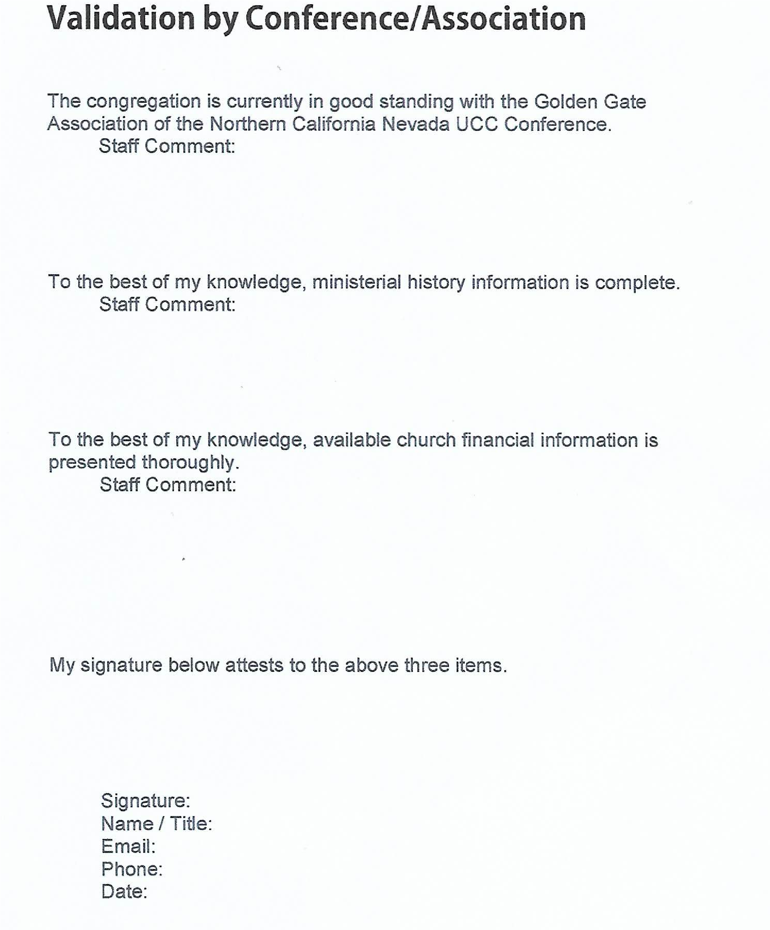
Rev. Dr. Davena L Jones/Conference Minister
davena@ncncucc.org
(510) 3590-7208
August 17, 2024
The church financial information is presented thoroughly best to my knowledge,
The ministerial history is correct and complete as presented best to my knowledge.
St. John's UCC is in good standing within the Golden Gate Association and the NCNC UCC Conference

