UNITED CHURCH OF CHRIST
LOCAL CHURCH PASTORAL PROFILE
for
Trinity United Church of Christ
310 W. 8th St.
Jasper, Indiana 47546
of the
Indiana-Kentucky Conference, Lincolnland Association

March 10, 2024

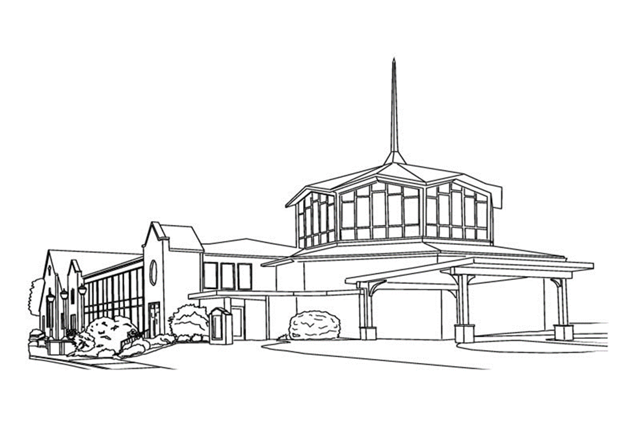

PROFILE CONTENTS

Position Posting

Who Is God Calling Us to Become?

Who Are We Now?

Who Is Our Neighbor?

References

Consent and Validation

“God is able to provide you with every blessing, so that
having all sufficiency in all things at all times,
you may abound in every good work.”
(2 Corinthians 9:8)

1. POSITION POSTING
a. LISTING INFORMATION
b. SCOPE OF WORK
c. COMPENSATION & SUPPORT
d. WHO IS GOD CALLING TO MINISTER WITH US?

1a. LISTING INFORMATION
Trinity United Church of Christ
310 W. 8th Street, Jasper Indiana 47546
www.trinityjasperucc.org

Conference: Indiana Kentucky
www.ikcucc.org

Rev. Dr. Monica J. Ouellette – Association Conference Minister
m.ouellette@ikcucc.org

Association: Lincolnland

No additional ecumenical affiliations

Summary Ministry Description

Trinity is an open, welcoming, loving, and affirming family of diverse believers who is excited to welcome the special person who the Lord is calling to bless us. We are committed to providing support, sacraments, and fellowship with all who seek the heart of God. Our congregational reach extends throughout our community in all directions: we are a faith family of service workers and vital laborers, educators, corporate leaders, elected officials, restaurateurs, physicians, volunteer firefighters, and delegates to municipal and nonprofit boards.

Generous with both our time and talents, we live and give past the boundaries of Sunday service and consider this one of our greatest strengths. Another strength is our willingness to change with the times while fulfilling God’s will for his people. For example, Trinity is one of two local congregations actively involved in our community’s annual Pride Festival.

Jasper, Indiana is a wholesome, energetic, resilient, family- and education-focused community, recognized in 2022 with the national Strong Towns Award. With a deep work ethic and love of the Arts, our community members continuously enhance the quality of life in Jasper by supporting and developing our local parks, festivals, community art and more. Centrally located in the heart of Jasper, our beautiful, mid-century modern church complements nicely the historical architecture and contemporary charm of our excellent surroundings. We are a dynamic and ever-evolving church, inviting a pastoral leader who embraces and enriches our vision of inclusivity, spirited hospitality, and loving fellowship. We are looking for a pastor to match our dynamism, who is ready to take us to the next level of service to our Lord, our community, and our world. We welcome your unique insights and look forward to answering your questions.

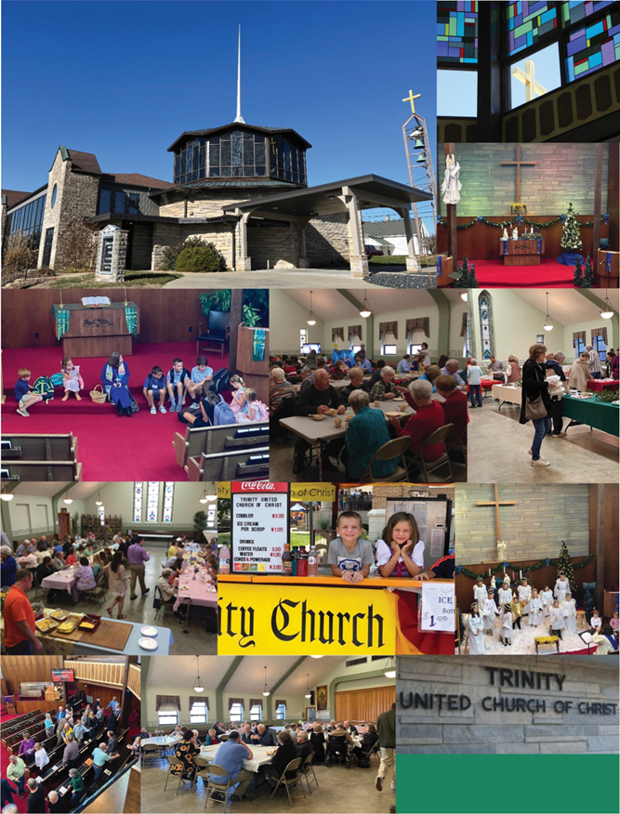

What we value about living in our area (2 – 3 sentences):

We value the rich German heritage of our community, the dedicated work ethic of its increasingly diverse people, the safe and clean surroundings, and the value of family relationships. A strong industrial base also provides for a vibrant local economy which enjoys many cultural and artistic amenities unique to a community of our size. For example, our area is blessed with a YMCA, the Thyen Clark Cultural Center/Library (named after a member of our Faith Family), and a soon to be constructed Wellness/Aquatic Center. All is very poignantly summarized in the Jasper motto “A Tradition of Progress.”

The current size of the Trinity Faith Community is around 175 with regular attendance in the 60-80 range. Our membership roll was audited in 2018.

Position Title
Pastor
Settled – a called position intended for longer-term ministry in which the minister moves church membership to the congregation and moves standing to the related association.

Compensation Level
Full Time
Prepared to meet or exceed conference compensation guidelines in effect at time of publishing.

1b. SCOPE OF WORK:
- Participates in monthly Council meetings and monthly Ministry Team meetings. (Outreach, Parish Life, Christian Education, Property, and Worship) Collaborates with lay leadership to develop meaningful programs.
- Plans and leads inspirational worship services that relate Bible teachings to everyday life.
- Provides an active voice and presence in Christian Education program for the spiritual growth of all ages,
- Ministers effectively to people in need.
- Makes pastoral calls on parishioners in the hospital, nursing care facilities, and the homebound on a regular occurrence, offering Holy Communion.
- Represents Trinity as an ambassador in the community.
- Plans and performs weddings, funerals and baptisms.
- Facilitates and helps with long-term strategic planning for the future of our church.
- Serves as a member of the Personnel Team and supervises paid staff.
- Provides support and guidance for the volunteer staff: media producers, media technicians, financial staff, church school teachers, and outreach assistance administrators.
- Directs and guides administrative tasks, such as email, social media, website, building access, and ordering church supplies, etc.
- Practices and encourages financial development and stewardship.
- Is especially effective in working with children and youth.
- Settled Pastor – Full Time – Senior Pastor
  - 40 – 50 hours weekly or 10 to 12 units per week.
  - Flexible schedule with agreed upon office hours.
Core Competencies
Open
Outgoing
Dedicated

1c. COMPENSATION AND SUPPORT

Housing
Parsonage or Housing Allowance

Basic Support
Base Salary: negotiable with consideration for current Conference recommended salary range:
$44,659 - $63,431
Vacation - 4 weeks
Maternity/Paternity Leave
UCC retirement annuity - 14%
UCC Life and Disability Insurance Benefits or other life/disability insurance
UCC Health Benefits or other health benefits
UCC Dental Benefits or other dental benefits
Social Security and Medicare
Sabbatical Leave - 3 months after 6 years of continuous service

Professional costs
Mileage
Professional Expenses
Continuing Education Funds and time to pursue
Cell Phone
All ordinary moving expenses
Reimbursement for Criminal Background Check fee

Living Situation
We prefer that the pastor reside within Dubois County.

Peer and Professional Support
Trinity UCC is part of the Lincolnland Association which has a Ministers’ Circle as well as a Committee on Ministry. Both groups will provide a very helpful support system. Additionally, the Indiana-Kentucky Conference staff is also available for collaboration and mentoring.

1d. WHO IS GOD CALLING TO MINISTER WITH US?

Describe the ministry goals you envision your next minister co-collaborating with the congregation to achieve.

- Further strengthen our Community Outreach
- Grow and nurture an engaged Faith Family
- Lead our exploration in what it means to be a designated Open and Affirming Church
- Reinvigorate our Christian Education programming
Describe how your vision of the minister you are now seeking will assist the congregation in making an impact beyond its walls.

Outreach and a positive community presence has always been an important part of Trinity’s ministry. Our new minister should share a passion for outreach and be comfortable engaging in a variety of community activities to become a visible voice in the community and with fellow clergy. Additionally, we seek someone who will reach beyond the walls of the Church to connect with those unable to participate in person.

Specify language requirements or culturally specific capacities we preferred in a next ministerial leader as of our congregation’s sense of calling.

Spanish language skills would be positive (but not required) as much of the community growth over the last 10-15 years has been within the Hispanic community.

Based on what you have learned about who your church is, who your church’s neighbor is, and who God is calling the church to become, describe four areas of excellence from The Marks of Faithful & Effective Authorized Ministry that your next minister will display to further equip the congregation’s ministry in these areas.

- Working collaboratively with intercultural awareness and sensitivity. This is important because we need to reach out to all groups and be sensitive about their cultures to be relevant as a church within our ever-diversifying community.
- Engaging in mission and outreach. We must keep active to promote justice and mercy, especially in these uncertain and volatile times.
- Empowering the Church to be faithful to God’s call, reflective of Christ’s mission, and open to the surprises of the Holy Spirit. We would like to see the next Pastor work with us in bringing people to God. We seek to create a wave of faithfulness that grows outside our community - to react and respond to the wider world.
- Providing hope and healing to a hurting world. Our world is crying for love, so a Pastor who can motivate, teach us, provide hope, and trust in one another is very important.

2. WHO IS GOD CALLING US TO BECOME?

“You shall love the Lord your God with all your heart,
and with all your soul, and with all your mind.”
(Matthew 22:37 NRSV)

Who is God calling you to become as a congregation?

We believe God is calling us to be an open and accepting congregation recognizing that Jesus’ teachings apply to all, especially the most vulnerable in society. Research indicates a trend toward a distrust of organized religion, and we strive to be a congregation that works to rebuild that trust, both within and outside our walls.

Describe how God is calling you to reach out to address the emerging challenges and opportunities of your community and congregation.

God is calling on Trinity UCC to minister to individuals who are marginalized in various ways. We have participated in the local Pride Event, reaching out and sending a message of support and welcome to the local LGBTQIA+ community. We were one of two churches that participated and received very positive feedback and appreciation for our efforts and look forward to continuing our participation in this event as well as others which assure people that God is still speaking to us all.

Although the pandemic put an end to it, Trinity helped organize and hosted an annual Martin Luther King Day community event. We believe our voice and support is vital for this event and similar outreach efforts. Additionally, with a growing local Hispanic population we believe that our programming and worship practices should extend a hand of welcome to this community as well as other minorities, be it due to socioeconomic status, ability, orientation, or other differences.

While our church does not have a formal long-term strategic plan, we embrace and embody the following guiding statements:

Mission: “God Speaks. We Listen.”

Vision: “An inclusive community of faith, passionately serving God with hope, confidence, and peace.”

3. WHO ARE WE NOW?
“You shall love your neighbor as yourself.”
(Matthew 22:39 NRSV)

a. CONGREGATIONAL REFLECTIONS
b. 11-YEAR REPORT
c. CONGREGATIONAL DEMOGRAPHICS
d. PARTICIPATION AND STAFFING
e. CHURCH FINANCES
f. HISTORICAL INFORMATION

3a. CONGREGATIONAL REFLECTIONS

Describe your congregation’s life of faith.

The key beliefs of our mission and vision statements are that God still speaks, inclusiveness and service. We believe the Holy Spirit has guided our congregation through a long history of service, outreach, community, and perseverance.

Describe several strengths or positive qualities of your congregation.

We welcome our individual differences as strengths, not weaknesses. And are open in discussing our various points of view and value the diversity of opinions. We are generous and giving – to our local and global community -- both financially and with our time and talents. Additionally, at Trinity we are warm, interested, and congenial with all who enter our doors – members, friends, and visitors alike.

Describe what worship is like when your congregation gathers.

We gather in our main sanctuary as a beloved community of members, friends, and guests. Our members serve as ushers, greeting individuals warmly and ensuring that bulletins are distributed, and appropriate seating is found. We place a strong emphasis on hospitality, and much socializing occurs before and after the service, with many people lingering in the sanctuary and Narthex, greeting each other and catching up. Often, refreshments are set up, and the Keurig coffee maker is always on, ready to provide a hot beverage for all. The music of our organ greets and calls us into the mode of worship. The service and sermons generally follow the common lectionary, and we have also utilized the narrative lectionary in the past.

Ours is a traditional and contemplative worship service with music, scripture, offering, and prayer being the key components—all supported by new technology. We enjoy congregational participation throughout, during the passing of the peace, announcements, scripture reading, children’s sermon, and a lively discussion of joys and concerns in preparation for prayer.

The Trinity services include a variety of musical selections, including traditional hymns and contemporary worship music, with special music provided by our chancel choir, members of our congregation, and guests. To us, good preaching delivers a motivational and inspirational message with modern insights and sound scriptural foundations.

Individuals who are unable to physically attend worship are also included; they are encouraged to participate via live-streaming, and the sacrament of communion is delivered to those in assisted living facilities by congregation members.

Describe the educational program/faith formation vision of your church.

At Trinity we have a vision of strengthening and re-envisioning our youth program. Christian education is provided for our children and youth. We sponsor attendance for youth at summer church camps. Youth lead worship at least annually. We host and sponsor a youth prayer circle which meets once a week and includes youth from outside the congregation. We host a children’s program, KICS (Kids in Christ’s Service), at a local school twice a month for elementary students. We recently did a pastor-led Lenten program during Lent called SHAPE which focused on spiritual gifts, heart, abilities, personalities, and experiences which was very positively received by our members and has led to a growing desire for additional adult educational opportunities.

Describe how your congregation is organized for ministry and mission.

The governing body of our church is our Church Council. The Council can have up to nine members. Council members are liaisons to standing ministry teams (Parish Life, Property, Outreach, Worship, and Christian Education) and also our focus teams, such as technology, nominating team, etc. Council meets monthly for approximately an hour and a half meeting. Council starts their meeting with devotions, a review of minutes, financial reports, and standing team liaison reports. Decisions are acted on as needed.

The standing ministry teams meet monthly for approximately an hour. The focus teams meet as needed. Decisions are communicated through various ways: newsletters, congregational meetings, or announcements made prior to worship.

The pandemic created challenges for us, just like any other church. Our pastor and council remained committed to staying in contact with our congregation through Sunday radio time, holding online meetings, internet voting, phone visitation, etc.

We are currently in the process of updating our constitution and bylaws. We can provide current information as well as proposed changes. The current annual report can be available upon request.

3b. 11-YEAR REPORT

Note: In 2013 and 2018 there was an intentional audit of our membership roll to improve visibility as well as efficiency in mailings.

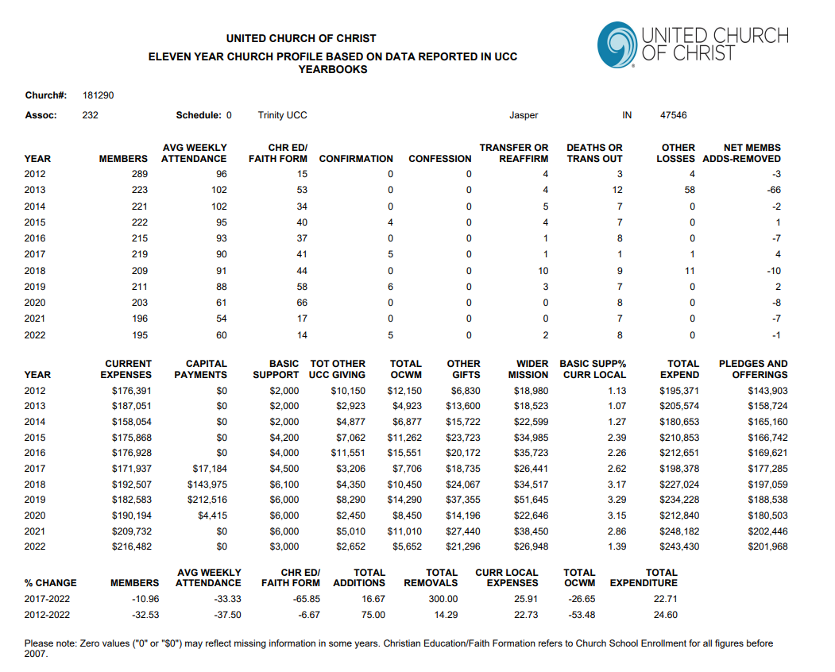

3c. CONGREGATIONAL DEMOGRAPHICS

Describe those who participate in your church.

 |  | Is this number an estimate?
Number of active participants: | 101 | Yes
Number of non-active members: | 111 | Yes
Total: | 212 | Yes

Percentage of total participants who have been in the church:

 |  | Is this number an estimate?
More than 10 years: | 142 (81%) | Yes
Less than 10, more than 5 years: | 18 (10%) | Yes
Less than 5 years: | 15 (8.5%) | Yes

Number of total participants by age:

0-11 | 12-17 | 18-24 | 25-34 | 35-44 | 45-54 | 55-64 | 65-74 | 75+ | Estimates?
18 | 19 | 16 | 13 | 11 | 19 | 43 | 35 | 38 | Yes

Percentage of adults in various household types:

 |  | Is this number an estimate?
Single adults under 35: | 12 (12%) | Yes
Households with minors: | 20 (21%) | Yes
Single adults aged 35-65: | 6 (6%) | Yes
Joint households with no minors: | 37 (38%) | Yes
Single adults over 65: | 21 (21%) | Yes

Education level of adult participants by percentage:

 |  | Is this number an estimate?
High School: | 66 (38%) | Yes
College: | 60 (34%) | Yes
Graduate School: | 39 (22%) | Yes
Specialty Training: | 7 (4%) | Yes
Other (please specify): | 3 (2%) | Yes

Percentage of adults in various employment types:

 |  | Is this number an estimate?
Adults who are employed: | 98 (56%) | Yes
Adults who are retired: | 58 (33%) | Yes
Adults who are not fully employed: | 19 (11%) | Yes

Describe the range of occupations of working adults in the congregation:

We are a faith family of service workers and vital laborers, educators, corporate leaders, elected officials, restaurateurs, physicians, volunteer firefighters, marketers, delegates to municipal and nonprofit boards and more.

Describe the mix of ethnic heritages in your congregation, and the overall racial make-up. Most UCC congregations tend to describe themselves as “diverse.” Yet, the vast majority of UCC congregations are mono-cultural. What does diversity mean in your context?

Our congregation is best described as homogeneous in terms of racial make-up. However, Trinity does reflect diversity within our congregation in sexual identity as well as in religious background.

Has your congregation recently had a conversation about welcoming diversity, or do you plan to hold one in the near future? Please note the date: comment after the exercise.

In 2023 we held sessions for our Faith Family to discuss the exploration of being an Open and Affirming Church, and the dialogue continues via a formed team. Thus far we have learned the power of active listening and strengthened our ability for openness and transparency. Also, in 2015 we held similar sessions to explore and discuss our thoughts on same-sex marriage. The church did adopt a policy to support Same Gender Weddings in 2015.

3d. PARTICIPATION AND STAFFING

Complete the following chart. Please leave blank any fields that are not applicable to your congregation.

Ways of Gathering | Estimated Number of people involved in attendance | Who plans each of the listed gatherings?
Adult Groups or Classes | 8-10 in both Men’s Group and Women’s Guild | Congregation member
Baptisms (number last year)
Children’s Groups or Classes | 2-6 during Sunday School; 11 students in renewed KICS (Kids in Christ’s Service) program | KICS program planned by Christian Ed team with lead person getting a stipend
Christmas Eve and Easter Worship | Easter 2023 – 114  Christmas 2023 - 90 | Pastor plans with help from Worship Team
Church-wide Meals | 40-50 in attendance | Parish Life team
Choirs and Music Groups | One choir of 8-10 | Organist and Choir Leader
Church-based Bible Study
Communion (served how often?) | First of month and other Holy days | Worship team; communion prep volunteers
Community Meals
Confirmation (number of confirmed last year) | 2022 – 5  2023 - 1 | Pastor led study
Drama or Dance Program | Special worship services | Pastor and worship team
Funerals (number last year) | 2022 – 6  2023 - 4 | Pastor and family members plan service  Women’s Guild coordinates meal
Intergenerational Groups
Outdoor Worship | Held annually pre-Covid | Pastor-planned with assistance from worship team and parish life committee
Prayer at Meditation Groups
Public Advocacy Work
Retreats
Theology or Bible Programs in the Community
Weddings (number last year)
Worship 9 am | 60 - 80 | Pastor plans with assistance from Worship Team
Young Adult Groups or Classes
Youth Groups or Classes | Circle of Concern weekly prayer group for all community high schoolers | High school student led and participated; Trinity member volunteers
Other | Blessing of Backpacks for back to school | Pastor and Worship team

Additional comments:

List all members or regular participants in your congregation who are ordained, licensed, or commissioned ministers. Indicate those with current United Church of Christ Three-Way Covenants (i.e., serving in a congregation) or Four-Way Covenants (i.e., serving in a ministry beyond a congregation).

Name | Three or Four Way Covenant? | Ministry Setting | Type of Ministry Role | Retired (Y or N)
Dan Sergesketter | Three Way | Part-time | Licensed | N

If one or more previous pastors or retired ministers currently hold membership in the church, describe their role(s) in the life of the congregation: List all current staff, including ministers. Exclude the position you are seeking to fill. Indicate which staff person serves as head of staff.

Staff Position | Head or Staff? | Compensation (full time, part time, volunteer) | Supervised by | Length of Tenure for current person in this position
Interim Pastor | Head | Full time | Pastoral Relations Team | 1 ½ years
Office Administrator | Staff | Part time | Pastor + Personnel Committee | 2 ½ years
Custodian | Staff | Part time | Pastor | 2 ½ years
Organist/Choir Director | Staff | Part time | Worship Team | 15+ years
Lawn Care | Staff | Part time | Property Team | 15+ years
Building Opener | Staff | Part time | Property Team | 4 years

REFLECTION
Reflection: After reviewing the congregational demographics and activities above, what does this information reflect about your congregation’s overall ministry?

That our worship services have focus and priority. However, the pandemic and retirement of Preschool Administration curtailed some activities which provide areas of improvement for youth and adult Christian education. We have attracted new members post-pandemic and our Faith Family is open and eager to expand our ministries.

3e. CHURCH FINANCES

Source | Amount
Annual Offerings and Pledged Givings | $216,609
Endowment Proceeds (as permitted within spending policy) | $36,000
Endowment Draw
Fundraising Events | Strassenfest (Community Festival) $4,975
Gifts Designated for a Specific Purpose | $23,653
Grants | $500
Rentals of Church Building | $1.820
Rentals of Church Parsonage
Support from Related Organizations (Women’s Guild) | $500
Transfers from Special Accounts | $29,452
Other (Please specify)
TOTAL | $313,509

Attach most recent church budget, spending plan, operating statement, or annual treasurer’s report as shared publicly with the congregation

 | 1/1/23- 12/31/23 | 1/1/23 - 12/31/23
 | Actual | Budget | Dollar Change
INCOME
Contributions - Envelopes | 202,142.00 | 185,000.00 | 17,142.00
Contributions-Non-Pledge | 13,335.00 | 2,500.00 | 10,835.00
Contributions-Loose Offer | 900.04 | 2,000.00 | (1,099.96)
Initial Offering | 191.00 | 250.00 | (59.00)
Church School | 41.00 | 150.00 | (109.00)
Building Use | 1,829.96 | 2,400.00 | (570.04)
Donations | 1,771.95 | 350.00 | 1,421.95
Edna Joseph Account | 0.00 | 0.00 | 0.00
Fund Raising-Strassenfest | 7,053.00 | 6,500.00 | 553.00
Fund Raising-VBS | 0.00 | 800.00 | (800.00)
TOTAL INCOME | $227,263.95 | $199,950.00 | $27,313.95
EXPENSE
1 CHURCH AT LARGE
OCWM | 3,000.00 | 3,000.00 | 0.00
Lincolnland Association | 750.00 | 750.00 | 0.00
CUE | 0.00 | 200.00 | 200.00
Bellewood and Brooklawn | 0.00 | 400.00 | 400.00
Merom Conference Center | 750.00 | 750.00 | 0.00
Total 1 CHURCH AT LARGE | $4,500.00 | $5,100.00 | $600.00
2 PASTORAL MINISTRY
Interim Pastor - Salary | 63,450.00 | 63,450.00 | 0.00
Interim Pastor - Pension | 11,561.18 | 11,548.00 | (13.18)
Interim Pastor - MDV Insurance | 6,139.11 | 5,410.00 | (729.11)
Interim Pastor - Life & Dis. Insurance | 1,238.73 | 1,237.00 | (1.73)
Interim Pastor - Soc. Sec. & Medicare | 6,301.60 | 6,310.00 | 8.40
Total 2 PASTORAL MINISTRY | $88,690.62 | $87,955.00 | ($735.62)
3 STAFF SALARIES
Custodian | 4,812.75 | 6,700.00 | 1,887.25
Office Administrator | 22,478.50 | 27,872.00 | 5,393.50
Organist | 4,400.00 | 5,700.00 | 1,300.00
Social Security Taxes | 1,907.80 | 2,497.00 | 589.20
Medicare Taxes | 446.18 | 584.00 | 137.82
Total 3 STAFF SALARIES | $34,045.23 | $43,353.00 | $9,307.77
4 OUR WORK AND SERVICE
Mileage - Pastor | 852.81 | 1,000.00 | 147.19
Cell Phone - Pastor | 888.00 | 900.00 | 12.00
Professional Expenses | 1,000.00 | 1,000.00 | 0.00
Continuing Education - Interim Pastor | 526.42 | 1,600.00 | 1,073.58
Bulletins | 28.82 | 0.00 | (28.82)
Candles | 92.49 | 95.00 | 2.51
Chancel Choir | 0.00 | 50.00 | 50.00
Copy Licnse/Website&Media | 713.49 | 1,415.00 | 701.51
Devotionals | 212.49 | 200.00 | (12.49)
Guest Pastor & Mileage | 150.00 | 500.00 | 350.00
Piano & Organ Upkeep | 1,686.50 | 1,900.00 | 213.50
Sacraments & Rites | 184.30 | 250.00 | 65.70
Worship Supplies | 467.59 | 300.00 | (167.59)
Outreach Team | 0.00 | 0.00 | 0.00
Parish Life Team | 224.64 | 200.00 | (24.64)
Office Supplies | 89.86 | 50.00 | (39.86)
Mailing Cost | 640.66 | 1,200.00 | 559.34
Paper Products | 291.18 | 250.00 | (41.18)
Resources/Calendars | 27.50 | 50.00 | 22.50
Financial Supplies | 366.93 | 550.00 | 183.07
Equipment & Media | 1,398.67 | 1,600.00 | 201.33
Conference Delegate Fees | 209.92 | 550.00 | 340.08
Staff Appreciation | 785.00 | 900.00 | 115.00
Fund Raising Expense | 3,399.35 | 3,000.00 | (399.35)
Total 4 OUR WORK AND SERVICE | $14,236.62 | $17,560.00 | $3,323.38
5 OUR YOUTH
Educational Material | 0.00 | 700.00 | 700.00
Confirmation | 49.20 | 200.00 | 150.80
Vacation Church School | 0.00 | 800.00 | 800.00
Jr and Sr Youth Ministry | 0.00 | 650.00 | 650.00
Children's Ministry-KICS | 348.46 | 400.00 | 51.54
Ed. Supplies/Tchr Apprec. | 0.00 | 400.00 | 400.00
Total 5 OUR YOUTH | $397.66 | $3,150.00 | $2,752.34
6 OUR CHURCH PROPERTY
Utilities - 310 W 8th St | 22,646.60 | 21,500.00 | (1,146.60)
Utilities - 315 W 9th St | 1,962.63 | 1,650.00 | (31,263.00)
Telephone | 2,683.55 | 2,550.00 | (133.55)
Internet Service | 958.80 | 1,000.00 | 41.20
Fire Alarm Service | 1,172.40 | 900.00 | (272.40)
Elevator Maintenance | 4,539.21 | 2,300.00 | (2,239.21)
Insurance - All Property | 27,394.00 | 25,100.00 | (2,294.00)
Lawn Mowing/Leaf Cleanup | 4,852.00 | 4,400.00 | (452.00)
Pest Control | 893.60 | 900.00 | 6.40
Repair & Maintenance | 4,606.75 | 5,500.00 | 893.25
Custodial Supplies/Trash | 371.38 | 400.00 | 28.62
Internet Router Maintenance | 573.00 | 600.00 | 27.00
Opening Building | 1,030.00 | 1,040.00 | (20.00)
Total 6 OUR CHURCH PROPERTY | $73,713.92 | $67,840.00 | ($5,873.92)
7 PARSONAGE
Utilities - 421 W 8th St | 2,236.77 | 2,000.00 | (236.77)
Repair & Maint - 421 W 8 | 0.00 | 1,500.00 | 1,500.00
Cable TV - 421 W 8th St | 870.68 | 900.00 | 29.32
Pest Control - 421 W 8th | 330.40 | 400.00 | 69.60
Total 7 PARSONAGE | $3,437.85 | $4,800.00 | $1,362.15
TOTAL EXPENSE | $219,021.90 | $229,758.00 | $10,736.10
NET INCOME (LOSS) | $8,242.05 | ($29,808.00) | $36,050.05

Considering total budgeted expenses for the year, compare total ministerial support. What is the percentage? 40%

Has the church ever failed to pay its financial obligations to a minister of the church? No

Is your church 5-for-5, i.e., does it include each of the following contributions during the church year? (indicate those included during the most recent fiscal year) Yes

_X_ Our Church’s Wider Mission (OCWM – Basic Support) $3000
_X_ One Great Hour of Sharing $583
_X_ Strengthen the Church $305
_X Neighbors in Need $860
_X_ Christmas Fund $220

In what way is OCWM (Basic Support) gathered? If calculated as a percentage of operating budget, what is that percentage? OCWM is part of our annual budget and has been for many years. An annual amount is suggested by the Outreach Team and approved first by the Budget Team, then by the Council, and finally voted on by the members.

What is the church’s current indebtedness? zero
Total amount of loan debt: zero
Reason for debt: N/A
Are capital and other payments current? N/A
If a building program is projected or underway, describe it, including the projected start/end date of the building project and the total project budget. N/A

If the church has had capital campaigns in the last ten years, describe:

Year(s) | Purpose | Goal | Result | Impact
2017 | To make improvements around the church (God’s Home Improvement Campaign) | No Goal Set | $289,845 | Improved access for all, regardless of ability: i.e. completed Circle Drive Improvement, accessible parking and ADA building access

If a capital campaign is underway or anticipated, describe:
N/A

Describe the prominent mission component(s) involved in the most recent (or current) capital campaign.

We recognized that inclusion is a critical component for a church and undertook the 2017 GHI (God’s Home Improvement) campaign to fund building improvements to welcome worshipers and guests who are able-bodied as well as those with varying levels of ability.

Does your church have an endowment?

We are one of three beneficiaries of the Edna Joseph Trust which is held by a local bank. The three beneficiaries have benefitted by the way the trustees refigured the distribution formula around five years ago. The beneficiaries now receive more in the annual distribution.
In 2022 our distribution was $38,000, in 2023 we received $36,000, and this year it is $34,000.

What is the market value of the assets?

$2,703,779

Are funds drawn as needed, regularly, or under certain circumstances?

We withdraw funds under certain circumstances, for example most recently the upgrades to media to stream worship services. Each year $10,000 is requested by the Outreach Team to help fund our Outreach Assistance Program. (This program helps people in our community to pay their rent and utility bills.)

What is the percentage rate of draw (last year, compared to 5 years ago)?
We do not draw from the Edna Joseph Trust, rather we receive a distribution which aligns with the growth of the fund which is overseen by trustees.

Describe draw on endowment, if any, to meet operating budget expenses for the most recent year and the past five years:
We have not used the Edna Joseph Account for any operating budget expenses.

At the current rate of draw, how long might the endowment last?

The trustees’ investment policy assures that the Edna Joseph Trust will be around for generations.

Please comment on the above calculations or estimates:

Other Assets
Edna Joseph Checking Account $209,770
God’s Home Improvement Checking Account $29,919
Memorial Fund Checking Account $9,563
Maintenance Fund Checking Account $4,875

Reserves (savings): Balance in General Fund Checking Account is $58,791

Investments (other than endowment): None

Does your church have a parsonage?
Yes
Fair market rental value of the parsonage: $2,100 a month
How is the parsonage used? Previous pastors have made it their home.
421 West 8th Street, Jasper In 47546 (1 block from church)
Finished square footage: 3,278
Number of Bedrooms, Number of Bathrooms: 4 Bedrooms, 2 Baths
Assessed real estate value: $202,800 (Zillow prediction of $254,000.)
Available for minister residence: Y/N Yes
Expected minister residence: TBD
Condition of structure, systems and appliances:
- The parsonage structure is in good overall condition; a well-built brick home.
- The central heat and A/C systems in the parsonage are appropriate for the size of the home and are in working condition. Our contractor said they may need updating in 5-6 years as they are 5 years old.
- The parsonage includes an electric stove, refrigerator, dishwasher and microwave. The washer and dryer is approximately ten years old.
- The parsonage is in need of some repairs that we are actively pursuing.
- Lawn mowing/leaf removal is a service provided for the parsonage.

Entity in the church responsible for review and needed repairs,
Property Team - David Peters, Property Team Liaison

Describe all buildings owned by the church:

Our wide array of facilities allows us to extend an extravagant welcome to members, friends, visitors and the local community and embrace them into our loving family of faith.
- Church Building - a mid-century modern facility which is equipped with an elevator and handicap accessible (push button) exterior doors. It includes a unique octagon-shaped sanctuary with a balcony level for seating, welcoming Narthex, large sunshine-filled foyer for gatherings, generously sized Parish Hall, Chapel Room, study, multiple classrooms, a community room, and large kitchen outfitted with commercial grade appliances. A 2018 upgrade is a larger, more accessible covered driveway to provide drop-offs and easy access for all, regardless of ability.
- Office Building - adjacent to the church building with a reception area, two offices, a conference room, a workroom, a kitchenette, and bathroom.
- Parsonage - brick single-family 2-story home less than two blocks from our church building. It sits on a double lot with mature trees in a quiet middle class neighborhood and is two blocks from a beautiful city property called Central Green which includes green space and a water feature for children. The street includes a sidewalk and is tree-lined. Home has a large living room, 4 bedrooms, 2 full baths, kitchen with adjacent dining area, basement and two car attached garage.
- Three grassy, undeveloped lots next to the church which are used for youth activities and gatherings and which hold strong potential for additional uses.
- Paved Parking lots which include handicap spaces.

Describe non-owned buildings or space used or rented by the church: N/A

Which spaces are accessible to wheelchairs?

The entire church facility (Worship Space, Fellowship Spaces, Educational Spaces, Kitchen, Restrooms) with the exception of the chancel and choir loft. However, accessibility to these spots could be provided fairly easily.

Reflection: After reviewing the church’s finances and assets described above, what does this information reflect about your congregation’s mission and ministry?

The Trinity Family is very giving with their contributions to the General Fund and also their donations to special funds and missions both local, regional and international. The Council is an excellent steward of these monies and spends wisely. We are also blessed to have the Edna Joseph trust account.

3f. HISTORICAL INFORMATION

Name one to three significant happenings in the history of your church that have shaped the identity of your congregation.

- 2005 - Conflict within Trinity after General Synod’s resolution supporting same sex marriages. Several families who were not aligned with the resolution left Trinity. After a thoughtful, and intentional churchwide dialogue spanning a number of years, in 2015 a policy was approved to perform same-sex marriages.
- 1994 - A significant church building addition that provided larger gathering spaces and additional classrooms.
- 1966 - The building of our current unique, octagon-shaped sanctuary which gave us a more beautiful, intimate environment for worship.

Add the most important event in the life of your church in the past 10 years.

In 2018 the church family recognized the need to modify the main building to be more accessible, welcoming and inclusive for all who choose to gather. Through prayer, diligent fundraising, regular communication and open discourse, we came together to develop and fund the “God’s Home Improvement” project.

Describe your congregation’s values and practices when it comes to conflict.

We are a practical congregation that welcomes diversity of viewpoint and open discussion. Listening sessions, held over multiple months for the most critical topics (i.e. same sex marriage), are a common way that our church makes certain all voices are heard. Our process includes documentation of research as well as decisions. Major decisions are recommended by Council and input by the congregation is invited, encouraged, and whole-heartedly considered. A draft of the Annual Budget is available to all prior to voting, and our annual (and sometimes more frequent) congregational discussion of the budget is handled in a polite, inviting, and open manner. We’ve grown to be transparent and proactive in seeking opinions, and we place great value on this as a congregation.

Ministerial History

Staff Member’s Name | Years of Service | UCC Standing (Y/N)
Rev. Dr. James Mennerick - Sr. Pastor | 1978 - 1997 (19 yrs) | Y
Rev. Ann Houlette - Associate Pastor | 1992 - 1997 (5 yrs) | Y
Rev. Dr. David Keller - Senior Pastor | 2000-2001 (7M) | Y
Rev. Richard Pearson - Senior Pastor | 2002-2005 (3Y) | Y
Rev. Dr. Christopher Breedlove - Senior Pastor | 2007 - 2010 (3Y) | Y
Rev. Jane Hillman - Pastor | 2013 - 2022 (9Y) | Y

Comment on what your church has learned about itself and its relationship with persons who provided ministerial leadership:

Our congregation has strengthened its communicative openness, and we welcome and encourage a diverse discourse of ideas. We respect the dialogue that we share with our pastors.

Has any past leader left under pressure or by involuntary termination?
Yes

Has your church been involved in a Situational Support Consultation?
No

Has a past pastor been the subject of a Fitness Review while at your church?
No

4. WHO IS OUR NEIGHBOR?
“You shall love your neighbor as yourself.”
(Matthew 22:39 NRSV)

a. COMMUNITY VISION
b. MISSION InSite

4a. COMMUNITY VISION

How do the relationships and activities of your congregation extend outward in service and advocacy?

We have a variety of established charitable programs, including
- Lenten fundraising project which rotates between Local, Regional, and International ocus (we started this program in 1978)
Last 4 local projects: Dubois County Habitat for Humanity ($6,748); Mentors for Youth/Big Brothers ($3,384, COVID year); Generations ($6,138); CASA org for neglected/abused children ($5,368)
Last 4 regional projects: The Dove Recovery House for Women ($5,266); Stepping Forward ($5,256); Anderson Woods Camp for special needs individuals ($6,333); Red Cross and UCC Merom Camp ($6,735)
Last 4 International projects: Water for South Sudan ($6,463); Heifer International ($6,033); African Mercy Ship ($8,244); Bhutan Christian Church Project ($5,029); 2024 project is to support the Good Samaritan Children’s Home and St. Michael’s Children’s Home in Ukraine.

- Outreach Assistance to provide help with rent, utilities or medical needs for local individuals who are experiencing financial distress.
- Christmas in July for local underprivileged families.
- “Adopt a Family” which supports financial resources for a family in need for a year.
- “Clothe the Children” shopping event for at-risk families at Christmas.
- Providing hygiene kits for Church World Services.
- Monthly Community Food Bank collections.
- Other unique relief (such as natural disasters) as the need arises.

Additionally, we joyously open our doors to welcome interested local groups and look to expand this ministry. An AA group meets twice weekly in our building, as well as a playgroup for toddlers, and a monthly homemakers club. Strings, Inc., a non-profit arts organization dedicated to providing professional, personalized violin instruction, meets in our building as well.

Describe your congregation’s participation in meetings, relationships and activities connecting the wider United Church of Christ (association / conference / national setting).

We regularly participate in local, association and conference meetings. Several members have held positions in the Lincolnland Association and the Indiana-Kentucky Conference.

Check any statements below that apply to your UCC faith community.

__ Accessible to All (A2A) While not officially designated as A2A, our remodeling toward an accessible facility is strong progress toward this designation
__ Creation Justice
__ Economic Justice
__ Faithful and Welcoming
X_ God Is Still Speaking (GISS)
__ Border and Immigrant Justice
__ Inter-cultural/Multi-racial (I’M)
__ Just Peace
X_ Global Mission Church
__ Open and Affirming (ONA)
__ WISE Congregation for Mental Health With a number of individuals, as well as our community at large, is interested in protecting and improving mental health, Trinity is positioned well to work toward this
X_ Other UCC designations: 5 for 5
__ Designations from other denominations
__ None

Reflect on what the above statement(s) mean(s) to your community. Is your congregation interested in working toward any of the above statements of witness in the near future?

We are especially focused on exploring the Open and Affirming (ONA) goal. We took a step in that direction by adopting an open marriage policy over seven years ago.

Describe your congregation’s participation in ecumenical and interfaith activities (with other denominations and religious groups, local and regional).

Historically, our pastors have participated in the Dubois County Clergy Association, which includes all denominations in the area. It has been replaced with the Mayoral Ecumenical Council. We have sponsored local Martin Luther King programs, local PRIDE events, and post 9/11 Muslim outreach programs. The women of Trinity have participated for many years in an ecumenical World Day of Prayer service.

If your congregation has a mission statement, how does that mission statement compare to the actual time spent engaging in different activities? Think of the range of activities from time spent gathering, to governance, to time spent going out.

Our mission statement is “God Speaks. We Listen.” It is relatively new, but it does reflect what we believe in two major areas of discernment (what God is saying) and action (we are listening). One area of opportunity we have at Trinity is to “push the envelope” a bit further and in addition to continuing our historic mission work, to add fresh initiatives and programs.

Reflect on the scope of work assigned to your pastor(s). How is their community ministry and their ministry in and on behalf of the wider church accounted for in the congregation’s expectations on their time?

It has always been important to us that our pastors participate fully in the wider community – both as a member of the clergy as well as by being an active and engaged citizen.

4b. MISSION InSite

Comment on your congregation’s MissionInsite report with data for your neighborhood(s) or area. What trends and opportunities are shown?

In the area of Quality of Children’s Education, the MinistryInsite Priorities report identifies this as a Strong Life Concern within our study area. While the local public (and private) institutions for grades K-12 are quite good, we believe there is a need for early Childhood Education within our community. Our church building previously housed a preschool and provides an important and timely opportunity for Trinity.

As documented in the MinistryInsite Priority report, the top reason for individuals within our study area for not participating in a religious congregation or community is “Did not feel welcome.” We wholeheartedly agree with the report’s top recommendations that we can build further upon our legacy of providing “warm and friendly encounters,” as well as welcoming people to our church with “traditional worship experiences.”

While the Insite report does not address housing insecurity, through our conversations with community leaders and public servants, we recognize that, while invisible to many, we have homeless issues within the area, and our Outreach Team has been researching how the Trinity Family can help. This includes migratory homeless individuals as well as “couch surfers” who have no permanent home.

Also not mentioned in the Insite report is the trend toward increased alcohol and substance abuse within our area. We believe this provides an opportunity for Trinity to become more deeply involved within this population (i.e. The Dove Recovery House for Women and The Next Step Recovery Home for Men). Of note, the Dove Recovery House was our 2023 Lenten fundraising recipient.

How do your congregation’s internal demographics compare or contrast to a) the neighborhoods adjacent to your church, and b) other neighborhoods with which your church connects?

Trinity’s demographics in terms of racial identity are not very diverse, which aligns with the “Very homogeneous” rating for our area according to the QuickInsite report. As our community changes we have the opportunity to welcome individuals of different races. In terms of socio economics, our members and faith friends tend to reflect the different levels within Jasper.

How are the demographics of the community currently shaping ministry, or not?

As outlined in the QuickInsite Report, the local Hispanic/Latino minority community continues to grow, and we have an opportunity to welcome more individuals within that group into our faith family and bring them closer to the Lord. We need to make these changes more reflective in our ministries.

What do you hear when you talk to community leaders and ask them what your church is known for?
We are well known for community outreach, generosity, and giving back. For example, our church has participated each year in the annual community German heritage festival (called Strassenfest) by running a booth selling ice cream and homemade fruit cobbler, baked by the good people of Trinity. Until 2022 we were very well known for an early childhood education program (named “Trinity Tree House”) which is currently not operating.

What do new people in the church say when asked what got them involved?

Our welcoming culture and openness to involving new members by asking them to consider their time and talents and encouraging them to use them within the wider church. Also, our inclusivity (i.e. females in leadership, same-gender partners, etc.), community involvement, as well as the friendly, intimate setting and spirit of our church.

5. REFERENCES

Reverend Debbie Roe - current minister in the Lincolnland Association; former member and Interim Pastor of Trinity UCC. (812) 536-3588 pastordebbie@psci.net



AUGUSTANA – ST. PAUL UNITED CHURCH OF CHRIST
7916 S. 750 W.
Holland, IN 47541

February 20, 2024

It is with great pleasure that I write this reference letter for Trinity United Church of Christ in Jasper, Indiana. Trinity played a huge part in my journey to Ordination, and I will always think of them with great love and appreciation.

In 1989 my family moved to Jasper and having grown up in the United Church of Christ as the child of a UCC minister, I immediately looked up the UCC church in town and began attending Trinity and within a few short months joined the church. I was actively involved, first serving as the Director of Christian Education, then the Youth Pastor, and next became the Associate Pastor with primary responsibilities of Christian Education, Youth and Family Ministry.

When the Sr. Pastor left, I was asked by the congregation to serve as Interim. Following Trinity’s call to a new settled Pastor, I left the church for six months to give this Pastor a chance to bond with the congregation and then was asked by him, to return as Associate. While I returned to that position, I made it clear from the beginning that my calling was to full time Parish Ministry and that I would be open to fulfilling that call wherever it took me. I received a call from two yoked congregations in Holland, Indiana which is about thirteen miles from Jasper. While I have respected boundaries, I have been able to see and be aware of Trinity’s story in the time since through Association activities and my work as Chairperson for the Committee on Ministry.

Situated in the heart of Jasper, Trinity in 1989 (the year I came to it) was “the” Protestant church to belong to. With a large and thriving congregation, people were drawn to the vibrant ministries it offered through Christian Education, several youth groups, an innovative preschool with highly skilled and qualified teachers, fellowship opportunities, an active Women’s Guild, a wonderful music program with adult and children’s choirs, and an outreach program that was well organized and far reaching not only in Jasper, but regionally and globally as well. One of the things I was charged with as Associate was to take leadership of the formation of a Stephen Ministry team. I spent an intensive week of training in St. Louis to become a Stephen Ministry leader and then trained six more people from the congregation to become Stephen Ministers. I was grateful for the investment of time and resources that Trinity put into this valuable program.

Trinity has a history of dedicated and strong lay leaders, many of whom still actively serve today. As in so many of our churches, Trinity has experienced a gradual decrease in membership and some of the above-named ministries have had to be discontinued or reimagined, but other things have been birthed to reflect where they are at in this time and place. Trinity has emerged as a leader in the faith community of Jasper as being a visible advocate and welcoming presence for people who identify as LGBTQ. They are currently exploring becoming an ONA church. They also continue to be a very generous congregation providing financial assistance to those in need and specifically adopting a family each year that they support through financial gifts on a monthly basis and also raise thousands of dollars through a special dedicated Lenten offering that rotates between local, regional, and global needs.

Their beautiful sanctuary, foyer, fellowship hall and educational wing makes Trinity an inviting place to host outside groups that would like to use its facilities. Throughout the years they have served the wider church through members participating in Association and Conference committees and events.

I would describe the people of Trinity as being very welcoming, kind, supportive, nurturing, and compassionate, eager to grow in their faith and extend God’s love to one another and the community of Jasper. I am honored to have served this church and recommend them wholeheartedly to anyone seeking to serve in this type of setting. They are ready to be loved and ministered to and will in turn welcome you extravagantly into this family of faith.

If you would like to contact me, I would be happy to share my experience with you.
Blessings!

Rev. Debbie Roe
Pastor, Augustana UCC and St. Paul UCC

Nancy Eckerle - Director of City of Jasper Chamber of Commerce, City Council Member. She is familiar with Trinity ministries. (812) 482-6866, neckerle@jasperindiana.gov

JASPER CHAMBER OF COMMERCE
P.O. BOX 307
JASPER, IN 47547-0307
January 4, 2024

I am writing this letter to inform you of the great work that Trinity Church does in Jasper, IN. Many members of the congregation are active community members - being involved in civic engagement, volunteer opportunities and helping members of their own church when they find them to be in need and/or struggling with daily living activities.

Last year I was able to chat with a couple of their church members as they were seeking more ways to be involved in Jasper and the surrounding area of Dubois County. While we talked, I expressed a need to re-establish a Welcome Wagon or Newcomer's Club for this area. We have not worked out the details of how this would work - but Trinity Church is very interested in taking the lead to meet with real estate agents & the Jasper Chamber to gain names of new residents, welcome new folks to Jasper and to meet and greet them with a "welcome packet" of information about Jasper & Dubois County.

The Women's Group also organizes a Cookie Walk every year during our annual community Christmas event called O'Tannenbaum Days. This is a highly successful event full of homemade cookies and other goodies. It is well-attended by the general public and the Women's Group is really welcoming to those attending and you can tell that they put a lot of time and effort into making a huge variety of delicious cookies that make wonderful platters for family and friend gatherings during the holiday season.

Jasper is a fine community - - full of much pride and accomplishment. We are growing in ways that welcome new residents and businesses. Just in 2023, the Jasper Chamber helped to facilitate over 40 ribbon-cutting ceremonies for new businesses that opened their doors in our community of just over 16,000 people. The growth is steady-so the community, neighborhoods, schools, churches and others can help to integrate the new residents without much notice -- but with welcoming arms.

Thanks for your consideration of Jasper, Indiana and Trinity Church as your new location for being a pastor. I believe you will find Jasper to be a fun, yet hard-working community full of much passion for all we do -- with love for one another -- and always working very hard to achieve success.

With appreciation,
Nancy Eckerle, Director, Jasper Chamber of Commerce

Dr. Tracey Lorey, PhD - Superintendent of Greater Jasper Consolidated Schools who is experienced with Trinity’s strong community outreach. (812) 482-1801, tlorey@gjcs.k12.in.us

Greater Jasper Consolidated Schools
1520 St. Charles
Jasper, IN 47546
January 22, 2024

Dear Pastoral Recruit,
It is with great pleasure that I write to recommend Trinity United Church of Christ to you as a potential ministry opportunity.

Greater Jasper Consolidated Schools is the public school system serving the Jasper community. Many students in our district have benefited from the works of kindness by Trinity UCC that represent their mission of care and nurturing of others. Programs such as Clothe the Children, Backpack Blessing and donations to the Community Food Bank all directly benefit the families we mutually serve. The church family consistently demonstrates a dedication to enhance the well- being of its members and the Jasper community. They foster a welcoming and inclusive environment aimed at making a positive impact on others.

Many of the pastoral leaders at Trinity UCC are also members of the GJCS staff. These outstanding individuals extend their church mission into the schools through their various roles as mentors, teachers, counselors and administrators. Both organizations are better because of the service and kindness extended by these individuals both in their professional vocations and their spiritual mission.

As a community partner, we encourage you to explore firsthand the impact Trinity UCC makes in the Jasper community. We are confident a partnership would lead to a fulfilling and impactful ministry experience. We look forward to witnessing the positive impact your leadership could bring.

Sincerely,

Tracy Lorey, Ph.D. Superintendent, GJCS

6. CLOSING THOUGHTS
a. CLOSING PRAYER
b. STATEMENT OF CONSENT
c. CONFERENCE/ASSOCIATION VALIDATION

6a. CLOSING PRAYER
Include here any prayer or dream for the minister you imagine journeying toward you… a poem, for example, or a Scripture passage or a piece of music that is meaningful to your Search Committee:
Loving God, we pray for the reader of this church profile as they discern their calling to our church. We pray blessings upon their journey of candidacy and blessings upon the path that God is laying for them. We ask that you would fill all of us with a spirit of humility as we continue finding our next pastor. Help us to remember that no one is more important than another, and that we are all here to serve and bring glory to you. May we be humble in all things, from the smallest decisions to the biggest decisions. May we be slow to speak and quick to listen. Help us be mindful of our words and actions so that we may lead with a spirit of understanding and compassion.
Grant us wisdom and discernment, so we may make the right decisions and be an example of Jesus to those around us. We pray that our church would be filled with the fruits of the spirit: love, joy, peace, patience, kindness, goodness, faithfulness, gentleness, and self-control. We feel we are a beloved family, and we are waiting to welcome our next pastor, and all who they consider as family, into our lives and community. We thank you for your grace and mercy and all the blessings we have received, including the blessing of welcoming our next pastor. Amen.
6b. STATEMENT OF CONSENT

The covenantal relationship between a church and those called by that church to serve as pastors and teachers and in other ministerial positions is strengthened when vital information is openly shared by covenantal partners. To that end, we attest that, to the best of our abilities, we have provided information in this profile that accurately represents our church. We have not knowingly withheld any information that would be helpful to candidates.

As the committee charged with the responsibility for identifying and recommending a suitable new minister for our church, we have been authorized to share the information herein with potential candidates. We understand that a candidate may wish to secure further knowledge, information, and opinions about our church. We encourage a candidate to do so, recognizing that an open exchange of relevant information builds the foundation for continuing and healthy relationships between calling bodies and persons seeking a ministry position.

1. Which individuals and groups in the church contributed to the contents of this Local Church Profile? (for example, church council or consistory, transition team, etc.)

This Profile was informed via congregational input and Listening Sessions. It was then developed and finalized by a seven-member Search Team. The Profile was made available to the congregation for prayers and awareness.

2. Additional comments for interpreting the profile:

We were told this process of selecting a new pastor is a long process. We can't imagine this church will be the same when someone is called. We have word smithed this document numerous times. We have tried to be politically correct, socially correct, church life correct, and the list goes on; however, we can't imagine there is anything in this call agreement that is cast in stone. If you have a question, an issue, or a concern, please ask. It would be a great misfortune if you passed us by because of something written or not written here. In the end, we are just people making our way in life and living the best life we can, with the goal in mind, to go to heaven. We are all growing; we all can change. If God is speaking to you, Trinity Church is listening.

Mark Blackgrave Anna Grant Kurt Heise
Lisa Schmidt Alexander Thomas Casey Uebelhor
Susan McGovren, Chairperson
March 10, 2024

6c. VALIDATION BY CONFERENCE/ASSOCIATION

The congregation is currently in good standing with the association / conference named.
Staff Comment: Yes

To the best of my knowledge, ministerial history information is complete.
Staff Comment: Yes

To the best of my knowledge, available church financial information is presented thoroughly.
Staff Comment: Yes

My signature below attests to the above three items.

Signature: Rev. Dr. Monica J. Ouellette
Name / Title: Associate Conference Minister
Email: m.ouellette@ikcucc.org
Phone: 814-571-6542
Date: March 14, 2024



This document is created through support to Our Church’s Wider Mission (OCWM) and is only possible through the covenantal relationships of all settings of the United Church of Christ.

“Jesus answered them, ‘Have faith in God!’” – Mark 11:22

