Search and Call Tools for Congregations
Advancing the Spirit’s guidance into God’s future

The new Local Church Profile is not just for congregations in search of a pastor. All congregations are encouraged to engage in its process of discovery every 3-5 years. The UCC Local Church Profile reflects valuable data, assesses ministry, clarifies change, and helps advance the calling of the congregation. Not just to be completed by a search committee – the more participation, the better!
MINISTERIAL EXCELLENCE, SUPPORT & AUTHORIZATION
Who is
God calling us to become
INTRODUCING THE NEW
LOCAL CHURCH PROFILE

?
Who
is our neighbor
Who
are
we
Rachel Hackenberg
Microsoft
[Pick the date]
UNITED CHURCH OF CHRIST
LOCAL CHURCH PROFILE

Campbell United Church of Christ
Campbell, CA

Pastor, Part Time

Northern California/Nevada Conference, Santa Clara Association

March 1, 2023

LOCAL CHURCH PROFILE CONTENTS
- Position Posting
- Who Is God Calling Us To Become?
- Who Are We Now?
- Who Is Our Neighbor?
- References
- Consent and Validation

“God is able to provide you with every blessing, so that
having all sufficiency in all things at all times,
you may abound in every good work.”
(2 Corinthians 9:8)
INSTRUCTIONS

The new Local Church Profile supports the calling and discernment of United Church of Christ congregations with their current or future pastoral leadership.

For many congregations, the interim time between ministers is an intentional season that is guided in part by the preparation of a Local Church Profile. Using the Profile, the church can discover its data and express its story for the reliable discernment of a search committee and the beginning of a new pastorate. Searching ministers will want to see this document in its entirety.

The interim season is not the only time in a church’s life when it’s valuable to give attention to explore a congregation’s vocation. Three sections of the Local Church Profile – WHO ARE WE NOW, WHO IS OUR NEIGHBOR, and WHO IS GOD CALLING US TO BECOME – are meant to be updated every 3-5 years. Known together as the “Discovery Document,” these three sections can be completed by a visioning group, a governing body, a transition team, or other group – not just the search committee – in order to draw forward the gifts and imaginative possibilities of a congregation. The church’s engagement with the “Discovery Document” might not have the same sequence as the completed Local Church Profile that is read by candidates.

Some questions are easy to answer. Some are not so easy. Prompts are provided to stimulate narrative response if needed; these italicized prompts are merely examples from which to choose or to inspire your own. Efforts to answer the questions will prompt conversations and explorations and storytellings and many prayers, and as the Spirit moves throughout the process, congregations will shape a collective articulation of Christ’s leading (WHO IS GOD CALLING US TO BECOME). This last question to be answered becomes the first section to be read by searching ministers in the Local Church Profile, and it is boldest and most actionable piece for faithful leadership into the future.

Your conference can provide materials referenced in the Local Church Profile, such as the 11-Year Report containing data as reported by your congregation annually to the UCC Data Hub and MissionInsite reports containing demographic information on your community. More information on types of pastorate in the United Church of Christ can be found in the Call Agreement Workbook. Be sure to use the Call Agreement Workbook’s Scope of Work to describe in this Local Church Profile the position being sought.

When it is time for ministerial search, the conference can counsel you on posting the Local Church Profile together with your public listing at UCC Ministry Opportunities (http://oppsearch.ucc.org).

The last page of the Local Church Profile contains a statement that parallels the consent statement signed by ministers in the UCC Ministerial Profile. In keeping with the covenantal relationship between a church and those it seeks to call, this statement encourages an open, honest exchange of information. On behalf of the United Church of Christ, and on the basis of the best knowledge available to them, your conference staff will validate your completed Local Church Profile when it is ready to be shared in relationship with prospective new leaders.
POSITION POSTING
LISTING INFORMATION
SCOPE OF WORK
COMPENSATION & SUPPORT
WHO IS GOD CALLING TO MINISTER WITH US?

LISTING INFORMATION

Church name: Campbell United Church of Christ
Street address: 400 W Campbell Ave, Campbell, CA 95008
Supplemental web links: http://www.campbellucc.com

Additional ecumenical affiliations (e.g. denominations, communions, fellowships): N/A

Conference: Northern California Nevada Conference
Association: Santa Clara Association
UCC Conference or Association Staff Contact Person (Name, Title, Phone, Email):

Rev. Davena Jones, Bridge Conference Minister, (510) 359-7208, davena@ncncucc.org
Rev. Dr. Celestine Fields Assoc Conference Minister, (925) 644-1484,
celestine@ncncucc.org
Summary Ministry Description:
Our mission/vision leans strongly towards spreading God’s love through our small (but mighty!) food pantry, heart for social-justice and desire to be inclusive. Our “open and affirming” stance is a major aspect of our identity, with outreach to the LGBTQIA+ community being important. We are a tight-knit community that has a high level of lay participation in planning and ministry but we are also a church that has been in transition, with a gradual but steady decline in our membership over the past several years. In light of that, we’ve partnered with RootedGood to participate in the “Oikos Accelerator” program. (https://www.rootedgood.org/the-oikos-accelerator) This program was developed to “empower congregations to align their mission and money by creatively using their buildings and properties to further their mission and build financial resilience by helping to launch a social enterprise.” In short, we are working on a redevelopment project, partnering with various groups in our community, to create badly needed affordable housing in the City of Campbell. The pastor we seek would be a part-time, designated-term (3 years with option to extend) who is co-responsible, with Council, for ensuring that the ministries and primary activities of the church are fulfilled and are in alignment with the mission/vision of the church. This includes planning and leading Sunday worship, providing educational opportunities for spiritual growth (ie. Bible study or similar) and pastoral care to our small congregation for a total of 25 hours per week. We would like the pastor to provide guidance to the congregational leadership whenever possible and represent the church and the UCC denomination to the public, the community and the organizations and activities of the United Church of Christ.

Photographs:

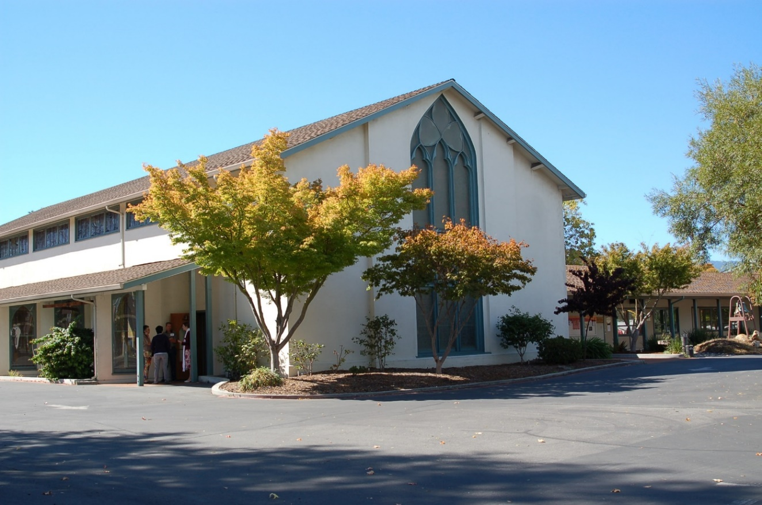
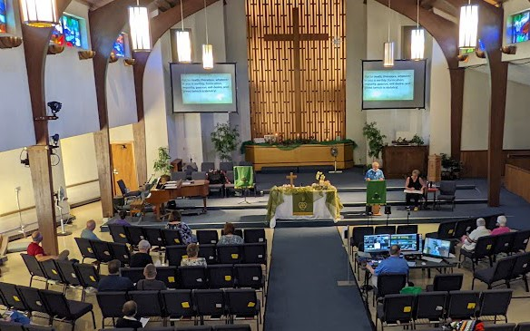
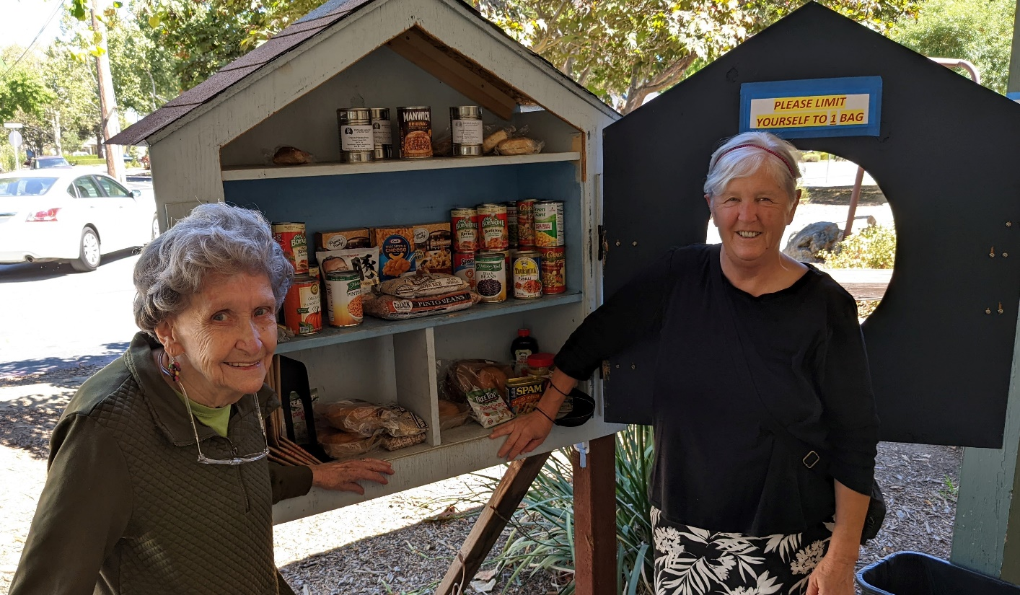

What we value about living in our area:

We value our region’s ethnic and cultural diversity and the prevalent spirit of tolerance for diverse sexualities and forms of gender expression/identity, as well as our mild climate and beautiful natural landscape.

Current size of membership: ~30

Languages used in ministry (other than English): N/A

Position Title: Pastor

Position Duration:

Designated-Term – a called position for a designated time period (3 years with option to extend) for a defined purpose, in which the pastor may move church membership to the congregation served and may move standing to the related association
(Note: Depending on how our church and our pastor’s interests evolve over the appointment term, we would be happy to explore the possibility of installing the designated term pastor as a permanent called pastor at the end of the term.)

Compensation Level:

1/2 Time – up to 25 hrs/week

Does the total support package meet conference compensation guidelines? Yes

SCOPE OF WORK
The scope of work we would anticipate from our part-time pastor would need to take into account the changing needs of the congregation as well as the particular pastoral gifts and interests of the person we call. We would also expect that some weeks would require more effort in some domains while other weeks would need an entirely different mix. As an example, the following table and chart show a blend of activities that we have found helpful to the success of our continued ministry in Campbell. The time commitment needed for The Oikos Accelerator (see Summary Ministry Description) will vary. These materials are based on a 1/2 time appointment using 25 hours per week:

Suggested Time Commitments | Hours
Worship leading & preparation | 8
Management & administration | 4
Education/Outreach/Oikos | 4
Pastoral care & congregational support | 5
Association & denomination | 2
Personal nurture & welfare | 2
T O T A L | 25

Overall, we expect that our congregation will be flexible in allowing our next pastor to budget their time in the way that everyone can agree best meets the needs of what our congregation is called to do in this time and place, as well as the needs of the pastor.

Core Competencies:

• Leadership: Inspire us, partner with us, empower us as our congregation strives to walk more closely with Christ
• Creativity: Join in our vision through The Oikos Accelerator as we embark on this new direction for our ministries and the communities we’d like to serve
• Christ-centeredness: Bring Christ ever more to the foreground in our congregational life while teaching us to do the same in our personal journeys

COMPENSATION AND SUPPORT

Salary Basis & Benefits: Commensurate with the called candidate’s qualifications and experience, and ½ time position (up to 25 hrs/week) we will offer salary and benefits in accordance with the compensation guidelines of the Northern California Nevada Conference of the United Church of Christ.

Benefits: Salary plus benefits

What is the expected living situation for your next minister?

Our minister should anticipate finding their own housing in our area; we prefer candidates who already have stable local housing situations. We are open to allowing our pastor to choose how much of their compensation will be directed toward salary and how much will be allocated for living allowance.

Comment on the residential/commuting expectations for your next minister.

Our expectation is that our pastor will live within a reasonable commuting distance to be accessible to the congregation members as needed.

State any incentives: Negotiable

Describe peer and professional supports available for ministers in your association/conference:

Networking & support as part of the NCNCUCC Santa Clara Association

If applicable, describe how your church will adopt part-time adjustments in the pastoral schedule to support a minister’s bi-vocational employment:

We will negotiate and make mutually workable adaptations to the given situation. We understand that we must work with the pastor in determining the best use of allocated time and in meeting congregational needs.

WHO IS GOD CALLING TO MINISTER WITH US?

Describe the ministry goals you envision your next minister co-collaborating with the congregation to achieve.

Our hope is that our new pastoral leader will be able to provide guidance and support as we embark on the ambitious next phase of God’s plan for us through Oikos Accelerator. We’re looking for a coach, rather than a star player, connective tissue rather than muscle, a leader who can provide perspective to the various lay leaders and help the puzzle pieces fit together to best equip the membership to reach further into our various ministries, shaping these through Oikos Accelerator to maximize our relevance to the community we serve and hope to serve, while balancing sensitivity to the needs of our members. We hope for a pastoral leader who can be a willing and patient listener, someone mature and emotionally secure who feels empowered to give and receive honest communication even when difficult, and who can help to mediate differences of opinion over our future direction. We want someone who can bring their own ideas and sense of strategy to the table, but with a deep desire to be collaborative rather than seize the reins.

At the same time, we want a pastor who, through worship leading, personal counseling, and providing leadership in Christian learning opportunities for church and community, can shepherd our spiritual growth as individuals while maintaining our spiritual perspective if/when the Oikos details pull us toward the mundane.

We seek an effective and knowledgeable preacher/speaker who is skilled at planning and leading worship, helping us to live out our Christian faith in the modern world. We also seek a compassionate and caring counselor who ministers effectively in crisis situations and inspires us through their own practice of discipleship in daily life. Our pastor must place a high priority on maintaining confidentiality and must be accepting of people with divergent views.

Describe how your vision of the minister you are now seeking will assist the congregation in making an impact beyond its walls.

Our church has a passion that is being channeled into providing a service to the
community through our food pantry and a fledgling project to provide affordable housing for people in our community. We are seeking a pastor who will be open to helping us discern what God is calling us to do and provide spiritual support and inspiration to the congregation as we embark on this new chapter in our congregational life. A pastor who can encourage us to put our faith into action and rein us in if we get too far afield of what we discern as God’s calling.
We seek a pastor who can provide spiritual education and enlightenment as well as be a
cheerleader and coach.

Specify language requirements or culturally-specific capacities preferred in a next ministerial leader, and why those matter to the congregation’s sense of calling.

No specific requirements.

Based on what you have learned about who your church is, who your church’s neighbor is, and who God is calling the church to become, describe four areas of excellence from The Marks of Faithful & Effective Authorized Ministry that your next minister will display to further equip the congregation’s ministry in these areas.

A survey of our congregation identified the following areas of excellence, from The Marks of Faithful and Effective Authorized Ministry, as priorities for our new pastor:

- Loving God, following Jesus Christ,
- Guided by the Holy Spirit; living a life of discipleship.
- Praying actively and nurturing spiritual practices.
- Understanding the power of the Holy Spirit at work through the elements of Christian worship to nurture faith.
- Strategically creating the future of God’s Church.
- Performing necessary and appropriate administrative tasks.
- Working collaboratively with intercultural awareness and sensitivity.
- Encouraging leadership development of self and others through continuing education and lifelong learning.
- Exhibiting knowledge, understanding, and continuing study of the Hebrew Scriptures and the New Testament.
- Maturing in effective proclamation and preaching.
- Bringing life to sacred stories and traditions in worship, proclamation, and witness.
- Leading faith formation effectively across generations.

Of these, the four we see as most central to our search – those that are most likely to set apart an excellent candidate amidst a well-qualified pool, based on the specific challenges and opportunities before us – are (1) living a life of discipleship; (2) strategically creating the future of God’s Church; (3) effective proclamation and preaching; and (4) working collaboratively with intercultural awareness and sensitivity.

WHO IS GOD CALLING US TO BECOME?
“You shall love the Lord your God with all your heart, and with all your soul, and with all your mind.” (Matthew 22:37 NRSV)

Who is God calling you to become as a congregation?

We are an open and affirming church called to reach out to all those who wish to worship God with reverence and joy. No one is turned away from our church; our welcome is deep and authentic. We have also remained static with a congregation that has been dwindling. We had an arts program, Lighted Window Presents, that had been successful at bringing people into our church for plays and concerts, sometimes including spirited post-event discussions. Unfortunately, the pandemic brought this to a halt, although now with COVID restrictions easing, we do have a few people who would like to kickstart it. We have a successful partnership with organizations like the Rainbow Women’s Chorus, whose concerts we’ve hosted, and Orchard City Indivisible, a progressive activist group that rents meeting space from us. We seem to be at a turning point though. As we have gone through the RootedGood Oikos Accelerator program, it has become clear that while we are low on people resources, we are quite “rich” in terms of the land upon which our buildings sit. The need for affordable housing is huge. So, as we struggle through determining the best path forward (fleshing out the details of doing property redevelopment), we feel called to make use of this land to help provide affordable housing for our community. What lies beyond that for this congregation, God has yet to reveal.

Describe how God is calling you to reach out to address the emerging challenges and opportunities of your community and congregation.

Our current approach to outreach and community engagement has been relatively fragmented and short-lived. Our speaker series attracted occasional community interest and increased awareness within our congregation of issues facing the community. Lighted Window has helped make our church known to more community members and contributed to the growth of the arts in our area. Sharing our space with Orchard City Indivisible as well as other groups has been shown to be of benefit to the local community. They also help to supply our food pantry. In the case of Orchard City Indivisible, their social justice mission is very much compatible with our church’s mission and that of the United Church of Christ. For many years, we have been renting a large portion of our property to the Old Orchard School, a private, for-profit K-8 school. While it has been a mutually beneficial relationship which has helped sustain us financially, it does not align with our mission of following Christ in providing for the needs of the local community. Many small churches are dealing with losing relevance and shrinking congregations. It has become very clear that without a radical shift in how we serve God and our community, we will likely be on a path to closure, thus the choice of participating in the Oikos Accelerator program. We will need leadership around navigating the transformations ahead.
WHO ARE WE NOW?
“You shall love your neighbor as yourself.” (Matthew 22:39 NRSV)
CONGREGATIONAL REFLECTIONS
11-YEAR REPORT
CONGREGATIONAL DEMOGRAPHICS
PARTICIPATION AND STAFFING
CHURCH FINANCES
HISTORICAL INFORMATION

CONGREGATIONAL REFLECTIONS

Describe your congregation’s life of faith.

Our church professes two key pillars of faith, and we have experienced our proudest and most productive times when we most fully embodied these.

The first pillar consists of a commitment to six scripturally-based core values:
- Extravagant joy (John 15:9, 11)
- Passionate faith (James 2:17)
- Loving respect (John 13:34)
- Deep connectedness (John 15:5)
- Intentional growth (Acts 2:46-47)
- Shared laughter (1 Peter 1:8)

The second pillar is the practice of Christian discipleship, as manifested in the following:
- Practicing the good in daily life – Daily Prayer
- Our habit of weekly renewal – Weekly Worship
- Hearing Gods voice – Daily Bible Reading
- The call to Christ-like living – Service to Others
- Our call to relationship with spirit – Nurturing Relationships
- Generosity -- a reflection of God’s heart in our lives

Describe several strengths or positive qualities of your congregation.

Our congregation believes in and has adopted the pillars of faith outlined above. We
welcome all people no matter where they are on their faith journey. Newcomers are made to feel accepted, welcomed and heard. Inclusivity is not just a word or saying at our church but a key element in our faith practice.

We care deeply about one another and those who touch our congregation. One Sunday an elderly woman was having difficulty getting up to receive communion. Without being asked a gentleman from our congregation offered his assistance and arm. He then helped her get back to her seat. This is the essence of who we are as a church. We care about each other and those around us. Whether it is opening a door for someone or sitting quietly with someone who is having a hard time, we are there for each other and those who come to our church.

Our congregation provides outreach to the local community via our participation in the Silicon Valley Safe Park Program and our Campbell UCC Food Pantry. There are often shortages in the pantry that are miraculously cured with little or no fuss by caring people both within and outside the congregation.

Describe what worship is like when your congregation gathers.

Worship is reflective and honest, based on Scripture passages, usually following the ones suggested by the UCC website for each week. We put out the colors for each season (like Pentecost red). We have a professional music director who chooses pieces to complement each week’s scriptures and message and leads a small group of talented volunteer singers and instrumentalists. Members of the community also participate as lay readers, communion assistants, and sometimes worship leaders. Over the past year, we have enjoyed various guest pastors who have incorporated messages that put the scriptures into contemporary, real-life perspective. Pre-pandemic, in conjunction with our heart for social justice, we have sometimes omitted the message to leave time for guest service programs in support of other community needs. Most recently, we had a visit from Teen Challenge.

We offer communion or (in the absence of an ordained leader) an agape meal every week, and our table is open to all who choose to partake. Due to the pandemic, we offered services online via Zoom and continue to do this even as we now meet in person.

Describe the educational program/faith formation vision of your church.

Since we have been without a pastor for over a year, we do not have any current educational programs. This is something we would like to change once we have a permanent pastor.

Describe how your congregation is organized for ministry and mission.

- When it comes to decision-making, how many hours are spent in meetings per month?
The council and committees/teams (worship, Oikos, pastor search) each meet for 2-6 hours per month.
- Think of a time when action had to be taken quickly, for example when a crisis or disaster occurred. How was that accomplished?

COVID - We of course faced the COVID-19 pandemic with the rest of the world. Churches everywhere had to stop in-person services and struggled to determine how to proceed. Many closed permanently. In our typical ‘small but mighty’ way, one of our amazing members stepped up and created from nowhere an online experience that allowed us to continue to worship, pray, praise, and connect with God and each other, when it was so vitally important. This transition occurred without missing a single Sunday service. It has transitioned several times since then and is now interactive, allowing those online to participate more fully in the service and adding to the experience for everyone. As in person services resume, we continue to use the online venue for folks who can’t make it in-person, including friends from various parts of the country.

- Can you provide the next minister with a copy of an organization structure, bylaws and/or annual report to further explain the patterns of the church’s activity and governance? [Yes/No]
Yes.

11-YEAR REPORT

Document attached

CONGREGATIONAL DEMOGRAPHICS

Describe those who participate in your church.
 |  | Is this number an estimate? (check if yes)
Number of active members: | 36 | Yes
Number of active non-members: | 8 | Yes
Total of church participants (sum of the numbers above): | 44 | Yes

Percentage of total participants who have been in the church:
 |  | Is this number an estimate? (check if yes)
More than 10 years: | 82% | No
Less than 10, more than 5 years: | 9% | No
Less than 5 years: | 9% | No
Number of total participants by age:
0-11 | 12-17 | 18-24 | 25-34 | 35-44 | 45-54 | 55-64 | 65-74 | 75+ | Are these numbers an estimate? (check if yes)
0 | 2 | 1 | 4 | 0 | 12 | 3 | 16 | 6 | Yes

Percentage of adults in various household types:
 |  | Is this number an estimate? (check if yes)
Single adults under 35: | 10% | Yes
Joint household with minors: | 5% | Yes
Single adults age 35-65: | 30% | Yes
Joint household with no minors: | 40% | Yes
Single adults over 65: | 15% | Yes

Education level of adult participants by percentage:
 |  | Is this number an estimate? (check if yes)
High school: | 35% | Yes
College: | 40% | Yes
Graduate School: | 25% | Yes
Specialty Training: | 10% | Yes
Other (please specify):

Percentage of adults in various employment types:
 |  | Is this number an estimate? (check if yes)
Adults who are employed: | 50% | Yes
Adults who are retired: | 40% | Yes
Adults who are not fully employed: | 10% | Yes

Describe the range of occupations of working adults in the congregation:

Our congregation has been dwindling and aging for many years and although energetic, most of the membership is now retired or close to retirement. We have a variety of occupations and professional backgrounds. These include several members in the technology industry, as well as teachers, health care professionals, small business owners, homemakers, and nonprofit staff. We can also claim an attorney, a firefighter, and a professional actor! Few of the members of our congregation work in minimum-wage occupations, as unskilled manual laborers, or as domestic workers outside our own homes.

Describe the mix of ethnic heritages in your congregation, and the overall racial make-up. Most UCC congregations tend to describe themselves as “diverse.” Yet, the vast majority of UCC congregations are mono-cultural. What does diversity mean in your context?

We have a low percentage of people of color in the congregation relative to our local community’s population, but we are more racially diverse than we have been historically. We are a loving and open congregation, but our already limited ability to grow our membership was completely halted by the pandemic. The congregation definitely would welcome increased diversity and growth, but our focus has shifted to using our resources to bless the community through the multi-year Oikos Accelerator process.

Has your congregation recently had a conversation about welcoming diversity, or do you plan to hold one on the near future (perhaps using, for example, the Welcoming Diversity Inventory)? Please note the date. Comment after the exercise:

At this point in time, no we are not engaging in discussions around diversity nor are we actively reaching out to various communities. We welcome all who wish to attend but historically, we’ve done much of our outreach to the LGBTQIA+ community since those within that community have too often been rejected by church and religion.

PARTICIPATION AND STAFFING

Complete the following chart. Please leave blank any fields that are not applicable to your congregation.
Ways of Gathering | Estimated number of people involved in attendance | Who plans each of the listed gatherings? (list any and all worship planners, such as various lay leaders, pastors, musicians, other staff)
Adult Groups or Classes | 0
Baptisms (number last year) | 0
Children’s Groups or Classes | 0
Christmas Eve and Easter Worship | 30 | Guest Pastor*, Music Director*, Tech Manager, Office Admin*, volunteers.
Church-wide Meals/Coffee Hour/Soup Exchange | 10-20 people per gathering | Volunteers/ad-hoc committee
Choirs and Music Groups | 5-8 | Ruth Huber* (music director), choir
Church-based Bible Study | 0
Communion (served how often?) | 10-20 (weekly) | Pastor/worship leader + lay assistants
Community Meals/Safe Park | 15-20 (semi-annually) | Volunteers
Confirmation (number confirmed) | 0
Drama or Dance Program (also includes music events) | 0 – Stopped due to COVID | Lighted Window Committee, Flo Galvez* (lay member & theater professional), various guest artists
Funerals (number last year) | 1 | Guest pastor*
Intergenerational Groups | N/A
Outdoor Worship | N/A
Prayer or Meditation Groups | 0
Public Advocacy Work | N/A
Retreats | N/A
Theology or Bible Programs in the Community | N/A
Weddings (number last year) | 0
Worship (time slot: 10 AM Sunday) | 10-20 | Guest pastor*, rotating lay/ communion readers, Flo Galvez* (office administrator – compiling/ distributing worship road maps, securing guest pastors & lay readers), Ken True (road maps, tech), Ruth Huber* & choir, collection plates in the back. Communion every Sunday
Young Adult Groups or Classes | N/A
Youth Groups or Classes | N/A
Other (food pantry) | 1 volunteer coordinator,  8 regular vols,  6 regular food collection & transportation vols. 100 people served per week | Mary Edson (coordinator)
Other (lecture/performance series – some Sundays in place of pastor) | Guest speakers, 15-30 attendees | Flo Galvez coordinates or members volunteer to arrange single lectures or series

Additional comments: Asterisks denote church members who are paid salaries/honoraria for their contributions; all other lay contributors listed are volunteers.

List all members or regular participants in your congregation who are ordained, licensed, or commissioned ministers. Indicate those with current United Church of Christ Three-Way Covenants (i.e. serving in a congregation) or Four-Way Covenants (i.e. serving in a ministry beyond a congregation).
Name | Three- or Four-Way Covenant?  (3 or 4 or No) | Ministry Setting | Type of Ministry Role | Retired?  (Y or N)
None

If one or more previous pastors or retired ministers currently hold membership in the church, describe their role(s) in the life of the congregation:

None

List all current staff, including ministers. Exclude the position you are seeking to fill. Indicate which staff person serves as head of staff.
Staff Position | Head of Staff? | Compensation (full time, part time, volunteer) | Supervised by | Length of Tenure for current person in this position
Office Administrator | Flo Galvez | Part time, hourly | Council or pastor | ~3.5 years
Bookkeeper | Larry Ong | Part time, hourly | Treasurer | 8+ years
Music Director | Ruth Huber | Part time, salaried | Council or pastor & worship committee | ~8 years
Lighted Window Theater Director | Flo Galvez | Per-show honoraria | Lighted Window Committee | 18 months/paused

***Note: No current head of staff – Church Council collectively supervises staff members

REFLECTION
Reflection: After reviewing the congregational demographics and activities above, what does this information reflect about your congregation’s overall ministry?

We are a small community but we deeply care for one another. Most events and worship are lightly attended, but we do have a core group who volunteer extensively, often on multiple fronts. At this point, we more closely resemble a home-based church.

Even with high levels of organizer energy and the congregation having a passion for social justice education, we have had only limited success with ministries focused on it. Post-service lectures given by outside speakers, on issues including LGBTQ rights and housing, have been attended by most regular church participants but have not attracted the broader community to the extent hoped; and a pastor-led book club focused on racial justice issues drew a consistent but very small group of participants.

Other ministries face challenges from a lack of participation or leadership. Our collective charitable pursuits are represented almost exclusively by the food pantry. Meanwhile, we struggle in the area of religious education. We lack the youth participation to offer youth groups or a comprehensive Sunday school curriculum. This is a self-perpetuating problem, as families with children turn to other churches for these resources.

The work being done with the Rooted Good/Oikos Accelerator program, however, will probably be our most exciting and transformative mission yet! The serious potential of creating affordable housing on our property would certainly provide hope and help to our local community. While not the primary focus of this mission, it might even breathe some life into us as a congregation. Since this will likely be a 5-6 year project, we hope to find a pastor who would see this as an energizing and exciting way to serve God’s people!

CHURCH FINANCES

Current annual income (dollars used during most recent fiscal year)

*** Data from FY 21-22, ending in June 2022

Source | Amount
Annual Offerings and Pledged Giving | $ 37.3K
Investment Income | $ 1.9K
Reduction of Assets (to balance the budget) | $ 0
Directed Donations | $ 6.1K
Misc. Income | $ 1.3K
Rentals of Church Building | $ 283.3K
Rentals of Church Parsonage | N/A
TOTAL | $ 329.9K

Current annual expenses (dollars budgeted for most recent fiscal year): $ 324.5K

Attach most recent church budget, spending plan, operating statement, or annual treasurer’s report as shared publicly with the congregation, or – if your church does not pass an annual budget – list current budgeted expenses here.

This is the budget for the 2022-23 year passed by the congregation during the annual meeting in June.
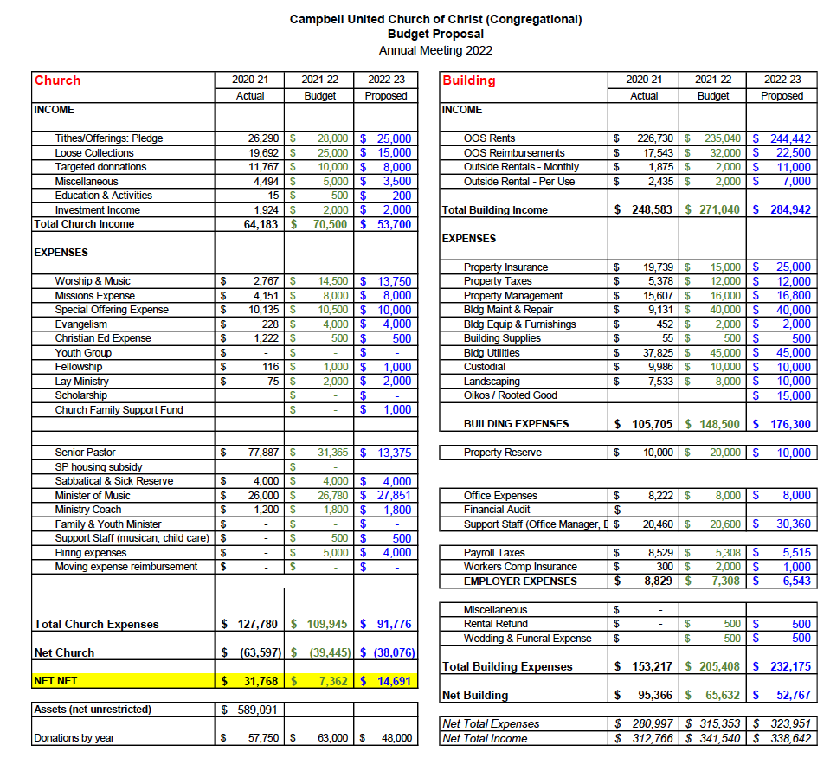

Considering total budgeted expenses for the year, compare total ministerial support. What is the percentage?

Assuming a half-time pastor, ministerial salaries (senior pastor + music director) would be 23% of total projected expenses.

Has the church ever failed to pay its financial obligations to a minister of the church? No

Is your church 5-for-5, i.e. does it include each of the following contributions during the church year? (indicate those included during the most recent fiscal year)

_Yes_ Our Church’s Wider Mission (OCWM – Basic Support)
_Yes_ One Great Hour of Sharing
_Varies_ Strengthen the Church
_Varies_ Neighbors in Need
_Varies_ Christmas Fund

We have collections and pass on contributions for a few of these, but on a more ad hoc rather than strictly annual basis, depending on fit with worship themes from week to week. However, we contribute directly to the NCNC Association (OCWM) an amount of about $8K each year (listed in the budget under Missions Expense) in addition to any of the special contributions listed above.

In what way is OCWM (Basic Support) gathered? If calculated as a percentage of operating budget, what is that percentage? (recommended 10%)

This year budgeted as 15% of church’s donation income ($53.7K).

What is the church’s current indebtedness?
Total amount of loan debt: $ 0
Reason for debt: N/A
Are capital and other payments current? N/A

If a building program is projected or underway, describe it, including the projected start/end date of the building project and the total project budget.
N/A

If the church has had capital campaigns in the last ten years, describe:
Year(s) | Purpose | Goal | Result | Impact
 | N/A | $ | $
 |  | $ | $
If a capital campaign is underway or anticipated, describe:
Year(s) | Purpose | Goal | Result | Impact
 | N/A | $ | $
 |  | $ | $

Describe the prominent mission component(s) involved in the most recent (or current) capital campaign.

N/A

Does your church have an endowment? No. We have banked funds, but none managed as an endowment.

What is the market value of the assets?

At the end of the last fiscal year all financial assets, including operating funds, amounted to $800K and unrestricted net assets amounted to $588K

Are funds drawn as needed, regularly, or under certain circumstances?

No. We have sufficient funds in our operating accounts to cover operations.

What is the percentage rate of draw (last year, compared to 5 years ago)? N/A

Describe draw on endowment, if any, to meet operating budget expenses for the most recent year and the past five years:

We don’t manage our banked funds as an endowment; however, the chart below shows net income/expense amount for each fiscal year. Expenditures were high in 2007-08 due to upgrades to church buildings (including portions of the property used for rental purposes), and thus represent a conversion of assets from liquid funds to real property investment rather than a reduction in the church’s net worth.

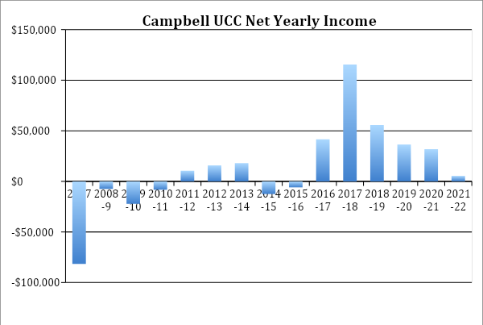

At the current rate of draw, how long might the endowment last?

We attempt to balance our budget each year and expect to be able to continue doing so; hiring a part-time rather than a full-time pastor is consistent with that aim.

Other Assets

Financial Assets
Checking Accounts (3): $444K
Savings Accounts (2): $72K
Investments, CDs (3): $301K

Does your church have a parsonage? No

Describe all buildings owned by the church:

The following rough map (not to scale) of the buildings and areas on the Church’s property may be a useful aid to the information below.
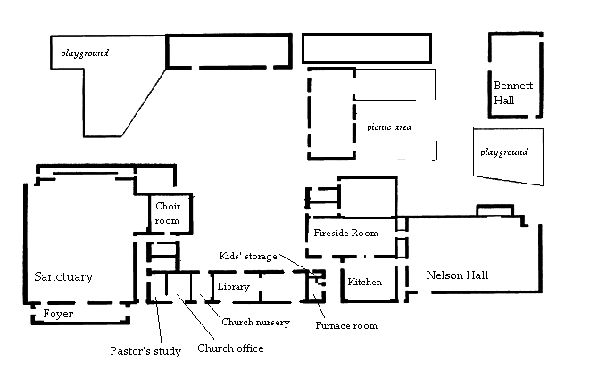
OOS
Office
Classroom
Storage sheds
Classrooms
Classrooms

The following rooms are used by the Church

Sanctuary, Foyer, Choir Room, Pastor’s study, Church Office, Church Library (currently used for the food pantry)

The following rooms are used by the church, but also occasionally rented:

Fireside Room, Nelson Hall and Sanctuary

The following rooms are rented exclusively to Old Orchard School:

Classrooms, OOS (Old Orchard School) Office, Bennet Hall

The sanctuary is used for regular Sunday services and Lighted Window arts events (and for rentals); the Fireside Room is used for smaller arts events, Bible studies (when scheduled), Council meetings, and other small-group gatherings, including the TOPS weight loss group who rents on a weekly basis. Nelson Hall is used as an alternate worship space, is used by Old Orchard School for occasional assemblies, and is rented to the community activist group Orchard City Indivisible for weekly meetings. It is also rented by other groups in the community; for example, we previously had a regular church tenant and are open to renting to other churches that share our welcoming, progressive values.
Describe non-owned buildings or space used or rented by the church: N/A

Which spaces are accessible to wheelchairs? (worship space, pulpit, fellowship space, facilities, etc.)

Most spaces (except the sanctuary balcony, which is used only for storage) can be accessed without the use of stairs. However, we fall well short of full compliance with ADA standards. For example, we have numerous doors that could not be opened by a wheelchair user without assistance.

Reflection: After reviewing the church’s finances and assets described above, what does this information reflect about your congregation’s mission and ministry?
For example, when was a time the church made a major budget change? How is the budgeting process done? What new ministry initiative has your church financed?

We budget consistently from year to year, including our rental income, which helps give us a stable, predictable income stream. Our congregation has dwindled in size and money has become a bit tighter, but the smaller community also has reduced demands on pastor time, so the shift to a part-time pastor should ensure solvency over the next several years.

HISTORICAL INFORMATION

Name one to three significant happenings in the history of your church that have shaped the identity of your congregation. Add the most important event in the life of your church in the past 10 years.

- About ten years ago, our Pride Flag was destroyed by vandals who had been doing similar things in our community spreading their message of hate. A group of congregants went out to our sign, which had also been defaced and cleaned it up. Then we went out into the neighborhood and offered to help clean up leaves and tidy yards. We chose to “turn the other cheek” as it were and spread love not hate. That spirit continues to this day in our outreach programs and actions of the people of the church. Love of God and Community remain as bedrock principles.

- For the last 15+ years our Congregation has been holding communion every Sunday instead of the more typical once a month. At first some of us were not sure if we liked this; we worried that doing it weekly took away from it seeming more special. Today members consider it a very important, even indispensable, part of our Sunday worship.

- Our Food pantry has been growing and assisting more people. It draws those from surrounding neighborhoods and the homeless encampments that are in the community. We managed to keep it open during the pandemic by a member building a “box” (see picture on page 5) that was (and still is!) stocked daily and accessible to people who needed it. There is often fresh produce contributed by our members and businesses in the community. We also share food resources with other food distribution sources.

Describe a specific change your church has managed in the recent past.

We have not had a permanent pastor for over a year. We have utilized pulpit supply for Sunday worship, including a couple of our former pastors. We have arranged for pastoral support for our members from another UCC church close by and the pastors are well known to our members. We have adjusted to this arrangement with our strong leadership and volunteers filling the gaps.

Every church has conflict, some minor, some larger. “Where two or three are gathered, there will be disagreement….” Describe your congregation’s values and practices when it comes to conflict.
For example, what is an example of a recent conflict and something your congregation learned from it? Describe an occasion when your church experienced conflict without being able to resolve it well. Does your church have policies, protocols or structures for dealing with conflict?)

Over the last 10 years, we have gone from a period of disruption and conflict to a period of relative harmony. These issues were precipitated by an interim pastor and they took some time to work through. With the help of the incoming called pastor, we engaged in conflict resolution/nonviolent communication trainings. These facilitated healing and gave us some tools for moving forward. Currently, when disagreements arise, we make concerted efforts to handle them with dignity and respectful dialogue. In keeping with this idea, we have created a behavioral covenant which we read at the beginning of our Council meetings as a reminder to treat each other respectfully.

Ministerial History (include all previous ministerial staff for the past 30 years)

Staff member’s name | Years of service | UCC Standing (Y/N)
Naomi Schulz | 2018-2021 | Y
Lauren Shields (Bridge pastor) | 2016-2018 | Y
Blair Hull | 2014-2016 | Y
Tracy Barnowe (Interim) | 2012-2014 | Y
Elaine O’Rourke | 2001-2011 | Y
Meg Self | 1992-1999 | Y
Ollie Thomas | 1983-1992 | Y

Comment on what your church has learned about itself and its relationship with persons who provided ministerial leadership:

The church has learned that pastors bring varied concepts and perspectives with them. Some of those ideas are accepted and embraced while others require more discernment. Always doing it “the Campbell way” is not as important as doing it according to our Lord’s way. There are certain traditions to which we hold tight such as communion each week and passing the peace as well as communal prayer for our fellow congregants, friends and family. This congregation is open to change with consensus being the byword.

Has any past leader left under pressure or by involuntary termination? No

Has your church been involved in a Situational Support Consultation? Yes. About 10 yrs ago.

Has a past pastor been the subject of a Fitness Review while at your church? No

WHO IS OUR NEIGHBOR?
“You shall love your neighbor as yourself.” (Matthew 22:39 NRSV)
COMMUNITY VISION
MISSION InSite

COMMUNITY VISION

How do the relationships and activities of your congregation extend outward in service and advocacy?

We operate a long-lasting food pantry that, with the onset of COVID, expanded from limited hours 3 days a week, to providing a “Blessing Box” that allows 24/7 access to an ever-expanding clientele from the local community. With this expansion, volunteer participation has also greatly expanded. Around the same time, we entered in talks with several other congregations to create a new Safe Park program in Campbell/West San Jose. Our east parking lot is now part of the monthly rotation, with us hosting 1 or 2 months each year. Some members are also engaged individually in community volunteer activities and occasionally turn to others in the congregation for support. Before COVID, our Lighted Window program internally produced theatre events featuring local performers and congregation members, as well as concerts with nationally recognized musical artists. There has been renewed interest in starting this up again. In addition, we hosted various speakers reflecting the social justice aims of Campbell UCC.

Describe your congregation’s participation in meetings, relationships and activities connecting the wider United Church of Christ (association / conference / national setting).

A few attend the Northern California Nevada Conference meeting each year. Pastors in years past have attended UCC National events. A member of the congregation was sent to represent our church at the General Synod held in Milwaukee in 2019.

Many local churches love to tell the story of what they are doing in the community to transform lives. Some have identified certain aspects of their witness into the wider community using language shared with other UCC congregations. (Find more information as desired at ucc.org.)

Check any statements below that apply to your UCC faith community.
 | Accessible to All (A2A) |  | Just Peace
 | Creation Justice |  | Global Mission Church
X | Economic Justice | X | Open and Affirming (ONA)
 | Faithful and Welcoming |  | WISE Congregation for Mental Health
X | God Is Still Speaking (GISS) |  | Other UCC designations:
 | Border and Immigrant Justice |  | Designations from other denominations
 | Inter-cultural/Multi-racial (I’M) |  | None

Reflect on what the above statement(s) mean(s) to your community. Is your congregation interested in working toward any of the above statements of witness in the near future?

We feel we have had tremendous success with our O&A policies; newcomers to our church in recent memory have often expressed that our commitment to including and celebrating queer individuals and families is more overt and more obviously deeply held than what they have encountered at other congregations that self-describe as O&A. We also continue to elaborate our commitments to progressive/GISS theology through rigorous commitments to gender-inclusive God-language and to an ever-deepening understanding of how the gospels speak to contemporary social justice issues.

As we’ve progressed through the Rooted Good/Oikos process, it has led us to decide that we should explore how we might redevelop our land for the greater community good by providing affordable housing, while still maintaining a worship space. While we may have fewer people resources than we have had in the past, we are very “rich” in land resources. We look forward to partnering with the city and/or other non-profit groups within our community and are excited by the possibilities that lie ahead!

Describe your congregation’s participation in ecumenical and interfaith activities (with other denominations and religious groups, local and regional).

We currently have no interfaith involvements at an organizational level, although we would welcome the opportunity to revive these pursuits. In the past, we had a strong presence at the San Jose Gay Pride Ecumenical Church Services, and several former pastors participated in the Campbell Ministerial Association. Our commitment to ecumenical principles remains strong even in the absence of formal affiliations, as evidenced by the numerous interfaith couples and families who have found a welcoming church home with us. These members have also, in turn, offered the rest of the community opportunities for exposure to religious diversity as part of our church life. Our work with
the Safe Park program and our food panty has led to some working partnerships with the Campbell ward of the LDS church as well as First Congregational Church of San Jose.

If your congregation has a mission statement, how does that mission statement compare to the actual time spent engaging in different activities? Think of the range of activities from time spent gathering, to governance, to time spent going out.

We continue to be driven by the motto “Real Faith for Real Life.” We strive to keep our worship relevant and authentic to our congregation by inviting contributions and feedback from all who feel inspired to offer them, whether in informal settings, at council meetings (all of which are open to anyone interested), or through our Oikos process. Historically, we have also sought to engage with the “real life” of our larger local community through our social justice lecture series – educating ourselves about the issues around us, and our neighbors about our church’s values. We believe God is still speaking to us; sometimes it feels like a soft whisper that grows louder through all the words of the people who touch members of our congregation.

Reflect on the scope of work assigned to your pastor(s). How is their community ministry and their ministry in and on behalf of the wider church accounted for in the congregation’s expectations on their time?

Our proposed scope of work for a ½ time pastor assumes four hours per week for education and outreach and two hours per week for denomination/association/local activities. Our congregation has historically been strongly supportive of pastor-initiated community ministries, including participation in Silicon Valley Pride (we had a booth full of bibles where we blew bubbles and distributed water as we talked with people) and the creation of our Lighted Window arts program. We are eager for a pastor who will bring their own new ideas for community ministry and collaborate with us in their execution!

MISSION InSite
Comment on your congregation’s MissionInsite report with data for your neighborhood(s) or area. What trends and opportunities are shown?

Average Worship attendance has been in decline over the last 10+ years. During the same time, our surrounding community has grown by 3.7%. Campbell has recently completed their updated Housing Element mandated by the state and our church has asked the city to rezone our campus to give us the possibility of helping Campbell achieve its affordable housing goals.

How do your congregation’s internal demographics compare or contrast to a) the neighborhoods adjacent to your church, and b) other neighborhoods with which your church connects?

Many of our members do not live in Campbell, and half of our congregation are of the Baby Boomer generation or older, compared with our surrounding community which has about 20% Boomers. Our congregation is primarily white, with few Asian, African-American, and Hispanic members. This is not consistent with the surrounding community.
How are the demographics of the community currently shaping ministry, or not?

After going through the New Beginning Process in 2016, we embarked on a lecture series of topics/themes of interest to church members and to our surrounding community. (LGBTQ issues during Pride Month, and Housing crisis in Santa Clara County). Those things came to an end when COVID hit and have not been attempted again. Instead, we have concentrated our efforts on helping those in the community that are struggling with housing and food insecurity.

What do you hear when you talk to community leaders and ask them what your church is known for?
Our church is known in the community for our food pantry, which serves the
needy in our local area and our participation in community outreach (Safe Park program, Pride participation, farm worker caravan, etc.)

What do new people in the church say when asked what got them involved?

New community members have cited our strong open & affirming orientation, our weekly practice of communion and emphasis on its openness to people of all faith backgrounds, our enthusiastic embrace of diverse personal beliefs and faith commitments, and the fact that we are a small community where newcomers are welcomed warmly and repeat visitors are greeted by name with genuine enthusiasm. Some also mention our theologically progressive emphasis and our welcoming, professionally run music program.

REFERENCES

The following individuals are available to communicate with prospective candidates – please feel free to contact them with any questions.

REFERENCE 1

Richard Corson (retired pastor/pulpit fill)
richardcorson@att.net

REFERENCE 2

Penny Phillips
(408) 375-2848
feipeini@gmail.com
First Congregational Church of San Jose

REFERENCE 3

Dr. Elane O’Rourke (former pastor)
(615) 995-4279
elane@elaneorourke.com
School for Seekers
CLOSING THOUGHTS
CLOSING PRAYER
STATEMENT OF CONSENT
CONFERENCE/ASSOCIATION VALIDATION

CLOSING PRAYER

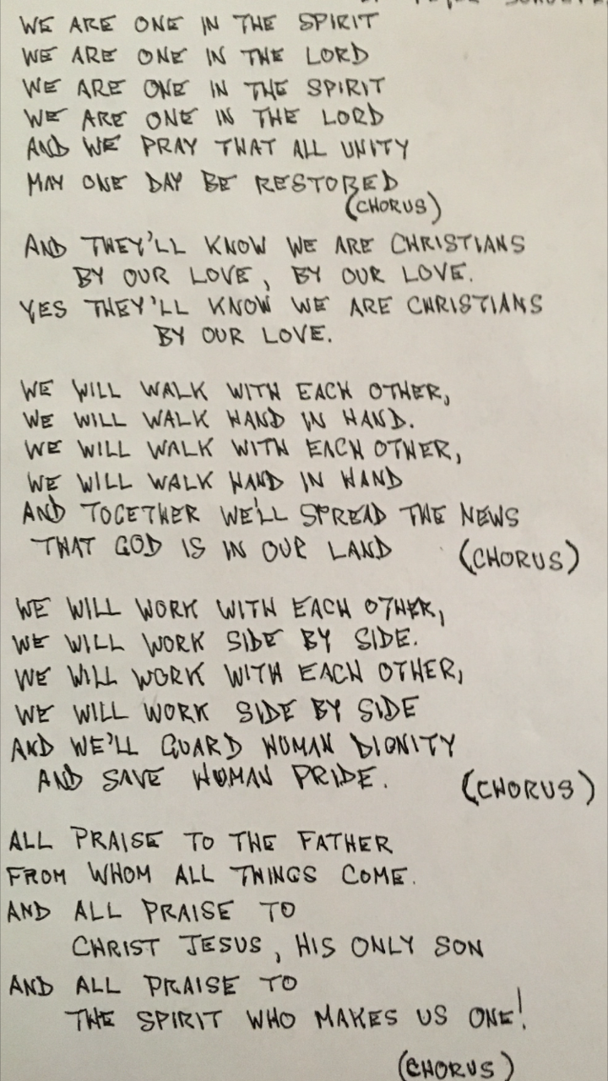
STATEMENT OF CONSENT

The covenantal relationship between a church and those called by that church to serve as pastors and teachers and in other ministerial positions is strengthened when vital information is openly shared by covenantal partners. To that end, we attest that, to the best of our abilities, we have provided information in this profile that accurately represents our church. We have not knowingly withheld any information that would be helpful to candidates.
As the committee charged with the responsibility for identifying and recommending suitable new minister for our church, we have been authorized to share the information herein with potential candidates. We understand that a candidate may wish to secure further knowledge, information, and opinions about our church. We encourage a candidate to do so, recognizing that an open exchange of relevant information builds the foundation for continuing and healthy relationships between calling bodies and persons seeking a ministry position.

- Which individuals and groups in the church contributed to the contents of this Local Church Profile? (for example, church council or consistory, transition team, etc.)

Pastor search committee, treasurer, church membership

- Additional comments for interpreting the profile:

Please feel free to contact us for clarification of, or elaboration on, any of the information contained in this profile!

Signed:
Name / Title / Date: Debbi Cosentino/ Chair Pastor Search Committee / March 1st, 2023
VALIDATION BY CONFERENCE/ASSOCIATION

The congregation is currently in good standing with the association / conference named.
Staff Comment: Yes, Campbell UCC is in good standing with the Santa Clara Association of the Northern California Nevada Conference.

To the best of my knowledge, ministerial history information is complete.
Staff Comment: Yes, as written the ministerial history provided is complete and accurate.

To the best of my knowledge, available church financial information is presented thoroughly.
Staff Comment: Yes, the provided information is accurate best to our knowledge.

My signature below attests to the above three items.

Signature:
Name / Title: Rev. Davena L Jones/ Bridge Conference Minister
Email: davena@ncncucc.org
Phone: (510) 359-7208
Date: March 23, 2023

This document is created through support to Our Church’s Wider Mission (OCWM) and is only possible through the covenantal relationships of all settings of the United Church of Christ.

“Jesus answered them, ‘Have faith in God!’” – Mark 11:22

“They Will Know We Are Christians,” Fr. Peter Scholtes, copyright 1966.

