occupa3a

Search and Call Tools for Congregations
Advancing the Spirit’s guidance into God’s future

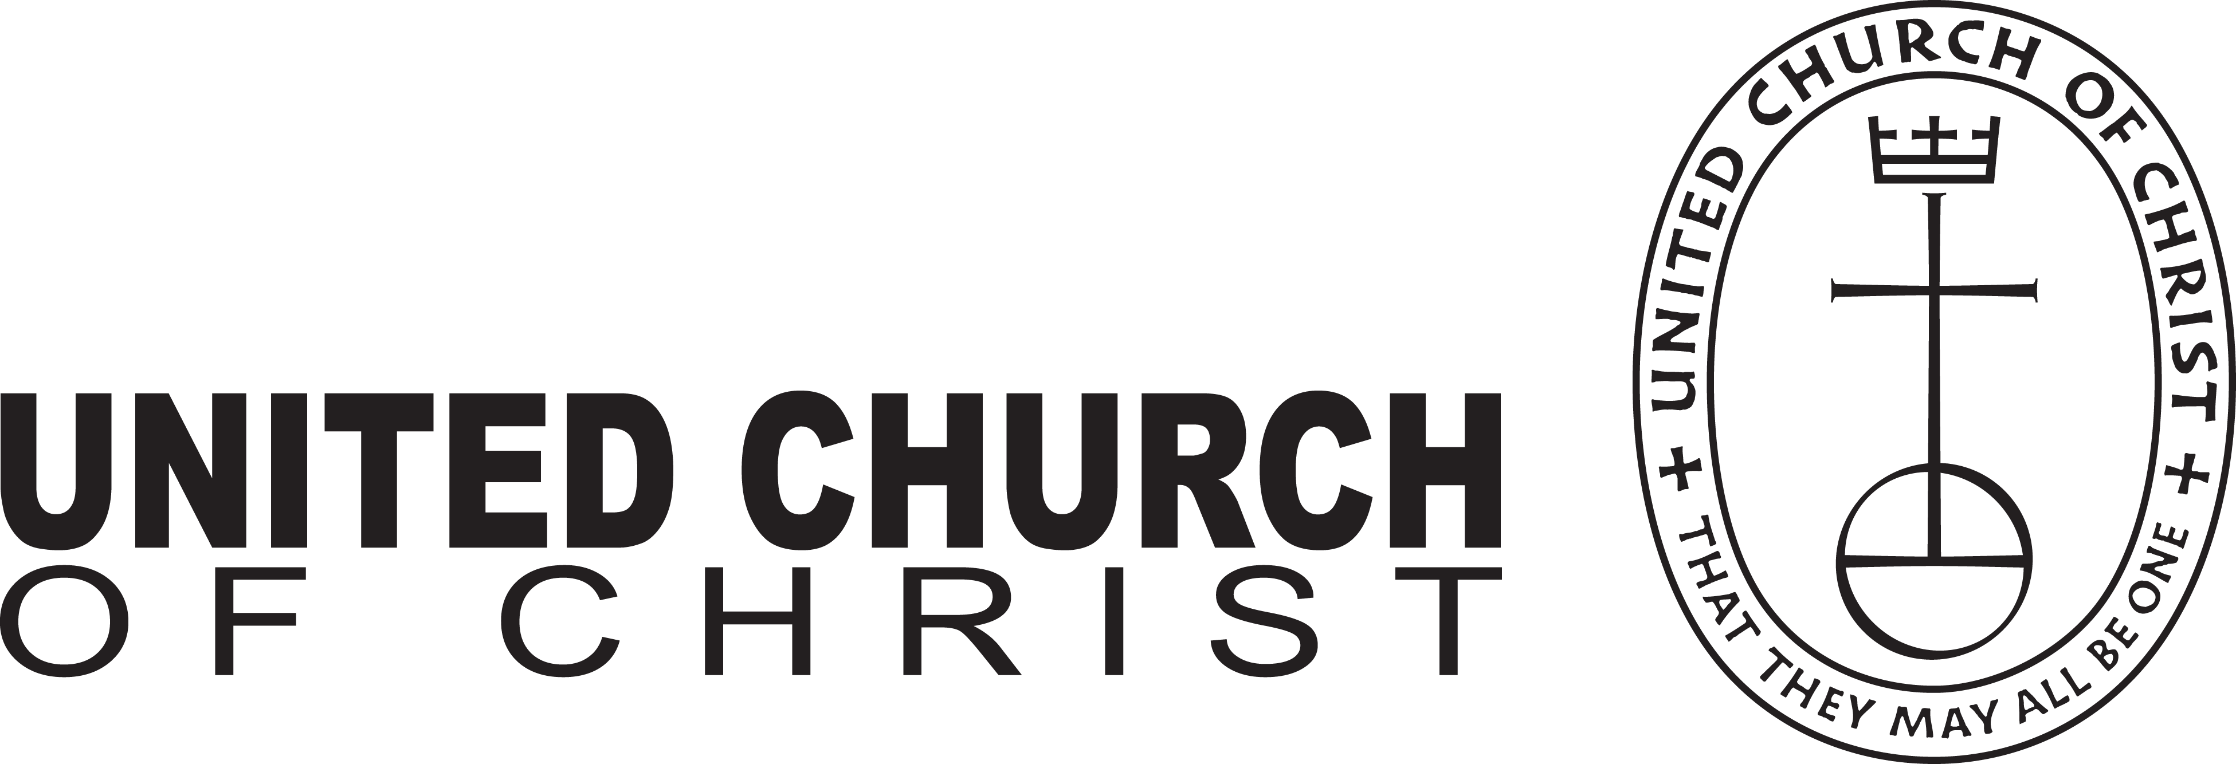
Rachel Hackenberg
Microsoft
[Pick the date]
INTRODUCING THE NEW
LOCAL CHURCH PROFILE

?
Who is
God calling us to become
Who
is our neighbor
Who
are
we
The new Local Church Profile is not just for congregations in search of a pastor. All congregations are encouraged to engage in its process of discovery every 3-5 years. The UCC Local Church Profile reflects valuable data, assesses ministry, clarifies change, and helps advance the calling of the congregation. Not just to be completed by a search committee – the more participation, the better!
MINISTERIAL EXCELLENCE, SUPPORT & AUTHORIZATION

UNITED CHURCH OF CHRIST
LOCAL CHURCH PROFILE

St. Paul’s United Church of Christ
Erie, Pennsylvania

Part Time Pastor

Penn West Conference, Lake Erie Association

May 31, 2022

LOCAL CHURCH PROFILE CONTENTS
- Position Posting
- Who Is God Calling Us To Become?
- Who Are We Now?
- Who Is Our Neighbor?
- References
- Consent and Validation

“God is able to provide you with every blessing, so that
having all sufficiency in all things at all times,
you may abound in every good work.”
(2 Corinthians 9:8)
INSTRUCTIONS

The new Local Church Profile supports the calling and discernment of United Church of Christ congregations with their current or future pastoral leadership.

For many congregations, the interim time between ministers is an intentional season that is guided in part by the preparation of a Local Church Profile. Using the Profile, the church can discover its data and express its story for the reliable discernment of a search committee and the beginning of a new pastorate. Searching ministers will want to see this document in its entirety.

The interim season is not the only time in a church’s life when it’s valuable to give attention to explore a congregation’s vocation. Three sections of the Local Church Profile – WHO ARE WE NOW, WHO IS OUR NEIGHBOR, and WHO IS GOD CALLING US TO BECOME – are meant to be updated every 3-5 years. Known together as the “Discovery Document,” these three sections can be completed by a visioning group, a governing body, a transition team, or other group – not just the search committee – in order to draw forward the gifts and imaginative possibilities of a congregation. The church’s engagement with the “Discovery Document” might not have the same sequence as the completed Local Church Profile that is read by candidates.

Some questions are easy to answer. Some are not so easy. Prompts are provided to stimulate narrative response if needed; these italicized prompts are merely examples from which to choose or to inspire your own. Efforts to answer the questions will prompt conversations and explorations and story-telling and many prayers. As the Spirit moves throughout the process, congregations will shape a collective articulation of Christ’s leading (WHO IS GOD CALLING US TO BECOME). This last question to be answered becomes the first section to be read by searching ministers in the Local Church Profile, and it is boldest and most actionable piece for faithful leadership into the future.

Your conference can provide materials referenced in the Local Church Profile, such as the 11-Year Report containing data as reported by your congregation annually to the UCC Data Hub, and MissionInsite reports containing demographic information on your community. More information on types of pastorate in the United Church of Christ can be found in the Call Agreement Workbook. Be sure to use the Call Agreement Workbook’s Scope of Work to describe in this Local Church Profile the position being sought.

When it is time for ministerial search, the conference can counsel you on posting the Local Church Profile together with your public listing at UCC Ministry Opportunities (http://oppsearch.ucc.org).

The last page of the Local Church Profile contains a statement that parallels the consent statement signed by ministers in the UCC Ministerial Profile. In keeping with the covenantal relationship between a church and those it seeks to call, this statement encourages an open, honest exchange of information. On behalf of the United Church of Christ, and on the basis of the best knowledge available to them, your conference staff will validate your completed Local Church Profile when it is ready to be shared in relationship with prospective new leaders.
1. POSITION POSTING
a. LISTING INFORMATION
b. SCOPE OF WORK
c. COMPENSATION & SUPPORT
d. WHO IS GOD CALLING TO MINISTER WITH US?

1a. LISTING INFORMATION

Church name: St. Paul’s United Church of Christ
Street address: 1024 Peach Street, Erie, Pa. 16501
Supplemental web links:
cherylpierce@stpaulsuccerie.com
Facebook is at St.Paul’s United Church of Christ Erie
stpaulsuccerie.com

Additional ecumenical affiliations (e.g. denominations, communions, fellowships):

Conference: Penn West Conference
Association: Lake Erie Association
UCC Conference or Association Staff Contact Person (Name, Title, Phone, Email):

Rev. David Ackerman
Conference Minister, United Church of Christ
312 South Maple Ave., suite PWC
Greensburg, Pa. 15601
david@pennwest.org

Summary Ministry Description:
Like most traditional churches these days, St. Paul’s congregation has grown smaller especially since the pandemic brought additional challenges. We do desire to continue be a church with strong spiritual bonds. We are always looking for new opportunities to help in ways that may challenge us to look outside ourselves. We look forward to working together with a pastor to expand our footprint in the community. St. Paul’s also houses “The Upper Room of Erie” a daytime homeless shelter. The Upper Room is a separate non- profit entity but we benefit each other. We provide part of our building as a place where their organization can help assist the less fortunate to find their way in the world and the Upper Room contributes financially to help defray the cost of utilities. Several members of St. Paul’s also serve on the Upper Room executive board. There are several colleges in our community that we might be able to reach out to. There are also several groups that are very committed to re-energizing downtown Erie. We need to find a way to become a part of the transformation. We need a pastor who is willing to help us reach out to the community.

Photographs:
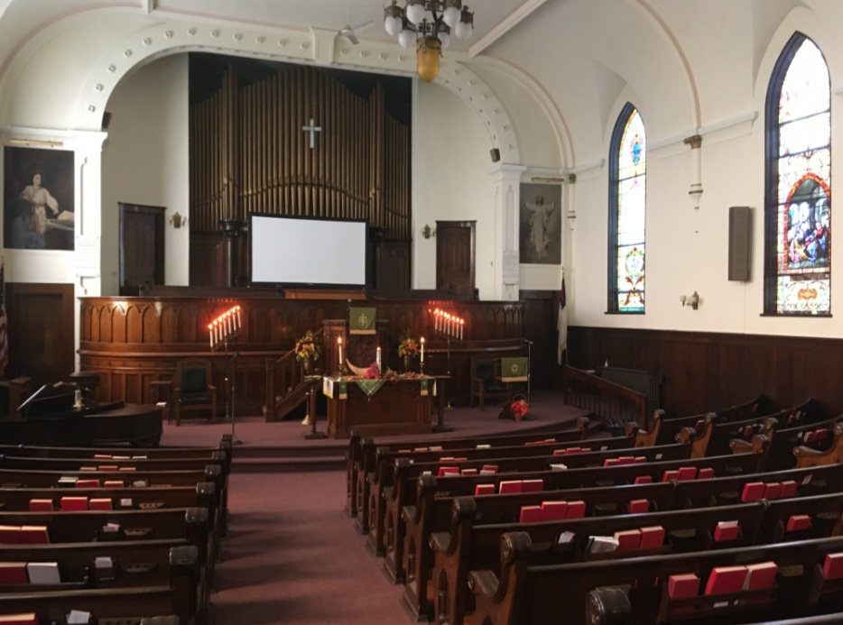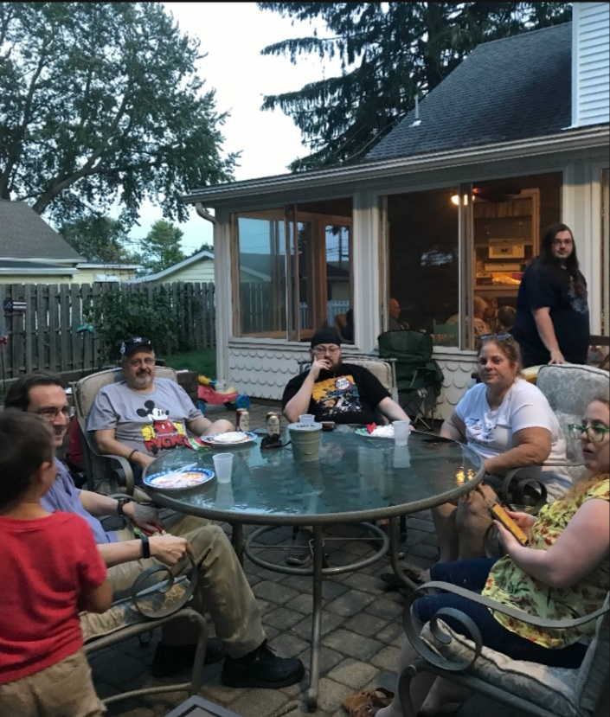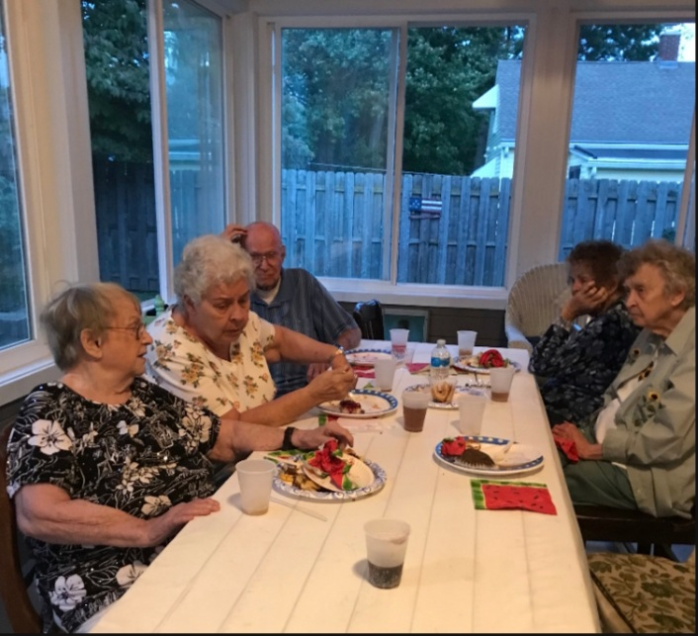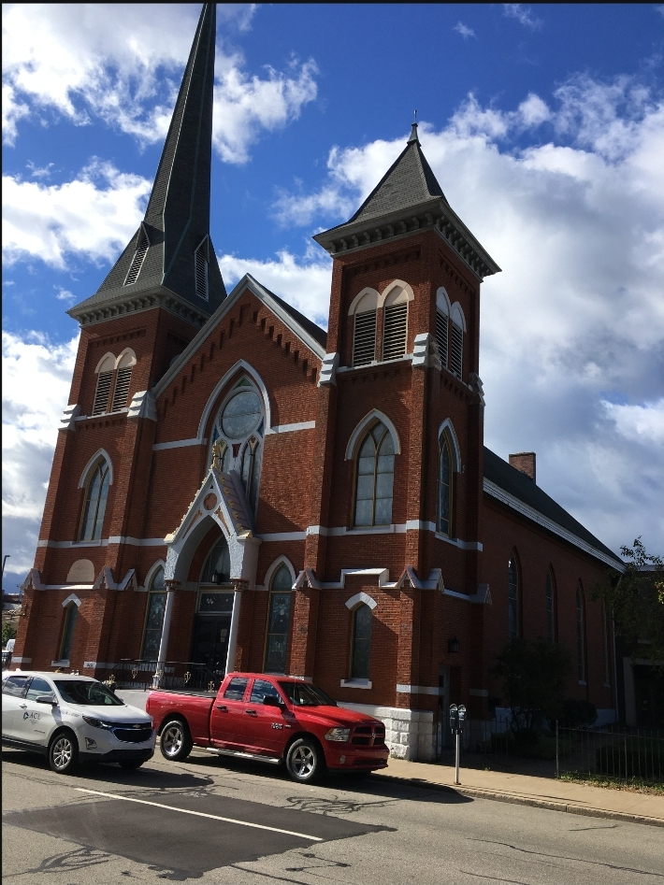

What we value about living in our area:

* Western Pennsylvania and particularly the city of Erie have a lot to offer. We are blessed with four seasons. Warm sunny summers, colorful Falls, snowy winters and inviting Springs with Lake Erie on our doorstep. There is Presque Isle Peninsula with sandy beaches, inland hiking trails, boating, & beautiful sunsets. We are home to the Presque Isle Bay with public shoreline, marinas, hotels, restaurants and a convention center. There is a long history tied to the harbor enclosed by Presque Isle. Downtown Erie is seeing a revival with many evening indoor and outdoor activities. The Warner Theater is in the final phase of renovation which will be an even better venue for professional shows & concerts. There are Spring, Fall & ethnic festivals. In the winter tubing and ski resorts are a half hour drive away. Educational opportunities are also here. There are Penn State Behrend, Mercyhurst, and Gannon Universities along with a new Community College. Erie has a small town feel with bigger city amenities. We are also only a two-hour drive to Pittsburgh, PA, Cleveland, OH, or Buffalo, NY.

Current size of membership: 97

Languages used in ministry (other than English): None

Position Title: Pastor (part time)

Position Duration:

Settled – a called position intended for longer-term ministry in which the minister moves church membership to the congregation and moves standing to related association

Compensation Level: ½ Time

Does the total support package meet conference compensation guidelines?
- Yes. As a part time position this does not include benefits that are included in a full time position.
1b. SCOPE OF WORK
- Preparation and leadership of Sunday worship including scripture study, crafting of liturgy bulletin, sermon preparation, guiding and sometimes finding lay liturgists, planning of music in coordination with musical staff or volunteers, preaching, offering of prayers, etc.
- Faith formation and vitality through prayer, Bible study, service, identifying helpful resources and opportunities and helping lay persons take advantage of them
- Pastoral care in collaboration with lay people (at least to those who are sick, elderly, or grieving)
- Participate in wider church activities such as conference and association meetings as time permits
- Study and prayer to increase faith and to improve skills so as to lead, teach, preach better
- Energizing and deepening spiritual connections and faith understandings of others in all they do

The Half – time Pastor position is understood to be a 20-25 hour per week position.

Core Competencies:
- Devout, energetic, compassionate
1c. COMPENSATION AND SUPPORT

Salary Basis $ 23,432.00 (Includes Housing allowance)

Benefits (choose one):
Salary plus Benefits
Salary includes Optional Benefits
XX - No Benefits

What is the expected living situation for your next minister?
- Finding a good location in Erie County with the assistance of a housing allowance.

Comment on the residential/commuting expectations for your next minister.
- Within thirty (30) minutes you can get anywhere in Erie, such as Presque Isle, shopping at Millcreek Mall and numerous other destinations.

State any incentives:
- Four (4) weeks of vacation, milage/travel allowance, continuing education (workshops, classes etc.)

Describe peer and professional supports available for ministers in your association/conference:
- Inter Church Ministries
- Lake Erie Association
- Penn West Conference

If applicable, describe how your church will adopt part-time adjustments in the pastoral schedule to support a minister’s bi-vocational employment:
- We have had part-time pastors for a number of years now. Our pastors have been free to set their own schedules to accommodate their additional employment and/or educational demands. As long as they can meet their commitments to the congregation and Sunday services, they can work their own schedule. With the pandemic’s shift to more online & zoom meetings, this should be easier still. A monthly report to council detailing their ministry to St. Paul’s would be expected.

1d. WHO IS GOD CALLING TO MINISTER WITH US?

Describe the ministry goals you envision your next minister co-collaborating with the congregation to achieve.

- Our number one goal at this point is to revitalize old members! We need to be a part of the community, network with other churches and organizations. Such as the use of the church to facilitate meetings -bring traffic from other organizations to promote community partnerships so we can continue to be a viable component of downtown Erie,

Describe how your vision of the minister you are now seeking will assist the congregation in making an impact beyond its walls.

- Our pastor needs to be outgoing and reaching out to all parts of the community. Without a neighborhood to draw from, we need to be visible to all. We are recognized in some circles as home of the Upper Room and we can use that but we need to be known beyond because the Upper Room has considered finding a place of their own. So we can’t count on being dependent on just that relationship.

* Create bible study and Christian Educational meetings at other places in the community
* Visit shut-ins and utilize social medias in mobile ministries
* Community Garden and other stewardship opportunities

Specify language requirements or culturally-specific capacities preferred in a next ministerial leader, and why those matter to the congregation’s sense of calling.

- Must be able to communicate clearly to a broad spectrum of people of all ages and socio-economic ranges.

Based on what you have learned about who your church is, who your church’s neighbor is, and who God is calling the church to become, describe four areas of excellence from The Marks of Faithful & Effective Authorized Ministry that your next minister will display to further equip the congregation’s ministry in these areas.

- Strengthening Inter- and Intra- Personal Assets
- Caring for All Creation
- Engaging Sacred Stories and Traditions
- Nurturing UCC Identity

2. WHO IS GOD CALLING US TO BECOME?
“You shall love the Lord your God with all your heart, and with all your soul, and with all your mind.” (Matthew 22:37 NRSV)

Who is God calling you to become as a congregation?
- We believe God is calling us to transform into a people that have God woven into their everyday lives and that we need to spread that throughout our community.

Describe how God is calling you to reach out to address the emerging challenges and opportunities of your community and congregation.

* People not physically being in the church we started streaming our church services. The input from people that watch has been mostly positive. It is a work that is evolving as we continue it. * In addition, we have been meeting the needs of our congregation that have arisen from the pandemic.
* We have had mission statements in the past but the statement above encompasses those. Also we have had mission statement workshops but none that were recent.
3. WHO ARE WE NOW?
“You shall love your neighbor as yourself.” (Matthew 22:39 NRSV)
a. CONGREGATIONAL REFLECTIONS
b. 11-YEAR REPORT
c. CONGREGATIONAL DEMOGRAPHICS
d. PARTICIPATION AND STAFFING
e. CHURCH FINANCES
f. HISTORICAL INFORMATION

3a. CONGREGATIONAL REFLECTIONS ________

Describe your congregation’s life of faith.
- Our congregation is a family of faith, and the Pastor is our spiritual guide and teacher. We use teamwork in our approach to solutions and welcome input from everyone. We work together with the Pastor to grow in our faith and live our message in the community outside of the church walls.

Describe several strengths or positive qualities of your congregation.
- Our congregation is very welcoming to visitors to our worship services
- When a crisis arises, we band together to do whatever is necessary to abate the issue.

Describe what worship is like when your congregation gathers.

- Our congregation gathers in our large and beautiful sanctuary. On Sunday mornings the sunlight usually streams in through the stained-glass windows that date back to the 1800’s. We typically have some informal social time before the service begins where we greet each other and catch up on recent events. When you sit in the pews and look around you can feel and see the presence of God. Our service is based on the word of God and how it can be related to our current times. A Pastor’s preaching should be thought provoking, challenging, and uplifting.

Describe the educational program/faith formation vision of your church.

- We have had a few opportunities for adult education both live and virtual. One of the topics was surviving our offenses with others.

Describe how your congregation is organized for ministry and mission.
- When it comes to decision-making, how many hours are spent in meetings per month? Our worship team meets about 6-8hrs./month. Our church council meetings are about 1.5-2 hours/month. The Council President surveys the council when an emergency arises and works out the best solution or resolution to the issue.
- Think of a time when action had to be taken quickly, for example when a crisis or disaster occurred. How was that accomplished? We experienced a break-in & vandalism a couple years ago. Once notified, the Council president took steps to see that the church was secured & police contacted. The vandal was client of the Upper Room so the president communicated with the director as well. The president then contacted the pastor & Council to make them aware of the situation. The vandal was apprehended. Council met and made the decision to prosecute the offender.
- Can you provide the next minister with a copy of an organization structure, bylaws and/or annual report to further explain the patterns of the church’s activity and governance? Yes, our Bylaws and annual report.

3b. 11-YEAR REPORT

3c. CONGREGATIONAL DEMOGRAPHICS ____

Describe those who participate in your church.
 |  | Is this number an estimate? (check if yes)
Number of active members: | 20 | Yes
Number of active non-members:  Viewing On-line | 10  30 | Yes
Total of church participants (sum of the numbers above): | 60 | Yes

Percentage of total participants who have been in the church:
 |  | Is this number an estimate? (check if yes)
More than 10 years: | 79% | Yes
Less than 10, more than 5 years: | 20% | Yes
Less than 5 years: | 1% | Yes

Number of total participants by age:
0-11 | 12-17 | 18-24 | 25-34 | 35-44 | 45-54 | 55-64 | 65-74 | 75+ | Are these numbers an estimate? (check if yes)
5 | 3 | 3 | 4 | 4 | 2 | 20 | 15 | 8 | Yes

Percentage of adults in various household types:
 |  | Is this number an estimate? (check if yes)
Single adults under 35: | 3% | Yes
Households with minors: | 15% | Yes
Single adults age 35-65: | 10% | Yes
Joint households with no minors: | 60% | Yes
Single adults over 65: | 12% | Yes

Education level of adult participants by percentage:
 |  | Is this number an estimate? (check if yes)
High school: | 100% | Yes
College: | 30% | Yes
Graduate School: | 5% | Yes
Specialty Training: | 3% | Yes
Other (please specify):

Percentage of adults in various employment types:
 |  | Is this number an estimate? (check if yes)
Adults who are employed: | 25% | Yes
Adults who are retired: | 40% | Yes
Adults who are not fully employed: | 20% | Yes

Describe the range of occupations of working adults in the congregation:

- Most of the adults in the congregation are now retired but, in that group, we have a retired military man, people that worked in retail, food service and hospital finance. With respect to working we have municipal & county workers, manufacturing and maintenance.

Describe the mix of ethnic heritages in your congregation, and the overall racial make-up. Most UCC congregations tend to describe themselves as “diverse.” Yet, the vast majority of UCC congregations are mono-cultural. What does diversity mean in your context?

- We are like the vast majority of UCC congregations mono-cultural.

Has your congregation recently had a conversation about welcoming diversity, or do you plan to hold one on the near future (perhaps using, for example, the Welcoming Diversity Inventory)? Please note the date. Comment after the exercise:

- Our church council has discussed the issue but it has not been brought to the congregation.

3d. PARTICIPATION AND STAFFING

Complete the following chart. Please leave blank any fields that are not applicable to your congregation.
Ways of Gathering | Estimated number of people involved in attendance | Who plans each of the listed gatherings? (list any and all worship planners, such as various lay leaders, pastors, musicians, other staff)
Adult Groups or Classes | 6 – online  4 – in person | Pastor
Baptisms (number last year) | 2 | Pastor
Children’s Groups or Classes | 0 | N/A at this time
Christmas Eve  Easter Worship | 50– online  45– in person  50– online  25 – in person | Pastor and worship team  Christmas Eve was a joint service with The Cross church.
Church-wide Meals (Annual Mtg.) | 1 | Fellowship group and Church Council
Choirs and Music Groups | 0 | N/A at this time
Church-based Bible Study | 0 | Pastor
Communion (served how often?) | Every week | Pastor and worship team
Community Meals | 0 | N/A at this time
Confirmation (number confirmed last year) | 0 | Pastor
Drama or Dance Program | 0 | N/A at this time
Funerals (number last year) | 5 | Pastor
Intergenerational Groups  (Fellowship group) | 17-25 | Fellowship Committee
Outdoor Worship | 0 | N/A at this time
Prayer or Meditation Groups | 5 | Pastor
Public Advocacy Work | 0 | N/A at this time
Retreats | 0 | N/A at this time
Theology or Bible Programs in the Community | 0 | N/A at this time
Weddings (number last year) | 1 | Licensed Minister
Worship (time slot: 10:30 AM) | 20 | Pastor and worship team
Worship (time slot: _______)
Young Adult Groups or Classes | 0 | N/A at this time
Youth Groups or Classes | 0 | N/A at this time
Other
Additional comments: With the pandemic our gathering activities have been greatly affected.
List all members or regular participants in your congregation who are ordained, licensed, or commissioned ministers. Indicate those with current United Church of Christ Three-Way Covenants (i.e. serving in a congregation) or Four-Way Covenants (i.e. serving in a ministry beyond a congregation).
Name | Three- or Four-Way Covenant?  (3 or 4 or No) | Ministry Setting | Type of Ministry Role | Retired?  (Y or N)
Eric Campbell | No | Licensed | One Sunday a month or when needed | N
If one or more previous pastors or retired ministers currently hold membership in the church, describe their role(s) in the life of the congregation:
List all current staff, including ministers. Exclude the position you are seeking to fill. Indicate which staff person serves as head of staff.
Staff Position | Head of Staff? | Compensation (full time, part time, volunteer) | Supervised by | Length of Tenure for current person in this position
Cheryl Pierce |  | Hourly | Pastor & Council Pres. | 19 yrs.

REFLECTION
Reflection: After reviewing the congregational demographics and activities above, what does this information reflect about your congregation’s overall ministry?

- We need to refocus our ministry to the people that populate downtown Erie. Our building is a great location to be a facility for downtown organizations that need space to have meetings, classes, small groups and the like. Our main purpose should be spreading the Gospel of Jesus Christ to the people of the community.

3e. CHURCH FINANCES

Current annual income (dollars used during most recent fiscal year)
Source | Amount
Annual Offerings and Pledged Giving | $ 27,470.00
Endowment Proceeds (as permitted within spending policy, such as a cap of typically 4.5%-5% on total return) | $ 1,200.00
Endowment Draw (beyond what is permitted by spending policy, “drawing down the principal”) | $ 0
Fundraising Events (Erie gives non-members & match) | $ 922.00
Gifts Designated for a Specific Purpose | $ 0
Grants | $ 2,000.00
Rentals of Church Building (Upper Room & The Cross) | $ 11,500.00
Rentals of Church Parsonage | $ 0
Support from Related Organizations  (e.g. Women’s Group) | $ 0
Transfers from Special Accounts | $ 0
Other (specify): (Interest) | $ 802.00
Other (specify): Memorial Fund | $ 4,800.00
TOTAL | $ 48,694.00

Current annual expenses (dollars budgeted for most recent fiscal year): $ 42,134.00
St. Paul’s UCC Proposed 2022 Budget
Description 2021 2021 2022
Budget Actual Proposed
Benevolences 1,000 900 1,000
Worship Supplies 300 458 500
Ministry of Music 200 214 200
Organ/Piano Maintenance 225 216 225
Dir. Of Music Salary 3,300 2,700 3,300
Pastor – Base Salary 8,700 6,190 17,400
Social Security Allowance 675 480 1,331
Pastor Travel 1,300 650 1,200
Housing Allowance 6,600 3,300 5,200
Pension, Death, Disability
Family Medical
Supply Pastors 200 400
Member/Program Development 50 50
Christian Education 50 50
Secretary Salary 4,500 4,949 4,500
Postage 50 50
Office Supplies 500 695 500
Office Equip/Service
Financial Administration 50 50
Insurance: Bldg/Workers Comp 4,500 4,323 4,500
Payroll Taxes (church SS & Medi) 500 570 2,030
Church Utilities 15,000 12,260 15,000
Church Repairs/Improvements 100 100
Sexton Salary 500 500
Bldg. Maint. Supplies/Service 5,000 3,912 5,000
Unforeseen Expenses 50 50
Flowers 100 100
TOTAL EXPENSES 53,450 42,134 63,236

Considering total budgeted expenses for the year, compare total ministerial support. What is the percentage? * 38%

Has the church ever failed to pay its financial obligations to a minister of the church?
- NO
Is your church 5-for-5, i.e. does it include each of the following contributions during the church year? (indicate those included during the most recent fiscal year)
_X_ Our Church’s Wider Mission (OCWM – Basic Support)
_X_ One Great Hour of Sharing
_X_ Strengthen the Church
_X_ Neighbors in Need
_X_ Christmas Fund

In what way is OCWM (Basic Support) gathered? If calculated as a percentage of operating budget, what is that percentage?
- It would be collected by a special offering.

What is the church’s current indebtedness? *We have no indebtedness.
Total amount of loan debt:
Reason for debt:
Are capital and other payments current?

If a building program is projected or underway, describe it, including the projected start/end date of the building project and the total project budget.

- Not currently.

If the church has had capital campaigns in the last ten years, describe:
Year(s) | Purpose | Goal | Result | Impact
--------- | --------------------------- | $------------ | $---------- | --------------------------------------
If a capital campaign is underway or anticipated, describe:
Year(s) | Purpose | Goal | Result | Impact
-------- | -------------------------- | $----------- | $---------- | ---------------------------------------
Describe the prominent mission component(s) involved in the most recent (or current) capital campaign.

- N/A

Does your church have an endowment? * YES

What is the market value of the assets? *$112,000.00 Bauer Fund & Giese Fund

Are funds drawn as needed, regularly, or under certain circumstances?
- We can only use the interest on the funds for specified expenses.

What is the percentage rate of draw (last year, compared to 5 years ago)?
- We can only use the interest on the funds for specified expenses.

Describe draw on endowment, if any, to meet operating budget expenses for the most recent year and the past five years:
- We can only use the interest on the funds for specified expenses.

At the current rate of draw, how long might the endowment last?
- It will last forever because we cannot touch the principal.

Please comment on the above calculations or estimates:

Other Assets

Reserves (savings):
Memorial account $15,000.00 -- $26,000.00

Investments (other than endowment): Certificate of Deposits -- $38,000.00
Does your church have a parsonage? NO

Fair market rental value of the parsonage:
How is the parsonage used?
Street / City / State / Zip:
Finished square footage:
Number of Bedrooms, Number of Bathrooms:
Assessed real estate value:
Available for minister residence: Y/N
Expected minister residence: Y/N
Condition of structure, systems and appliances
Entity in the church responsible for review and needed repairs

Describe all buildings owned by the church:
- Located in downtown Erie, Pennsylvania at 1024 Peach Street is a red brick Church. The sanctuary was constructed in 1851, with the addition of the narthex, balcony and two steeples being added in 1879. The taller steeple was fitted with two bells still operated today by rope pulls. Beautiful stained-glass windows were installed in 1895 and in 1907 another addition was completed to accommodate a Teller Pipe Organ and choir loft. Other than electrical and sound upgrades the soaring sanctuary that can seat 300+ looks much the same as it did over 100 years ago.
In 1957 a combined social hall, office and Sunday School brick building was constructed and attached at the rear of the sanctuary. Sometimes called the Education Building, it comprises 3 floors of approximately 5,500 square feet each. The bottom floor (basement) houses Fellowship Hall, a Parlor and kitchen. The middle floor is home to the Church Office, Pastor’s Study, Choir Room, Chapel, Nursery and Sunday School rooms. The top floor is currently occupied by the Upper Room daytime homeless shelter, a separate non-profit organization.
Constructed well before the term handicap accessibility was created, we are not considered handicap accessible but do have a chairlift to transport folks to Fellowship Hall and a ramp in the sanctuary to help with wheelchair/walker access.

Describe non-owned buildings or space used or rented by the church:

- There are none, but we do have an inactive cemetery located in Green Township.

Which spaces are accessible to wheelchairs?
- The sanctuary.
- There is a chairlift that goes from the first floor to the fellowship hall.

Reflection: After reviewing the church’s finances and assets described above, what does this information reflect about your congregation’s mission and ministry?

- Our budgeting process is done by looking at the previous year’s bills and income.

3f. HISTORICAL INFORMATION

Name one to three significant happenings in the history of your church that have shaped the identity of your congregation. Add the most important event in the life of your church in the past 10 years.
- The Upper Room (homeless day shelter) – The church was very hesitant to allow this type of operation into the building but over the years it evolved into being a part of our outreach to the community.
- The pandemic – With the start of the pandemic we started streaming our services on Facebook and then we purchased better equipment for improving the output. It allows us to reach more people and if a member of the church can’t make it in person they can view online.
- We welcomed a seminary student as a ¼ time pastor while she finished her last two years of seminary.

Describe a specific change your church has managed in the recent past.

- In the last two years, much has changed. Covid has done much to all of us – but it has forced our congregation to leap into an active online presence while maintaining relationships with long-time members who need check -ins and help. We have also offered our facility to other groups in the community, maintaining and assisting a safe environment for them to meet. This has led to an exciting outreach – by our continued on-line presence (reaching local and even international), our outreach to our members and our community outreach to others.

Every church has conflict, some minor, some larger. “Where two or three are gathered, there will be disagreement….” Describe your congregation’s values and practices when it comes to conflict.

- When a conflict arises, we try to work out the issues and come to a reasonable conclusion. We as a congregation understand that everyone will not agree on everything and that everyone’s opinion is worthy of discussion.

Ministerial History (include all previous ministerial staff for the past 30 years)

Staff member’s name | Years of service | UCC Standing (Y/N)
Julia DiFiore | 2019-2021 | Yes
Rev. Robin Swope | 2012-2019 | Yes
Rev. Wayne Sova | 2007-2010 | Yes
Rev. Carl Hull | 1998-2006 | Yes
Rev. David Edmunds | 1986-1998 | Yes

Comment on what your church has learned about itself and its relationship with persons who provided ministerial leadership:

- The relationship between a pastor and their congregation is a very important issue and needs to be addressed in the very beginning so that both parties know what is expected of each party.

Has any past leader left under pressure or by involuntary termination?

* Yes

Has your church been involved in a Situational Support Consultation?

* Yes - through Lake Erie Association

Has a past pastor been the subject of a Fitness Review while at your church?

* No

4. WHO IS OUR NEIGHBOR?
“You shall love your neighbor as yourself.” (Matthew 22:39 NRSV)
a. COMMUNITY VISION
b. MISSION InSite

4a. COMMUNITY VISION

How do the relationships and activities of your congregation extend outward in service and advocacy?

- In the past we have participated in the local CROP walk.
Our church is the locale for a community outreach that provides a breakfast.
Local churches that rotate Sundays to handout bag lunches and before the pandemic hot lunches in our Fellowship Hall. The third floor is utilized as a day shelter for the homeless.

Describe your congregation’s participation in meetings, relationships and activities connecting the wider United Church of Christ (association / conference / national setting).

- We are in the Lake Erie Association and the Penn West Conference. We have attended annual meetings of both of those. In addition, there is a member that is currently the moderator of the Association, also is on the nominating committee for the Association and the Conference Mission grant committee.

Many local churches love to tell the story of what they are doing in the community to transform lives. Some have identified certain aspects of their witness into the wider community using language shared with other UCC congregations. (Find more information as desired at ucc.org.) Check any statements below that apply to your UCC faith community.

__ Accessible to All (A2A)
__ Creation Justice
__ Economic Justice
__ Faithful and Welcoming
__ God Is Still Speaking (GISS)
__ Border and Immigrant Justice
__ Inter-cultural/Multi-racial (I’M)
__ Just Peace
__ Global Mission Church
__ Open and Affirming (ONA)
__ WISE Congregation for Mental Health
__ Other UCC designations:
__ Designations from other denominations
_X_ None

Reflect on what the above statement(s) mean(s) to your community. Is your congregation interested in working toward any of the above statements of witness in the near future?

- We are looking into a few of these statement in the purpose of working towards witness into our community – but we need some education and leadership to help us understand each designation and which would be the best fit(s) for our congregation.

Describe your congregation’s participation in ecumenical and interfaith activities (with other denominations and religious groups, local and regional).

- In 2021we had a combined Christmas Eve service with the Cross church and this year (2022) we have started an outreach Community United Church (UCC) and New Hope Presbyterian Church. This program is providing a lunch each Sunday to the homeless. The program director uses us as a fill in.

If your congregation has a mission statement, how does that mission statement compare to the actual time spent engaging in different activities? Think of the range of activities from time spent gathering, to governance, to time spent going out.

- Prior to the pandemic we had a monthly coffee hour after our service. Our Fellowship group would also have a monthly lunch outing to a local restaurant. We are starting both up in the near future. The governance of the church was steady.

Reflect on the scope of work assigned to your pastor(s). How is their community ministry and their ministry in and on behalf of the wider church accounted for in the congregation’s expectations on their time?

- We are currently without a Pastor and using a Pulpit fill for Sunday services.

4b. MISSION InSite

Comment on your congregation’s Mission Insite report with data for your neighborhood(s) or area. What trends and opportunities are shown?

- After reviewing the Mission Insite report we see that our focus needs to be not only the downtown area but we need to expand out into the neighboring municipalities. Doing that would give us the opportunity to make people aware of St. Paul’s existence and what we do at the church.

How do your congregation’s internal demographics compare or contrast to a) the neighborhoods adjacent to your church, and b) other neighborhoods with which your church connects?

- Our church is in the downtown area but our congregation lives in the neighboring municipalities.
- Once you leave the downtown area our congregation would be more like those neighborhoods.

How are the demographics of the community currently shaping ministry, or not?

- It is hard to say. In some ways our ministry is the same as it always has been but we have been trying to employ a more inclusive atmosphere.

What do you hear when you talk to community leaders and ask them what your church is known for?
- The Upper Room Homeless Day Shelter

What do new people in the church say when asked what got them involved?

- I found your church on Google and checked you out on Facebook.
- Felt welcomed by all.

5. REFERENCES

Name up to three people who have agreed to serve as phone and written references. Advise the three references: “The contact information you provide may be shared publicly. Please use contact information that you feel comfortable giving to candidates so they can reach you with their questions.”

Make sure they are not members of your church but are persons who know your church well enough to be helpful to candidates seeking more information. Request a letter from each reference in answer to the four prompts below. Attach the letters (up to three) as desired.

REFERENCE 1
Rev. David Edmunds (Minister at Elwood Presbyterian Church and Belle Valley Presbyterian Church in Erie, Pa.) (814-864-4809 (Was Minister at St. Paul’s 1986-1998)
Belle Valley


Presbyterian Church

April, 2022

Dear Friends:

I served St. Paul UCC from 1987-99, as their solitary pastor. This was also my first pastorate after completing my seminary education. I came to St. Paul’s with a large sense of vision, but a very green edge to my abilities and experience in pastoral ministry. The congregation was very loving and, I believe, very patient with my journey of growth as their pastor. I moved on as God was calling elsewhere, and eventually I transitioned into the PCUSA.

Though I realize that it has been 23 years since I was involved at St. Paul’s, these are my remembrances of the strengths/growth areas of their ministry:
- A “homey” family-feel to the culture of the congregation. The existing congregation needs to continue keeping their focus keenly on visitors for welcoming them and reaching out to them, as well as envision the specific audience that they feel God is calling them to creatively reach out to. Mission is always about going out “there” beyond the walls of the facility and finding creative ways to build relationships with the “Nones” (those without any church affiliation) out in the neighborhoods around the facility and around its members.
- A beautiful facility that, though it raises challenges to their existing financial resources in terms of maintenance, provides lots of space for ministry/outreach opportunities that can support the neighborhoods of the downtown area. There is room for collaborative ministry with other non-profits, and other congregations without their own facilities. St. Paul’s currently is home to a newer start-up congregation (“The Cross”) with a commitment to urban ministry. Are there creative ways to share the ownership of the facility among 2-3 tenants, in order to share the maintenance costs? Or are their ways to sell the facility so that St. Paul’s can lease back the space needed for their ministry (again, so that the costs of facility maintenance can be taken over by another).
- A wonderfully supportive relationship with the ministry of The Upper Room (a daytime drop-in shelter providing services to the homeless and disenfranchised, the lonely and isolated!), housed on the third floor of St. Paul’s educational building (but The Upper Room also has access to the church’s fellowship hall/kitchen area for regular meals). Members of the congregation also serve on the Upper Room’s board. And the congregation regularly provides projects of support to the clients of The Upper Room (collections of warmer clothing in the winter months, for example).
- Though the congregation has been hit by some attrition over the years, the core leadership group is a passionate and faithful body of disciples of Jesus Christ desiring to serve the community as best they can.

I believe that one of the most significant experiences I had through the ministry of St. Paul’s was how God connected us to the ministry of The Upper Room approximately 25 or more years ago. No one ever thought that relationship would continue to be as prominent as it has become in the life of this congregation, and here we are 25+ years later and that partnership is even stronger!

St. Paul’s is located in a wonderful setting in downtown Erie, that enables their access to a marvelous array of outreach and mission opportunities. They are limited in availability of parking, as they lost their former resources of parking space even before I served there. This issue will need someone who can seek collaboration with neighbors in the downtown area, who would be generous providers of such space, and are able to realize the positive community value that a neighboring church provides.

In Christ, Rev. David Edmunds (pastor of Belle Valley & Elmwood Avenue Presbyterian Churches)

“For I know the plans I have for you to give you a future and a hope...If you look for me with your whole heart, you will find me.”
(Jeremiah 29:11,13)
1694 Norcross Road, Erie, Pennsylvania 16510 (814-520-5688) presbyteriannetwork.com/bellevalleychurch/ facebook.com/belle.church/ Rev. Dave Edmunds: (814) 397-1861; reved87@verizon.net

REFERENCE 2
Rev. Dr. E. Thomas ( Minister at St. Paul’s at Hermitage Pa.)
(724-342-2310) (pastor@stpaulshermitage.org ) (Friend of the church)

Telephone
(724) 342-2310

St. Paul’s United Church of Christ
An Historic Church for God’s People Today
159 Todd Avenue
Hermitage, Pennsylvania 16148-1729
www.StPaulsHermitage.org

March 23, 2022

RE: St. Paul’s United Church of Christ, Erie, PA
SUBJ: Reference Letter

To Whom It May Concern,

I am writing this reference on behalf of St. Paul’s United Church of Christ, Erie, PA because I have gotten to know many of their congregants over the past five years. I have also attended Service with them and celebrated the Service for them when there was a need.

The congregants of St. Paul’s are genuinely good people. Many competent and gifted lay leaders are quite active in tending to the daily concerns of the church and her mission in the heart of downtown Erie. As part of St. Paul’s outreach to the concerns of the inner-city, they house the Upper Room in a section of their property. The upper Room cares for the homeless and provides for their needs. Some of the congregants of St. Paul’s serve on the board of the Upper Room.

Every Sunday, St. Paul’s has allowed their hall space to host the “Bishop’s Breakfast,” an effort of the Catholic Diocese of Erie to feed the homeless. It was founded by the late Most Rev. Donald W. Trautman. The congregation regularly engages in coffee hours and dinners throughout the year on special holidays as a means to build-up fellowship. There is much potential for St. Paul’s as they are also very near to Gannon University and its campus facilities. This congregation is a community of believers welcoming all people no matter where they are on life’s journey.

St. Paul’s UCC, Erie, PA, is a close-knit congregation, and when faced with challenges they work diligently to find a way forward. This congregation needs a qualified and experienced Ordained minister, a solid spiritual leader, a good listener and someone with effective communication skills who is willing to work with the local consistory and the congregation for the good of the entire body of believers.

My prayer is that St. Paul’s will receive an Ordained clergyperson who will spiritually nourish and nurture the souls entrusted to his/her pastoral/spiritual care and make divine Worship central to all the good already occurring in the heart of the City of Erie, with St. Paul’s as a beacon of light and hope.

Respectfully Submitted,

Rev. Dr. E. Thomas
Pastor

REFERENCE 3
Joy Johnson (authorized (licensed) minister at Communite United Church in Erie, Pa.) (814) 864-4429 / Email / Friend of the church)
April 22, 2022

LETTER OF REFERENCE REGARDING:

St. Paul’s United Church of Christ
1024 Peach Street
Erie, PA 16501-1811

Dear Reader:
If you are looking for a Christ-centered, friendly, and hard-working congregation of faith, you will find it in St. Paul’s UCC of Erie, Pennsylvania.
I am fortunate to have served as pulpit supply for St. Paul’s a few times, and each time I did, I came away having felt welcomed and optimistic about what the people of this church can do. They are sincere, dedicated, and committed to not only their church, but also to the Erie community, and the many homeless people in need who are served through the Upper Room organization which occupies space – and hearts – in St. Paul’s building.
As an associate pastor at a local, “sister” church, I have opportunity to talk with the wonderful people of St. Paul’s from time to time and have witnessed their coming through a fair amount of strife over the past few years as they have sought to find the right pastoral leadership for this time in their history. What strikes me as remarkable is that St. Paul’s is not only resilient to circumstances that would drag them down, but the folks there are able to move on from challenges and difficulties with restored resolve to continue God’s work.
Any new pastor would be given the opportunity to grow this congregation and lead with substantial support from its Consistory, members, and friends. There is a unique niche to be served at St. Paul’s, as Erie’s inner city needs this church, whether it knows it or not!
My best wishes go out to this congregation and its leadership!
Sincerely,
Joy L. Johnson, associate pastor
Community United Church, Erie, PA

6. CLOSING THOUGHTS
a. CLOSING PRAYER
b. STATEMENT OF CONSENT
c. CONFERENCE/ASSOCIATION VALIDATION

6a. CLOSING PRAYER ______

Include here any prayer or dream for the minister you imagine journeying toward you… a poem, for example, or a Scripture passage or a piece of music that is meaningful to your Search Committee:

With God all things are possible
Matthew 19:26

6b. STATEMENT OF CONSENT

The covenantal relationship between a church and those called by that church to serve as pastors and teachers and in other ministerial positions is strengthened when vital information is openly shared by covenantal partners. To that end, we attest that, to the best of our abilities, we have provided information in this profile that accurately represents our church. We have not knowingly withheld any information that would be helpful to candidates.
As the committee charged with the responsibility for identifying and recommending suitable new minister for our church, we have been authorized to share the information herein with potential candidates. We understand that a candidate may wish to secure further knowledge, information, and opinions about our church. We encourage a candidate to do so, recognizing that an open exchange of relevant information builds the foundation for continuing and healthy relationships between calling bodies and persons seeking a ministry position.

- Which individuals and groups in the church contributed to the contents of this Local Church Profile? (For example, church council or consistory, transition team, etc.)
- Search Committee
- Church Council

- Additional comments for interpreting the profile:

Signed:
Charles Pierce
Search Committee Chairperson
May 27, 2022
6c. VALIDATION BY CONFERENCE/ASSOCIATION _____

The congregation is currently in good standing with the association / conference named.
Staff Comment: Yes.

To the best of my knowledge, ministerial history information is complete.
Staff Comment: Yes.

To the best of my knowledge, available church financial information is presented thoroughly.
Staff Comment: Yes.

My signature below attests to the above three items.

Signature: 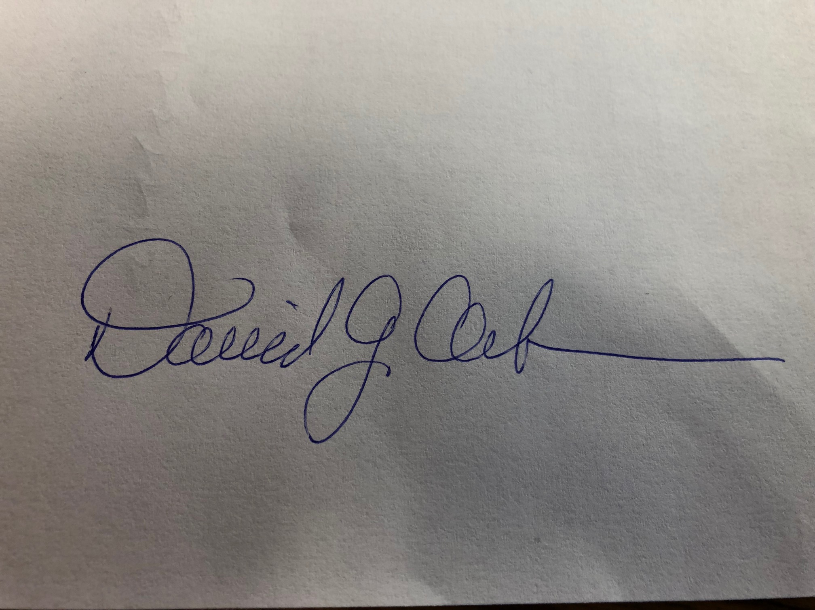
Name / Title: David J. Ackerman / Conference Minister
Email: david@pennwest.org
Phone: 724-834-0344
Date: May 31, 2022

This document is created through support to Our Church’s Wider Mission (OCWM) and is only possible through the covenantal relationships of all settings of the United Church of Christ.

“Jesus answered them, ‘Have faith in God!’” – Mark 11:22

