Missouri Mid-South
UNITED CHURCH OF CHRIST
POSITION POSTING
LISTING INFORMATION
SCOPE OF WORK
COMPENSATION & SUPPORT
WHO IS GOD CALLING TO MINISTER WITH US?

LISTING INFORMATION

Church name: Grace United Church of Christ (UCC)
Street address: 4025 Wilmington Avenue, St. Louis, MO 63116
Supplemental web links: graceuccstl.org

Additional ecumenical affiliations (e.g. denominations, communions, fellowships):

Conference: Missouri Mid-South
Association: St. Louis Association
UCC Conference or Association Staff Contact Person
Rev. Damien Lake
Associate Conference Minister
314-918-2605
damien@mmsucc.org

Summary Ministry Description: Grace UCC is a south St. Louis Open and Affirming congregation with a rich history of helping students and members discern what God is calling them to do.

We have worked hard to support our mission ministries (we’re a 5 for 5 Congregation) and we care for each other. Our regular local ministries include making sandwiches for Gateway 180 Homelessness Reversed (paused during the pandemic), supporting the Carondelet Free Store, Trinity Food Pantry, Isaiah 58 Ministry, Feed My People, Lydia’s House, Habitat for Humanity, St. Louis Association, Eden Theological Seminary and Woerner School, a neighborhood public school. We are the charted organization for Boy Scout Troop 181. A recent new national ministry has been supporting medical debt relief.

Photographs:
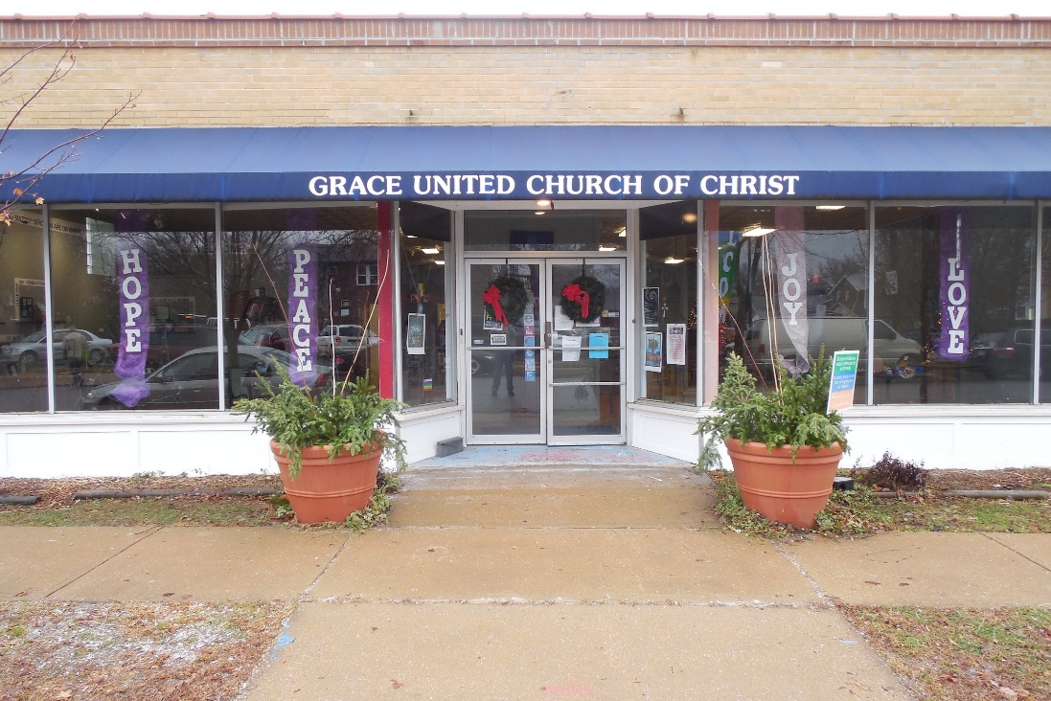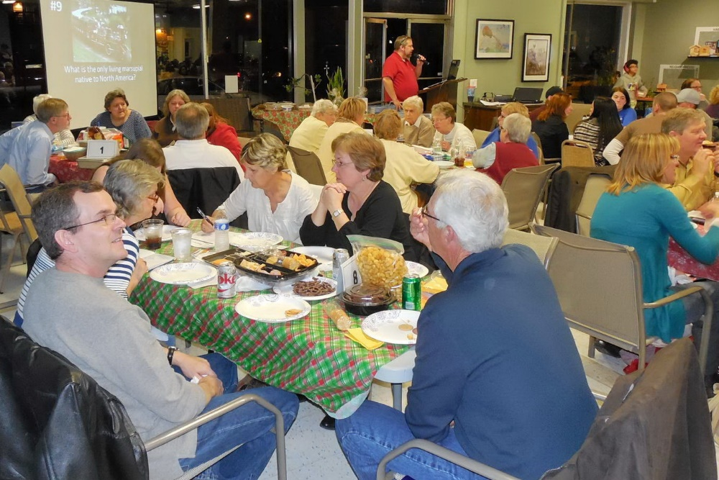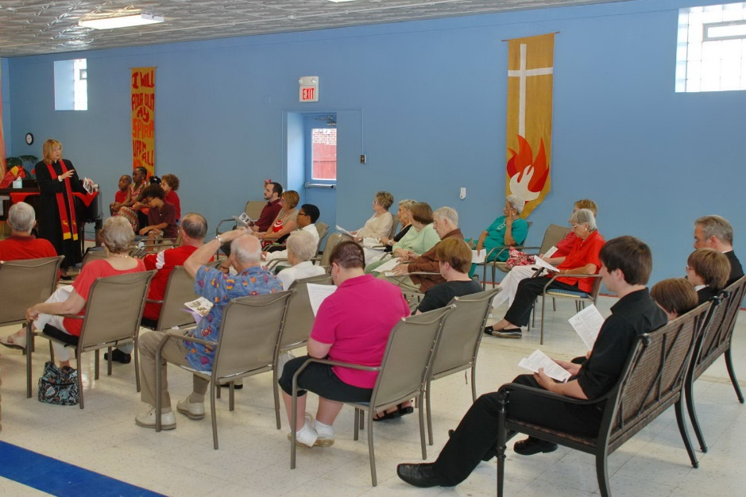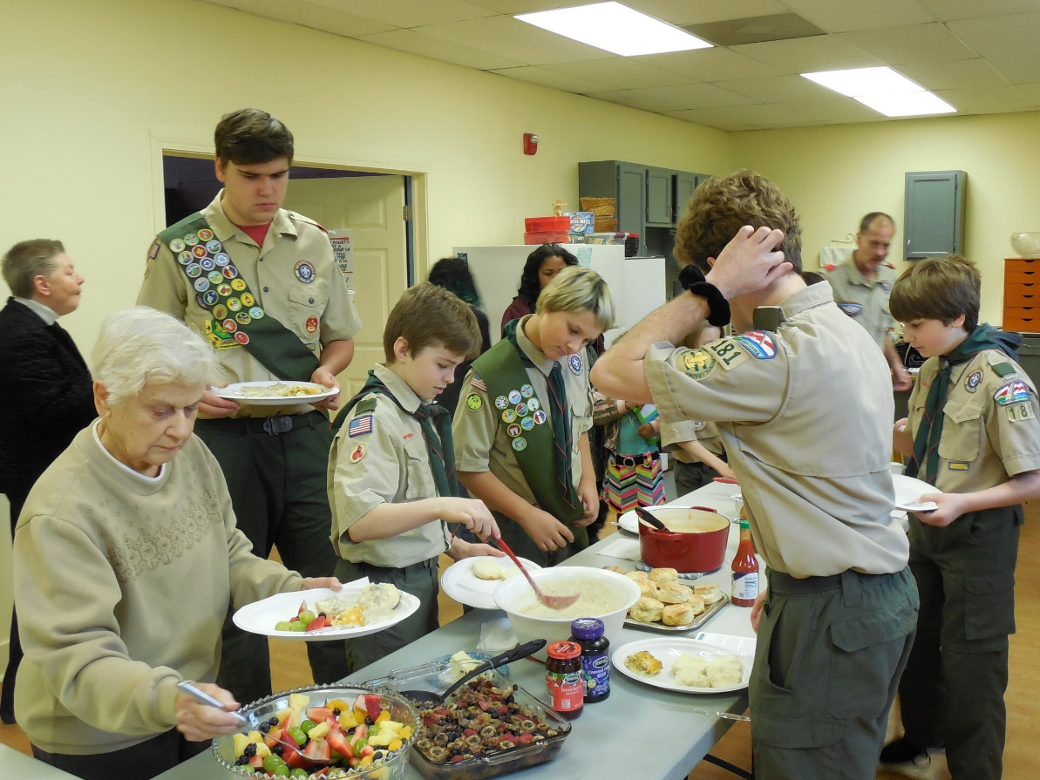

What we value about living in our area: Grace UCC is located 2-3 blocks north of Carondelet Park, a major urban park. We have a long association with Woerner School, and have both expensive and modest residential areas close by Grace with a diversity of people in the neighborhood.

Current size of membership: about 50.

Languages used in ministry (other than English): None

Position Title: Designated Term, Grace UCC

Position Duration: 3+ years – a called position to work toward the church’s declared purpose for a specific season.

Compensation Level: ½ Time

Does the total support package meet conference compensation guidelines? Yes.

SCOPE OF WORK
Our goals for working with the designated term pastor will be to explore our options for moving forward. Our prior Pastor served both Grace UCC and Mt. Tabor UCC. Mt. Tabor has voted to dissolve and is working toward that goal. Grace doesn’t have the resources to call a full time pastor by ourselves, but we would be willing to share.

When the St. Louis COVID lockdown started in March of 2020, we started a Facebook Live ministry and an Uber conference call ministry to keep together and share our prior pastor’s joyful message about God’s love with a wider audience. We worked with theater set and sound designers to improve our production capability in simple but effective ways. Every Sunday more than 400 people are reached by the Facebook Live service, with many shares. The Uber conference call allows our members to call in on any phone line and participate in services or meetings. Throughout the pandemic we have called each other regularly and sent cards. We want to stay together and continue to expand our outreach in creative ways. We are seeking a designated term pastor who will see the possibilities in our congregation, and find new ways to be the church.

Core Competencies:
(List three core competencies that you imagine could be foundational in your next minister’s relationship with the church. For example, a church seeking a pastoral care minister might hope to call someone who is caring, sensitive and sociable, while a church seeking an executive minister might want an organized, detail-oriented and time-conscious person.)

Grace UCC is looking for a pastor who is caring, creative and a good communicator.

COMPENSATION AND SUPPORT
Salary Basis: Salary and housing allowance, no parsonage available.

Benefits: Open for discussion/negotiation. Benefits for our recent Pastor included retirement annuity, life/disability insurance, health insurance, and education expense.

What is the expected living situation for your next minister? Minister provides their own housing using the salary and housing allowance.

Comment on the residential/commuting expectations for your next minister.
Most commuting and driving would be in south St. Louis city and county. Members reside in this area, several hospitals in area and UCC Conference is located nearby.

State any incentives (such as student loan debt repayment, additional family leave or vacation, etc.): 2 weeks paid vacation each year

Describe peer and professional supports available for ministers in your community/association/conference: Missouri Mid-South Conference UCC is located in St. Louis County in the community of Webster Groves, about 15 min drive from Grace UCC.

WHO IS GOD CALLING TO MINISTER WITH US?

Our goals for working with the designated term pastor will be to explore our options for moving forward. Our prior pastor served both Grace UCC and Mt. Tabor UCC during the past 10 years, but Mt. Tabor has since voted to dissolve. We don’t have the resources at Grace to call a full time pastor by ourselves at this time.

Goals for Year One: 1) The new pastor will need time to develop close relationships with our current membership and help us renew our pre-pandemic in-person ministries like monthly Sandwich Sunday and our monthly collections for specific missions; 2) Understand and expand the technology we use to keep in touch with home-bound members – currently Facebook Live and Uber call. 3) Develop ways to engage our regular (now 450+ each week) Facebook Live viewers and invite them to participate more fully in the life of our church.

Goals for Year Two: 1) Develop ways for our aging congregation to stay in touch with each other and the church. We use phone calls and cards, but other technologies like Zoom could offer a closer experience. 2) With the increased understanding we have gained about how technology might help us engage home-bound members, reach out to other disabled communities. 3) Develop specific programming to engage our on-line viewers outside of the Sunday service. 4) Find ways to engage our Facebook Live communities to support our ministries with contributions. We could learn from other larger UCC congregations which have come up with solutions.

Goals for Year Three: 1) Call our pastor to full-time. 2) Engage with students and resources at Eden Seminary to provide a learning experience and a “production studio” in which to find new ways to be the church.

While these goals have a substantial technology element, we expect to engage other UCC churches and resources at Eden Seminary to help us explore possibilities.

STATEMENT OF CONSENT

The covenantal relationship between a church and those called by that church to serve as pastors and teachers and in other ministerial positions is strengthened when vital information is openly shared by covenantal partners. To that end, we attest that, to the best of our abilities, we have provided information in this profile that accurately represents our church. We have not knowingly withheld any information that would be helpful to candidates.
As the committee charged with the responsibility for identifying and recommending suitable new minister for our church, we have been authorized to share the information herein with potential candidates. We understand that a candidate may wish to secure further knowledge, information, and opinions about our church. We encourage a candidate to do so, recognizing that an open exchange of relevant information builds the foundation for continuing and healthy relationships between calling bodies and persons seeking a ministry position.

- Which individuals and groups in the church contributed to the contents of this Position Posting?

- Additional comments for interpreting the profile:

Signed: Susan Hagen, Consistory Member

VALIDATION BY CONFERENCE/ASSOCIATION

The congregation is currently in good standing with the association / conference named.
Staff Comment:

My signature below attests to the above two item.

Signature: 

Name / Title: Rev. Damien Lake, Associate Conference Minister
Email: damien@mmsucc.org
Phone: 314-918-2605
Date: 9-14-21

This document is created through support to Our Church’s Wider Mission (OCWM) and is only possible through the covenantal relationships of all settings of the United Church of Christ.

“Jesus answered them, ‘Have faith in God!’” – Mark 11:22

