UNITED CHURCH OF CHRIST
LOCAL CHURCH PROFILE

First United Church of Christ of Orlando
Orlando, Florida

Pastor

Florida Conference, United Church of Christ
Western Region

October 13, 2020

LOCAL CHURCH PROFILE CONTENTS
- Position Posting
- Who Is God Calling Us To Become?
- Who Are We Now?
- Who Is Our Neighbor?
- References
- Consent and Validation

“God is able to provide you with every blessing, so that
having all sufficiency in all things at all times,
you may abound in every good work.”
(2 Corinthians 9:8)

POSITION POSTING
LISTING INFORMATION
SCOPE OF WORK
JOB DESCRIPTION
COMPENSATION & SUPPORT
WHO IS GOD CALLING TO MINISTER WITH US?

LISTING INFORMATION

Church name: First United Church of Christ of Orlando
Street address: 4605 Curry Ford Rd; Orlando, FL 32812
Supplemental web links: www.firstuccorlando.org

Additional ecumenical affiliations (e.g. denominations, communions, fellowships): N/A

Conference: Western Region, United Church of Christ
Association: N/A
UCC Conference or Association Staff Contact Person:
Rev. Leslie Etheredge; Western Regional Minister; FL Conference, United Church of Christ; (205)515-8741; Letheredge@uccfla.org

Summary Ministry Description:

First United Church of Christ Orlando is an open and inclusive fellowship where strangers become friends. In the name of Jesus Christ, we welcome into membership persons of all races, creeds, traditions, sexual orientations, gender expressions, physical abilities and ethnic origins. We ask those who unite with us to share the witness of their particular traditions with our Christian community of faith.

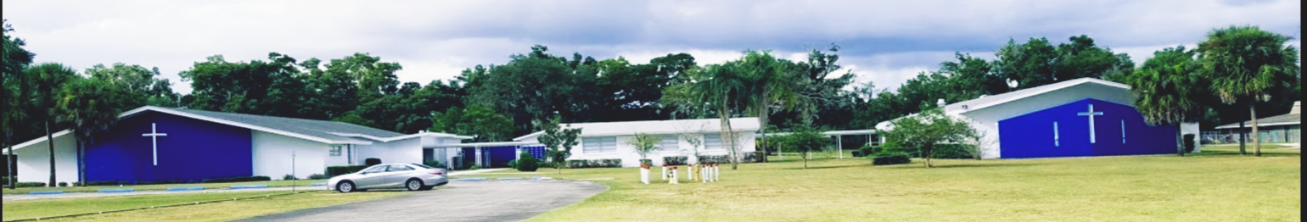
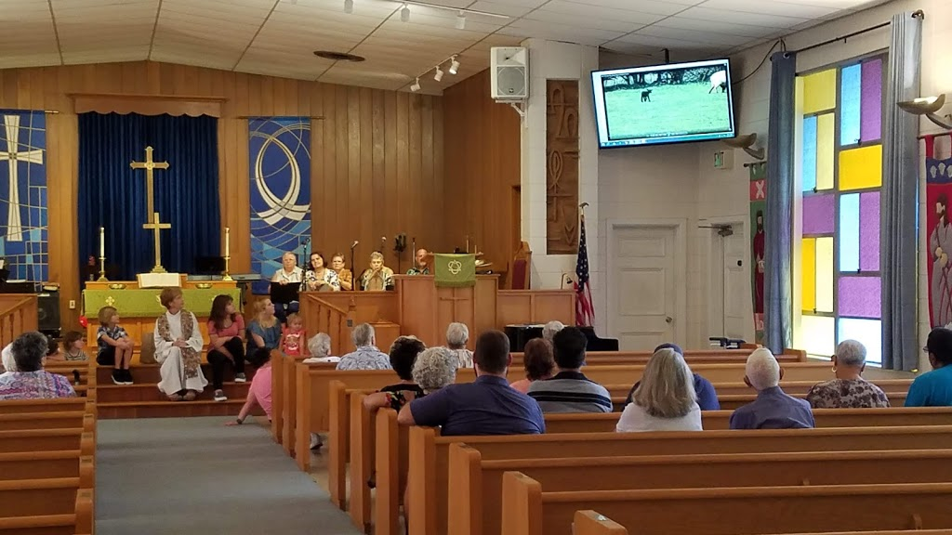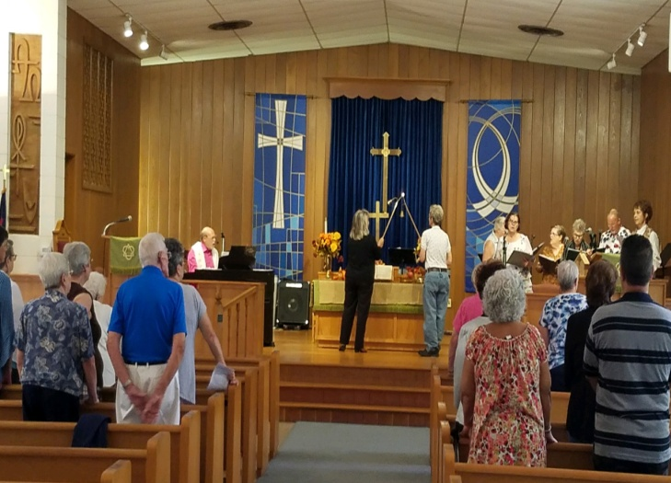
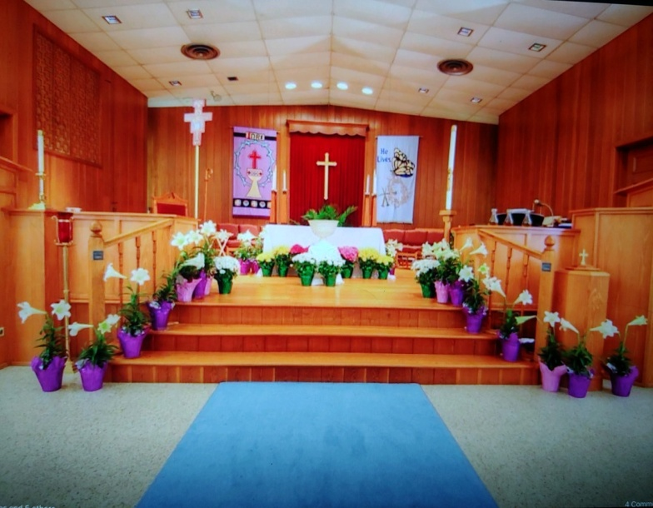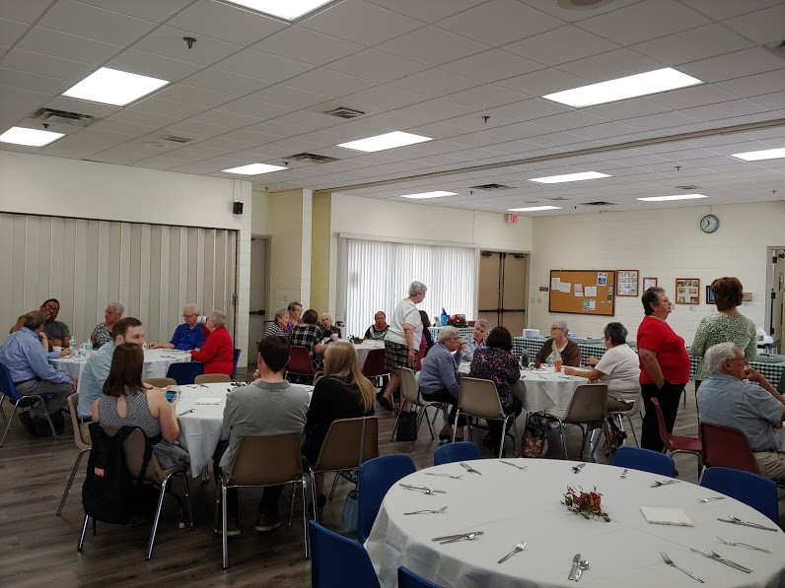
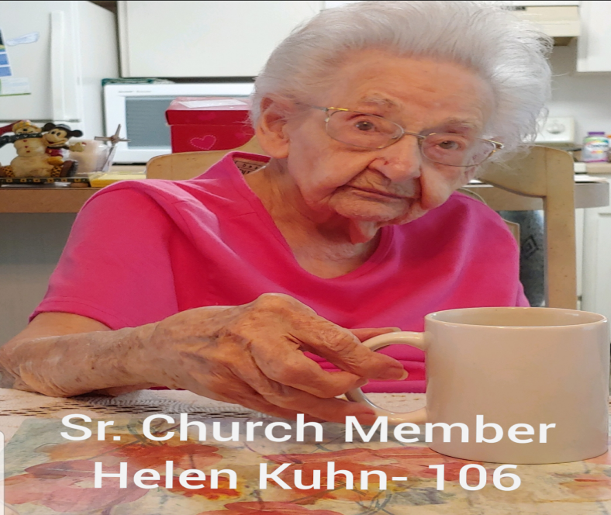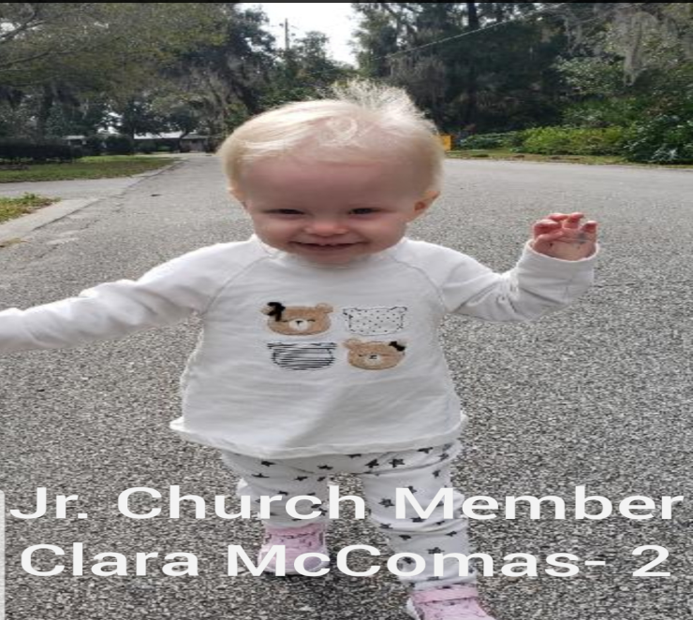

What we value about living in our area:

Orlando is a diverse, multi-ethnic city located in central Florida and the county seat of Orange County. It is the third largest metropolitan area in the state. Orlando is known as the theme park capital of the world and has also become a center of technology, engineering and manufacturing. It is home to the University of Central Florida and our city has established a reputation of medical leadership. Orlando is the home of Disney World, Universal Studios Orlando, Oracle, Darden Corporation, and several major technology groups. Our city is home to several sports teams supported by enthusiastic fans.

Current size of membership: Our church has approximately 81 members.

Languages used in ministry (other than English): English is the primary language at this time. We are open to include the Hispanic community in our ministry as well.

Position Title: Pastor

Position Duration: Designated – a called position for a specified term of no less than 1 year, and which at the conclusion, both pastor and church determine employment moving forward.

Compensation Level: Part time

Does the total support package meet conference compensation guidelines? Yes

SCOPE OF WORK

Scope of work for Half Time Pastoral Position (20-25 hours weekly)

- Preparation and leadership of Sunday worship including scripture study, crafting of liturgy and bulletin, sermon preparation, guiding and sometimes finding lay liturgists, planning of music in coordination with musical staff or volunteers, preaching, offering of prayers, etc.
- Faith formation and vitality through prayer, Bible study, service, identifying helpful resources and opportunities and helping lay persons take advantage of them
- Pastoral care in collaboration with lay people (at least to those who are sick, elderly, grieving, or homebound)
- Participate in wider church activities such as conference and association meetings as time permits
- Study and prayer to increase faith and to improve skills so as to lead, teach, and preach better
- Energizing and deepening the spiritual connections and faith understandings of others in all they do, with the goal to be better Christians
- Perform standard ministerial services

Core Competencies:

We are seeking a pastor who is caring, sensitive, sociable, vision oriented and capable of growing both our membership as well as our contributions to Orlando and our local community. Our diverse, multi-ethnic, multi-generational membership ranges from young children to senior citizens. Our pastor should be able to minister to all, and willing to learn about our congregation and our community. Pastor should have adequate skills to communicate with groups and in a one on one setting with personal and spiritual maturity.

JOB DESCRIPTION

FIRST UNITED CHURCH OF CHRIST ORLANDO
PASTOR JOB DESCRIPTION

For Part-time Pastoral Position
(20-25 hours weekly)
- Preparation and leadership of Sunday worship including scripture study, crafting of liturgy and bulletin, sermon preparation, guiding and sometimes finding lay liturgists.
- Communicate music themes in coordination with musical staff so that hymns/service music may be selected
- Encourage faith formation and vitality through prayer, Bible study, service, identifying helpful resources and opportunities and helping lay persons take advantage of them
- Provide pastoral care in collaboration with lay people (at least to those who are sick elderly, grieving, homebound)
- Study and prayer to increase faith and to improve skills to lead, teach, preach better
- Provide counseling and make appropriate referrals
- Teach confirmation/new member class for youth and adults
- Participate in wider church activities, conference meetings, area clergy association
- Monitor phone for messages and be empowered to respond to them
- Provide oversight of Christian Education and Vacation Bible School
- Establish relationships with the leaders of the churches who hold their worship services in our facilities, which currently are, IPG church (Iglesias Pentecostal Genesis) and New Rebirth Apostolic Church.
- Attend and participate in Church Council, Deacons, Trustee and other committee meetings as outlined in the Bylaws
- Conduct funerals for members and friends of the congregation
- Officiate at weddings for members and friends of the congregation
- Lead Lenten services
- Administer church business and oversee church staff

COMPENSATION AND SUPPORT

Salary Basis (from the Call Agreement Workbook, equal to Cash Salary plus Housing Allowance): $45,000 plus up to $2,500 moving expenses

Benefits: Salary plus Benefits

Expected living situation for your next minister: (e.g. parsonage, living nearby with a housing allowance, living elsewhere to commute as needed)? We do not have a parsonage.

Comment on the residential/commuting expectations for your next minister.
It would be helpful for our new pastor to live within convenient driving distance.

State any incentives (e.g. school debt reduction or retention bonus after a certain number of years in position): An incentive or bonus would be considered by Church Council/Finance based upon growth and performance.

Describe peer and professional supports available for ministers in your association/conference: The FL Conference is a great place in which to carry out your call to ministry. Ministers are supported by means of Clergy Clusters, a gathering of peers that meet monthly and Regional Ministers that provide resources, guidance and collegiality. There is an annual clergy retreat where ministers are invited to come together for worship, learning and fellowship or just relaxation. There are many opportunities provided by the FL Conference for continuing education, justice and advocacy, mission, spiritual formation/discipline and consistent offerings from well-known speakers on a variety of timely and relevant topics.

If applicable, describe how your church will adopt part-time adjustments in the pastoral schedule to support a minister’s bi-vocational employment: This is a part time position requiring approximately 20-25 hrs per week allowing for bi-vocational employment if needed.

WHO IS GOD CALLING TO MINISTER WITH US?

Describe the ministry goals you envision your next minister co-collaborating with the congregation to achieve. We are excited about the prospect of our new pastor helping us to increase our visibility and outreach to our community, increasing membership and participation, and focusing on an atmosphere of ‘Open and Affirming’ Christian hospitality and cooperation.

Describe how your vision of the minister you are now seeking will assist the congregation in making an impact beyond its walls. We seek a pastor with vision, talents and skills consistent with growth, development and outreach.

Specify language requirements or culturally-specific capacities preferred in a next ministerial leader, and why those matter to the congregation’s sense of calling.
First United Church of Christ Orlando is located in an area with a high concentration of Hispanic residents. We currently have two other churches that we are in communion with, that use our buildings for their Hispanic services. It would be nice for our new leader to have language and social experience with this group.

Based on what you have learned about who your church is, who your church’s neighbor is, and who God is calling the church to become, describe four areas of excellence from The Marks of Faithful & Effective Authorized Ministry that your next minister will display to further equip the congregation’s ministry in these areas.

- NURTURING UCC IDENTITY by Exhibiting a commitment to the core values of the United Church of Christ: continuing testament, extravagant welcome, and changing lives.
- CARING FOR ALL CREATION by Providing hope and healing to a hurting world.
- STRENGTHENING INTER- AND INTRA- PERSONAL ASSETS by respecting the dignity of all God’s people.
- ENGAGING SACRED STORIES AND TRADITIONS by bringing life to sacred stories and traditions in worship, proclamation, and witness.

WHO IS GOD CALLING US TO BECOME?
“You shall love the Lord your God with all your heart, and with all your soul, and with all your mind.” (Matthew 22:37 NRSV)

Who is God calling you to become as a congregation?
OUR VISION STATEMENT: The vision of the First United Church of Christ of Orlando, Florida is to become the most effective inclusive progressive Christian ministry in Central Florida. Therefore: We envision becoming totally inclusive in this journey to what we believe God’s purpose for us to be. Reaching out to others and incorporating us all in the love of Christ by aggressively seeking and welcoming people of all: ages, colors, economic classes, languages, sexual orientation and theological positions, fulfilling our understanding of the gospel.

Describe how God is calling you to reach out to address the emerging challenges and opportunities of your community and congregation.
In 2019 we hosted numerous fellowship events at our church in order to minister and serve our community. These included a Basket Social, Fall Festival, and Quilt Show. In 2020 after a brief 2 month hiatus due to the COVID-19 virus, we are one of only two local UCC churches that have continued services after this outbreak. We reviewed every vulnerable step in our service and developed safe and effective protocol to ensure that both our congregation and the congregation for our Hispanic churches who use our facility, were able to safely come together to continue worshiping.
With the assistance of our previous interim pastor Bob Roberts, our congregation provided feedback pertaining to the current strengths, weaknesses, activities, and desires for growth and improvement of our ministry. We spent several weeks evaluating and validating our feedback. It became apparent that we possessed a strong core of faithful members – and that our community was changing faster than we were changing. We concluded that we needed to reaffirm our intent to continue and increase our outreach – and partner with a new leader to help us grow in membership and outreach while embracing the changing demographics of our community. The resulting Vision for our church is:
OUR VISION STATEMENT: The vision of the First United Church of Christ of Orlando, Florida is to become the most effective inclusive progressive Christian ministry in Central Florida. Therefore: We envision becoming totally inclusive in this journey to what we believe God’s purpose for us to be. Reaching out to others and incorporating us all in the love of Christ by aggressively seeking and welcoming people of all: ages, colors, economic classes, languages, sexual orientation and theological positions, fulfilling our understanding of the gospel.

WHO ARE WE NOW?
“You shall love your neighbor as yourself.” (Matthew 22:39 NRSV)
CONGREGATIONAL REFLECTIONS
11-YEAR REPORT
CONGREGATIONAL DEMOGRAPHICS
PARTICIPATION AND STAFFING
CHURCH FINANCES
HISTORICAL INFORMATION

CONGREGATIONAL REFLECTIONS

Describe your congregation’s life of faith.
God is loving, forgiving and blesses us abundantly. God loves each of us unconditionally God’s mercy is infinite.

Describe several strengths or positive qualities of your congregation.
We are diverse and social. We are inspired to help others, friendly, supportive, loving and forgiving. Our congregation includes a committed core of serving members.

Describe what worship is like when your congregation gathers.
Worship begins with a warm greeting by our greeters and ushers. Worship includes a sermon, children’s time, scripture, music, prayer, and offering. We have a coffee hour together following worship, which will resume after the COVID-19 guidelines have been lifted.
The ideal sermon is inspiring, engaging, and sincere.

Describe the educational program/faith formation vision of your church. We value our youth. We spend time with them during the ’Children’s Sermon’. Our youth serve as acolytes. Our Christian Education team provides Sunday School lessons and activities. The children participate in projects, musical presentations, readings and plays. Prior to COVID-19, we have held week-long Vacation Bible School for the area youth.

Describe how your congregation is organized for ministry and mission. When it comes to decision-making, how many hours are spent in meetings per month?
Church Council meets for approximately 2 hrs/month. The Finance Committee meets for approximately 1 hr/month. Trustees and Diaconate meet for approximately 1 hour per month.

Think of a time when action had to be taken quickly, for example when a crisis or disaster occurred. How was that accomplished?
The process for crisis resolution would be a meeting of Church Council or the appropriate committee (Trustee, Diaconate, Finance, etc.) Most recently, the Council oversaw completion to replace the flooring and ceiling in our social hall. They obtained bids, presented to Council for approval and then to the congregation for final approval. On another occasion, the church was broken into by a burglar. The Church Council president was contacted and the Trustees took charge of the repairs.

Can you provide the next minister with a copy of an organization structure, bylaws and/or annual report to further explain the patterns of the church’s activity and governance?
Yes – our Bylaws.

11-YEAR REPORT
UNITED CHURCH OF CHRIST
ELEVEN YEAR CHURCH PROFILE BASED ON DATA REPORTED IN UCC YEARBOOKS

 | Church#: | 120460
 | Assoc: | 182 | Schedule: | 0 | First United Church of Christ of Orlando Inc | Orlando | FL | 32812

 | YEAR | MEMBERS | AVG WEEKLY ATTENDANCE | CHR ED/  FAITH FORM | CONFIRMATION | CONFESSION | TRANSFER OR REAFFIRM | DEATHS OR TRANS OUT | OTHER LOSSES | NET MEMBS  ADDS-REMOVED
 | 2009 | 160 | 118 | 24 | 0 | 10 | 0 | 12 | 28 | -30
 | 2010 | 141 | 96 | 15 | 0 | 0 | 7 | 9 | 17 | -19
 | 2011 | 125 | 85 | 4 | 0 | 6 | 0 | 4 | 18 | -16
 | 2012 | 107 | 60 | 9 | 0 | 2 | 5 | 4 | 21 | -18
 | 2013 | 103 | 75 | 15 | 0 | 3 | 8 | 3 | 12 | -4
 | 2014 | 113 | 89 | 25 | 0 | 14 | 12 | 5 | 11 | 10
 | 2015 | 110 | 83 | 75 | 0 | 0 | 16 | 4 | 15 | -3
 | 2016 | 111 | 65 | 5 | 0 | 0 | 2 | 0 | 1 | 1
 | 2017 | 81 | 52 | 4 | 0 | 0 | 0 | 6 | 24 | -30
 | 2018 | 82 | 44 | 13 | 0 | 3 | 7 | 2 | 7 | 1
 | 2019 | 80 | 45 | 21 | 0 | 1 | 1 | 4 | 0 | -2

 | YEAR | CURRENT EXPENSES | CAPITAL PAYMENTS | BASIC SUPPORT | TOT OTHER UCC GIVING | TOTAL  OCWM | OTHER  GIFTS | WIDER MISSION | BASIC SUPP% CURR LOCAL | TOTAL EXPEND | PLEDGES AND OFFERINGS
 | 2009 | $163,098 | $0 | $3,151 | $2,575 | $5,726 | $9,475 | $15,201 | 1.93 | $178,299 | $158,580
 | 2010 | $159,484 | $0 | $1,398 | $4,872 | $6,270 | $8,620 | $14,890 | 0.88 | $174,374 | $143,275
 | 2011 | $149,502 | $0 | $81 | $2,381 | $2,462 | $0 | $2,462 | 0.05 | $151,964 | $117,445
 | 2012 | $147,122 | $0 | $148 | $1,813 | $1,961 | $0 | $1,961 | 0.10 | $149,083 | $98,849
 | 2013 | $141,879 | $0 | $1,000 | $2,099 | $3,099 | $0 | $3,099 | 0.70 | $144,978 | $150,045
 | 2014 | $151,135 | $0 | $1,330 | $2,497 | $3,827 | $0 | $3,827 | 0.88 | $154,962 | $105,210
 | 2015 | $165,212 | $0 | $2,096 | $2,454 | $4,550 | $0 | $4,550 | 1.27 | $169,762 | $116,013
 | 2016 | $103,980 | $0 | $2,170 | $2,144 | $4,314 | $1,175 | $5,489 | 2.09 | $109,469 | $94,228
 | 2017 | $105,502 | $0 | $2,142 | $1,252 | $3,394 | $720 | $4,114 | 2.03 | $109,616 | $61,083
 | 2018 | $105,006 | $0 | $2,000 | $5,415 | $7,415 | $30 | $7,445 | 1.90 | $112,451 | $49,161
 | 2019 | $210,117 | $0 | $2,500 | $671 | $3,171 | $0 | $3,171 | 1.19 | $213,288 | $66,599

 | % CHANGE | MEMBERS | AVG WEEKLY ATTENDANCE | CHR ED/  FAITH FORM | TOTAL ADDITIONS | TOTAL REMOVALS | CURR LOCAL EXPENSES | TOTAL  OCWM | TOTAL EXPENDITURE
 | 2014-2019 | -29.20 | -49.44 | -16.00 | -92.31 | -75.00 | 39.03 | -17.14 | 37.64
 | 2009-2019 | -50.00 | -61.86 | -12.50 | -80.00 | -90.00 | 28.83 | -44.62 | 19.62

Please note: Zero values ("0" or "$0") may reflect missing information in some years. Christian Education/Faith Formation refers to Church School Enrollment for all figures before 2007.

CONGREGATIONAL DEMOGRAPHICS

Describe those who participate in your church.
 |  | Is this number an estimate? (check if yes)
Number of active members: | 45 | Yes
Number of active non-members: | 45 | Yes
Total of church participants (sum of the numbers above): | 90 | Yes

Percentage of total participants who have been in the church:
 |  | Is this number an estimate? (check if yes)
More than 10 years: | 25% | Yes
Less than 10, more than 5 years: | 25% | Yes
Less than 5 years: | 50% | Yes

Number of total participants by age:
0-11 | 12-17 | 18-24 | 25-34 | 35-44 | 45-54 | 55-64 | 65-74 | 75+ | Are these numbers an estimate? (check if yes)
4 | 1 | 1 | 2 | 1 | 5 | 6 | 16 | 20 | Yes

Percentage of adults in various household types:
 |  | Is this number an estimate? (check if yes)
Single adults under 35:
Joint household with minors: | 2% | Yes
Single adults age 35-65: | 8% | Yes
Joint household with no minors: | 42% | Yes
Single adults over 65: | 48% | Yes

Education level of adult participants by percentage:
 |  | Is this number an estimate? (check if yes)
High school: | 19% | Yes
College: | 52% | Yes
Graduate School: | 11% | Yes
Specialty Training: | 14% | Yes
Other (please specify): | 4% | Yes

Percentage of adults in various employment types:
 |  | Is this number an estimate? (check if yes)
Adults who are employed: | 20% | Yes
Adults who are retired: | 75% | Yes
Adults who are not fully employed: | 5% | Yes

Describe the range of occupations of working adults in the congregation: Professional, education, finance, management, skilled services

Describe the mix of ethnic heritages in your congregation, and the overall racial make-up. Most UCC congregations tend to describe themselves as “diverse.” Yet, the vast majority of UCC congregations are mono-cultural. What does diversity mean in your context?
We are diverse. Our membership includes black, white, Hispanic, Asian cultures. We also have members from Puerto Rico, Holland, Australia.

Has your congregation recently had a conversation about welcoming diversity, or do you plan to hold one on the near future (perhaps using, for example, the Welcoming Diversity Inventory)? Please note the date. Comment after the exercise:
Our Vision Statement includes ‘…seeking and welcoming people of all: ages, colors, economic classes, languages, sexual orientation and theological positions, fulfilling our understanding of the gospel.’ We believe diversity makes us stronger and we are committed to welcoming all to worship with us.

PARTICIPATION AND STAFFING

Complete the following chart. Please leave blank any fields that are not applicable to your congregation.
Ways of Gathering | Estimated number of people involved in attendance  In 2019 | Who plans each of the listed gatherings? (list any and all worship planners, such as various lay leaders, pastors, musicians, other staff)
Adult Groups or Classes | Mary Martha Sewing Group (4)  Rebecca’s Food Pantry (12) | Mary Martha members  Food Pantry admin team
Baptisms (number last year) | 5 | Pastor
Children’s Groups or Classes | Sunday School (5-9)  Vacation Bible School (30) | Christian Education, Church Council
Christmas Eve and Easter Worship | Christmas Eve (65)  Easter (80) | Pastor, Diaconate, Music Director, Choir
Church-wide Meals | Thanksgiving (50)  Labor Day Barbecue (50)  Mary Martha monthly luncheon (approx. 15) | Lay leaders (10)  Lay leaders (10)  Mary Martha members
Choirs and Music Groups | First UCC Choir (8) | Music Director, Choir Members
Church-based Bible Study | (9) | Pastor
Communion (served how often?) | Monthly | Pastor, Diaconate
Community Meals
Confirmation (number confirmed last year)
Drama or Dance Program
Funerals (number last year) | (4) | Pastor
Intergenerational Groups
Outdoor Worship
Prayer or Meditation Groups
Public Advocacy Work | Gay Pride (10)  Women’s March (5)  Thrift Shop (7)  Alzheimer’s March (2) | Lay leaders
Retreats
Theology or Bible Programs in the Community
Weddings (number last year) | (1) | Pastor
Worship (time slot: 10-11 AM) | Weekly | Pastor, Diaconate, Music Director, Choir
Worship (time slot: _______)
Young Adult Groups or Classes
Youth Groups or Classes
Other

Additional comments:
Our children are ages 2-12 yrs old. Not yet ready for confirmation.

List all members or regular participants in your congregation who are ordained, licensed, or commissioned ministers. Indicate those with current United Church of Christ Three-Way Covenants (i.e. serving in a congregation) or Four-Way Covenants (i.e. serving in a ministry beyond a congregation).
Name | Three- or Four-Way Covenant?  (3 or 4 or No) | Ministry Setting | Type of Ministry Role | Retired?  (Y or N)
Kim Baker | No | Weekly worship | Music director | N
John Vertigan | 3 | UCC Florida Conference | Conference Minister | N

If one or more previous pastors or retired ministers currently hold membership in the church, describe their role(s) in the life of the congregation: N/A

List all current staff, including ministers. Exclude the position you are seeking to fill. Indicate which staff person serves as head of staff.

Staff Position | Head of Staff? | Compensation (full time, part time, volunteer) | Supervised by | Length of Tenure for current person in this position
Vacancy
Sexton | Staff | Part time | Trustees | 11 yrs
Secretary | Staff | Part time | Pastor/Council President | 2 years
Music Director | Staff | Part time | Pastor/Deacons | 3 years

REFLECTION
Reflection: After reviewing the congregational demographics and activities above, what does this information reflect about your congregation’s overall ministry?
There is a need to increase our youth membership, adult learning and local outreach.

CHURCH FINANCES
Current annual income (dollars used during most recent fiscal year of 2019)
Source | Amount
Annual Offerings and Pledged Giving | $36,913
Endowment Proceeds (as permitted within spending policy, such as a cap of typically 4.5%-5% on total return) | $897
Endowment Draw (beyond what is permitted by spending policy, “drawing down the principal”) | $0
Fundraising Events | $3,597
Gifts Designated for a Specific Purpose | $150,998
Grants (Disaster Clean-Up Buckets) | $0
Rentals of Church Building | $21,138
Rentals of Church Parsonage | $ N/A
Support from Related Organizations  (e.g. Women’s Group) | $3,342
Transfers from Special Accounts | $9,790
Other (specify): Sprint Cell Tower Rental | $10,240
Other (specify): Thrift Store, Food Pantry | $10,922 (Thrift Store)  $12,929 (Food Pantry)
TOTAL | $260,766

Current annual expenses (dollars budgeted for most recent fiscal year): $120,988
Attach most recent church budget, spending plan, operating statement, or annual treasurer’s report as shared publicly with the congregation, or – if your church does not pass an annual budget – list current budgeted expenses here.

Considering total budgeted expenses for the year compare total ministerial support. What is the percentage? 37%

Has the church ever failed to pay its financial obligations to a minister of the church? No

Is your church 5-for-5, i.e. does it include each of the following contributions during the church year? (indicate those included during the most recent fiscal year)
_Y_ Our Church’s Wider Mission (OCWM – Basic Support)
_Y_ One Great Hour of Sharing
_Y_ Strengthen the Church
_Y_ Neighbors in Need
_Y_ Christmas Fund

In what way is OCWM (Basic Support) gathered? If calculated as a percentage of operating budget, what is that percentage? (Recommended 10%) Budgeted Item: $2,000

What is the church’s current indebtedness?
Total amount of loan debt: $0
Reason for debt: N/A
Are capital and other payments current? N/A

If a building program is projected or underway, describe it, including the projected start/end date of the building project and the total project budget. N/A

If the church has had capital campaigns in the last ten years, describe: N/A
Year(s) | Purpose | Goal | Result | Impact
 |  | $ | $
 |  | $ | $

If a capital campaign is underway or anticipated, describe:
Year(s) | Purpose | Goal | Result | Impact
 |  | $ | $
 |  | $ | $

Describe the prominent mission component(s) involved in the most recent (or current) capital campaign. N/A

Does your church have an endowment? Yes

What is the market value of the assets? $89,831

Are funds drawn as needed, regularly, or under certain circumstances? Income earned is allocated per a specified formula at year end.

What is the percentage rate of draw (last year, compared to 5 years ago)? Income only being used.

Describe draw on endowment, if any, to meet operating budget expenses for the most recent year and the past five years: N/A

At the current rate of draw, how long might the endowment last? N/A

Please comment on the above calculations or estimates: N/A

Other Assets

Reserves (savings): $15,209 Major Maintenance savings account

Investments (other than endowment): $10,147 Rebecca’s Food Pantry savings account

Does your church have a parsonage? No
Fair market rental value of the parsonage: N/A
How is the parsonage used? N/A
Street / City / State / Zip: N/A
Finished square footage: N/A
Number of Bedrooms, Number of Bathrooms: N/A
Assessed real estate value: N/A
Available for minister residence: N/A
Expected minister residence: N/A
Condition of structure, systems and appliances N/A
Entity in the church responsible for review and needed repairs N/A

Describe all buildings owned by the church: Sanctuary, Crismon Fellowship Hall, Classroom Buildings (2) used for Thrift Store, two work sheds

Describe non-owned buildings or space used or rented by the church: N/A
Which spaces are accessible to wheelchairs? (worship space, pulpit, fellowship space, facilities, etc.) Worship, fellowship, facilities.

Reflection: After reviewing the church’s finances and assets described above, what does this information reflect about your congregation’s mission and ministry?
We are blessed to have willing church members to assist with our church finances. We realize this is an opportunity for us to either have new church members with a finance background to assist, or have the financial means to hire a professional outside of our congregation.

HISTORICAL INFORMATION
Name one to three significant happenings in the history of your church that have shaped the identity of your congregation. Add the most important event in the life of your church in the past 10 years.
Our church celebrated our 50th Anniversary in 2009 with a congregational dinner and special recognition of several charter members whose efforts formed this church and its ongoing ministry. The Mary Martha’s Sewing Group has also celebrated a 50th Anniversary in 2016. The Finance Committee and congregation paid off the mortgage on our church October 5, 2003 and celebrated this achievement. First UCC Orlando established ‘Rebecca’s Food Pantry’ which ministers by providing food to those in need. We embrace the LGBTQ community with ‘Open and Affirming’ fellowship; the Orlando Gay Chorus regularly uses our facilities for practice. Vacation Bible School provides local youth with fun, meaningful experiences and lessons with other children and ethnic groups.

Describe a specific change your church has managed in the recent past.
Several senior members of the congregation have passed and some of our valued leadership had relocated to other areas. The change brings opportunities for others to explore new and changing leadership roles and responsibilities.

Every church has conflict, some minor, some larger. “Where two or three are gathered, there will be disagreement….” Describe your congregation’s values and practices when it comes to conflict.
Conflict resolution and managing change are areas of opportunity for our church. Some members have been unable to accept changes in leadership or new methods of doing things. Sadly – some of those people chose to leave our congregation rather than trying to work things
out. It is our hope that our new pastor will help us improve our abilities to accept change and effectively resolve conflict.

Ministerial History (include all previous ministerial staff for the past 30 years)

Staff member’s name | Years of service | UCC Standing (Y/N)
Pastor Terry Hood | 2018-2020 | Y
Rev Leigh McCaffrey | 2012-2016 | Y
Rev Joel Reif | 1999-2012 | Y
Rev Fred Fourie | 1996-1998 | Y
Rev Anthony DeWet | 1994-1995 | Y
Rev Don Crismon | 1983-1993 | Y

Comment on what your church has learned about itself and its relationship with persons who provided ministerial leadership:
For many years, our congregation enjoyed traditional worship and conservative values with established leaders. We are now faced with the certainty of change of our church family, our leadership and our community. It is now more important than ever for us to work with a pastor who will be able to lead us in the expansion of our ministry by embracing respect for tradition and manage change within our congregation, our community – and the world.

Has any past leader left under pressure or by involuntary termination? No

Has your church been involved in a Situational Support Consultation? No

Has a past pastor been the subject of a Fitness Review while at your church? No

WHO IS OUR NEIGHBOR?
“You shall love your neighbor as yourself.” (Matthew 22:39 NRSV)
COMMUNITY VISION
MISSION InSite

COMMUNITY VISION

How do the relationships and activities of your congregation extend outward in service and advocacy?
Our local community outreach includes Basket Social, Quilt Show, Fall Festival, Rebecca’s Food Pantry, the Thrift Store, Vacation Bible School, Mary Martha Sewing Group, the Russell Home, use of our facilities by Alcoholics Anonymous, Orlando Gay Chorus, New Rebirth Apostolic Church, and the Iglesias Pentecostal Genesis Church. In the past year, we provided financial support for ‘OCWM’, One Great Hour of Sharing, Strengthen the Church, Neighbors in Need, and the Christmas Fund. Also, once we are all safe to return to normal operations, we will continue to allow community organizations to use our facilities for their events and activities.

Describe your congregation’s participation in meetings, relationships and activities connecting the wider United Church of Christ (association / conference / national setting).
Our pastor and designated lay leaders have attended denominational, UCC Conference and workshop meetings and activities. Our new pastor will be expected to continue to do so.

Many local churches love to tell the story of what they are doing in the community to transform lives. Some have identified certain aspects of their witness into the wider community using language shared with other UCC congregations. Check any statements below that apply to your UCC faith community.

__ Accessible to All (A2A)
__ Creation Justice
__ Economic Justice
__ Faithful and Welcoming
_X_ God Is Still Speaking (GISS)
__ Border and Immigrant Justice
__ Inter-cultural/Multi-racial (I’M)
__ Just Peace
__ Global Mission Church
_X_ Open and Affirming (ONA)
__ WISE Congregation for Mental Health
__ Other UCC designations:
__ Designations from other denominations
__ None

Reflect on what the above statement(s) mean(s) to your community. Is your congregation interested in working toward any of the above statements of witness in the near future?
We are excited about the prospect of working with a pastor who will help us increase our awareness of these ways to improve our ministry.

Describe your congregation’s participation in ecumenical and interfaith activities (with other denominations and religious groups, local and regional).
We partner with members of the Community Christian Church for our Food Pantry and Thrift
Store activities.

If your congregation has a mission statement, how does that mission statement compare to the actual time spent engaging in different activities? Think of the range of activities from time spent gathering, to governance, to time spent going out.
Our Mission Statement declares that we welcome into membership persons of all races, creeds, traditions, sexual orientations, gender expressions, physical abilities and ethnic origins. We directly support our Mission Statement through the open and affirming participation in our worship services, bible study, communion, adult classes and groups and public advocacy groups..

Reflect on the scope of work assigned to your pastor(s). How is their community ministry and their ministry in and on behalf of the wider church accounted for in the congregation’s expectations on their time?
They will participate in wider church activities such as conference and association meetings as time permits.

MISSION InSite

Comment on your congregation’s Mission Insite report with data for your neighborhood(s) or area. What trends and opportunities are shown?
The Mission InSite report indicates population growth, higher than average adult education attainment, moderate diversity, lower than average median family income and predominately white population – with a possible increase of Hispanic population.

How do your congregation’s internal demographics compare or contrast to a) the neighborhoods adjacent to your church, and b) other neighborhoods with which your church connects?
Congregational demographics appear to be reflective of Orlando as a whole.

How are the demographics of the community currently shaping ministry, or not?
The community surrounding our church is characterized by an increasing Hispanic population. We are currently renting our facilities to two Hispanic Churches for their services.

What do you hear when you talk to community leaders and ask them what your church is known for?
We believe this is an area of opportunity for us. We do not yet have the visibility and vitality that we believe we are capable of achieving.

What do new people in the church say when asked what got them involved?
Several new attendees mention that they saw our website and decided to check us out. Some local residents have joined us because of our close proximity to their homes. Many new people have accepted our invitation to become involved (i.e. serve as board members) but many employed members are hesitant to accept due to work schedules.

REFERENCES

REFERENCE 1
Reverends Dan and Barbara Entwistle / Pastor / Retired
(407) 673-1618 / danbarent@cfl.rr.com / Supply Pastor

REFERENCE 2
Judy McElroy
Food Pantry / Thrift Store Volunteer
(407)719-2429 / judimc@bellsouth.net

REFERENCE 3
Debbie Yarborough
Long standing friend of the Church
(407) 521-2288 / dyarborough@att.net

PROMPTS FOR REFERENCES
Describe some areas of strength in this church’s ministry.
Describe some areas for improvement in this church’s ministry.
Describe a significant experience you have had of this church’s ministry.
Anything else you wish to share.

CLOSING THOUGHTS
CLOSING PRAYER
STATEMENT OF CONSENT
CONFERENCE/ASSOCIATION VALIDATION

CLOSING PRAYER
Include here any prayer or dream for the minister you imagine journeying toward you… a poem, for example, or a Scripture passage or a piece of music that is meaningful to your Search Committee:

‘Dear gracious, loving God – open our hearts and our minds to recognize the one you are sending to us to grow our ministry to our community and to our world. We ask for your blessing on our pastor, church, our congregation, our leadership and our ministry.’ Amen

STATEMENT OF CONSENT
The covenantal relationship between a church and those called by that church to serve as pastors and teachers and in other ministerial positions is strengthened when vital information is openly shared by covenantal partners. To that end, we attest that, to the best of our abilities, we have provided information in this profile that accurately represents our church. We have not knowingly withheld any information that would be helpful to candidates.
As the committee charged with the responsibility for identifying and recommending suitable new minister for our church, we have been authorized to share the information herein with potential candidates. We understand that a candidate may wish to secure further knowledge, information, and opinions about our church. We encourage a candidate to do so, recognizing that an open exchange of relevant information builds the foundation for continuing and healthy relationships between calling bodies and persons seeking a ministry position.

- Which individuals and groups in the church contributed to the contents of this Local Church Profile? Search Committee: Joni Danford, Chairperson; Jean Romansky, Carol Carver, Janice Karas, Cheryl Samarjia. Also: Milt Denker, Dana Ney

VALIDATION BY CONFERENCE/ÅSSOCIATION
The congregation is currently in good standing with the association / conference named.
Staff Comment: Yes

To the best of my knowledge, ministerial history information is complete.
Staff Comment: Yes
To the best of lily knowledge, available church financial information is presented thoroughly.
Staff Comment: Yes
My signature below attests to the above three items.
Signature:
Name / Title: Leslie Etheredge, Western Region Minister, FL Conference UCC
Email: letheredge@uccfla.org
Phone: 205-515-8741
Date: 10/13/20
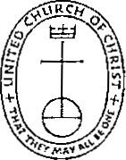
UNITED CHURCH OF C H R I S T This document is created through support to Our Church's Wider Mission (OCWM) and is only possible through the covenantal relationships of all settings of the United Church of Christ.
"Jesus answered them, 'Have faith in God!"' — Mark 7 1: 22

