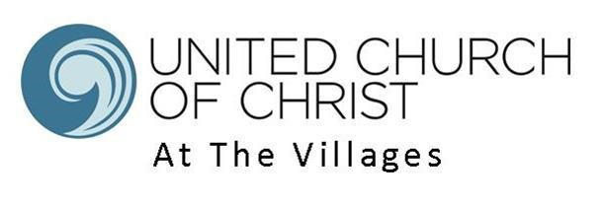

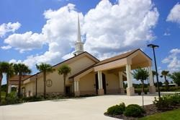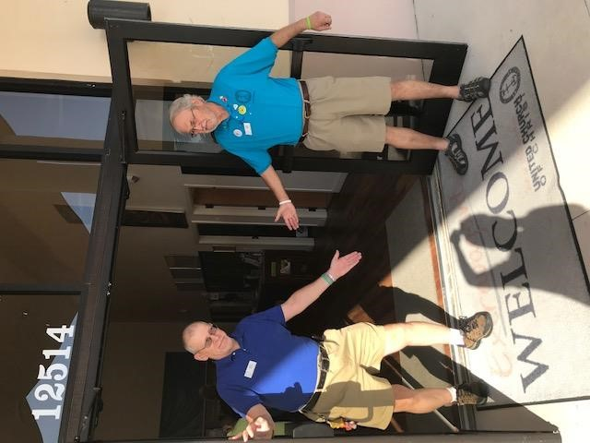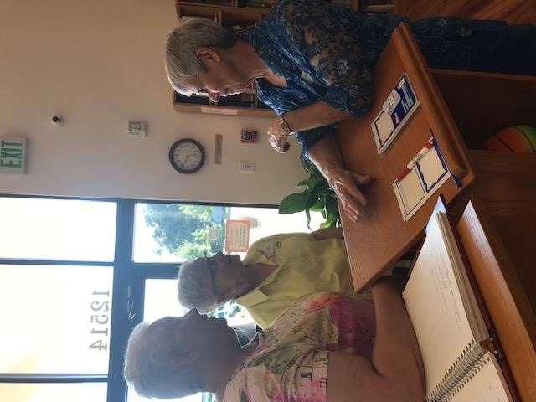

“
The church is not a building, it is a
community of Faith, Love and Support…”

Check out this
short
video of our church
-

UCC at The Villages Vide
o

Table of Contents
LISTING INFORMATION ............................................................................................................................................. 2
SCOPE OF WORK .......................................................................................................................................................... 4
COMPENSATION AND SUPPORT .............................................................................................................................. 6
WHO IS GOD CALLING TO MINISTER WITH US? .................................................................................................. 7
WHO IS GOD CALLING US TO BECOME? ............................................................................................................... 9
CONGREGATIONAL REFLECTIONS ....................................................................................................................... 10
11-YEAR REPORT ....................................................................................................................................................... 13
CONGREGATIONAL DEMOGRAPHICS .................................................................................................................. 13
PARTICIPATION AND STAFFING ............................................................................................................................ 16
CHURCH FINANCES .................................................................................................................................................. 20
HISTORICAL INFORMATION ................................................................................................................................... 23
COMMUNITY VISION ................................................................................................................................................ 26
MISSION INSITE ......................................................................................................................................................... 29
REFERENCES .............................................................................................................................................................. 31
CLOSING PRAYER ..................................................................................................................................................... 32
STATEMENT OF CONSENT ...................................................................................................................................... 32 VALIDATION BY CONFERENCE/ASSOCIATION .................................................................................................. 33

“God is able to provide you with every blessing, so that having all sufficiency in all things at all times, you may abound in every good work.” (2 Corinthians 9:8)

POSITION POSTING

LISTING INFORMATION

Church name: United Church of Christ at the Villages
Street address: 12514 CR 101, Oxford, Florida 34484 - Mailing Address: PO Box 194 Supplemental web links: https://uccatv.weebly.com/

Additional ecumenical affiliations:
- Temple of Shalom – joint events
- Interfaith Peace Group

Conference:
- The National UCC Conference
- Florida UCC Conference

Association: None
UCC Conference or Association Staff Contact Person:
Reverend Leslie Etheredge - Western Regional Minister – 205-515-8741 - letheredge@uccfla.org

Summary Ministry Description:
United Church of Christ at the Villages needs a minister that will inspire and invigorate our congregation. We need to be more socially involved and visible to market our church to the people of The Villages and neighboring areas. It is important that we get a meaningful message from our pulpit to help us understand and be better informed to live by and for Jesus. Our church has the potential to grow exponentially with the strong inclusive nature of our congregation. We need a minister that will take us to the next level and open us up to all people of the community and let them know we are here for them. This person needs to be a caring and compassionate person for our older members that face various challenges. As stated, our church has a strong congregational relationship, but we now need a pastor to strengthen and guide the flock to become more involved in social, charitable, and spiritual fulfillment.

Photographs:
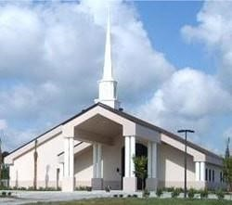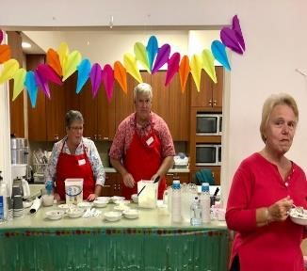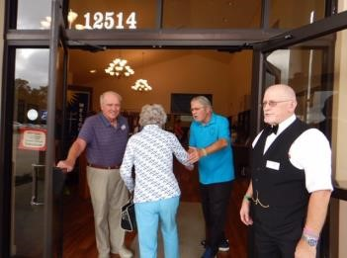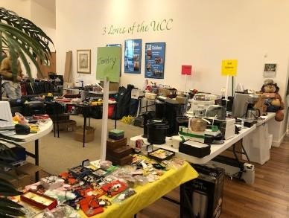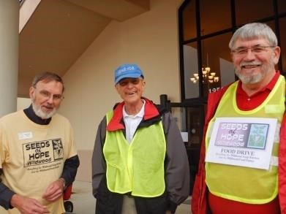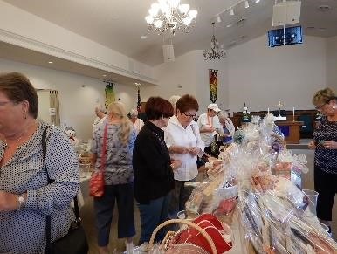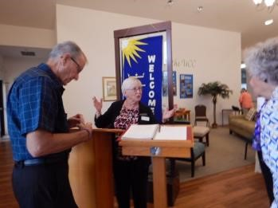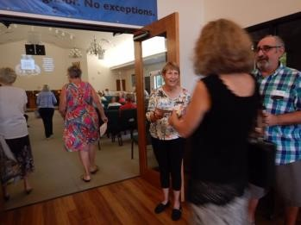

What we value about living in our area:
We value the wonderful people and opportunities that we have in this area. It is a community of caring and generous people with clear sense of charity. It is a friendly hometown filled with activity and entertainment. It is a true blessing to behold.

Current size of membership: 185 (confirmed as of 09/01/20)

Languages used in ministry: None, other than English

Position Title: Pastor

Position Duration:
Settled – a called position intended for longer-term ministry in which the minister moves church membership to the congregation and moves standing to related conference.

Compensation Level: Full Time

Does the total support package meet conference compensation guidelines? Yes

SCOPE OF WORK

With the collaborative support of the Congregation, Governing Board, Ministry Team
Leaders, and authorized Small Group Ministries, the Pastor shall: serve as the Spiritual Leader and Pastoral Overseer of the ministries of UCCTV; foster collegial alignment of the ministries of all staff members and lay leaders in support of effective ministry; provide strategic visioning in partnership with the Governing Board; monitor the spiritual pulse of the congregation through assessment, review and accountability; ensure staffing, facilities and programs are effectively aligned to meet the church’s overall strategic goals; provide guidance and wisdom on the gamut of organizational, financial, and ministry challenges that confront every congregation; and ensure that present and future systems, practices and policies of the church responsibly and effectively support the church’s mission, vision, values and its overall ministry objectives.

Key Responsibilities and Duties include:

WORSHIP
- Oversees the congregation’s overall liturgical, preaching, and musical ministries.
- Plans, prepares, and conducts meaningful liturgical and worship experiences with the collaborative support from the relevant lay and staff worship planning team and the Diaconate Team.

PREACHING & TEACHING
- Oversees the congregation’s overall preaching and teaching ministries.
- Preaches in all the worship services or ensures the availability of preaching coverage when necessary.
- Ensures quality preaching that is theologically meaningful, relevant to the contemporary challenges of the world in which we live and rooted in our Sacred Scriptures.
- Develops thoughtful discipleship-centric and spiritually relevant Adult Education programming and ministries in coordination with lay leaders.

PASTORAL CARE & OUTREACH
- Oversees the congregation’s overall pastoral care strategies.
- Delivers pastoral care and follow-up to members of the congregation, including but not limited to, hospital, nursing facilities, hospice, and home visitation.
- Manages the “care call” ministry of the Pastoral Care Team.
- Provides pastoral counsel, funeral support ministry, and wedding services to members of the congregation.
- Supervises the planning of outreach activities in the community and surrounding neighborhoods.
- Coordinates the assimilation of new members.

STAFF LEADERSHIP
- Oversees the congregation’s paid (full or part-time) staff engaged in support of its ministries and provides staff supervision, leadership, mentoring, training, development, performance, evaluations, hiring, dismissing, and staffing in collaborative consultation with the Governing Board and the Personnel Committee.
- Coordinates time-specific staff meetings and other activities to synchronize, clarify, and
execute staff goals in support of the church’s overall ministry objectives.

LAY LEADERSHIP
- Oversees the congregation’s nurture, development, and training of lay leaders across all its ministries.
- Provides guidance to lay leaders across all ministries in support of the church’s overall ministry objectives.
- Provides pastoral wisdom and insights to all lay-led ministry teams (Diaconate,
Administration, Finances & Stewardship, and Missions) to ensure effective management of all ministry, business, facility, and logistical support functions in support of the church’s overall ministry objectives.

Core Competencies:
- Pastoral Care
- Worship Leadership
- Deliver Inspiring Sermons

COMPENSATION AND SUPPORT

Salary Basis:
Salary and Housing | $ 60,000
Annuity | $ 8,400 | (salary + housing x 14%)
Life Insurance & Disability Benefit Plan | $ 900 | (salary + housing x 1.5%)
Medical/Dental Insurance | $ 14,408 | (rates offered by PBUCC)
Professional Expenses | $ 750
Continuing Education | $ 750
Social Security offset | $ 4,590 | (salary + housing x 7.65%)
Total Salary & Benefit Package | $ 89,798

Benefits: Salary plus Benefits. Mileage reimbursement is available to cover outside church travel as needed. The not to exceed amount is $2,588 (4,500 miles/year @ $.575)

What is the expected living situation for your next minister?
Minister will have their own accommodation outside of the Church. We require that the future pastor live within a 15-mile radius of the church.

Comment on the residential/commuting expectations for your next minister: Minister would have their own housing accommodation with means of transportation.

State any incentives:
- Moving Expense (to be determined)
- Sabbatical Leave

Describe peer and professional supports available for ministers in your association/conference:
The Florida Conference offers great opportunities for continuing education, justice and social advocacy, mission, spiritual guidance, and consistent offerings from well-known speakers on a variety of timely and relevant topics

If applicable, describe how your church will adopt part-time adjustments in the pastoral schedule to support a minister’s bi-vocational employment:
Position requires full-time commitment.

WHO IS GOD CALLING TO MINISTER WITH US?

Describe the ministry goals you envision your next minister collaborating with the congregation to achieve.
Based on our recent internal survey, the following is deemed most essential:
- Provide strong pastoral care & counseling for members
- Help members deepen their personal and spiritual relationship with God and the Christian tradition
- Spread the word of God to others in our community and with local religious groups. ➢ Cultivate members to discover their own gifts for ministry and service

Describe how your vision of the minister you are now seeking will assist the congregation in making an impact beyond its walls:
The Minister needs to be confident and outgoing. This person needs to encourage new challenges and endeavors. They need to inspire using the words of God and their weekly sermons. This will hopefully encourage the congregation to become more actively involved in the Church. The Minister needs to understand the congregation’s weaknesses and strengths to capitalize on how to motivate the Church in the right direction. With this all said, the Minister will not only inspire our members, but potential visitors that come to check out our Church. He or she needs to make them feel connected right away to inspire them to come back and encourage others to join them.

Specify language requirements or culturally specific capacities preferred in a next ministerial leader, and why those matter to the congregation’s sense of calling.
English is the congregation’s primary language therefore the pastor needs to be articulate in this language. There is some diversity within our church. It is important to have a minster who is adaptable to helping all members based on their culture and diversity.

Based on what you have learned about who your church is, who your church’s neighbor is, and who God is calling the church to become, describe areas of excellence from The Marks of Faithful & Effective Authorized Ministry that your next minister will display to further equip the congregation’s ministry in these areas.

Our congregation desires to share our faith and ministry with the local and extended communities. Our next minister will help us in the following ways:
- Drawing on the ministry of Jesus Christ to confront unfair social & economic issues
- Practicing the Word of God to all whom we encounter
- Strengthening and maximizing the members of our church
- Understanding and helping our community
- Engaging in mission and outreach
- Building relationships of mutual trust and interdependence within our church

WHO IS GOD CALLING US TO BECOME?
“You shall love the Lord your God with all your heart, and with all your soul, and with all your mind.” (Matthew 22:37 NRSV)

Who is God calling you to become as a congregation?
From the moment our church was formed, it was decided that we would be Open and Affirming (ONA). That has been the precept that sets us apart from other congregations in our community. It is a drawing point for many people and the LGBTQ community makes up about a third of our congregation. In our church survey, most respondents said they are comfortable with ONA and find it easy to talk with friends about it. “No matter where you are on life’s journey, you are welcome here”. We believe that God is still calling us to be Open and Affirming and to expand on it.
In the last year we have become an active WISE (Welcoming, Inclusive, Supportive, Engaged) congregation; clearly called by God to expand the circumference of our welcoming even further. During the Covid-19 days, WISE continues to meet virtually, providing education and support.

Describe how God is calling you to reach out to address the emerging challenges and opportunities of your community and congregation.
We believe God calls us to listen to the voices of our congregation. In our Congregational survey being inspired, educated, and challenged by our worship service is a definite priority. Another priority is the tending of our flock through visitation to the sick, shut-in, and bereaved; and counseling for those in need of support. We would be looking for guidance from our new Pastor to strengthen ways to best serve these needs.

WHO ARE WE NOW?
“You shall love your neighbor as yourself.” (Matthew 22:39 NRSV)

CONGREGATIONAL REFLECTIONS

Describe your congregation’s life of faith.
UCC at The Villages is mostly a congregation of older retired members and friends who reside in or near The Villages, Florida. Many of these members are seasonal, from October through April, at which time our membership doubles. Within our community we are known as the “progressive” church with an “Extravagant Welcome” to all, “No matter who you are or where you are in life’s journey”.

Our mission statement calls us to worship as a Christian community, sharing God’s love, wisdom and compassion as revealed in God’s Holy Word. We are Open and Affirming, welcoming people of all Ethnicities, Races, Nationalities, and Sexual and Gender Identities into the full life and ministry of our church. We are very respectful of each other in our diversity.

Our members are mostly traditional in worship style and look to deepen their spiritual relationship to God. However, we are also open to worship that expresses God in more contemporary forms, through words and music. Our members act out our Christian Faith on social, political, and economic issues, and engage in acts of charity and service to those in need. We are proud to be a WISE Church, and our Peace Service, shared with our Jewish and Muslim friends, is unique in our community.

We are a vibrant congregation that believes that a strong personal relationship with God provides us the opportunity to use our gifts of time, talent, and resources to grow in our faith. We look to our Pastor to guide and inspire us as we continue in this journey of following Jesus and loving and caring for our neighbor, whether in our community or around the world.

Describe several strengths or positive qualities of your congregation.
We, as a congregation, have a strong sense of belonging to a unique, progressive community, and feel that the Church has made a difference in our spiritual lives. We are a very friendly group and show genuine care and concern for each other. Our members actively engage in acts of charity and service to those in need and offer numerous fellowship opportunities to one another.

We are different from other church congregations in our area, as we are accepting of ALL whom we meet on life’s journey. We offer worship that provides a meaningful experience of God and the Christian traditions. Members are also encouraged to act upon the relationship of their Christian faith to social, political, and economic issues. Thus, we are incredibly supportive of members or groups who “try something new” as we encourage them to discover their gifts for ministry and service. As a result, every member who is capable and interested has an equal opportunity to hold leadership positions.

We are a well-educated, mature congregation, with over 70% holding graduate or postgraduate degrees. Because most of our members are retired, we have the time, together with the motivation to take an active role in the Church’s varied programs, alongside religious and charitable activities in our local community.

Describe what worship is like when your congregation gathers.
In this time of Covid-19, it has become extremely evident how vital a part of our church life is centered around our weekly Sunday service. We are a very social congregation. Arriving at church, people are greeted at the front doors and gift bags are given as a “Welcome” to visitors. As we gather in the sanctuary for the morning service, a video is shown relating to the upcoming message, to prepare us for worship. Scripture readings from both the Old and New Testament presented by volunteer lay liturgists, music from the choir and by the congregation, as well as Passing of the Peace, are an integral part of our service.

In April, in response to Covid-19, our congregation transitioned to virtual services since we were no longer able to worship together in person. Our recorded service strives to keep the congregants connected in many ways - greeters and ushers invite us into the service from the doorsteps of their homes, while pictures of members engaged in a variety of activities are shared weekly during this time of separation. Volunteer liturgists read the scripture from their living rooms, and music is performed by members who record from all types of remote locations, including their bathrooms. Finally, various members came together virtually to form a Covid-19 Choir that sings Let There Be Peace on Earth as a group to close our weekly service.

The statement ‘We are more than just a building, we are a church,’ is very descriptive of our congregation during this time of virtual worship. While we are apart, we are still connected through video sermons, communion, music, and prayer.

The sermon from our Pastor, however, is the heart of the service, as we look for his/her words to guide and inspire us in the coming week. Our service uniquely concludes with joining of hands and singing “Let There Be Peace on Earth”, a very moving and spiritual send-off for the week. Fellowship among our members then continues with coffee hour in the Fellowship Hall.

Describe the educational program/faith formation vision of your church.
UCC of The Villages offers many opportunities for Faith Formation. Our on-line Prayer Circle, led by our Pastor, and three active Bible Study groups meet weekly. In addition, an on-line Women’s Spirituality Group meets monthly. Because we are a congregation of mostly retired members, our ministry groups can offer opportunities to both our congregation and the community at large.

Our Church ministries include monthly seminars as a WISE congregation as well as a regularly active and supportive Shepherds program, offering support to the entire congregation. Other local ministries include – Food and Clothing Donations for local charities, Prayers Shawls, a Suitcase Drive, the Martin Luther King Scholarship Breakfast, local Food Pantries, Little Libraries, after-school tutoring, and an Inter-Faith Council. Our members are also highly active in Justice and Peace activities, with ongoing discussion about what we as a Faith community can do to alleviate racism. We also strongly support the UCC National and World Missions, through time and financial support.

Describe how your congregation is organized for ministry and mission.
Our congregation is governed by four continually active committees, which report to the Governing Board. These committees: Diaconate, Missions, Administration, and Finance and Stewardship - meet once a month. They report to the Governing Board, which also meets monthly. Each of these meetings lasts about 1½ hours. The only other committee that meets with regularity is Pastoral Relations, which meets quarterly, unless the need arises to meet more often, while the Personnel Committee meets on an as-needed basis.

Emergency meetings of the Governing Board, which have occurred only twice in the last 5 years, were scheduled with 2-3 days’ notice. Other emergency decisions have been able to be handled through e-mail. Since all are retired, it is somewhat easier to be flexible on short notice.
Can you provide the next minister with a copy of an organization structure, bylaws and/or annual report to further explain the patterns of the church’s activity and governance?
Links below is the 2019 annual report, organization structure and bylaws.
- 2019 Annual Report
- Organization Structure
- Bylaws / Constitution

11-YEAR REPORT
To view the 11-year Report, click the link below.
Eleven Year Report

CONGREGATIONAL DEMOGRAPHICS
Describe those who participate in your church. (As of 12/31/2019)
 |  | Is this number an estimate? (check if yes)
Number of active members: | 185
Number of active non-members: | 10
Total of church participants (sum of the numbers above): | 195

Percentage of total participants who have been in the church:
 |  | Is this number an estimate? (check if yes)
More than 10 years: | 56
Less than 10, more than 5 years: | 84
Less than 5 years: | 55
Number of total participants by age (Not currently collected):
0-11 | 12-17 | 18-24 | 25-34 | 35-44 | 45-54 | 55-64 | 65-74 | 75+ | Are these numbers an estimate? (check if yes)
0 | 1 | 0 | 0 | 2 | 2 | 43 | 96 | 51

Percentage of adults in various household types (Not currently collected):
 |  | Is this number an estimate? (check if yes)
Single adults under 35: | 2
Households with minors: | 1
Single adults age 35-65: | 10
Joint households with no minors: | 50
Single adults over 65: | 28

Education level of adult participants by percentage (Not currently collected):
 |  | Is this number an estimate? (check if yes)
High school: | 10
College: | 55
Graduate School: | 10
Specialty Training: | 15
Other (please specify):

Percentage of adults in various employment types (Not currently collected):
 |  | Is this number an estimate? (check if yes)
Adults who are employed: | 5
Adults who are retired: | 95
Adults who are not fully employed: | 0

Describe the range of occupations of working adults in the congregation:
We have a wide range of retirees from many different occupations including, teachers, engineers, health care professionals, business professionals.

Describe the mix of ethnic heritages in your congregation, and the overall racial make-up. Most UCC congregations tend to describe themselves as “diverse.” Yet, the vast majority of UCC congregations are mono-cultural. What does diversity mean in your context?
- In terms of race and age, we are a predominantly white, over 65-year-old congregation but one that is diverse in other ways. We have a rich history of being Open and Affirming in an overall community that is far less so.
- Our congregation is made up of couples and singles of both straight and LGBTQ community members who work so well together that the label of gay or straight has no real meaning to most of us.
- We are also a WISE congregation and have a group that continues to meet and work on developing an awareness of mental health issues in our church and community.
- Though we do not have a racially diverse congregation, we do reach out to other groups in our community. In the past, we have worked with the migrant workers in Dade
County as well as supporting the Royal Young Performers, a predominantly black youth group. We also host a Suitcase Drive every year for local domestic violence shelters and our Mission Christmas Drive targets low-income populations in our greater community.

Has your congregation recently had a conversation about welcoming diversity, or do you plan to hold one on the near future (perhaps using, for example, the Welcoming Diversity Inventory)? Please note the date. Comment after the exercise:
We are embracing the call for increased diversity in our congregation and encouraging acceptance of diversity in our wider community. Currently, the Men's Bible study is working with the interim pastor to create a forum about racism in America; more specifically about progressive churches that think they are not racist. Our Women’s
Spirituality Group is developing a book study on racism. Our WISE program also speaks to our desire to be welcoming to all.

PARTICIPATION AND STAFFING

Complete the following chart. Please leave blank any fields that are not applicable to your congregation.
Ways of Gathering | Estimated number of people involved in attendance | Who plans each of the listed gatherings? (list all worship planners, such as various lay leaders, pastors, musicians, other staff)
Adult Groups or Classes | 9 in each class | Under umbrella of Diaconate, initiated by church members, Fall prevention Program x2
Baptisms (number last year) | 1 in 2019 | Pastor, Diaconate, Office Administrator, Moderator/Asst. Moderator
Children’s Groups or Classes
Christmas Eve and Easter Worship | Christmas Eve -  105, Easter 111 | Pastor, Diaconate, Music Director, Office Administrator, volunteers
Church-wide Meals | 60 | We have had BBQ's, German dinners, Valentine Day dinners, and Harvest meals with the migrant farm worker group from Dade County. Planning varies by the activity, usually includes lots of volunteers
Choirs and Music Groups | 250 | - Seeds of Hope Concert – monies and donated food for food pantry in Wildwood with multiple volunteers  - Folk Guitar Group – on occasion, performs prior to the service and during the service – music director and volunteers  - Musical Showcases, music director and choir, and volunteers  - Choral Workshop, music director  - Piedmont College choir, music director
Church-based Bible Study | 8-11  5 online, 6 in person | - When church was in session, class was held before church. Currently is a virtual class.  - Men’s Saturday Prayer Breakfast led by volunteers
Communion (served how often?) | 125 - 160 | Once a month
Community Meals | 1 | Seder with Temple Shalom – Diaconate and group from the temple
Confirmation (# confirmed last yr.) | 1 in 2019
Drama or Dance Program | 150 | The Faith Club – Mission team and multiple volunteers
Funerals (number last year) | 2 | Pastor, Bereavement Group, families
Intergenerational Groups
Outdoor Worship | 25 | Easter morning
Prayer or Meditation Groups | 20  73 online members | - Prayer vigils for community, national, world events – lead by pastor  - Woman’s Spirituality Group – meets monthly
Public Advocacy Work
Retreats |  | Governing Board (x2) and pastor
Theology or Bible Programs in the
Community
Weddings (number last year)
Worship (Summer) | 60 | One service – Pastor, Music Director, Office Administrator, Ushers, Diaconate, volunteers
Worship (Winter) | 160 | One service – Pastor, Music Director, Office Administrator, Ushers, Diaconate, volunteers
Young Adult Groups or Classes
Youth Groups or Classes
Other | 5  5-8  36  45  8  30  3 | - Joy luncheon for Bereaved members, volunteers  - Men’s Breakfast – meets once per month, volunteers  - Dine with Nine – each group of nine gets together once a month for fellowship, volunteers  - Social Gospel – each group of 8 meets once a week to discuss how to interpret the gospel considering modern events – volunteers  - Participation in the Wildwood School  System after school program and tutoring  - Church cruises, volunteers  - Annual Yard Sale, huge number of volunteers  - Carpenters for Christ

Additional comments: None
List all members or regular participants in your congregation who are ordained, licensed, or commissioned ministers. Indicate those with current United Church of Christ Three-Way Covenants (i.e. serving in a congregation) or Four-Way Covenants (i.e. serving in a ministry beyond a congregation).
Name | Three- or Four- Way Covenant?  (3 or 4 or No) | Ministry Setting | Type of  Ministry  Role | Retired? (Y or N)
Rev. Kathy Peters | No |  |  | Y – helped tremendously while we were waiting for an interim.  Host Women’s Spirituality  Group
Rev. Elsa Marshall | No |  |  | Y – helped while we were looking for an interim
Rev. John Allen | No |  |  | Y – served on Pastoral Care  Committee, helped with Finance
Rev. Nancy Adams | No |  |  | Y – volunteers with the Social  Gospel Group & Interfaith Network
Rev. Louise Tallman | No |  |  | Y – previously was our Minister of Visitation
Rev. Kent Knife | No |  |  | Y – meets with Pastor Luis for pastoral care

If one or more previous pastors or retired ministers currently hold membership in the church, describe their role(s) in the life of the congregation: No

List all current staff, including ministers. Exclude the position you are seeking to fill. Indicate which staff person serves as head of staff.

Staff Position | Head of Staff? | Compensation  (FT, PT, volunteer) | Supervised by | Length of Tenure for current person in this position
Music Director |  | Part time | Diaconate/Personnel Committee | 5 years
Office Administrator |  | Part time | Pastor/Personnel Committee | > 10 years
Intentional Interim Pastor |  | Part time | Pastor Relations & Personnel Committee | < 1 year

REFLECTION
Reflection: After reviewing the congregational demographics and activities above, what does this information reflect about your congregation’s overall ministry?
As a congregation, we reflect the overall demographics of The Villages but have created a special niche in the religious community here by being Open and Affirming and being a WISE congregation. Our congregation values our interfaith outreach as well as our outreach beyond the “bubble” of The Villages to work with programs in Wildwood and Royal. We are also interested in programs that deepen our religious faith and understanding of how we can affect change in our world.

CHURCH FINANCES
Current annual income (dollars used during most recent fiscal year)
Source | Amount
Annual Offerings and Pledged Giving | $263,773
Endowment Proceeds (as permitted within spending policy, such as a cap of typically 4.5%-5% on total return) | N/A
Endowment Draw (beyond what is permitted by spending policy, “drawing down the principal”) | N/A
Fundraising Events | $5,511
Gifts Designated for a Specific Purpose | $114,000
Grant to Faith Club | $400
Rentals of Church Building | $11,220
Rentals of Church Parsonage | N/A
Support from Related Organizations (e.g. Women’s Group) | N/A
Transfers from Special Accounts | N/A
Other (specify): | N/A
TOTAL | $394,904
Current annual expenses (dollars budgeted for most recent fiscal year):
$293,257. Click link below for a recent treasurer’s report showing our budget for 2020. Our budget is approved each December for the coming year.
2020 August Treasurer's Report

Considering total budgeted expenses for the year, compare total ministerial support. What is the percentage?
Budgeted at 28.6%
Has the church ever failed to pay its financial obligations to a minister of the church? No

Is your church 5-for-5, i.e. does it include each of the following contributions during the church year?
We are proud to say that our Church is a 5-for-5 Church:
- Our Church’s Wider Mission (OCWM – Basic Support)
- One Great Hour of Sharing
- Strengthen the Church
- Neighbors in Need
- Christmas Fund

In what way is OCWM (Basic Support) gathered? If calculated as a percentage of operating budget, what is that percentage?
It is a line item in our Budget

What is the church’s current indebtedness?
Total amount of mortgage loan debt: $372,735

If a building program is projected or underway, describe it, including the projected start/end date of the building project and the total project budget.
No project is under way or being considered at this time.

If the church has had capital campaigns in the last ten years, describe: None
If a capital campaign is underway or anticipated, describe: Not Applicable
Describe the prominent mission component(s) involved in the most recent (or current) capital campaign. Not Applicable
Does your church have an endowment? No

Other Assets
- Reserves (CD as savings): $135,240
- Investments (other than endowment): $0
- Does your church have a parsonage? No

Describe all buildings owned by the church:
We have the one building which is our sanctuary, pulpit, offices, and Fellowship Hall.

Describe non-owned buildings or space used or rented by the church: None Which spaces are accessible to wheelchairs?
Our worship facility is all on one floor. Except for the choir loft and storage closets, the entire building is accessible

Reflection: After reviewing the church’s finances and assets described above, what does this information reflect about your congregation’s mission and ministry?
Our church is in a solid financial position. We have never missed a mortgage payment and have enough money to handle our day to day expenses along with supporting our ministry team. Covid-19 has brought about an unusual year in that we have no live worship services (now recording services for viewing on You Tube). All our small group meetings are held on GoToMeeting. Our giving is slightly behind our budget, but our expenses are even further below our budget.

HISTORICAL INFORMATION

Name one to three significant happenings in the history of your church that have shaped the identity of your congregation. Add the most important event in the life of your church in the past 10 years.
- The most important change in the life of the church was moving into our own worship space and taking on the spiritual as well as the financial responsibility for maintaining and growing our congregation in our new space on August 15, 2010. Festivities began with a Kadimah, or pilgrimage, in the tradition of its original host, Temple Shalom, which provided worship space to us for three years. When members of Temple Shalom moved to their current location, they carried their Torah for more than four miles. In that spirit, we carried our Bible, chalice and cross nearly a mile down the same road, starting at Temple Shalom, where our Jewish friends sounded the Shofar (ceremonial ram's horn) and sang farewell. Members of the congregation and their guests celebrated the first service in our new home, including Holy Communion and music.
- The second most important change in the life of the church is the development of our interfaith community, especially with Temple Shalom. We have community Thanksgiving services with them each year with combined choirs and a fellowship hour. We have shared Seder meals with them, and they have attended Maundy Thursday services with us. We hold an “Interfaith Sunday” or “Peace Sunday” with representation from Temple Shalom and the Mosque of Ocala who both participate in the service. One of our members coauthored a play adaption of “The Faith Club” which is a discussion by a Muslim, Christian, and a Jew of their different religions and approaches to life that has been performed across the region.
- The third most important change in the life of the church was the previous pastor’s departure before a transition plan could be put in place. Given this circumstance, the church had to quickly determine how it was going to run as well as provide a meaningful worship experience for the congregation. Thanks to our clergy members and many volunteers, we were able to do this for the 5 months it took to call our interim pastor.

Describe a specific change your church has managed in the recent past.
Covid-19 – The Governing Board had to “think on its feet” and work through many technical and operational issues to come up with a plan to bring our weekly service to our members, do outreach, and continue with the life of the church. As this is written, we are still in virtual mode and review this status monthly.

The need to quickly develop a transition plan after our last pastor left demonstrates the commitment and flexibility of the congregation in the face of rapid change.

Every church has conflict, some minor, some larger. “Where two or three are gathered, there will be disagreement….” Describe your congregation’s values and practices when it comes to conflict.
There had been some concerns expressed by the congregation about our previous pastor’s fulfillment of all areas of his job description. Our Pastoral Relations and Personnel Committees worked to mitigate these issues that arose between the pastor and the congregation. These committees worked to develop objectives and expectations with the pastor. In the end, the pastor left. The lessons learned include: the importance of not letting things just “simmer” – to address problems head on and the importance of transparency in all church dealings – no secrets.
A church member offered to donate a performance organ to the church. At first blush, it was decided that organ came under the purview of the Administration Team as the acquisition of new equipment. As the process continued, however, it became apparent that the Diaconate Team felt that they should oversee the acquisition as it is a musical instrument and music is their responsibility. The two chairs met to discuss. The discussion went to the Governing Board where it was decided that the acquisition would be handled by the Diaconate Team.
There is no policy/procedure in writing to determine how conflicts are handled. However, the example above demonstrates how most conflicts are handled between ministry teams – chairs meet to discuss, if no resolution, then the discussion goes to the Governing Board.

Ministerial History (include all previous ministerial staff for the past 30 years)

Staff member’s name | Years of service | UCC Standing (Y/N)
Rev. Dr. C. William Wealand | 2004-2008 | Y
Rev. Drew Willard | 2010-2019 | Y

Comment on what your church has learned about itself and its relationship with persons who provided ministerial leadership:
It is important to have clear and well-defined By-Laws and Constitution and Job Descriptions. Also, it is important that all members understand what a congregational church is and how it works. And the importance of using the resources offered by the Florida Conference.

Has any past leader left under pressure or by involuntary termination? Ask us
Has your church been involved in a Situational Support Consultation? No
Has a past pastor been the subject of a Fitness Review while at your church? No

WHO IS OUR NEIGHBOR?
“You shall love your neighbor as yourself.” (Matthew 22:39 NRSV)

COMMUNITY VISION

How do the relationships and activities of your congregation extend outward in service and advocacy?
We provide books to Little Free Libraries at Wildwood Elementary School, the Alonzo Young Cultural Center and in the community of Royal. Our members contribute books to the library and several donors have given us money to buy books.
We also support the community of Royal by publicizing and participating in their fund raisers, participating in the ’40 Acres and a Mule’ tour, providing volunteers to help during with their summer school programs. Beverly Steele, director of Young Performing Artists and the Alonzo Young center has spoken at our church many times. We also collect a Love Offering when she speaks and at other times. In addition, we have given them cash donations from the Mission budget.
At Christmas we buy toys and provide gift cards to the women and children at two battered women shelters, The Haven and Shepherd’s Lighthouse. Missions also hosts a suitcase drive once a year to supply both shelters with suitcases and toiletries. We hold a small drive in May to collect hairbrushes for the women at Shepherd’s Lighthouse. When they request books for the clients, we provide books from our collection from Little Free Library.
We support farm workers by inviting one of the leaders of Farm Workers Self Help to speak at Harvest Sunday, and provide a love offering. We have also sent money to an Imolakee farm workers’ rights group, when we had money in our budget at the end of 2018.
In 2019 two members of our church held a voter registration event at church to register members to vote or to make changes to their registration.
We established community garden plots open to all members of the community on a first come, first served basis.

Until Covid-19, we collected food for the Wildwood Food Pantry and Soup Kitchen every week. Now, we collect and send money every month to support them in this time of increased need. This is emphasized every week in our newsletter. Every February about 30 volunteers host a yearly musical fund raiser at church. We collected clothing for the Caring Hands ministry at the Wildwood Baptist church.
In addition, we have both an emeritus member, and a board member on the Martin Luther King Scholarship Committee which provides scholarships to students from 3 area counties. Our church actively supports the scholarship program at the Gold level.
Describe your congregation’s participation in meetings, relationships and activities connecting the wider United Church of Christ (association / conference / national setting).
We contribute to the, UCC in Florida newsletter, “Celebrate Florida” by writing articles about our projects and events. We have 2 delegates to the Florida conference and have had additional members attend the conference, averaging 6 members. We are also a ‘5 by 5’ church, contributing to all 5 branches of our Church’s Wider Mission.

Many local churches love to tell the story of what they are doing in the community to transform lives. Some have identified certain aspects of their witness into the wider community using language shared with other UCC congregations. (Find more information as desired at ucc.org.) Check any statements below that apply to your UCC faith community.

Accessible to All (A2A) |  | Just Peace
Creation Justice |  | Global Mission Church
Economic Justice |  | Open and Affirming (ONA)
Faithful and Welcoming |  | WISE Congregation for Mental Health
God Is Still Speaking (GISS) |  | Other UCC Designation
Border and Immigrant Justice |  | Designations from other Denominations
Inter-cultural/Multi-racial (I’M) |  | None

Reflect on what the above statement(s) mean(s) to your community. Is your congregation interested in working toward any of the above statements of witness soon?
While we are an Open and Affirming (ONA) and a WISE Congregation, it would be our hope and intent to become certified in some of the other statements as well. We would look to our new Pastor for guidance in achieving these certifications.

Describe your congregation’s participation in ecumenical and interfaith activities (with other denominations and religious groups, local and regional).
We support performances of The Faith Club, a Readers Theater play adapted by a member of our congregation. It explores the relationship of a Jewish, Christian, and Muslim woman who meet after the tragedy on 9/11 to learn more about each other’s religion. We provide financial support, publicity when needed and some cast members. After the play there is time for discussion and refreshments. We usually have clergy from those religions present to answer questions as well. This Readers Theater has been performed in other churches in the area and at a college.
Three of our Mission team are also members of the Interfaith Peace Partners. This is a group of Clergy and interested laity (RC, UCC, Lutheran, Episcopal, A.M.E., independent Christian small churches, UUA, Muslim, Jewish, Bahai and Unity) who put on programs and healing services.
We post events from the local Unitarian Universalists church and Temple Shalom. In 2018 we contributed money to Temple Shalom when they had a person from the ACLU talk about hate groups in the United States. We helped host the reception after.

If your congregation has a mission statement, how does that mission statement compare to the actual time spent engaging in different activities? Think of the range of activities from time spent gathering, to governance, to time spent going out.
The Mission Statement is the mission of UCC at The Villages is to be a welcoming inclusive community of Christian faith for all. To minister to our congregation, we are working on the internal processes to care for the congregation (reorganizing the Shepherds). We have a support group for people who have or have loved ones affected by mental health problems, WISE, and the Women’s Spirituality Group, meet on-line also. We have 3 online Bible studies. We had 5 groups of ‘social justice socials’ that met to discuss social issues. We are planning a climate change program with information on the cost of solar panels. Our support members and communities are involved in several different activities that range anywhere from a couple hours a week to a couple weeks depending on the scope of the project.

Reflect on the scope of work assigned to your pastor(s). How is their community ministry and their ministry in and on behalf of the wider church accounted for in the congregation’s expectations on their time?
We expect the Pastor to support the outreach and advocate for the members of the congregations to work within our communities in whatever ways we can bring value.

MISSION INSITE

Comment on your congregation’s MissionInsite report with data for your neighborhood(s) or area. What trends and opportunities are shown?
Based on a population area of a 15-mile radius, the overwhelming majority is an aging population. An elderly community has a higher percentage of mental health needs and we currently support that. A cornerstone of our mission is our WISE initiatives. In addition, opportunities exist in supporting the aging population with their day to day needs. Most of our mission work is focused on low income pockets within our reach. Click on the following link to view the Full Executive MissionInsite Report:
Executive MissionInsite Report

How do your congregation’s internal demographics compare or contrast to a) the neighborhoods adjacent to your church, and b) other neighborhoods with which your church connects?
While the surrounding communities within the Villages draw an aging population. We built our church on open land approximately 11 years ago and acknowledge new houses are going up adjacent to the church that is expected to draw young families. Currently our church is not set up for young families. However, we do have missions that support children in surrounding low income communities i.e.., Little Libraries, elementary school tutoring, etc.

How are the demographics of the community currently shaping ministry, or not?
Our missions are aligned closely with our demographics and we continue to look for opportunities to help our communities. We also acknowledge that our communities are made up of many different faiths and we have an interfaith mission and support interfaith initiatives. Also, there is a new assisted living community opening across from the church. There is expectation that we will receive new members that will reinforce our church as an older population. There will likely be call for more pastoral care.

What do you hear when you talk to community leaders and ask them what your church is known for?
We have good relationships with community and church leaders and they have all commented on how much they appreciate what we do and respect us as a church, that we are open and affirming and that we stand for justice and peace. We have worked with the Unitarians with mutual support on various programs & celebrations.
What do new people in the church say when asked what got them involved?
We are inclusive, open, and affirming, passionate about social justice and that our worship service is engaging and uplifting. In addition, the congregation is engaged with each other in fellowship.

REFERENCES
Name up to three people who have agreed to serve as phone and written references.

REFERENCE 1
Imam Dr. Shady Alshorman Ph.D.
Islamic Center of South Lake County – Religious Minister
18296 US Hwy 27, Clermont, FL 34715 | Cell: (407) 953-0101
Imamshady@yahoo.com | https://www.facebook.com/27Masjid/

REFERENCE 2
Rabbi Zev Sonnenstein | Temple Shalom
(352) 748-1800, ext. #3 | RabbiZev1@aol.com
Our church has celebrated our commonalities and diversities with our Muslim and Jewish brothers and sisters on many occasions. Imam Shady and Rabbi Zev were not the first leaders in their faiths to join us, but they have continued the relationship. It is our hope that our new leader will do the same.

REFERENCE 3
Reverend Janet Onnie | Unitarian Universalist Fellowship
(941) 323-9513 | janetonnie@icloud.com
We have much in common with the Unitarian Universalists and have participated in some of their presentations and activities. The UUs teach English as a 2nd language to a group of Mexican women in our area. Our biggest adventure was helping with a “Three Kings” party held for several years after Christmas for these women and their families.

REFERENCE 4
Michele Uss | Temple Shalom – Music Accompanist
(203) 314-9910 | ussmichele@gmail.com
Michele Uss has filled in for our worship services when our organist was unavailable. She
has been a part of a Seder we had at our church. She directed a joint choir for Thanksgiving.

CLOSING THOUGHTS

CLOSING PRAYER

As our final closing prayer, we wish to share with potential candidates how we end all our services with the song “Let there be Peace on Earth” sung by our church members at the end of our services. Click on the link to take you to the video:
Let there be Peace on Earth

STATEMENT OF CONSENT

The covenantal relationship between a church and those called by that church to serve as pastors and teachers and in other ministerial positions is strengthened when vital information is openly shared by covenantal partners. To that end, we attest that, to the best of our abilities, we have provided information in this profile that accurately represents our church. We have not knowingly withheld any information that would be helpful to candidates.
As the committee charged with the responsibility for identifying and recommending suitable new minister for our church, we have been authorized to share the information herein with potential candidates. We understand that a candidate may wish to secure further knowledge, information, and opinions about our church. We encourage a candidate to do so, recognizing that an open exchange of relevant information builds the foundation for continuing and healthy relationships between calling bodies and persons seeking a ministry position.

Which individuals and groups in the church contributed to the contents of this Local Church Profile?
Pastoral Search Committee:
Marlo Campbell | Chris Janis | Lorraine Klippel Glenn Kramer
Nora Lawson | Joanne LeFevre | Jeff Osterman
Advisors:
Tom Ohlson | Billie Navojosky | Jo Posillico

Signed: Glenn Kramer

10/02/2020
Co-Chairperson Pastoral Search Committee Date:

Signed: Jeff Osterman

10/02/2020
Co-Chairperson Pastoral Search Committee Date:

VALIDATION BY CONFERENCE/ASSOCIATION

The congregation is currently in good standing with the association / conference named. Yes
To the best of my knowledge, ministerial history information is complete. Yes
To the best of my knowledge, available church financial information is presented thoroughly. Yes

My signature below attests to the above three items.
Signature:

Name/Title: Reverend Leslie Etheredge, Western Regional Minister, FL Conference
Email: letheredge@uccfla.org Date:

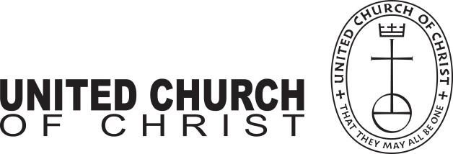
This document is created through support to Our Church’s Wider Mission (OCWM) and is only possible through the covenantal relationships of all settings of the United Church of Christ.

“Jesus answered them, ‘Have faith in God!’” – Mark 11:22

UNITED CHURCH OF CHRIST AT THE VILLAGES
(UCCTV)
Pastoral Job Description

JOB TITLE: Pastor

ACCOUNTABLITY: Reports to the Governing Board and is Accountable to the Congregation

POSITION STATUS: Full-Time

DATE: September 2, 2020

Overall Summary:

With the collaborative support of the Congregation, Governing Board, Ministry Team Leaders, and authorized Small Group Ministries, the Pastor shall: serve as the Spiritual Leader and Pastoral Overseer of the ministries of UCCTV; foster collegial alignment of the ministries of all staff members and lay leaders in support of effective ministry; provide strategic visioning in collaborative partnership with the Governing Board; monitor the spiritual pulse of the congregation through assessment, review and accountability; ensure staffing, facilities and programs are effectively aligned to meet the church’s overall strategic goals; provide guidance and wisdom on the gamut of organizational, financial, and ministry challenges that confront every congregation; and ensure that present and future systems, practices and policies of the church responsibly and effectively support the church’s mission, vision, values and its overall ministry objectives.

The Pastor’s Key Responsibilities and Duties:

WORSHIP

1) Oversees the congregation’s overall liturgical, preaching, and musical ministries.
2) Plans, prepares, and conducts meaningful liturgical and worship experiences with the collaborative support from the relevant lay and staff worship planning team and the Diaconate Team.

PREACHING & TEACHING

1) Oversees the congregation’s overall preaching and teaching ministries.
2) Preaches in all the worship services or ensures the availability of preaching coverage when necessary.
3) Ensures quality preaching that is theologically meaningful, relevant to the contemporary challenges of the
world in which we live, and rooted in our Sacred Scriptures.
4) Develops thoughtful discipleship-centric and spiritually relevant Adult Education programming and ministries
in coordination with lay leaders.

PASTORAL CARE & OUTREACH

1) Oversees the congregation’s overall pastoral care strategies.
2) Delivers pastoral care and follow-up to members of the congregation, including but not limited to, hospital,
nursing, hospice, and home visitation.
3) Manages the “care call” ministry of the Pastoral Care Team.
4) Provides pastoral counsel, funeral support ministry, and wedding services to members of the congregation.
5) Supervises the planning of outreach activities in the community and surrounding neighborhoods.
6) Coordinates the assimilation of new members.

STAFF LEADERSHIP

1) Oversees the congregation’s paid (full or part-time) staff engaged in support of its ministries and provides
staff supervision, leadership, mentoring, training, development, performance, evaluations, hiring,
dismissing, and staffing in collaborative consultation with the Governing Board and the Personnel
Committee.
2) Coordinates time-specific staff meetings and other activities to synchronize, clarify, and execute staff goals
in support of the church’s overall ministry objectives.

LAY LEADERSHIP

1) Oversees the congregation’s nurture, development, and training of lay leaders across all its ministries.
2) Provides guidance lay leaders across all ministries in support of the church’s overall ministry objectives.
3) Provides pastoral wisdom and insights to all lay-led ministry teams (Diaconate, Administration, Finances &
Stewardship, and Missions) to ensure effective management of all ministry, business, facility, and logistical
support functions in support of the church’s overall ministry objectives.

Evaluation and compensation: The Pastor will file monthly reports to the Governing Board on salient ministry accomplishments and activities. The Personnel Committee, in conjunction with the Pastoral Relations Committee, will conduct the Pastor’s annual performance evaluation and review of his/her compensation package.

ESSENTIAL KNOWLEDGE AND SKILLS:

The Pastor is expected to be a person of…

1) Exceptional biblical knowledge, exegetical, and teaching skills.
2) Strong progressive religious conviction.
3) High moral leadership.
4) A deep sense of impartiality and respect for confidentiality.
5) Mature clarity about the importance of professional boundaries.
6) Seasoned effective preaching and sermon preparation skills aligned with the teachings of the UCC.
7) Excellent writing skills.
8) Skillful coaching and counseling abilities.
9) Tested effective leadership, planning, and execution skills.
10) A profound sense of compassion for the struggles and concerns of others.

REQUIRED EDUCATION/CERTIFICATION REQUIRED:

1) Ordination in the United Church of Christ (other paths to Ordination may be considered) or an approved denominational body in ecumenical partnership with the United Church of Christ

DESIRABLE ADDITIONAL RELIGIOUS TRAINING:

Clinical Pastoral Education – CPE (1-4 Units)

