Search and Call Tools for Congregations

Advancing the Spirit’s guidance into God’s future

INTRODUCING THE NEW
LOCAL CHURCH PROFILE

Who are we
Who is our
neighbor
Who is God
calling us ?
to become

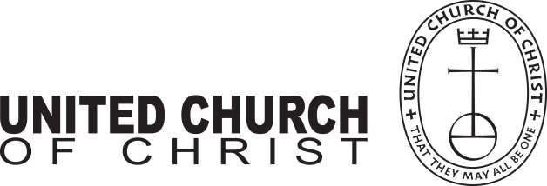
The new Local Church Profile is not just for congregations in search of a pastor. All congregations are encouraged to engage in its process of discovery every 3-5 years. The UCC Local Church Profile reflects valuable data, assesses ministry, clarifies change, and helps advance the calling of the congregation. Not just to be completed by a search
committee – the more participation, the better!

MINISTERIAL EXCELLENCE, SUPPORT & AUTHORIZATION
Rachel Hackenberg
Microsoft

UNITED CHURCH OF CHRIST
LOCAL CHURCH PROFILE

Faith United Church of Christ
Windsor, Colorado

Settled Minister

Rocky Mountain UCC Conference
Platte Valley Association
Est. 1969

LOCAL CHURCH PROFILE CONTENTS

Position Posting
- Who Is God Calling Us To Become?
- Who Are We Now?
- Who Is Our Neighbor?
- References
- Consent and Validation

“God is able to provide you with every blessing, so that having all sufficiency in all things at all times,
you may abound in every good work.” (2 Corinthians 9:8)

INSTRUCTIONS
The new Local Church Profile supports the calling and discernment of United Church of Christ congregations with their current or future pastoral leadership.

For many congregations, the interim time between ministers is an intentional season that is guided in part by the preparation of a Local Church Profile. Using the Profile, the church can discover its data and express its story for the reliable discernment of a search committee and the beginning of a new pastorate. Searching ministers will want to see this document in its entirety.

The interim season is not the only time in a church’s life when it’s valuable to give attention to explore a congregation’s vocation. Three sections of the Local Church Profile – WHO ARE WE NOW, WHO IS OUR NEIGHBOR, and WHO IS GOD CALLING US TO BECOME – are
meant to be updated every 3-5 years. Known together as the “Discovery Document,” these three sections can be completed by a visioning group, a governing body, a transition team, or other group – not just the search committee – in order to draw forward the gifts and imaginative possibilities of a congregation. The church’s engagement with the “Discovery Document” might not have the same sequence as the completed Local Church Profile that is read by candidates.

Some questions are easy to answer. Some are not so easy. Prompts are provided to stimulate narrative response if needed; these italicized prompts are merely examples from which to choose or to inspire your own. Efforts to answer the questions will prompt conversations and explorations and storytellings and many prayers, and as the Spirit moves throughout the process, congregations will shape a collective articulation of Christ’s leading (WHO IS GOD CALLING US TO BECOME). This last question to be answered becomes the first section to be read by searching ministers in the Local Church Profile, and it is boldest and most actionable piece for faithful leadership into the future.

Your conference can provide materials referenced in the Local Church Profile, such as the 11- Year Report containing data as reported by your congregation annually to the UCC Data Hub and MissionInsite reports containing demographic information on your community. More information on types of pastorate in the United Church of Christ can be found in the Call Agreement Workbook. Be sure to use the Call Agreement Workbook’s Scope of Work to describe in this Local Church Profile the position being sought.

When it is time for ministerial search, the conference can counsel you on posting the Local Church Profile together with your public listing at UCC Ministry Opportunities (http://oppsearch.ucc.org).

The last page of the Local Church Profile contains a statement that parallels the consent statement signed by ministers in the UCC Ministerial Profile. In keeping with the covenantal relationship between a church and those it seeks to call, this statement encourages an open, honest exchange of information. On behalf of the United Church of Christ, and on the basis of the best knowledge available to them, your conference staff will validate your completed Local Church Profile when it is ready to be shared in relationship with prospective new leaders.

POSITION POSTING LISTING INFORMATION SCOPE OF WORK

COMPENSATION & SUPPORT
WHO IS GOD CALLING TO MINISTER WITH US?

LISTING INFORMATION

Church name: Faith United Church of Christ
Street address: 1020 Walnut Street, Windsor, CO 80550
Supplemental web links:
Website
Facebook page

Additional ecumenical affiliations (e.g. denominations, communions, fellowships):
Windsor Ministerial Association
Conference: Rocky Mountain UCC
Association: Platte Valley
UCC Conference or Association Staff Contact Person (Name, Title, Phone, Email):
Rev. Sue Artt, Conference Minister, sue@rmcucc.org • 303.984.9118, ext. 1002
Rev. Erin Gilmore, Associate Conference Minister, erin@rmcucc.org • 801.694.6300

Faith United Church of Christ is a Christ-centered, theologically diverse congregation that seeks to be informed by the past, involved in the present, and in touch with the future. Located in one of the fastest growing cities in CO, we want to be a vibrant, relevant church that nurtures faith formation in people of all ages and backgrounds. We are seeking a compassionate, caring leader who can partner with us as we seek to honor our rich heritage while also embracing innovative and fresh ideas to strengthen our mission and ministry. Faith UCC is home to a thriving preschool, a well-organized community food pantry, and other community outreach programs. Windsor is located along the front range of northern Colorado with many job opportunities, excellent schools and recreational activities available, and was recently named as the safest city in CO.
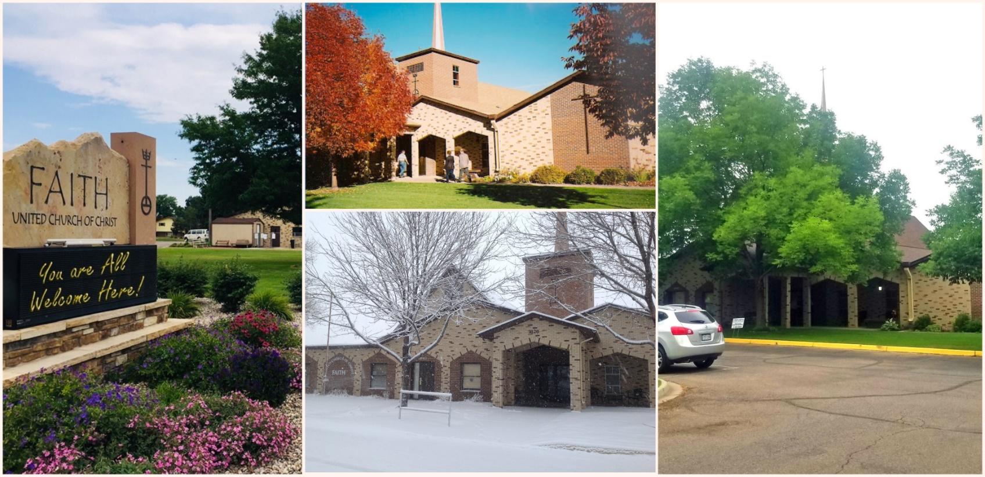
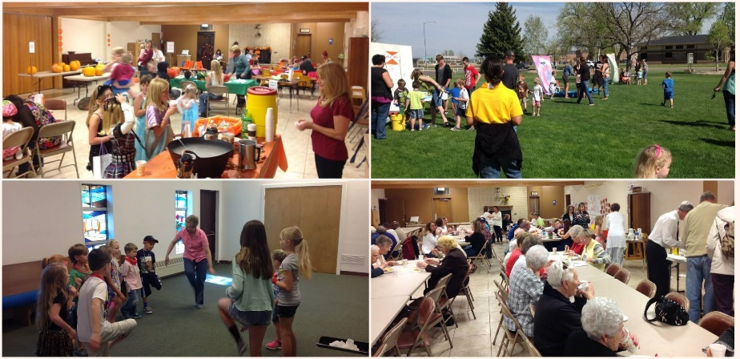
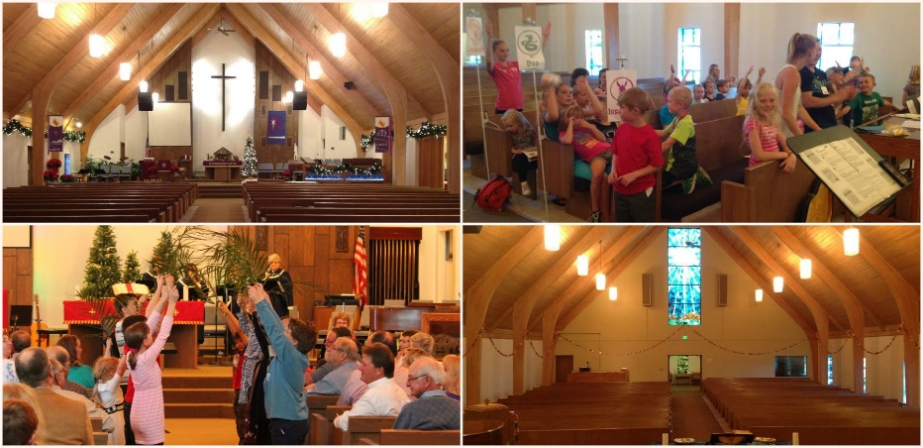

Within a 15-mile radius of Windsor, one can find many diverse recreational, cultural and arts activities, two major universities, excellent public and private schools. There are many job opportunities and access to first-rate medical care. While it is a growing community, there are still strong ties to agriculture and the rich history which settled and helped to grow this area.
    - Windsor named safest city in Colorado – August 2018!
    - Windsor was recently ranked No. 1 in a study of the "Best Cities to Live in Colorado."
    - Windsor named best place to raise a family in Colorado and another story citing the same study.
    - It’s one of The Best Places In Colorado For Young Families, According To Nerdwallet Study
    - One of The 10 Best Places To Live In Colorado For 2018
    - This booming Colorado town is an epicenter for green energy (and it’s still affordable)

Current size of membership: Member report for 2017 – 215 total members; 185 active, 30 active non-members, and 65 non-active members
Languages used in ministry (other than English): None
Position Title: Executive Minister
Position Duration (choose one, delete the other options listed):

Settled – a called position intended for longer-term ministry in which the minister moves church membership to the congregation and moves standing to related association
Compensation Level (choose one, delete the other options listed): Full Time
Does the total support package meet conference compensation guidelines? Yes

SCOPE OF WORK
(add here the Scope of Work developed by your church using the Call Agreement Workbook)
Full-time pastor position
- Preparation and leadership of Sunday worship including scripture study, crafting of liturgy and bulletin, sermon preparation, guiding and sometimes finding lay liturgists, planning of music in coordination with musical staff or volunteer, preaching, offering of prayer, etc.
- Faith formation and vitality through prayer, Bible study, service, identifying helpful resources & opportunities and helping lay persons take advantage of them
- Leadership development by working with people in the Church to create ministry and programs
- The Pastor shall have charge of the spiritual welfare of the church with the assistance of the deacons.
- Community engagement and leading the way for the church to be an ambassador of God’s love
- Weddings and funerals for participants in the worshipping community
- Strategic planning for current and new directions in ministry
- Attend meetings and give leadership as needed to church programs, in collaboration with lay leadership. The Pastor will serve in an advisory capacity to the Council at its official meetings, collaborating with lay leadership in advancing the mission of the Church. The Pastor will be invited and encouraged to attend other organization or committee meetings as a non-voting member to bring continuity and offer guidance to those meetings.
- Participate in wider Church activities such as Conference and Association meetings
- Administration responsibilities (unless delegated) such as email, website
- Faithful financial development and stewardship
- The Pastor shall serve as head of staff in directing and managing day to day activities of personnel. All personnel shall be responsible through the Pastor to Church Council.
- Availability to wider community for funerals, weddings, special worship programs, and as a representative of the Church to local organizations
- Counseling, listening and referral
- Study and prayer to increase faith and to improve skills to lead, teach, and preach better
- Energizing and deepening spiritual connections and faith understandings of others in all they do
- Interest in a second worship service has been expressed by many members. It is expected that our new Pastor will be open and inviting to the idea of a possible second service.
- At Faith, there is a Pastoral Relations Committee who are elected by the congregation. The Pastoral Relations Committee is an advisory group who shares the hopes, expectations and concerns of the Congregation with the Pastor.

We understand that a full-time pastor cannot “do it all.” Faith has a Church Council that is elected by the congregation that helps the Pastor in decision making. Also, we have an Office Secretary/Administrator who helps the Pastor as well as a Music Director, and Director of Christian Education. It is our hope that our new Pastor will be enthusiastic, energetic and will come with ideas to inspire more of our members to volunteer in various capacities and to help with new committees and projects. The membership at Faith are eager and craving faith-based activities and learning; we expect there will be ample volunteers who wish to aid our new Pastor!

Core Competencies:
Compassionate and Caring, Action Oriented Transformational Leader to motivate, inspire, empower and encourage.

COMPENSATION AND SUPPORT

Salary Basis (from the Call Agreement Workbook, equal to Cash Salary plus Value of Parsonage/Housing Allowance): $64,000

Benefits (choose one):
Salary plus Benefits

What is the expected living situation for your next minister (e.g. parsonage, living nearby with a housing allowance, living elsewhere to commute as needed)? Living in Windsor or nearby surrounding community. (Severance, Johnstown, Timnath, Greeley, Ft.Collins, Eaton, Loveland, etc) Less than 15 mi radius.

State any incentives (e.g. school debt reduction or retention bonus after a certain number of years in position): Subject to negotiation

Describe peer and professional supports available for ministers in your association/conference: Windsor Ministerial Association, Platte Valley and Rocky Mountain Conference associations

If applicable, describe how your church will adopt part-time adjustments in the pastoral schedule to support a minister’s bi-vocational employment: We are looking for a full-time Pastor

WHO IS GOD CALLING TO MINISTER WITH US?

Describe the ministry goals you envision your next minister co-collaborating with the congregation to achieve.
God is calling a compassionate leader who is eager to become a true part of our church community and the surrounding community. One who will truly embrace and become part of the church family. Our future Minister will hold the hands and comfort those who are struggling with real compassion. Our future Minister will be a willing partner with those who manage the business side of the church. Our future Minister will be emotionally invested when he/she is at the pulpit speaking and teaching God’s word and his/her passion will resonate with the congregation. Our future Minister will be supportive of the various groups within our church, and will have ideas for additional fellowship, educational and bonding opportunities. Our future leader will appreciate the community outreach programs currently in place at Faith.

Describe how your vision of the minister you are now seeking will assist the congregation in making an impact beyond its walls.
Faith already participates in several community outreach programs including our in-church Christian preschool, the community food pantry, and a free community meal served once a week, among others. Our Minister will be supportive of these activities, may offer suggestions for improvement, but will not try to micromanage what are already successful programs. Many in our congregation have expressed a desire to do even more, in the hopes that visibility and a positive image in the community will encourage attendance and active membership. After a time of settlement and getting to know the church and surrounding community, we hope our new Minister will come to the table with some fresh ideas and can help us organize and inspire. We would like to create a more symbiotic relationship with the preschool and increase our exposure with additional outreach in the community.

Specify language requirements or culturally-specific capacities preferred in a next ministerial leader, and why those matter to the congregation’s sense of calling.
Faith has a rich heritage upon which our church and town was built. However, with the explosive growth of our region in the last two decades, the general makeup of the community has changed and expanded far beyond the immigrant farming community that Windsor once was. We hope to be open to those from all walks of life and welcome new members. We look forward to learning about the culture and heritage of those from all descents. All are welcome here.

Based on what you have learned about who your church is, who your church’s neighbor is, and who God is calling the church to become, describe four areas of excellence from The Marks of Faithful & Effective Authorized Ministry that your next minister will display to further equip the congregation’s ministry in these areas.

- Loving God, following Jesus Christ, and being guided by the Holy Spirit; living a life of discipleship.

- Experiencing and appreciating a variety of theological perspectives.

- Understanding community context and navigating change with a community, AND, Engaging in mission and outreach.

- Exhibiting strong moral character and personal integrity

WHO IS GOD CALLING US TO BECOME?
“You shall love the Lord your God with all your heart, and with all your soul, and with all your mind.” (Matthew 22:37 NRSV)

Who is God calling you to become as a congregation?
God is calling us to become a more bonded group within the church, yet at the same time, open and welcoming to those who are not yet part of our congregation. We are hoping to grow in our faith, gain in our understanding of the word of God, and expand in our hearts. We desire a more energetic church with active members who are working towards a common goal. We desire more transparency within the church, specifically between leadership, Council and the congregation. We would like to be known as a lively congregation with programs for all ages.

Describe how God is calling you to reach out to address the emerging challenges and opportunities of your community and congregation.
GROWTH. Growth is both a challenge and an opportunity. The population increase has changed the very make-up of our community. We are working to acknowledge that Windsor is no longer a “small immigrant farming community”, to understand that with growth also comes change which can be both good and bad, and to appreciate the new opportunities afforded which we hope will include growth and survivability within our congregation.
What is UCC? Everyone knows Baptist, Lutheran, Methodist, Catholic, etc. UCC doesn’t seem to be known as commonly as some of the aforementioned denominations. Let’s work to change that on a local level.
An Open and Affirming (ONA) committee was started three years ago and brought to Council. It was determined that this was not the best step for our congregation at that time. We can truly state that our congregation is open and welcoming. But with broad theological and political beliefs, everyone may not be affirming. The discussion never got to official Committee as it was determined the issue was too polarizing in this congregation at this time.
Faith UCC has not had a vision statement or strategic plan for many years and hope to have a leader to assist us with a future vision and with goal setting.

WHO ARE WE NOW?
“You shall love your neighbor as yourself.” (Matthew 22:39 NRSV)

CONGREGATIONAL REFLECTIONS 11-YEAR REPORT
CONGREGATIONAL DEMOGRAPHICS PARTICIPATION AND STAFFING CHURCH FINANCES
HISTORICAL INFORMATION

CONGREGATIONAL REFLECTIONS

Describe your congregation’s life of faith.
For example, what beliefs and commitments are stated in your congregation’s purpose statement or membership vows? How is God most often described in worship liturgy? In what ways would you describe the Holy Spirit in your midst?
Faith UCC presently hosts a traditional Sunday worship service, with both contemporary and traditional music programs found within. The Lord’s Prayer is always present and our congregation seems to prefer to follow the traditional liturgical calendar. The congregation and officiants strive to be open and welcoming to all as is noted in Communion ceremonies, all are welcome no matter their membership status, denomination, beliefs, or age. God is described in traditional terms; Our Father, God, Lord, Creator, Almighty, and occasionally Yahweh. When receiving new members to the church, whether through membership ceremony, baptism or confirmation, the congregation vows to welcome these people into our church family and support them on their spiritual journey.
We are seeking more opportunities to learn about and grow in our faith, outside of the traditional Sunday worship. In addition, we are open to new ideas and ways to excite people and encourage them to attend Sunday worship and participate in all activities at Faith. We have strong desire to once again host vibrant children and youth programs and to breathe new life into all areas of the church.

Describe several strengths or positive qualities of your congregation.
Our congregation truly loves the community of Windsor. Our congregation has strong ties and believes the history of both our church and the community are important.
Love, concern and care among our membership and community is apparent. For example, Touch of Faith is a group within our church whose mission is to reach out to those who need some extra care such as shut-ins, sick and elderly. A Place At The Table is a free community meal held every Wednesday night at Faith. The meal is supported by the Windsor Food Pantry, individuals and groups within our Church, as well as other groups (such as the WHS Key Club and volunteers from other faiths and churches in the community just to name a few). Faith Church houses the Windsor Community Food Pantry and has since its inception in 1991. Our church building also houses Faithsteps Christian Preschool.
We have a great music program including a traditional choir, a contemporary faith and praise band called “Leap Of Faith”, a hand bell choir, a singing quartet with accompaniment “Faith and Praise”, and host other special musical guests on a regular basis.
Near the beginning of each service, we have several minutes where we “pass the peace” and where we greet one another. After Sunday worship service, coffee and snacks are often served and fellowship is enjoyed.

Describe what worship is like when your congregation gathers.
The Faith sanctuary would be considered mid-century traditional worship area with a peaked roof, beautiful stained glass and the focus being the cross. Our sanctuary offers a lot of natural light, comfortable pews, and warm wood tones. It has been updated in recent years to include advances in technology including good quality speakers and microphones, investment in attractive artificial plants/trees and colorful fabric hangings and altar and pulpit coverings. Butterflies are a common theme in the summer, and the hanging of the greens for Christmas makes the sanctuary a very special place.
Our worship is fairly traditional, with modern music added at times. Many enjoy the traditional worship, but also realize to attract new membership, more modern ways may need to be adopted. Worship services are currently structured based on music, scripture and sermon which typically follows the UCC lectionary calendar. A more contemporary service, rooted in tradition has been suggested, as well as interest in a second worship service has been expressed by many members. It is expected that our new Pastor will be open and inviting to the idea of a possible second service.
Ceremonies, whatever the Preacher’s style, are very important to be kept traditional - communion, baptism, confirmation. Baptism takes place as part of the Sunday worship service where all members of the congregation are engaged and participate.
Our congregation enjoys Preachers who are dynamic and sincere. One who speaks from the heart, isn’t afraid to pepper the sermon with tasteful humor and who is engaging the audience by moving out and about in front of the people and one who enunciates and is articulate. Our congregation has broad theological backgrounds and political views. We are looking for someone who will speak to current events in a biblical, spiritual and theological sense rather than in an abruptly political tone. We seek a leader to help us recognize there is something deeper that connects us - beyond individual political and ideological beliefs. Not knowing on which “side” a Preacher stands is appreciated by our congregation.

Describe the educational program/faith formation vision of your church.
For many years, Sunday school was prior to church and all children went with their family to church. Near the beginning of the service, there was “time with the children” and the very young then went to nursery. Those of elementary age and up sat back down with their parents. Over the last five years attendance of school aged children has steadily declined to the point that in the past year, Sunday School now takes place directly after “time with the children” and during the worship service.
Previous Sunday School curriculum included a package which was ordered online, but was found to be too simple. The school then used curriculum purchased from Group Publishing which followed the sermon “cycle” and was much more interactive and included contemporary music. This program was used for many years with revisions and additions to make it unique to Faith. During this time, fundraising projects were also done, one of which paid to purchase age appropriate bibles for each child.
In the past there was an adult Sunday school class, and there is a lot of demand for that to happen again and for it to be an exciting, insightful, and interactive religious adult education experience with a strong leader. In the last year, there has not been an adult class. During what one might consider a “high point” of adult religious education at Faith (over 10 years ago), there were adult classes based on “A Purpose Driven Life” which had a lot of participation. Many in our adult population desire a spiritually fulfilling, meaningful, religious adult educational experience.
VBS and Confirmation used to be strongly attended, however attendance has dropped dramatically in the last few years. Currently there aren’t many programs in place for young adults once they are beyond the age of Youth Group. Some kids do attend La Foret camp every year. But, there aren’t many young adults in the Church if we’re being honest. Fellowship opportunities for adults include book club and women’s fellowship groups, but those are primarily attended by those who are middle aged and older. Preparing noodles for the bake sales is a popular activity, and all ages are encouraged to help. There are many volunteer opportunities including helping with the regular Wednesday night meal, signing up to host coffee fellowship, where again, all ages are invited and encouraged to help.
In years past, young people participated in worship by serving as acolytes, reading scripture, and as greeters for church services. These services were primarily performed by the current confirmation class. We would like to see our Pastor take an active role in confirmation classes.
Describe how your congregation is organized for ministry and mission.
How are decisions communicated in your church?
We have a Church Leadership Council of an elected committee. Decisions made by the Council are typically communicated to members through the pastor during services, the weekly email newsletter (which also has copies available in the narthex), and very occasionally the Moderator will report to the congregation during the service. Fireside chats with small groups have been employed when discussing issues as well. There are plans that the newly elected 2018 Council will be furthering communication ideas.
How are teams or committees organized?
Members of Church Council and a select few other committees within the Church are first nominated by the Nominating Committee, then elected by the congregation. All other committees and teams are volunteer basis.

Where does your church struggle for vision?
There are a lot of great ideas and hopes for the future, but we lack strong leadership to help us follow through. As is the case with many volunteer activities, a lot of the same people participate and we struggle to get additional membership to be active - whether it be within in the Church, or with broader mission projects.
- When it comes to decision-making, how many hours are spent in meetings per month?
Church Council meets once a month for approximately 2 hours. The Trustees, Deacons and Pastoral Relations Committee meet for an additional few hours per month. Other special committees meet as needed.
- Think of a time when action had to be taken quickly, for example when a crisis or disaster occurred. How was that accomplished?
Telephone calls, social media, email, Church website, word of mouth….. when there is a crisis, our members act and are great about pulling together for the greater good. Touch of Faith is a group within our Church whose primary mission is to reach out to those in crisis and troubled times, such as shut-ins, elderly and the sick.
- Can you provide the next minister with a copy of an organization structure, bylaws and/or annual report to further explain the patterns of the church’s activity and governance? Yes.

- YEAR REPORT – click image for full size pdf
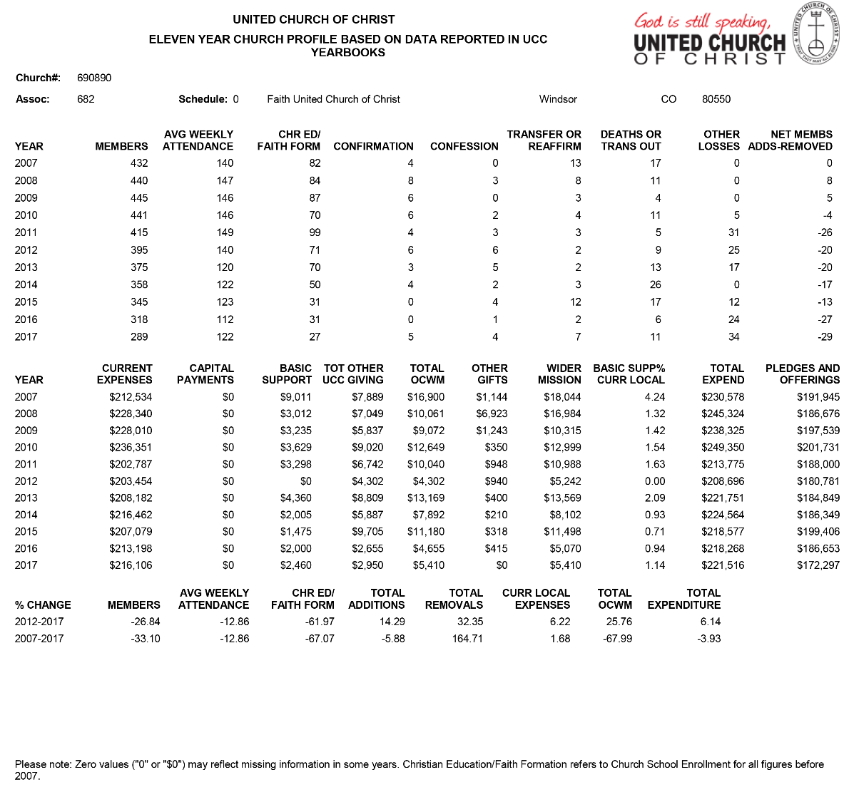

CONGREGATIONAL DEMOGRAPHICS

Describe those who participate in your church.
 |  | Is this number an estimate? (check if yes)
Number of active members: | 185 | Current as of 2016
Number of active non-members: | 30
Total of church participants (sum of  the numbers above): | 215 | *
*There are also 65 who are members, but are not active

Percentage of total participants who have been in the church:
 |  | Is this number an estimate? (check if yes)
More than 10 years: | 70%
Less than 10, more than 5 years: | 12%
Less than 5 years: | 18%
Number of total participants by age:
0-11 | 12-17 | 18-24 | 25-34 | 35-44 | 45-54 | 55-64 | 65-74 | 75+ | Are these numbers an  estimate? (check if yes)
16 | 18 | 8 | 6 | 13 | 15 | 34 | 42 | 63

Percentage of adults in various household types:
 |  | Is this number an estimate? (check if yes)
Single adults under 35: | 4
Joint household with minors: | 27
Single adults age 35-65: | 6
Joint household with no minors: | 112
Single adults over 65: | 31

Education level of adult participants by percentage:
 |  | Is this number an estimate? (check if yes)
High school: | 42%
College: | 35%
Graduate School: | 7%
Specialty Training: | 8%
Other (please specify): | 8%

Percentage of adults in various employment types:
 |  | Is this number an estimate? (check if yes)
Adults who are employed: | 30%
Adults who are retired: | 60%
Adults who are not fully employed: | 10%
Describe the range of occupations of working adults in the congregation: Farmers/agriculture, first responders, educators, healthcare workers, professionals, doctors, attorneys, construction, oil and gas industry, administrators, tradesmen, information technology, childcare. 60% retired.

Describe the mix of ethnic heritages in your congregation, and the overall racial make-up. Most UCC congregations tend to describe themselves as “diverse.” Yet, the vast majority of UCC congregations are mono-cultural. What does diversity mean in your context? Our congregation is reflective of the racial-ethnic trends in the surrounding areas which are approximately 83% white, 12% Hispanic/Latino, 2% Pacific Islander/American Indian/Other, 2% Asian, 1% Black/African American

Has your congregation recently had a conversation about welcoming diversity, or do you plan to hold one on the near future (perhaps using, for example, the Welcoming Diversity Inventory)?
Please note the date. Comment after the exercise: No, we have not had a conversation about welcoming diversity and had not been previously aware of the Welcoming Diversity Inventory.

PARTICIPATION AND STAFFING

Complete the following chart. Please leave blank any fields that are not applicable to your congregation.

Ways of Gathering | Estimated number of people involved in attendance | Who plans each of the listed gatherings? (list any and all worship planners, such as various lay leaders, pastors, musicians, other staff)
Adult Groups or Classes | ~ 60 | Two women’s groups, Book Club, Touch of Faith. No organized classes for adults
Baptisms (number last year) | 3 adults, 5 children | Pastor, Staff
Children’s Groups or Classes | 10 | Pastor, Staff, Youth Leader, Dir of Christian Ed
Christmas Eve and Easter Worship | Christmas 2017- 255  Easter 2017-253 | Easter 2018 – 220  Pastor, Music Leaders, Staff
Church-wide Meals | 3-4 per year | Women’s groups
Choirs and Music Groups | Choir- 15  Faith & Praise Singers -5  Hand Bell Choir – 9  Leap Of Faith Band- 7 | Each music group and/or Choir Director
Church-based Bible Study | none
Communion (served how often?) | ~ 6 weeks | Pastor, Staff, Deacons
Community Meals | Every Wed, ~ 45-60 people | Volunteers
Confirmation (number confirmed last year) | 5 | Dir of Christian Ed, Pastor
Drama or Dance Program | none
Funerals (number last year) | 8 (6 member, 2 non-member, 1 community) | Pastor, Staff, women’s groups (meal/refreshments)
Intergenerational Groups | Musical groups, Wed night meal | Music Director, volunteers
Outdoor Worship | 1 in 2017 | Pastor, Staff, Deacons
Prayer or Meditation Groups | none
Public Advocacy Work | none
Retreats | 3-5 | La Foret – Youth Director
Theology or Bible Programs in the Community | unknown | Dir of Christian Edu at apartment building across street from church
Weddings (number last year) | 1 | Settled Pastor performed, but ceremony was not held in church building
Worship (time slot: 10:30am ) | 2018 – 113  2017 – 122  2016 - 112 | Pastor, Staff, Deacons, Music Director
Worship (time slot: 9:30am ) | Summer only 2018- avg76 | Pastor, Staff, Deacons, Music Director
Young Adult Groups or Classes | none
Youth Groups or Classes | 5 | Dir of Christian Ed, Youth leader, Pastor, Staff
Other | 8 | Buildings and Grounds
Additional comments:

List all members or regular participants in your congregation who are ordained, licensed, or commissioned ministers. Indicate those with current United Church of Christ Three-Way Covenants (i.e. serving in a congregation) or Four-Way Covenants (i.e. serving in a ministry beyond a congregation).
Name | Three- or Four- Way Covenant? (3 or 4 or No) | Ministry Setting | Type of Ministry Role | Retired?  (Y or N)
Eldon Schmidt |  | Pastor Emeritus | none | Yes
If one or more previous pastors or retired ministers currently hold membership in the church, describe their role(s) in the life of the congregation: Eldon Schmidt is a Pastor Emeritus and his role in the Church is as a member.
List all current staff, including ministers. Exclude the position you are seeking to fill. Indicate which staff person serves as head of staff.
Staff Position | Head of Staff? | Compensation (full time, part  time, volunteer) | Supervised by | Length of Tenure for current person in this  position
Dir of Christian Education |  | Part time | Trustees | 1 years
Office Secretary/Administrator | Office Secretary/Administrator | Part time | Trustees | 37 years
Youth Director |  | Part time | Trustees | 1 year
Interim Pastor |  | Full time | Trustees | 6 months
Preschool Director |  | Part time | Preschool Board | In process of interviews. Interim is in place
Music Director |  | Part time | Trustees | 2 years
Pianist |  | Part time | Music Director | 2 years
Accountant |  | Part time | Trustees | 1 month

REFLECTION
Reflection: After reviewing the congregational demographics and activities above, what does this information reflect about your congregation’s overall ministry?
Our Church is fulfilling a need in the community through our Christian preschool and housing the Windsor Food Pantry. But what are we fulfilling spiritually to our own congregation? Aside from Sunday morning services, we are lacking in outreach, activities and spiritual services to our own members. We hope that in the future we can minister to our own congregation as much we currently do to the surrounding community.

CHURCH FINANCES

Current annual income (dollars used during most recent fiscal year)
Source | Amount
Annual Offerings and Pledged Giving | $190,000
Endowment Proceeds (as permitted within spending policy, such as a cap of typically 4.5%-5% on total return) | $113,000
Endowment Draw (beyond what is permitted by spending policy, “drawing down the principal”) | $0
Fundraising Events | $3,000
Gifts Designated for a Specific Purpose – OCWM, OGHS | $2000
Grants | $0
Rentals of Church Building (rental, plus pre-school reimbursement) | $1,000  $ 16,500
Rentals of Church Parsonage | $0
Support from Related Organizations  Women’s groups, grocery cards | $12,500
Transfers from Special Accounts | $
Other (specify): Memorial Fund | $51,000
Other (specify): Building Fund  Asset – Preschool | $40,500  $130,000
TOTAL | $559,500

Current annual expenses (dollars budgeted for most recent fiscal year): 2017 Final General Fund Expenses: $216,106. 2018 Budgeted Expenses: $220,574
Attach most recent church budget, spending plan, operating statement, or annual treasurer’s report as shared publicly with the congregation, or – if your church does not pass an annual budget – list current budgeted expenses here. Click here for budget

Considering total budgeted expenses for the year, compare total ministerial support. What is the percentage? 45%

Has the church ever failed to pay its financial obligations to a minister of the church? No

Is your church 5-for-5, i.e. does it include each of the following contributions during the church year? (indicate those included during the most recent fiscal year)
x Our Church’s Wider Mission (OCWM – Basic Support)
x One Great Hour of Sharing
Strengthen the Church
Neighbors in Need
x Christmas Fund

In what way is OCWM (Basic Support) gathered? If calculated as a percentage of operating budget, what is that percentage? (recommended 10%) A special offering during a designated time.

What is the church’s current indebtedness? No debt
Are capital and other payments current? yes

If a building program is projected or underway, describe it, including the projected start/end date of the building project and the total project budget.

If the church has had capital campaigns in the last ten years, describe:

Year(s) | Purpose | Goal | Result | Impact
2015-2017 | Pipes and Parking Lot | $100,000 | $60,000 | Sewer/pipes are being worked on presently. Parking lot repaving is not of immediate concern at this time.
If a capital campaign is underway or anticipated, describe:

Year(s) | Purpose | Goal | Result | Impact
2019 | Parking Lot | $ | $ | Anticipated
Describe the prominent mission component(s) involved in the most recent (or current) capital campaign.
Stewardship season, noted in the bulletin, specific pledges

Does your church have an endowment? Yes

What is the market value of the assets? $113,000

Are funds drawn as needed, regularly, or under certain circumstances? Under Certain Circumstances.
What is the percentage rate of draw (last year, compared to 5 years ago)? N/A
Describe draw on endowment, if any, to meet operating budget expenses for the most recent year and the past five years: Never

At the current rate of draw, how long might the endowment last? Depends on needs
Please comment on the above calculations or estimates: N/A

Other Assets

Reserves (savings): Restricted Cash- $46.4k Memorial, $52.5k Parking Lot, $129.1k Preschool, $28.9k Cash savings, $40.9k Building fund

Investments (other than endowment): No

Does your church have a parsonage? No
Describe all buildings owned by the church: The physical building at 1020 Main St. The Church does own additional mineral rights.
Describe non-owned buildings or space used or rented by the church: None

Which spaces are accessible to wheelchairs? (worship space, pulpit, fellowship space, facilities, etc.)
All, except the altar.

Reflection: After reviewing the church’s finances and assets described above, what does this information reflect about your congregation’s mission and ministry?
The Church has not been as forthcoming to the broader missions outside of our local community (such as OCWM, Great Hour Of Sharing, etc) because it has been felt that the need here, with the declining Church population, has been greater. We feel that in the past, there may have been more focus on the broader missions, whereas recently it is just mentioned.
Budgeting is done by the Trustees and through Council for approval and then brought to the congregation for approval during the Annual Meeting in January.

HISTORICAL INFORMATION

Name one to three significant happenings in the history of your church that have shaped the identity of your congregation. Add the most important event in the life of your church in the past 10 years.
In 1969 the Zion Evangelical Reformed and the German Congregational Church merged. Construction of the new church building began in 1970. The Windsor Severance Community Food Pantry began around 1988. Faithsteps Christian Preschool began in 1991. An additional service provided by the Food Pantry and volunteers throughout the community is the weekly meal, A Place At The Table, which has been averaging 45 diners every Wednesday night.
Over the past 10 years, the decline in overall membership and participation, especially that of young people and families, has had a significant impact.
Faith United Church of Christ will enjoy the 50th Anniversary next year and are very proud and excited for this celebration! A committee has already been formed and is at work brainstorming ideas and activities to commemorate our rich history.

Describe a specific change your church has managed in the recent past.
A mutual disagreement of leadership lead to the resignation of previous Pastor’s employment.

Every church has conflict, some minor, some larger. “Where two or three are gathered, there will be disagreement….” Describe your congregation’s values and practices when it comes to conflict.
This is an area in which our Church has struggled in the recent past. The current Council and committees are working hard to resolve and approach disagreement in a more congenial manner and through appropriate channels. We are a Church uniting together to overcome some problems and are making progress!

Ministerial History (include all previous ministerial staff for the past 30 years)

Staff member’s name | Years of service | UCC Standing (Y/N)
Rev Elizabeth Endicott | March 2018 - present | Current Interim Pastor, Y
Rev Mollie Landers Hatt | Nov 2017-February 2018 | Bridge Pastor, Y
Rev Fred Evenson | 2007-2017 | Associate Pastor 2007-2010,  Senior Pastor 2010-2017  Y
Rev Eldon Schmidt | 1993-2010 (retired) | Senior Pastor, Y
Rev Cheryl Smith | 1995-2010 | Associate Pastor, Y
Rev Ken Redfearn | 1992-1993 | Interim Pastor, Y
Rev Keith Haemmelmann | 1985-1992 | Senior Pastor, Y

Comment on what your church has learned about itself and its relationship with persons who provided ministerial leadership: In recent past, the members of Faith have learned that open, honest, respectful communication among all is paramount. Our congregation responds best to a dynamic, personable leader who follows through on their promises with actions. The congregation at Faith values and holds dear real compassion, integrity and one who is an active and willing partner on our journey with Christ.

Has any past leader left under pressure or by involuntary termination? No, however there was a growing mutual dissatisfaction between the immediate past Senior Pastor, Council and Congregation.

Has your church been involved in a Situational Support Consultation? No

Has a past pastor been the subject of a Fitness Review while at your church? No

WHO IS OUR NEIGHBOR?
“You shall love your neighbor as yourself.” (Matthew 22:39 NRSV)

COMMUNITY VISION
MISSION InSite

COMMUNITY VISION

How do the relationships and activities of your congregation extend outward in service and advocacy?
Local Level - Food Pantry, Preschool, Wed night meal
National Level – OCWM, Special Offerings
Our Church has a strong local presence with the services offered in our church building. We also have a Relay for Life Team, donate to WHS After Prom, host a cancer support group, Footsteps To Hope, and have had groups participate in the Crop Walk. Our bake sales are always very well attended and many in the community look forward to fresh grebble (German dougnuts) and purchasing noodles, butterballs (German dumplings), kuchen (German coffee cake) and other goodies to take home. The bake sale is a great opportunity for members of Faith to work together. We come together to make many of the traditional goodies at the church and it’s a wonderful time of fellowship and work for the common good of our congregation! Faith Church is the meeting area for Bells Of The Rockies a local hand bell choir, as well as Footsteps To Hope a local cancer support group.

Describe your congregation’s participation in meetings, relationships and activities connecting the wider United Church of Christ (association / conference / national setting).
We send delegates to the Rocky Mountain Conference meeting and are active participants in the Platte Valley Association. We have had members who in the past have served on the Rocky Mountain Conference Council.

Many local churches love to tell the story of what they are doing in the community to transform lives. Some have identified certain aspects of their witness into the wider community using language shared with other UCC congregations. (Find more information as desired at ucc.org.) Check any statements below that apply to your UCC faith community.
Accessible to All (A2A) ___Just Peace
Creation Justice ___Global Mission Church
Economic Justice ___Open and Affirming (ONA)
XFaithful and Welcoming ___WISE Congregation for Mental Health
X God Is Still Speaking (GISS) ___Other UCC designations:
Border and Immigrant Justice ___Designations from other denominations
Inter-cultural/Multi-racial (I’M) ___None

Reflect on what the above statement(s) mean(s) to your community. Is your congregation interested in working toward any of the above statements of witness in the near future?
Yes, possibly, but we haven’t had much communication regarding what these designations are. ONA has been discussed in the past, but it is not something in which our congregation seems to be ready for at this time.
Describe your congregation’s participation in ecumenical and interfaith activities (with other denominations and religious groups, local and regional).
Faith Church is part of the Windsor Ministerial Association and participates in several Ecumenical worship services in the year. We support our community by housing the Windsor Food Pantry within our walls, hosting a Place At The Table Meal which is a free meal offered every Wednesday at Faith, and by hosting the Weld Food Bank Mobile Truck once a month. Faith Church welcomes individuals and groups from other faiths and walks of life to participate in a Place At The Table and volunteer at the Food Pantry. Our church is the home and practice location for a hand bell choir, “Bells Of The Rockies”, as well as the meeting location for a faith based, non-denominational cancer support group called Footsteps To Hope.

If your congregation has a mission statement, how does that mission statement compare to the actual time spent engaging in different activities? Think of the range of activities from time spent gathering, to governance, to time spent going out.
There is not a current mission statement in place. There is a Faith and Covenant component in our Bylaws;
FAITH - This church acknowledges as its sole head, Jesus Christ, the Son of God and Savior of all. It acknowledges as brothers and sisters in Christ all who share in this confession. It looks to the Word of God in the Scriptures, and to the presence and power of the Holy Spirit, to prosper its creative and redemptive work in the world. It claims as its own the faith of the historic church expressed in the ancient creeds and reclaimed in the basic insights of the Protestant Reformers. It affirms the responsibility of the church in each generation to make this faith its own. In accordance with the teaching of our Lord and the practice among evangelical Christians, it recognizes two sacraments: Baptism and the Lord's Supper or Holy Communion.

COVENANT - We covenant one with another to seek and respond to the Word and the Will of God. We propose to walk together in the ways of the Lord, made known and to be made known to us. We hold it to be the mission of the church to witness to the Gospel of Jesus Christ in all the world, while worshipping God and striving for truth, justice and peace. As did our ancestors, we depend on the Holy Spirit to lead and empower us. We pray for the coming of the Kingdom of God. We look with faith toward the triumph of righteousness and eternal life.

Reflect on the scope of work assigned to your pastor(s). How is their community ministry and their ministry in and on behalf of the wider church accounted for in the congregation’s expectations on their time?
We hope that our Minister is active in the community and remains a part of the Windsor Ministerial Association and participates in things such as baccalaureate and the ecumenical Thanksgiving service. Faith Church is a popular referral for a local funeral home and is supportive of our Minister accepting services for nonmembers at his/her choosing.

MISSION InSite –
Links: QuickInsite and Executive Insite

Comment on your congregation’s MissionInsite report with data for your neighborhood(s) or area. What trends and opportunities are shown?
The most obvious trend and opportunity is that of continued population growth in our area. This is especially apparent with Singles, Young Families and those over age 65.

How do your congregation’s internal demographics compare or contrast to a) the neighborhoods adjacent to your church, and b) other neighborhoods with which your church connects?
Faith UCC racial and income demographics are in line with and reflective of the surrounding neighborhoods and community. We do attract several members from the senior/low income housing apartments which are directly across the road from the church. Our age demographics contrast to the surrounding neighborhoods and that is something which we would like to change through revitalization of our children, youth, and young adult programs.

How are the demographics of the community currently shaping ministry, or not?
It’s not. There is explosive population growth, yet the Church population and participation is declining. There are a lot of established churches in Windsor, and in the recent decade a lot of non-denominational, contemporary churches have flooded the area as well.

What do you hear when you talk to community leaders and ask them what your church is known for?
Faith is well known for our community involvement with our Christian preschool, Food Pantry and Wednesday night meal. We are also very visible because of our location within Windsor, which is right along Main Street and directly across from Windsor High School. Our electronic sign along the street announces both our presence and current activities. Our Church is a vibrant mixture of traditionalists and progressives.

What do new people in the church say when asked what got them involved?
This feels “like home” and people are comfortable and feel welcomed. They enjoy the supportive family feel. Although our surrounding community is growing, the Church still offers a welcoming, small town feel. Many state they like the diversity of the music and the musical talent. As noted above, the location in proximity to the apartments across the street has brought in several members. Our various community outreach programs are highly visible within Windsor and surrounding areas.

REFERENCES

Name up to three people who have agreed to serve as phone and written references. Advise the three references: “The contact information you provide may be shared publicly. Please use contact information that you feel comfortable giving to candidates so they can reach you with their questions.”

Make sure they are not members of your church but are persons who know your church well enough to be helpful to candidates seeking more information. Request a letter from each reference in answer to the four prompts below. Attach the letters (up to three) as desired.

REFERENCE 1 – Mark Long (click to read referral letter)
Funeral Director, Mark’s Funeral Service
(970) 686-9525, mark@marksfuneralservice.com
There is one funeral home and service located within Windsor city limits. Mark’s handles the majority of the funerals which are held in the church, both for members and non-members.

REFERENCE 2 – Debbie Martin (click to read referral letter)
Florist, author, public speaker
(970) 460-6445, debmartinflowers@gmail.com
Debbie grew up in Faith Church and her parent’s and inlaws still attend. Debbie’s immediate family presently attends another church in the area which is more conservative in its preaching. She hosts a women’s cancer support group, Footsteps To Hope, at Faith.

REFERENCE 3 – Tom Prenger (click to read referral letter)
President, Bank of Colorado
970-686-8484, tom.prenger@bankofcolorado.com
Tom is the branch president of the bank which is adjacent to the church building and where Faith does banking business.

CLOSING THOUGHTS CLOSING PRAYER STATEMENT OF CONSENT

CONFERENCE/ASSOCIATION VALIDATION

CLOSING PRAYER -

Include here any prayer or dream for the minister you imagine journeying toward you… a poem, for example, or a Scripture passage or a piece of music that is meaningful to your Search Committee:
The following was part of a message to the congregation from Pastors Eldon Schmidt and Cheryl Smith in celebration of Faith’s 25th Anniversary. As we approach our 50th Anniversary, we feel this message is meaningful and timeless.
“Real loyalty does not involve repetition but carrying things a stage further.” -Rudolf Bultmann
“Real loyalty” involves a future dimension. Loyalty to the past does not mean a blind repetition of what has been. Each generation of Christians is responsible for carrying the message of Christ to the next stage. The forms that contain and convey this message must undergo change – it is the message itself that must remain the same.

In some of our first meetings as a Search Committee, Matthew 19:20 and Matthew 28:19-20 were brought up and have helped to serve as inspiration.

Matthew 18:19-20 (GNT)
19 “And I tell you more: whenever two of you on earth agree about anything you pray for, it will be done for you by my Father in heaven. 20 For where two or three come together in my name, I am there with them.”

The Church is a vessel of worship. A form of worship is the service to our fellow men. The Church allows us to do this by reaching out to our fellow man. This is especially apparent in Faith’s various community outreach programs. We are inspired and hope to invite His presence into our lives even more by expanding opportunities for our members, outside of Sunday morning worship.

Matthew 28:19-20 (GNT)
19 Go, then, to all peoples everywhere and make them my disciples: baptize them in the name of the Father, the Son, and the Holy Spirit, 20 and teach them to obey everything I have commanded you. And I will be with you always, to the end of the age.”

Our new minister must be dedicated to the great commission Christ gave to his disciples and followers as commanded in Matthew 28:19 -20. Matthew 28:19 begins with the action word, “GO”!

As we conclude work on the Local Church Profile, we have found additional meaning in 2 Timothy 3:16-17 and Ecclesiastes 5:3.
2 Timothy 3:16-17 (GNT)
16 All Scripture is inspired by God and is useful[a] for teaching the truth, rebuking error, correcting faults, and giving instruction for right living, 17 so that the person who serves God may be fully qualified and equipped to do every kind of good deed.

Ecclesiastes 5:3 (AMPC)
A dream comes with much business and painful effort…

Lord, we walk with you in discernment. We pray for your guidance to open our hearts and our minds as we look forward to the future of our Church with our congregation. May we all work together for our dreams to come to fruition. Amen

STATEMENT OF CONSENT

The covenantal relationship between a church and those called by that church to serve as pastors and teachers and in other ministerial positions is strengthened when vital information is openly shared by covenantal partners. To that end, we attest that, to the best of our abilities, we have provided information in this profile that accurately represents our church. We have not knowingly withheld any information that would be helpful to candidates.
As the committee charged with the responsibility for identifying and recommending suitable new minister for our church, we have been authorized to share the information herein with potential candidates. We understand that a candidate may wish to secure further knowledge, information, and opinions about our church. We encourage a candidate to do so, recognizing that an open exchange of relevant information builds the foundation for continuing and healthy relationships between calling bodies and persons seeking a ministry position.

  - Which individuals and groups in the church contributed to the contents of this Local Church Profile?
Search Committee: Mary Nix, Taylor Stephens, Annette Hays, Norma Rutz, Jeff Housden, Betty Wiederspon, Brittan Vitosh, Adele Lind-Nichols, Dave Godbold
The Search Committee invited and encouraged comment from the entire Faith UCC Congregation via personal discussion, letters and emails over a period of several weeks.
Church Office Secretary/Administrator: Kathy Hettinger

  - Additional comments for interpreting the profile:

Signed:
Name / Title / Date:
Annette Hays, Search Committee Chairperson, 8/27/18

VALIDATION BY CONFERENCE/ASSOCIATION

The congregation is currently in good standing with the association / conference named.
Staff Comment:

To the best of my knowledge, ministerial history information is complete.
Staff Comment:

To the best of my knowledge, available church financial information is presented thoroughly.
Staff Comment:

My signature below attests to the above three items.

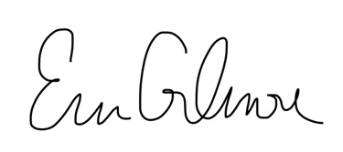

Signature:

Name / Title: Erin Gilmore/ Associate Conference Minister
Email: erin@rmcucc.org
Phone: 801-694-6300
Date: 9/5/2018

This document is created through support to Our Church’s Wider Mission (OCWM) and is only possible through the covenantal relationships of all settings of the United Church of Christ.

“Jesus answered them, ‘Have faith in God!’” – Mark 11:22

