Search and Call Tools for Congregations
Advancing the Spirit’s guidance into God’s future


Rachel Hackenberg
Microsoft
[Pick the date]
INTRODUCING THE NEW
LOCAL CHURCH PROFILE

?
Who is
God calling us to become
Who
is our neighbor
Who
are
we
The new Local Church Profile is not just for congregations in search of a pastor. All congregations are encouraged to engage in its process of discovery every 3-5 years. The UCC Local Church Profile reflects valuable data, assesses ministry, clarifies change, and helps advance the calling of the congregation. Not just to be completed by a search committee – the more participation, the better!
MINISTERIAL EXCELLENCE, SUPPORT & AUTHORIZATION

UNITED CHURCH OF CHRIST
LOCAL CHURCH PROFILE

Zion’s Reformed United Church of Christ
Greenville, Pennsylvania

Settled Pastor

Penn West Conference, Lake Erie Association

[Validation Date]

LOCAL CHURCH PROFILE CONTENTS
- Position Posting
- Who Is God Calling Us To Become?
- Who Are We Now?
- Who Is Our Neighbor?
- References
- Consent and Validation

“God is able to provide you with every blessing, so that
having all sufficiency in all things at all times,
you may abound in every good work.”
(2 Corinthians 9:8)
INSTRUCTIONS

The new Local Church Profile supports the calling and discernment of United Church of Christ congregations with their current or future pastoral leadership.

For many congregations, the interim time between ministers is an intentional season that is guided in part by the preparation of a Local Church Profile. Using the Profile, the church can discover its data and express its story for the reliable discernment of a search committee and the beginning of a new pastorate. Searching ministers will want to see this document in its entirety.

The interim season is not the only time in a church’s life when it’s valuable to give attention to explore a congregation’s vocation. Three sections of the Local Church Profile – WHO ARE WE NOW, WHO IS OUR NEIGHBOR, and WHO IS GOD CALLING US TO BECOME – are meant to be updated every 3-5 years. Known together as the “Discovery Document,” these three sections can be completed by a visioning group, a governing body, a transition team, or other group – not just the search committee – in order to draw forward the gifts and imaginative possibilities of a congregation. The church’s engagement with the “Discovery Document” might not have the same sequence as the completed Local Church Profile that is read by candidates.

Some questions are easy to answer. Some are not so easy. Prompts are provided to stimulate narrative response if needed; these italicized prompts are merely examples from which to choose or to inspire your own. Efforts to answer the questions will prompt conversations and explorations and storytellings and many prayers, and as the Spirit moves throughout the process, congregations will shape a collective articulation of Christ’s leading (WHO IS GOD CALLING US TO BECOME). This last question to be answered becomes the first section to be read by searching ministers in the Local Church Profile, and it is boldest and most actionable piece for faithful leadership into the future.

Your conference can provide materials referenced in the Local Church Profile, such as the 11-Year Report containing data as reported by your congregation annually to the UCC Data Hub and MissionInsite reports containing demographic information on your community. More information on types of pastorate in the United Church of Christ can be found in the Call Agreement Workbook. Be sure to use the Call Agreement Workbook’s Scope of Work to describe in this Local Church Profile the position being sought.

When it is time for ministerial search, the conference can counsel you on posting the Local Church Profile together with your public listing at UCC Ministry Opportunities (http://oppsearch.ucc.org).

The last page of the Local Church Profile contains a statement that parallels the consent statement signed by ministers in the UCC Ministerial Profile. In keeping with the covenantal relationship between a church and those it seeks to call, this statement encourages an open, honest exchange of information. On behalf of the United Church of Christ, and on the basis of the best knowledge available to them, your conference staff will validate your completed Local Church Profile when it is ready to be shared in relationship with prospective new leaders.
POSITION POSTING
LISTING INFORMATION
SCOPE OF WORK
COMPENSATION & SUPPORT
WHO IS GOD CALLING TO MINISTER WITH US?

LISTING INFORMATION

Church name: Zion’s Reformed United Church of Christ
Street address: 260 Main St. Greenville, PA 16125

Additional ecumenical affiliations (e.g. denominations, communions, fellowships):

Conference: Penn West
Association: Lake Erie Association
Rev. David Ackerman, Conference Minister, 724-834-0344, david@pennwest.org

Summary Ministry Description:
In a short paragraph, reflect on where your church is going and what it might look like when you get there. What do you need to get there? Who are you seeking to join you on this part of your church’s faith journey?

As a small town church in western Pennsylvania, we are a group of loving, caring and friendly folk who are proud of our heritage. We are blessed with dedicated members who provide worship, fellowship and service activities. Our members have been conscientious stewards of our resources. We value serving those in need within our community and outside our community. Now we are ready to grow. We are ready for a deeper spiritual journey. We want to find more opportunities to serve our community. We also want to learn how we can develop wider involvement in the United Church of Christ. We hope to attract a settled pastor who will respect and honor our past, and guide us to enrich our spiritual life while we strengthen participation in our conference, association and national church.

Photographs:
Insert 1 – 3 images of your church, its people, its parsonage or building or gathering space, etc.
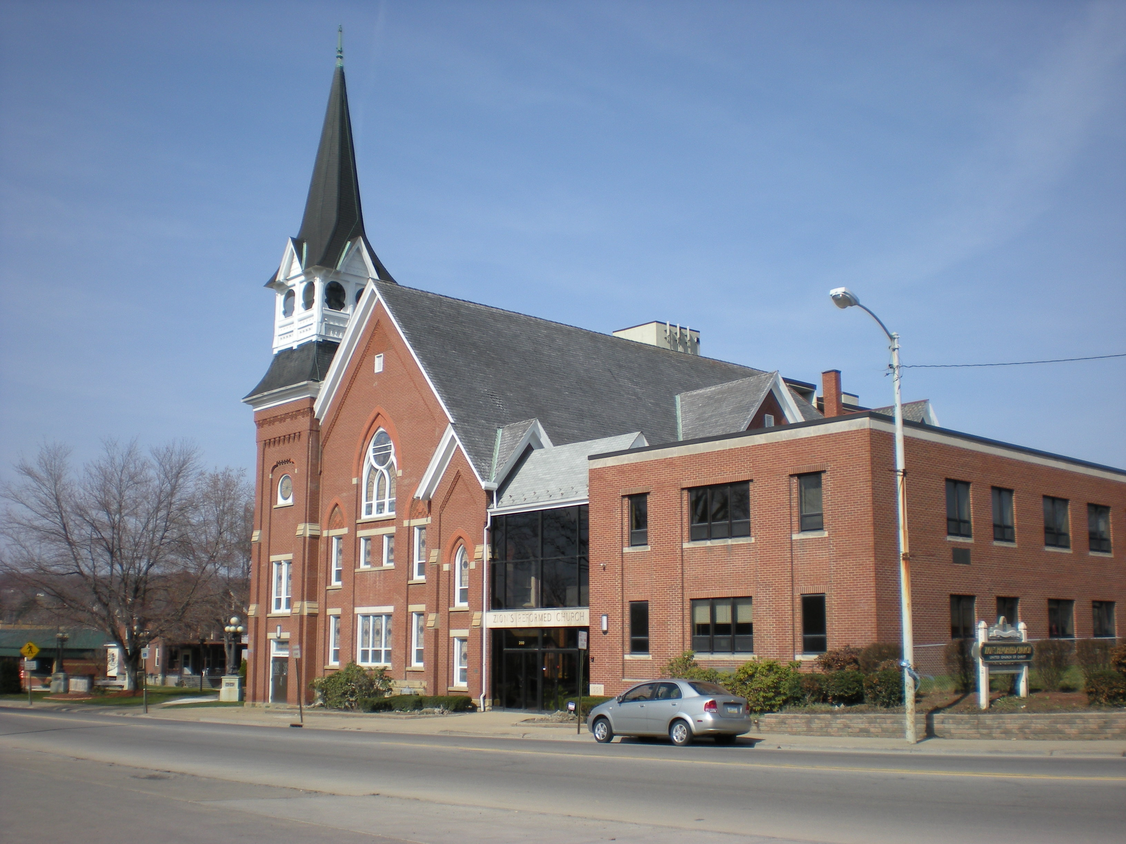
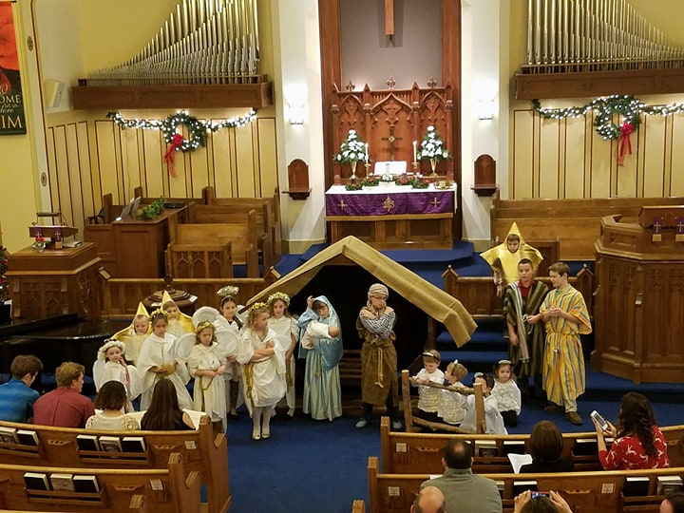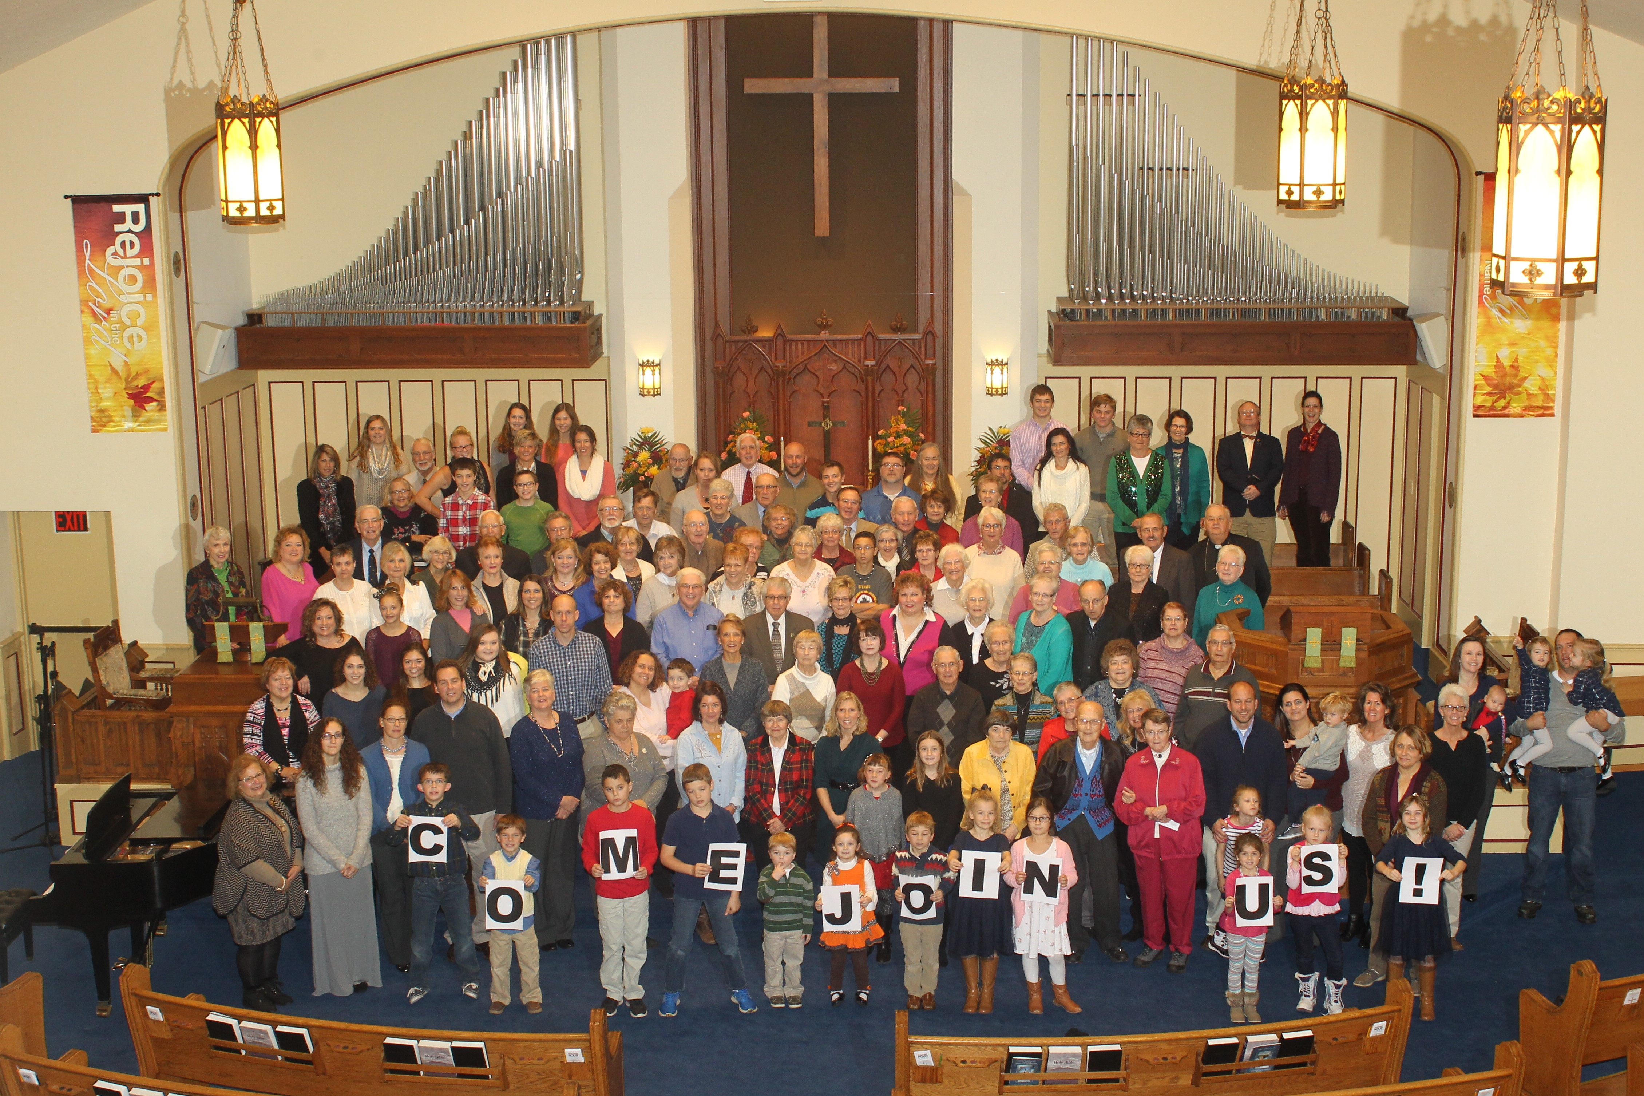
What we value about living in our area (2 – 3 sentences):
We value our small town life that is relaxed and familiar. We know nearly every family in our community and can quickly respond to individual needs. We have access to rural beauty that includes wilderness, mountains and lakes. We can travel easily to Pittsburgh or Cleveland for urban cultural events.

Current size of membership: 450

Languages used in ministry (other than English): Only English

Position Title: Settled Pastor

Position Duration (choose one, delete the other options listed):

Settled – a called position intended for longer-term ministry in which the minister moves church membership to the congregation and moves standing to related association

Compensation Level (choose one, delete the other options listed):
Full Time

Does the total support package meet conference compensation guidelines? Yes

SCOPE OF WORK

The responsibilities of the pastor include conducting services of worship, providing leadership to our Ministries, and building relationships within the congregation. Zion’s is fortunate in that we draw young families, yet sustain our more “seasoned” members. There are multiple generations of families at Zion’s who are active in Sunday School, mission opportunities and fellowship.
Our pastor will lead the Confirmand class, will support exploration for new Bible study opportunities, and will regularly reach out to our ill and elderly home bound members. Our pastor will facilitate Baptism, Marriage and Funeral services. The pastor will lead monthly communion services, and provide services observing Ash Wednesday, Lent, Palm Sunday, Easter, Pentecost, Advent and Christmas. Our pastor will meet with and advise the Consistory and Ministries regularly. The pastor will model community leadership roles, such as the advisory boards of St. Paul’s and the Good Shepherd Center, and will participate in the local Ministerium to guide opportunities for ecumenical service and work.

Core Competencies:
(List three core competencies that you imagine could be foundational in your next minister’s relationship with the church. For example, a church seeking a pastoral care minister might hope to call someone who is caring, sensitive and sociable, while a church seeking an executive minister might want an organized, detail-oriented and time-conscious person.)

We value a pastor who is compassionate, passionate and enthusiastic.

COMPENSATION AND SUPPORT

Salary Basis (from the Call Agreement Workbook, equal to Cash Salary plus Value of Parsonage/Housing Allowance): Range: $62,400 – 70,000.

Benefits (choose one): Salary plus Benefits

What is the expected living situation for your next minister? Living nearby with a housing allowance.

Comment on the residential/commuting expectations for your next minister.

Greenville and surrounding area is small geography. The next pastor could live in the community and easily commute in less than 15 minutes.

State any incentives:

Describe peer and professional supports available for ministers in your association/conference:

The Erie Association is comprised of 6 churches. Penn West Conference has 106 churches.
The local Ministerial Board meets monthly.

If applicable, describe how your church will adopt part-time adjustments in the pastoral schedule to support a minister’s bi-vocational employment:

WHO IS GOD CALLING TO MINISTER WITH US?

Describe the ministry goals you envision your next minister co-collaborating with the congregation to achieve.

We are ready to be challenged by our pastor. We wish to deepen our faith so that we may practice it more fully. We look forward to developing more Mission experiences, for youth and for adults, and hope our pastor will guide us. We want to expand how we address the needs in our community, such as guiding youth to meaningful hope-filled lives.

Describe how your vision of the minister you are now seeking will assist the congregation in making an impact beyond its walls.

Zion’s is ready for a pastor who will empower the congregation to recognize its blessings and strengths and to share those blessings outside the church building.

Specify language requirements or culturally-specific capacities preferred in a next ministerial leader, and why those matter to the congregation’s sense of calling.

There are no language requirements for the next pastor.

Greenville, like much of western Pennsylvania, has rural geography, and primarily a Caucasian population. Many residents have German ancestry and ties to the reformed traditions. Residents relied for decades on the various manufacturing employers related to the steel industry, most of which have now closed. Greenville also is home to a small liberal arts college. Greenville now is focused to redefine itself in order to support and grow the community. The next pastor at Zion’s will honor beloved traditions and inspire the congregation to meet needs in Greenville, and to welcome new customs.

Based on what you have learned about who your church is, who your church’s neighbor is, and who God is calling the church to become, describe four areas of excellence from The Marks of Faithful & Effective Authorized Ministry that your next minister will display to further equip the congregation’s ministry in these areas.

Our next pastor will exhibit a spiritual foundation and ongoing spiritual practice, and will guide our own spiritual growth and discipleship. Our pastor will combine beloved traditions with unfamiliar customs to facilitate a strong faith formation in all the generations. Our pastor will demonstrate caring for all creation through sincere compassion, fostering hope and healing to the world, and by modeling self-care and balance. Our pastor will strengthen relationships inside and beyond our congregation. Our pastor will guide us to look farther outside our walls as we engage in mission and outreach, and as we work toward justice and mercy. Our pastor will raise our own awareness, understanding and commitment to the UCC values of continuing testament, extravagant welcome, and changing lives.

WHO IS GOD CALLING US TO BECOME?
“You shall love the Lord your God with all your heart, and with all your soul, and with all your mind.” (Matthew 22:37 NRSV)

Who is God calling you to become as a congregation?

Describe how God is calling you to reach out to address the emerging challenges and opportunities of your community and congregation.
For example, describe two experiments your congregation has initiated or engaged in the past year, what were the results and where do you see your next steps? Has your church had a multi-year strategic plan or vision statement; if so, where do you see that plan/vision taking you?

Our congregation has a strong commitment to provide food for the community via the Good Shepherd Center. We have collection barrels for general and specific food/school supply drives. We provide ingredients for Holiday Meal baskets that include Christmas, Easter and Thanksgiving. We also participate in preparing and serving meals at the Good Shepherd Center. Most recently, our church participates in the Backpack Project. We donate monetary and hands-on support to provide weekend meals for area elementary students.
Our commitment to multi generation families and children includes support to the AWARE house and to St. Paul’s retirement village.

WHO ARE WE NOW?
“You shall love your neighbor as yourself.” (Matthew 22:39 NRSV)
CONGREGATIONAL REFLECTIONS
11-YEAR REPORT
CONGREGATIONAL DEMOGRAPHICS
PARTICIPATION AND STAFFING
CHURCH FINANCES
HISTORICAL INFORMATION

CONGREGATIONAL REFLECTIONS

Describe your congregation’s life of faith.
For example, what beliefs and commitments are stated in your congregation’s purpose statement or membership vows? How is God most often described in worship liturgy? In what ways would you describe the Holy Spirit in your midst?

In worship service, we sing that God is awesome. God reigns with wisdom, power and love. By story, music and practice, we are reminded of God’s gifts of love that we may share with each other and serve those around us. We are encouraged to experience, and to celebrate, joy, hope and love.

Describe several strengths or positive qualities of your congregation.

We, as a congregation, are warm and inviting. Members are dedicated to take care of each other and the community needs with little expectation for acknowledgement. Members provide food, personal items, school supplies, gifts and other specialized items to be distributed by the Good Shepherd. Members provide fellowship to ill and elderly shut-ins. We welcome other area churches and participate in several ecumenical services through the year. We want to learn more about being United Church of Christ.

Describe what worship is like when your congregation gathers.
For example, where does worship take place, and what is it based around? What was a recent baptism like? What are some words used to describe good preaching?

We use the sanctuary for the majority of worship services. We use the chapel for special services. Worship that inspires and challenges our congregation includes every day examples of how we are blessed and loved by God. We respond to a sermon that is enthusiastic and conversational in style. We want to be encouraged to share God’s love with each other and with those outside Zion’s doors. Nearly all aspects of the service relate to and support the day’s lesson. Music, both that sung by the congregation and that presented by the choir, references the day’s liturgy. The sermon expands the gospel so we understand how to appreciate, nurture and share our faith in everyday life. The sermon makes sense. We can understand how to apply our faith to our lives.

Describe the educational program/faith formation vision of your church.
For example, how are young people in leadership? How do people continue to form their faith over a lifetime? Name a topic studied or curriculum used recently; what was the impact of this study on those who attended?

We want our children, youth and adults to be inspired for a lifelong faith journey that includes study, thoughtful discussion and daily application. We want all members to participate and to feel they have a purpose in God’s world and church. Starting with acolytes, the youth are encouraged to participate in Sunday services. We look forward to Youth Sunday when the Confirmands lead service. We appreciate the youth who continue to serve with the adults as ushers, lay readers and communion.

Describe how your congregation is organized for ministry and mission.
For example, how are decisions communicated in your church? How are teams or committees organized? Where does your church struggle for vision?
- When it comes to decision-making, how many hours are spent in meetings per month?
The Consistory includes 12-16 members who are elected by the congregation to fill rotating 3 year offices. Consistory members lead ministries that include Finance, Welcoming & Fellowship, Service & Missions, and Youth & Education. Each ministry meets 2 hours monthly.
- Think of a time when action had to be taken quickly, for example when a crisis or disaster occurred. How was that accomplished?
Summer 2016. A local building in downtown Greenville was crumbling and fell onto the Good Shepherd Center, rendering it dangerous and condemned. Zion’s offered temporary space for Good Shepherd to continue its ministry of Community Clinic.
- Can you provide the next minister with a copy of an organization structure, bylaws and/or annual report to further explain the patterns of the church’s activity and governance? Yes

11-YEAR REPORT
(add here the 11-Year Report developed with the help of your conference staff, UCC Data Hub, and MissionInsite)

 |  |  |  |  |  |  |  |  | https:lldatahub.ucc.orglReportslElevenYearChurchReport.aspx
Church#: | 620940
Assoc: | 652 | Schedule: 0 | Zions Reformed UCC |  |  |  |  | Greenville | PA | 16125
 |  | AVGWEEKLY | CHRED/ |  |  |  | TRANSFEROR |  | DEATHS OR | OTHER | NETMEMBS
YEAR | MEMBERS | ATTENDANCE | FAITH FORM | CONFIRMATION |  | CONFESSfON |  | REAFFIRM | TRANS OUT | LOSSES | ADDS-REMOVED
2006 | 807 | 225 | 30 |  |  |  |  | 0 |  | 0
2007 | 807 | 225 | 30 |  |  |  | 0 | 0 | 0 | 0
2008 | 811 | 225 | 30 |  |  |  | 0 | 0 | 0 | 0
2009 | 811 | 225 | 30 |  | 0 |  | 0 | 0 | 0 | 0 | 0
2010 | 810 | 200 | 50 |  | 13 |  | 4 | 0 | 18 | 0 | -1
2011 | 810 | 200 | 50 |  | 0 |  | 0 | 0 | 0 | 0 | 0
2012 | 810 | 200 | 50 |  | 0 |  | 0 | 0 | 0 | 0 | 0
2013 | 792 | 175 | 40 |  |  |  | 0 | 0 | 18 | 0 | -18
2014 | 773 | 150 | 40 |  | 11 |  |  | 7 | 11 | 0 | 7
2015 | 766 | 150 | 40 |  |  |  |  |  | 8 | 0 | -7
2016 | 768 | 150 | 40 |  | 0 |  | 13 | 0 | 11 | 0 | 2
 | CURRENT | CAPITAL | BASIC | SPECIAL | TOTAL |  | OTHER | WIDER | BASICSUPP | TOTAL | PLEDGES AND
YEAR | EXPENSES | PAYMENTS | SUPPORT | SUPPORT | OCWM |  | GIFTS | MISSION | CURR LOCAL | EXPEND | OFFERINGS
2006 | $280,596 | $0 | $8,004 | $2,546 | $10,550 |  | $0 | $10,550 | 2.85 | $291,146 | $0
2007 | $280,596 | $0 | $8,004 | $1,107 |  | $9,111 | $0 | $9,111 | 2.85 | $289,707 | $0
2008 | $280,596 | $0 | $8,004 | $3,573 | $11,577 |  | $0 | $11,577 | 2.85 | $292,173 | $0
2009 | $280,596 | $0 | $8,004 | $1,683 |  | $9,687 | $0 | $9,687 | 2,85 | $290,283 | $0
2010 | $263,214 | $0 | $8,004 | $3,289 | $11,293 |  | $16,700 | $27,993 | 3.04 | $291,207 | $264,289
2011 | $263,214 | $0 | $8,004 | $2,254 | $10,258 |  | $0 | $10,258 | 3.04 | $273,472 | $0
2012 | $263,214 | $0 | $5,417 | $0 |  | $5,417 | $0 | $5,417 | 2.06 | $268,631 | $0
2013 | $293,313 | $0 | $4,959 | $813 |  | $5,772 | $19,168 | $24,940 | 1.69 | $318,253 | $229,915
2014 | $355,283 | $0 | $5,750 | $0 |  | $5,750 | $3,738 | $9,488 | 1.62 | $364,771 | $216,000
2015 | $364,707 | $0 | $5,750 | $6,696 | $12,446 |  | $2,533 | $14,979 | 1.58 | $379,686 | $211,323
2016 | $364,707 | $0 | $5,750 | $799 |  | $6,549 | $0 | $6,549 | 1.58 | $371,256 | $0
Please note: Zero values ("0" or "$0") may reflect missing information in some years. Christian Education/Faith Formation refers to Church School Enrollment for all figures before
2007.

CONGREGATIONAL DEMOGRAPHICS

Describe those who participate in your church.
 |  | Is this number an estimate? (check if yes)
Number of active members: | 160 | Yes
Number of active non-members: | 8 | Yes
Total of church participants (sum of the numbers above): | 168 | Yes

Percentage of total participants who have been in the church:
 |  | Is this number an estimate? (check if yes)
More than 10 years: | 75 % | Yes
Less than 10, more than 5 years: | 19% | Yes
Less than 5 years: | 6% | Yes
Number of total participants by age:
0-11 | 12-17 | 18-24 | 25-34 | 35-44 | 45-54 | 55-64 | 65-74 | 75+ | Are these numbers an estimate? (check if yes)
30 | 20 | 3 | 25 | 20 | 10 | 10 | 20 | 65 | Yes

Percentage of adults in various household types:
 |  | Is this number an estimate? (check if yes)
Single adults under 35: | 5 | Yes
Joint household with minors: | 20 | Yes
Single adults age 35-65: | 5 | Yes
Joint household with no minors: | 35 | Yes
Single adults over 65: | 25 | Yes

Education level of adult participants by percentage:
 |  | Is this number an estimate? (check if yes)
High school: | 30 | Yes
College: | 60 | Yes
Graduate School: | 10 | Yes
Specialty Training:
Other (please specify):

Percentage of adults in various employment types:
 |  | Is this number an estimate? (check if yes)
Adults who are employed: | 60 | Yes
Adults who are retired: | 30 | Yes
Adults who are not fully employed: | 10 | Yes

Describe the range of occupations of working adults in the congregation:

Occupations in Greenville are split between retired, blue collar and white collar jobs. Employed adults work in education, the medical profession, and manufacturing.

Describe the mix of ethnic heritages in your congregation, and the overall racial make-up. Most UCC congregations tend to describe themselves as “diverse.” Yet, the vast majority of UCC congregations are mono-cultural. What does diversity mean in your context?

The congregation in Zion’s in mono-cultural. Many Zion’s congregation members have German ancestry and ties to the reformed traditions.

Has your congregation recently had a conversation about welcoming diversity, or do you plan to hold one on the near future (perhaps using, for example, the Welcoming Diversity Inventory)? Please note the date. Comment after the exercise: We have not had this conversation.

PARTICIPATION AND STAFFING

Complete the following chart. Please leave blank any fields that are not applicable to your congregation.
Ways of Gathering | Estimated number of people involved in attendance | Who plans each of the listed gatherings? (list any and all worship planners, such as various lay leaders, pastors, musicians, other staff)
Adult Groups or Classes | 10 per group | Ministry of Christian Ed., Pastor
Baptisms (number last year) | 8 | Min. of Worship & Music, Pastor
Children’s Groups or Classes | 18 | Youth Ministry
Christmas Eve and Easter Worship | 200 | Dir. Of Music Min., Pastor
Church-wide Meals | 100 | Min. of Welcoming and Fellowship
Choirs and Music Groups | 18 | Dir. Of Music Min., Pastor
Church-based Bible Study
Communion (served how often?) | 140 served monthly
Community Meals | 40 | Min. of Service and Missions
Confirmation (number confirmed last year) | 10 -15 every 2 years | Pastor and more recently, Mentors
Drama or Dance Program
Funerals (number last year) | 10 | Pastor
Intergenerational Groups
Outdoor Worship
Prayer or Meditation Groups | 10 | Prayer Chain Participants, Pastor
Public Advocacy Work
Retreats
Theology or Bible Programs in the Community
Weddings (number last year) | 3 | Pastor
Worship (time slot:10:30 am) | 145
Worship (time slot: _______)
Young Adult Groups or Classes
Youth Groups or Classes | 20
Other
Additional comments:

List all members or regular participants in your congregation who are ordained, licensed, or commissioned ministers. Indicate those with current United Church of Christ Three-Way Covenants (i.e. serving in a congregation) or Four-Way Covenants (i.e. serving in a ministry beyond a congregation).
Name | Three- or Four-Way Covenant?  (3 or 4 or No) | Ministry Setting | Type of Ministry Role | Retired?  (Y or N)
Robert Kobele | No |  |  | yes
Glenn Sadler | No |  | Supply/visitation as needed | yes
If one or more previous pastors or retired ministers currently hold membership in the church, describe their role(s) in the life of the congregation:
List all current staff, including ministers. Exclude the position you are seeking to fill. Indicate which staffperson serves as head of staff.
Staff Position | Head of Staff? | Compensation (full time, part time, volunteer) | Supervised by | Length of Tenure for current person in this position
Office Manager/Project Coordinator  Custodian |  | Full time  Full time | Pastor  Pastor | 20 years  10 years
Director of Music Ministries  Director or Pre-School |  | Part time  Part time | Pastor  Pastor | 7 years  25 years
Treasurer  Parish Nurse |  | Part time  Volunteer | Pastor  Pastor | 1 year  10 years

REFLECTION
Reflection: After reviewing the congregational demographics and activities above, what does this information reflect about your congregation’s overall ministry?
We are committed to children, to music in worship, to health and wellness and to building stewardship.

CHURCH FINANCES

Current annual income (dollars used during most recent fiscal year)
Source | Amount
Annual Offerings and Pledged Giving | $228,000.
Endowment Proceeds (as permitted within spending policy, such as a cap of typically 4.5%-5% on total return) | $0
Endowment Draw (beyond what is permitted by spending policy, “drawing down the principal”) | $0
Fundraising Events | $3600.
Gifts Designated for a Specific Purpose | $3400.
Bequests | $61,000.
Rentals of Church Building | $7600.
Rentals of Church Parsonage | $0
Support from Related Organizations  (e.g. Women’s Group) | $0
Transfers from Special Accounts | $23,500.
Other (specify): | $0
Other (specify): | $0
TOTAL | $327,100.

Current annual expenses (dollars budgeted for most recent fiscal year): $318,000.
Attach most recent church budget, spending plan, operating statement, or annual treasurer’s report as shared publicly with the congregation, or – if your church does not pass an annual budget – list current budgeted expenses here.

Considering total budgeted expenses for the year, compare total ministerial support. What is the percentage? 22%

Has the church ever failed to pay its financial obligations to a minister of the church? No

Is your church 5-for-5, i.e. does it include each of the following contributions during the church year? (indicate those included during the most recent fiscal year)
_X_ Our Church’s Wider Mission (OCWM – Basic Support)
_X_ One Great Hour of Sharing
__ Strengthen the Church in 2018
_X_ Neighbors in Need
__ Christmas Fund in 2018

In what way is OCWM (Basic Support) gathered? If calculated as a percentage of operating budget, what is that percentage? (recommended 10%) 2%

What is the church’s current indebtedness?
Total amount of loan debt: 0
Reason for debt:
Are capital and other payments current?

If a building program is projected or underway, describe it, including the projected start/end date of the building project and the total project budget.
There is no current building project.

If the church has had capital campaigns in the last ten years, describe:
Year(s) | Purpose | Goal | Result | Impact
2014 | Updated the lighting and carpet in the sanctuary | $35,000 | $35,000 | The sanctuary is brighter.
 |  | $ | $
If a capital campaign is underway or anticipated, describe:
Year(s) | Purpose | Goal | Result | Impact
 |  | $ | $
 |  | $ | $
Describe the prominent mission component(s) involved in the most recent (or current) capital campaign.
We wished to enhance our worship.

Does your church have an endowment? Yes

What is the market value of the assets? $78,334.

Are funds drawn as needed, regularly, or under certain circumstances? Funds are drawn under certain circumstances.

What is the percentage rate of draw (last year, compared to 5 years ago)? None

Describe draw on endowment, if any, to meet operating budget expenses for the most recent year and the past five years: N/A

At the current rate of draw, how long might the endowment last? N/A

Please comment on the above calculations or estimates: We have a separate account with $30,000 to draw for operating expenses.

Other Assets

Reserves (savings): $0

Investments (other than endowment): $100,000: future projects, $100,000: scholarships, $52,000: youth
Does your church have a parsonage? No

Fair market rental value of the parsonage: N/A
How is the parsonage used?
Street / City / State / Zip:
Finished square footage:
Number of Bedrooms, Number of Bathrooms:
Assessed real estate value:
Available for minister residence: Y/N
Expected minister residence: Y/N
Condition of structure, systems and appliances
Entity in the church responsible for review and needed repairs

Describe all buildings owned by the church: The church building includes the sanctuary building that is attached to a 2 1/2 story education wing, with classrooms and offices. The lowest level includes multipurpose fellowship rooms, kitchen and furnace room. The property includes a shed.

Describe non-owned buildings or space used or rented by the church:

Which spaces are accessible to wheelchairs? (worship space, pulpit, fellowship space, facilities, etc.)
Spaces on the ground, worship and education levels are accessible by elevator for wheelchair use.

Reflection: After reviewing the church’s finances and assets described above, what does this information reflect about your congregation’s mission and ministry?
For example, when was a time the church made a major budget change? How is the budgeting process done? What new ministry initiative has your church financed?

In order to fill a strong role in the Greenville community, Zion’s is committed to balance and fiscal responsibility. We review the stewardship annually to create the budget and guide the necessary expenses. We will sponsor short term campaigns for building updates, such as carpet and lighting in the sanctuary. We take care of the property in our care so that we may provide space for community organizations such as AA and Strong Women.

HISTORICAL INFORMATION

Name one to three significant happenings in the history of your church that have shaped the identity of your congregation. Add the most important event in the life of your church in the past 10 years.

We have long commitment to the community, the youth and elderly. In February 1909, under Rev. Keifer, we moved the St. Paul’s Orphanage from Butler to Greenville.
In the 1930s we moved the “old folks home” from Main Street to Eagle Street to the St. Paul’s facility on Jamestown Road. In the 1970s, we purchased the old Penn High School building, and then sold it to permit construction for building the Greenville House, an apartment building for seniors. In the 2000s we purchased Zion’s Community Preschool to serve area families.
Since 2016 when the Good Shepherd Building was destroyed, we have hosted the
Community Clinic. We provide space for other community groups such as AA and Scouts.

Describe a specific change your church has managed in the recent past.

We continue to meet the needs of the community as economic changes impact the area. Good Shepherd: 25 area congregations collaborate to support the Good Shepherd Center for over two decades. In the beginning, Zion’s provided seed money to create an emergency shelter. Over time, the Good Shepherd has evolved to provide many needs that include food pantry, meal program, thrift store, community clinic. Zion’s continues to participate in the Good Shepherd with volunteers, financial support and Advisory Board. Zion’s also provides financial support and Advisory Board support for St. Paul’s, a continuing care retirement community.

Every church has conflict, some minor, some larger. “Where two or three are gathered, there will be disagreement….” Describe your congregation’s values and practices when it comes to conflict.
For example, what is an example of a recent conflict and something your congregation learned from it? Describe an occasion when your church experienced conflict without being able to resolve it well. Does your church have policies, protocols or structures for dealing with conflict?)

We have few serious conflicts in our history. When conflicts do arise, we strive to pull together. In the early 1990s, we called a new pastor. The congregation soon felt this was a mistake as Mr. O’Connor seemed to have an authoritarian leadership style that was “my way or not at all.” Many congregation members felt he disrespected and split families. The congregation called for a vote to remove the pastor and he left. This was a painful experience for many and the congregation understood the need to follow a formal interim process, in order to heal from the experience. We began intentional fellowship that included coffee hour following church service, and the monthly newsletter, “Zion’s Alive.” We enjoy many fellowship meals that celebrate our congregation and support ministries such as Youth Mission trips.
There was a conflict early 2000s, over music style. Several choir and congregation members were concerned by the conflict. The Music Director, Frank Stearns left the music director position.

Ministerial History (include all previous ministerial staff for the past 30 years)

Staff member’s name | Years of service | UCC Standing (Y/N)
Philip Garner | 1993 - 2016 | Y
John Clausing (Interim) | 1992 - 1993 | Y
Thomas O’Connor | 1990 - 1991 | Y
Robert Nace | 1963-1990 | Y

Comment on what your church has learned about itself and its relationship with persons who provided ministerial leadership:

We have developed close and loyal relationships with the pastors. We will not tolerate leaders who are divisive.

Has any past leader left under pressure or by involuntary termination?
Yes. The congregation held a formal meeting and asked Mr. O’Connor to leave. The congregation takes care of conflicts before they become polarizing.

Has your church been involved in a Situational Support Consultation?
No

Has a past pastor been the subject of a Fitness Review while at your church?
No

WHO IS OUR NEIGHBOR?
“You shall love your neighbor as yourself.” (Matthew 22:39 NRSV)
COMMUNITY VISION
MISSION InSite

COMMUNITY VISION

How do the relationships and activities of your congregation extend outward in service and advocacy?
Zion’s serves Greenville by continuing to provide space for the Good Shepherd Community Clinic. Zion’s contributes to the Backpack Program, Good Shepherd Center and to AWARE. Zion’s provides financial support and board participation for the Good Shepherd Center and for St. Paul’s, a continuing care retirement community.
In the past 10 years, Zion’s has sponsored several mission trips for adults and for youth. This includes the confirmand’s trips to Boston, an adult mission trip to Pine Ridge, a youth trip to West Virginia, and a planned multi-generational mission trip to Baltimore, Maryland.

For example, which service activities has your church participated in this past year? Where has the church participated in global connections of care and justice? What is currently transformational in your church’s engagement with neighbors near or far?

Describe your congregation’s participation in meetings, relationships and activities connecting the wider United Church of Christ (association / conference / national setting).

Zion’s members attend Association and Conference meetings annually. 6 Zion’s members participated in the Penn West Conference meeting in 2017.

Many local churches love to tell the story of what they are doing in the community to transform lives. Some have identified certain aspects of their witness into the wider community using language shared with other UCC congregations. (Find more information as desired at ucc.org.) Check any statements below that apply to your UCC faith community.

__ Accessible to All (A2A)
__ Creation Justice
__ Economic Justice
__ Faithful and Welcoming
__ God Is Still Speaking (GISS)
__ Border and Immigrant Justice
__ Inter-cultural/Multi-racial (I’M)
__ Just Peace
_X_ Global Mission Church
__ Open and Affirming (ONA)
__ WISE Congregation for Mental Health
__ Other UCC designations:
__ Designations from other denominations
_X_ 3 Great Loves

Reflect on what the above statement(s) mean(s) to your community. Is your congregation interested in working toward any of the above statements of witness in the near future?

Zion’s congregation is learning of the witness opportunities available. We anticipate increased participation in one or more above statements as we understand. We have members who are interested to learn more about the above ministry statements.

Describe your congregation’s participation in ecumenical and interfaith activities (with other denominations and religious groups, local and regional).

We sponsored an ecumenical hymn sing January 2018.
We participate in an ecumenical Good Friday service each Holy Week.
Our pastor has a history of participation in the local ministerial planning and support group.
We participate in National Day of Prayer.
We participate in an ecumenical Thanksgiving Eve service.

If your congregation has a mission statement, how does that mission statement compare to the actual time spent engaging in different activities? Think of the range of activities from time spent gathering, to governance, to time spent going out.

Zion’s Mission Statement: The mission of Zion’s Reformed United Church of Christ is to support all people to live a life of worship, fellowship and service to others through the teachings of Jesus Christ, Son of God and Savior.

Zion’s does provide many opportunities for members of all ages to develop their Christian Life in worship, fellowship and service, such as meals for Good Shepherd and mission trips.

Reflect on the scope of work assigned to your pastor(s). How is their community ministry and their ministry in and on behalf of the wider church accounted for in the congregation’s expectations on their time?

Our congregation supports the pastor’s efforts to visit home bound elderly and hospitalized. The pastor also has a strong relationship with the ministerial board and creating opportunities for ecumenical service. The pastor attends association and conference meetings and empowers members to attend, participate and share with the greater congregation.

MISSION InSite

Comment on your congregation’s MissionInsite report with data for your neighborhood(s) or area. What trends and opportunities are shown?

Zion’s reflects the neighborhood trends in Greenville. Both general population in Greenville and Zion’s membership have declined slowly in the past decade. There are many members in the oldest generation, and there is a growing interest for younger families. The middle generations seem sparse. This likely is due to loss of industry and commerce in the 1980s and 90s that led to families moving away. The neighborhoods close to the church building tend to be at or below poverty level.

How do your congregation’s internal demographics compare or contrast to a) the neighborhoods adjacent to your church, and b) other neighborhoods with which your church connects?

Most Zion’s members and families live within the Greenville Borough. Some long term families live in the Jamestown and Shenango areas. Residents of the poorest neighborhoods generally do not attend Zion’s.

How are the demographics of the community currently shaping ministry, or not?

Zion’s responds to the needs of children and families living in poverty via the Backpack Program and the Good Shepherd Center.

What do you hear when you talk to community leaders and ask them what your church is known for?

People are becoming more interested in the life and happenings in Zion’s church. People who visit Zion’s Sunday services like the enthusiasm, the music and the inclusion of children and families.

What do new people in the church say when asked what got them involved?
New people are excited by the renewed interest for the children. Folks are inspired to try new things. People like the enthusiasm of music and worship service.

REFERENCES

Name up to three people who have agreed to serve as phone and written references. Advise the three references: “The contact information you provide may be shared publicly. Please use contact information that you feel comfortable giving to candidates so they can reach you with their questions.”

Make sure they are not members of your church but are persons who know your church well enough to be helpful to candidates seeking more information. Request a letter from each reference in answer to the four prompts below. Attach the letters (up to three) as desired.

REFERENCE 1
Bill Kirker
Director of Spiritual Services, St. Paul‘s Senior Living Community
724-588-7610 wkirker@sp1867.org

I am pleased to share with you my perceptions regarding Zion’s Reformed United Church of Christ. In my role as the Director of Spiritual Services of St. Paul’s Senior Living Community in Greenville, PA, I interact with Zion’s Reformed in various ways. Their pastor and members of their congregation visit members who are now residents of St. Paul’s and several times a year a team comes to St. Paul’s to offer a special service and time of fellowship with Zion’s members who are now our residents. The pastor is an active member of the Greenville Area Christian Ministers Association and I have co-officiated with their former pastor at funerals.
Among the strengths of the church is their commitment to worshiping the Lord, ministry to members of the church, especially during challenging times, and service to the wider Body of Christ and the Greenville community. Zion’s is helping to raise up the next generation in Christ through their outstanding pre-school and their facilities house a community medical clinic, a ministry of the Good Shepherd Center, a local ministry that serves the needs of many who have financial and other needs.
A wise pastor once told me that if I ever found a perfect church not to join it, because it would no longer be perfect. While I am not aware of areas in need of improvement at Zion’s, I will yield to this wise pastor and say that churches are always seeking ways to improve their service to both their members and the body at large. This is evident with Zion’s.
In my role as Director of Spiritual Services, I have observed some of the gatherings that they have had with members who are our residents. There is time for worship and fellowship and these times help to maintain the bond with members who are no longer able to be with the congregation each Sunday but continue to desire to be a part of the congregation and maintain long-time relationships there.
Sincerely,
Pastor Bill Kirker
Director of Spiritual Services

REFERENCE 2
David Dobi / Senior Pastor, First Presbyterian Church Eco
724-588-6520 office@fpcgreenville.com

Zion’s Reformed Church, UCC, 260 Main St., Greenville, PA, is known first to me as a good Main St. Neighbor. Small town Main St. Is a hard place to live well. Visibility alone is difficult to manage in the best ways. When there are neighbors who share similar values (including integrity and competence) I am immediately glad to know those neighbors, and to celebrate their presence.
Zion’s Church is a welcome ministry partner. Our shared interest in service to Christ, the Church, and our community involving pre-school age children and participation in the important works of The Salvation Army and The Good Shepherd Center gives convincing evidence of that which we accomplish together that could not otherwise be addressed in the same ways.
There is encouragement for me to find an outward-looking vision for ministry at Zion’s, resisting things insular that take over so much of life in our western Pennsylvania communities engaged with a perceived shortage of just about every imaginable resource.

If there is one thing for which I wish, it would be opportunity to do more things together - to maximize shared resources, to address openly issues of unholy duplication of effort.
Any of the things above I know because I know Zion’s church folk, one more place I find the salt of the earth - reliable, dependable, gifted, dedicated ones - who live simply, love generously, care deeply, speak kindly - and leave the rest to God.
David A. Dobi, Senior Pastor
First Presbyterian Church ECO, Greenville

REFERENCE 3
Scott Hodge
Retired Greenville Resident
724-866-5034
My wife and I are retired and have been attending Zion’s UCC for 5 months on a regular basis. We have been lifelong residents of the Greenville Community.
Prior members:
- Hillside Presyterian Church
- Elder
- Member of Shenango Presbytery Committee on Ministry
- 1st United Methodist Church
- Member of Council of Ministries
- Salvation Army Advisory Board
Involved in community:
- School Board Member
- Numerous Business Organizations
- Kiwanis Club
We have witnessed United Church of Christ ministry in the community as an organization. Individual members are also active in the community and we consider that as a great strength of the church.
Like many mainstream churches in the area, Zion’s has lost attendance due to attrition and the lack of young families‘ attendance. There is a need to make an effort to reach the non-churched and non-active families in the area.
Zion’s is a very welcoming church with a dignity regarding worship. The music program is a real asset to the quality of worshp. Involvement of the youth in the worshp service and programs of the church is very apparent to the visitor and shows the value Zion’s has placed on that mission. This commitment to youth can be a real drawing card to families if they become aware of that asset. The pre-school program Mommy & Me has been a community outreach that had a positive effect on many families.
It is an honor to have been asked to be a reference by this committee.
Scott Hodge

CLOSING THOUGHTS
CLOSING PRAYER
STATEMENT OF CONSENT
CONFERENCE/ASSOCIATION VALIDATION

CLOSING PRAYER

Include here any prayer or dream for the minister you imagine journeying toward you… a poem, for example, or a Scripture passage or a piece of music that is meaningful to your Search Committee:

Ephesians 4:11-15 The gifts he gave were that some would be apostles, some prophets, some evangelists, some pastors, and teachers, to equip the saints for the work of ministry, for building up the body of Christ, until all of us come to the unity of the faith and of the knowledge of the Son of God, to maturity to the measure of the full stature of Christ. We must no longer be children, tossed to and from and blown about by every wind of doctrine, by people’s trickery, by their deceitful scheming. But speaking the truth in love, we must grow up in every way into him who is the head, into Christ, from whom the whole body, joined and knit together by every ligament with which it is equipped, as each part is working properly, promotes the body’s growth in building up in love.
STATEMENT OF CONSENT

The covenantal relationship between a church and those called by that church to serve as pastors and teachers and in other ministerial positions is strengthened when vital information is openly shared by covenantal partners. To that end, we attest that, to the best of our abilities, we have provided information in this profile that accurately represents our church. We have not knowingly withheld any information that would be helpful to candidates.
As the committee charged with the responsibility for identifying and recommending suitable new minister for our church, we have been authorized to share the information herein with potential candidates. We understand that a candidate may wish to secure further knowledge, information, and opinions about our church. We encourage a candidate to do so, recognizing that an open exchange of relevant information builds the foundation for continuing and healthy relationships between calling bodies and persons seeking a ministry position.

- Which individuals and groups in the church contributed to the contents of this Local Church Profile? (for example, church council or consistory, transition team, etc.)

Seven volunteers comprised two committees, the Survey committee and the Profile Committee to create this document. The Search Committee was commissioned to use this for guidance.

- Additional comments for interpreting the profile:

Signed:
Name / Title / Date:
VALIDATION BY CONFERENCE/ASSOCIATION

The congregation is currently in good standing with the association / conference named.
Staff Comment:

To the best of my knowledge, ministerial history information is complete.
Staff Comment:

To the best of my knowledge, available church financial information is presented thoroughly.
Staff Comment:

My signature below attests to the above three items.

Signature:
Name / Title:
Email:
Phone:
Date:

This document is created through support to Our Church’s Wider Mission (OCWM) and is only possible through the covenantal relationships of all settings of the United Church of Christ.

“Jesus answered them, ‘Have faith in God!’” – Mark 11:22

