**LOCAL CHURCH PROFILE**



St. Mark’s United Church of Christ

Cressona, Penna.

Full Time Pastor

Pennsylvania South East, Association: Schuylkill

[Validation Date] 05/17/17

**LOCAL CHURCH PROFILE CONTENTS**

Position Posting

Who Is God Calling Us To Become?

Who Are We Now?

Who Is Our Neighbor?

References

Consent and Validation

*“God is able to provide you with every blessing, so that*

*having all sufficiency in all things at all times,*

*you may abound in every good work.”*

*(2 Corinthians 9:8)*

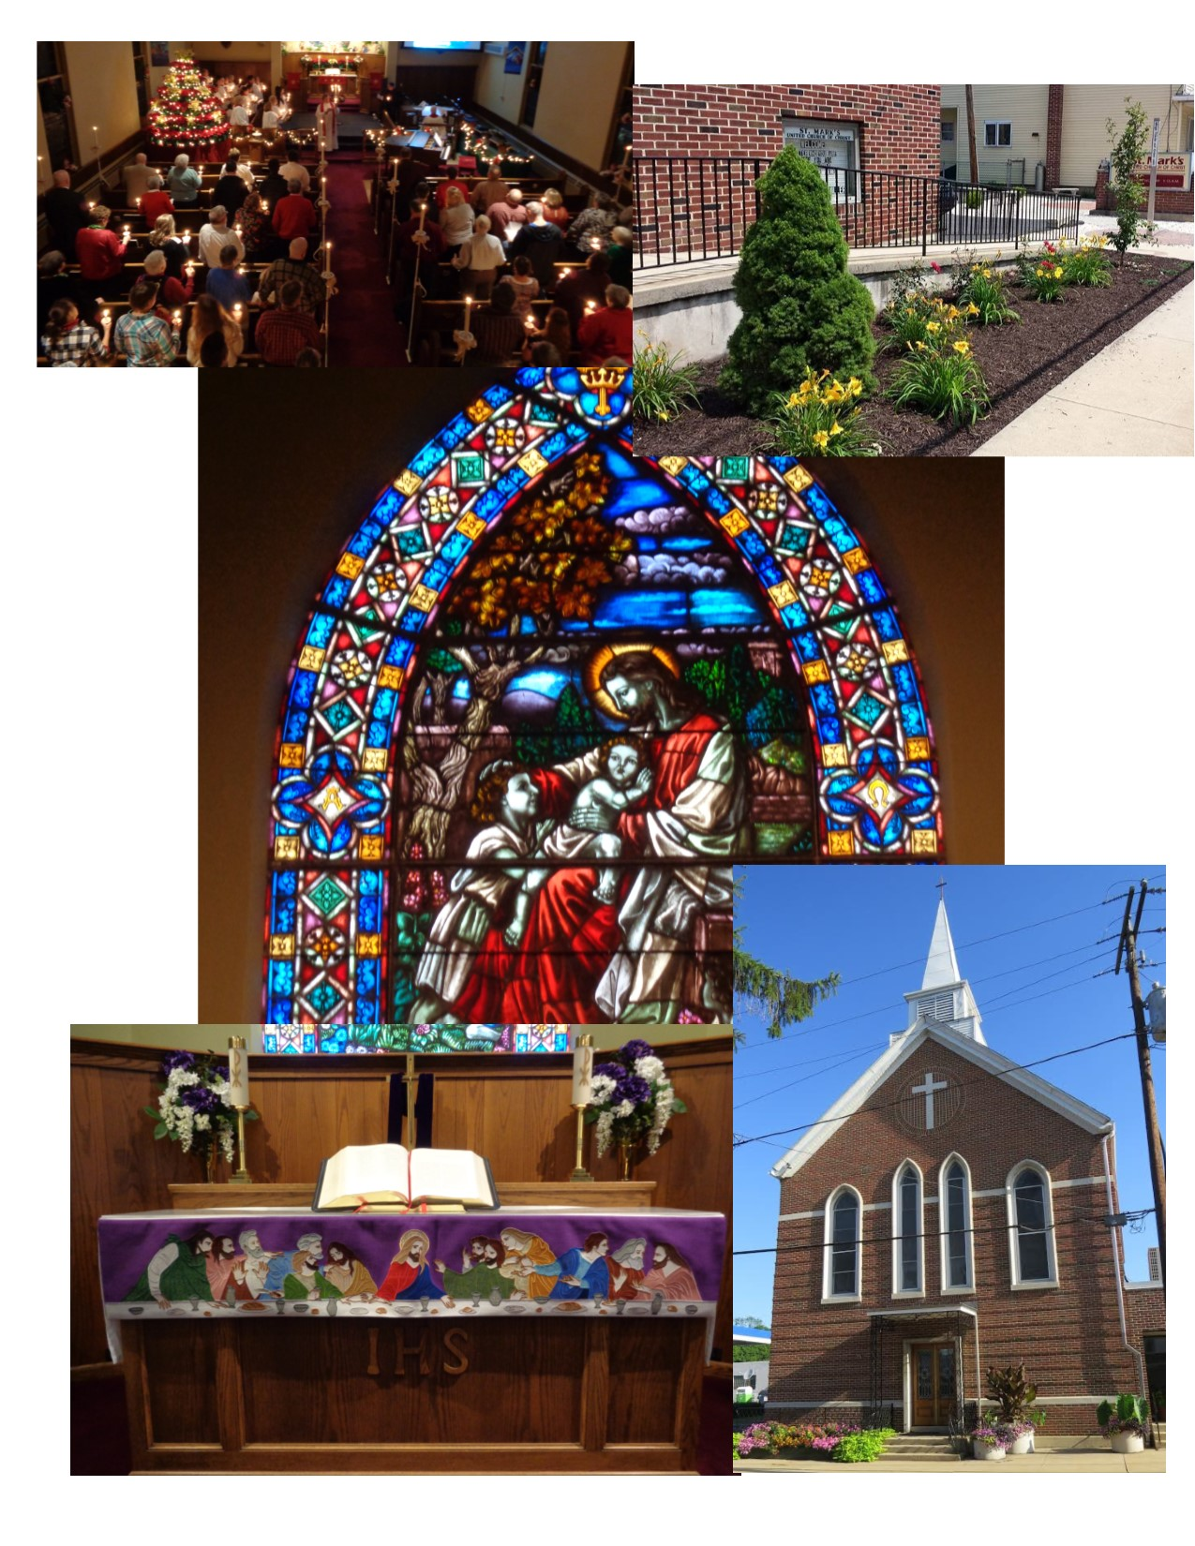

**POSITION POSTING**

LISTING INFORMATION

SCOPE OF WORK

COMPENSATION & SUPPORT

WHO IS GOD CALLING TO MINISTER WITH US?

LISTING INFORMATION

Church name: St. Mark’s United Church of Christ

Street address: 30 Pottsville Street, P O Box 55

Supplemental web links: [www.stmarksucccressona.org](http://www.stmarksucccressona.org)

stmarkscressona@verizon.net

Additional ecumenical affiliations:

Schuylkill Haven & Vicinity Council of Churches

Conference: Pennsylvania Southeast Conference of The United Church of

Christ

Association: Schuylkill

UCC Conference or Association Staff Contact Person

Name: Rev. Sharon Morris

Title: Associate Conference Minister

Phone: 484-949-8774 X 302

Email: MORRIS@PSEC.ORG

Summary Ministry Description:

St Mark’s is a congregation that is mindful of our roots while at the

same time nurtures our current needs while keeping an eye ever on

our future.

We are seeking a leader who will partner with us while giving us

guidance and direction on our faith journey.

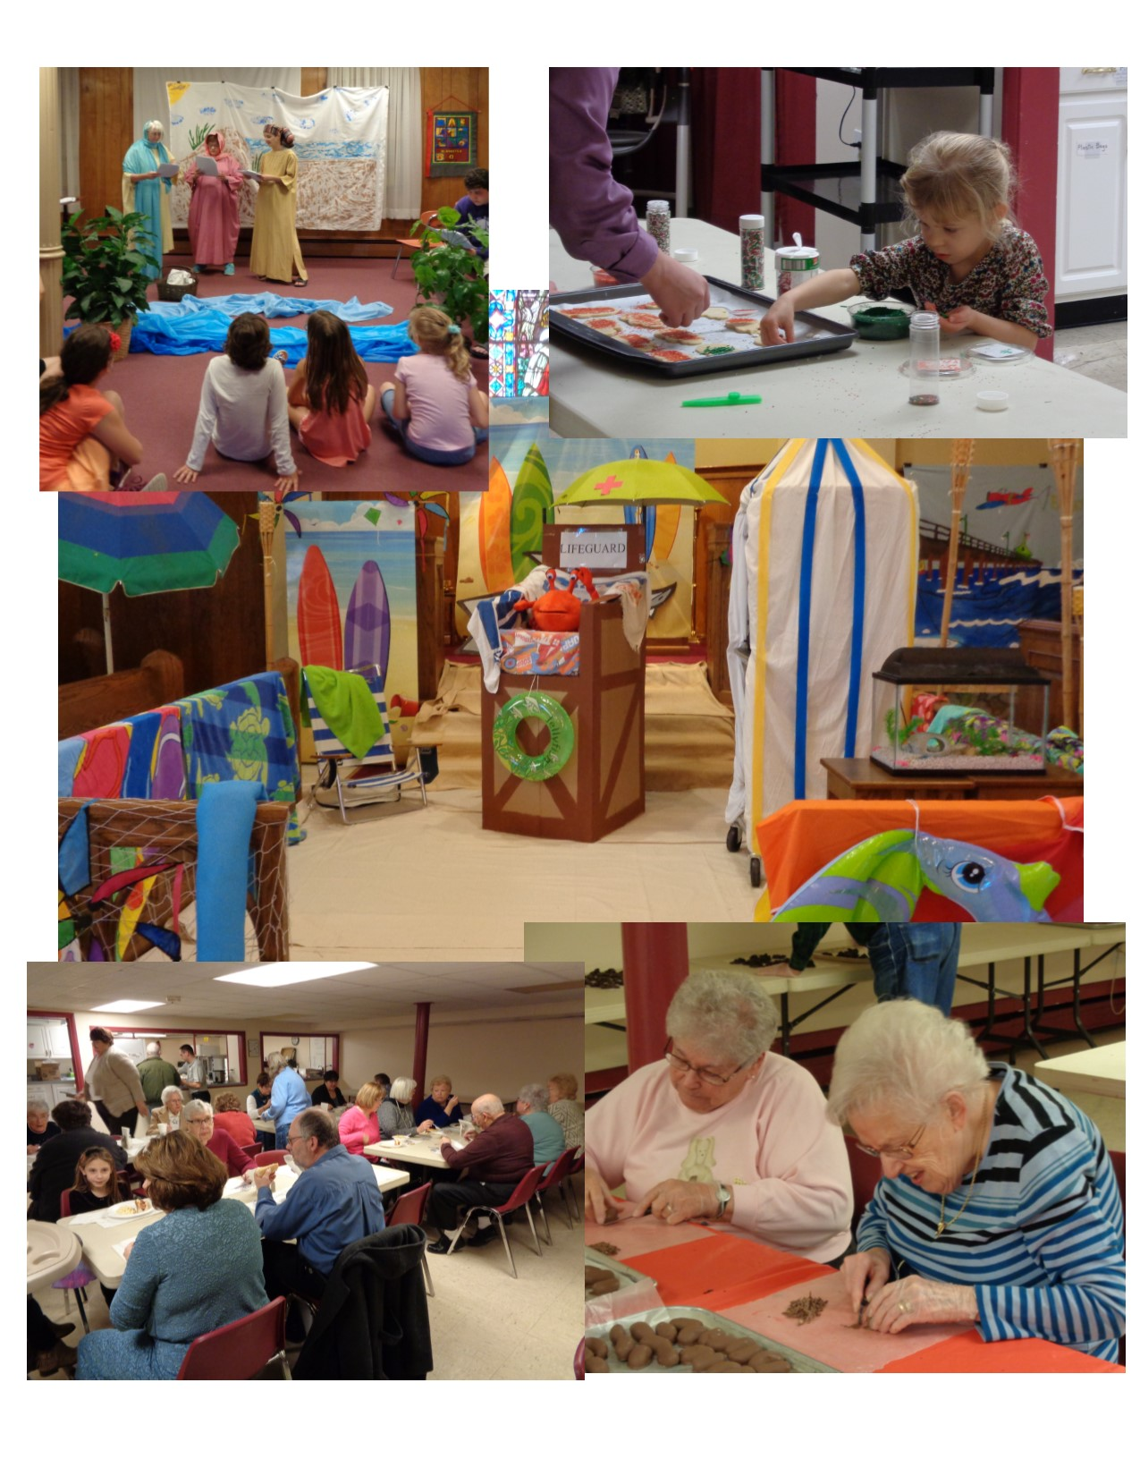

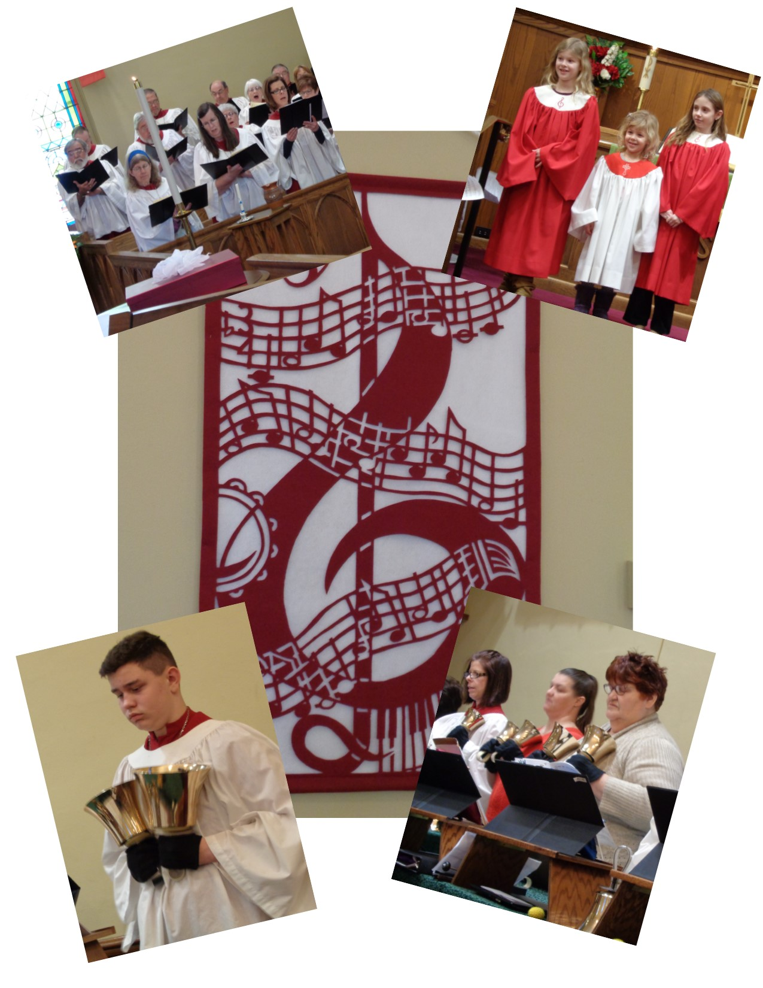

What we value about living in our area

Our community has strong family values, a good educational system and a strong sense of community (neighbors helping neighbors).

Current size of membership: 326 (active & in-active members)

Position Title: Settled Pastor

Position Duration:

Settled – a called position intended for longer-term ministry in which the minister moves church membership to the congregation and moves standing to related association.

Compensation Level: Full Time

Does the total support package meet conference compensation guidelines? No

SCOPE OF WORK

The Pastor will provide pastoral care, spiritual and administrative leadership and organizational direction to members of the congregation, with a broad program of worship, music, preaching, teaching and fellowship.

Accountability:

The Pastor is accountable to the United Church of Christ, Pennsylvania Southeast Conference and the Schuylkill Association which grants standing and exercises discipline. In matters relating to St. Mark’s United Church of Christ, the Pastor is accountable to the Consistory and ultimately the members of the congregation.

Responsibilities:

1. Provide biblically-based preaching which includes leading worship and teaching that will result in the spiritual growth of the membership and awaken them to an active outreach to their neighbors thereby stimulating the growth of membership.
2. Lead and inspire the consistory and the congregation in the development and effective operation of a wide range of program activities.
3. Visit the sick and distressed and provide communion to shut-ins four times per year minimally.
4. Provide pastoral service to those in crisis situations.
5. Have general spiritual oversight of the congregation.
6. Act as the head of Spiritual Council.
7. Stimulate growth of membership through evangelism.
8. Meet the spiritual needs of the congregation.
9. Utilize the Spiritual Council as a confidential sounding board, meeting quarterly or on an as needed basis.

10.Serve as a member of consistory and ex-officio member of all committees.

Skills:

1. Maturity
2. Ability to see both sides of a situation
3. Ability to deal with conflict
4. Trustworthiness
5. Visibility in the congregation
6. Availability for listening to church members
7. Confidentiality
8. Ability to set clear boundaries with church members

Relationships:

The pastor will relate to consistory and all committees; relate to staff as head: the Schuylkill Association, the Pennsylvania Southeast Conference and the United Church of Christ as a clergy member.

Benefits:

The pastor will receive a budgeted salary and benefits recommended by the Stewardship Committee which is approved by the consistory and the congregation.

Evaluation:

1. Performance review will be conducted by the Spiritual Council as requested by either the Spiritual Council or the pastor.
2. Compensation will be reviewed annually by the Stewardship Committee with input from consistory officers which includes the President, the Vice President, the Secretary and the Personnel Committee with final approval by consistory and the congregation.

Core Competencies: We would like a Pastor who is Caring, Organized and time-conscious.

COMPENSATION AND SUPPORT

Salary Basis:

Salary/Housing 47,200.00

Also Offered:

Medical Insurance

Dental Insurance

Vision Insurance

Pension (14%)

Life/Disability Insurance

Social Security

Background Check

Travel

Continuing Education

Comment on the residential/commuting expectations for your next minister.

We encourage our Pastor to select his or her own home that accommodates his or her lifestyle. We only suggest it be within a reasonable distance to the church.

State any incentives *(e.g. school debt reduction or retention bonus after a certain number of years in position)*:

Three months of sabbatical leave after 6 years of service. After returning from sabbatical, Pastor will serve for at least 1 year.

Describe peer and professional supports available for ministers in your association/conference:

Committee on Ministry – Schuylkill Association

Local Ministerium

Excellence Ministry Group

If applicable, describe how your church will adopt part-time adjustments in the pastoral schedule to support a minister’s bi-vocational employment: N/A

WHO IS GOD CALLING TO MINISTER WITH US?

Describe the ministry goals you envision your next minister co-collaborating with the congregation to achieve.

Our ministry goals consist of expanding our care giving team, trying to increase attendance and attract the youth, while expanding spiritual growth among members.

Describe how your vision of the minister you are now seeking will assist the congregation in making an impact beyond its walls.

We would like someone to partner with us in our current outreach ministries, assisting us in developing innovative programs to better serve the needs of our community.

Specify language requirements or culturally-specific capacities preferred in a next ministerial leader, and why those matter to the congregation’s sense of calling.

St. Mark’s UCC would prefer mainly an English-speaking pastor. We are looking for a pastor that can speak to our congregation and the children.

Based on what you have learned about who your church is, who your church’s neighbor is, and who God is calling the church to become, describe four areas of excellence from *The Marks of Faithful & Effective Authorized Ministry* that your next minister will display to further equip the congregation’s ministry in these areas.

We would like a Pastor who has lived a faith showing love of God, trust in Jesus, and openness to the Holy Spirit.

We encourage our Pastor to participate in the various settings of the United Church of Christ, including the conference/association and local ministerium.

Our congregation would appreciate a pastor who can function as part of a team, to give and receive supervision, and to mutually equip and motivate the community of faith.

St. Mark’s desires a Pastor who can communicate clearly and effectively with appropriate media and technologies which can be used not only in church school but during regular worship.

**WHO IS GOD CALLING US TO BECOME?**

Who is God calling you to become as a congregation?

As a congregation, God is challenging us to become more active in our community.

We see ourselves being called as a center of spiritual growth.

We also provide a meeting place for community mission programs that

are attached in a spiritual sense through our commitment to love one another. Some examples are boy scouts and girl scouts.

God is challenging us to be more open and accepting of societal changes

so we can be better equipped to open the doors in other ways.

In order to prepare, a steering committee was formed and with their input we made the following improvements to our church building:

* Painting
* Carpeting
* New Sound System
* New Video System
* Lighting Control System
* Complete overhaul of the organ.
* Digital LED programmable sign.

These improvements were made in 2+ years so that we could update

our building to the newest technologies to make our worship

experience modern as well as meaningful. We feel these improvements readies us to partner with a pastor to be able to

attract people from all walks of life.

In the near future, we have a plan to:

* Update the stain glass windows in the church
* Add a fire tower/stairway to improve the safety of everyone
* Purchase an adjacent property to expand our parking lot.

**WHO ARE WE NOW?**

CONGREGATIONAL REFLECTIONS

11-YEAR REPORT

CONGREGATIONAL DEMOGRAPHICS

PARTICIPATION AND STAFFING

CHURCH FINANCES

HISTORICAL INFORMATION

CONGREGATIONAL REFLECTIONS

Describe your congregation’s life of faith.

Our congregation’s life of faith includes; Fellowship, Community, Recharge, Unity, and Acceptance.

Our mission: Blanket Drive, Light Up the Night, we will do whatever it takes to keep the church running.

Describe the Holy Spirit in your midst:

We trust in the Spirit through prayers, teaching and trusting across all generations, and through special music hymns.

The Holy Spirit helps us to maintain an open mind;

* to Gods loving Ways
* by bringing us together
* to the possibilities of change

Describe several strengths or positive qualities of your congregation.

Acceptance, perseverance, dedication, fun, humor, caring for

others, persistence, one big family, family oriented, community involvement, service to the community, openness and acceptance to change.

Describe what worship is like when your congregation gathers.

Worship following the lectionary takes place in the sanctuary and may include:

* Readings by a member
* Passing of the Peace
* Meditation
* Blended worship
* Audio visual system
* Use of lighting

It is a work in progress, people of all ages participate, and we have active music programs.

Describe the educational program and/or faith formation vision of your church.

The Mission of the Christian Education Committee is to provide a basis for developing one’s faith by helping people understand the Bible, by showing its relationship to everyday living, by encouraging loving relationships between all peoples, by teaching stewardship and instilling Christian values.

Christian Education provides Sunday school classes for all ages. There is an adult Sunday school class and a nursery class for infants through kindergarten-age children. For children in first grade through sixth grade there is a one-room Sunday school class held using a curriculum geared towards mixed age levels. A two-year confirmation class is held for children who are entering seventh grade and are interested in becoming members of the church.

Describe how your congregation is organized for ministry and mission.

We have a monthly Newsletter, Sunday morning announcements, vision to grow and move the mission, goals of church, always changing, example being on consistory- always different from year to year, think about our volunteers.

An organizational chart can be provided if requested.

Always striving to meet the needs of the community, service the community, not afraid to try something new.

We are respectful of our volunteers’ time and commitment.

* When it comes to decision-making, how many hours are spent in meetings per month?

Decision making consists of Worship, Stewardship and Consistory. Worship, and Stewardship meet for approximately four hours per month. Consistory meets 1 ½ hours per month. All meetings have a defined start and ending time.

* Think of a time when action had to be taken quickly, for example when a crisis or disaster occurred. How was that accomplished?

We take action quickly with phone calls, email questions, and people step up.

* Can you provide the next minister with a copy of an organization structure, bylaws and/or annual report to further explain the patterns of the church’s activity and governance? **Yes**

11-YEAR REPORT

|  |  |  |
| --- | --- | --- |
|  |  |  |
| |  |  |  |  |  | | --- | --- | --- | --- | --- | |  |  |  |  |  | |  |  | |  | | --- | | **UNITED CHURCH OF CHRIST** | |  |  | |  |  |  |  |  | |  | |  | | --- | | **ELEVEN YEAR CHURCH PROFILE BASED ON DATA REPORTED IN UCC YEARBOOKS** | | | |  | |  |

|  |  |  |  |  |
| --- | --- | --- | --- | --- |
|  |  |  |  |  |
| |  |  |  |  |  |  |  |  | | --- | --- | --- | --- | --- | --- | --- | --- | | **Church#:** | 600260 |  |  |  |  |  |  | | **Assoc:** | 636 | **Schedule:** | 0 | Saint Mark's UCC | Cressona | PA | 17929 | | |  |  |  |
|  |  |  |  |  |
| |  |  |  |  |  |  |  |  |  |  | | --- | --- | --- | --- | --- | --- | --- | --- | --- | --- | | **YEAR** | **MEMBERS** | **AVG WEEKLY ATTENDANCE** | **CHR ED/ FAITH FORM** | **CONFIRMATION** | **CONFESSION** | **TRANSFER OR REAFFIRM** | **DEATHS OR TRANS OUT** | **OTHER LOSSES** | **NET MEMBS ADDS-REMOVED** | | 2005 | 473 | 189 | 129 | 10 | 1 | 8 | 12 | 4 | 3 | | 2006 | 473 | 189 | 83 | 0 | 0 | 0 | 0 | 0 | 0 | | 2007 | 458 | 73 | 45 | 0 | 0 | 6 | 14 | 7 | -15 | | 2008 | 408 | 72 | 49 | 3 | 0 | 6 | 10 | 49 | -50 | | 2009 | 388 | 86 | 52 | 1 | 0 | 6 | 7 | 20 | -20 | | 2010 | 391 | 86 | 60 | 4 | 0 | 4 | 5 | 0 | 3 | | 2011 | 390 | 84 | 56 | 5 | 0 | 1 | 3 | 4 | -1 | | 2012 | 360 | 84 | 48 | 5 | 0 | 0 | 4 | 31 | -30 | | 2013 | 357 | 81 | 45 | 4 | 0 | 3 | 10 | 0 | -3 | | 2014 | 348 | 78 | 32 | 1 | 0 | 0 | 9 | 1 | -9 | | 2015 | 346 | 79 | 49 | 3 | 0 | 2 | 7 | 0 | -2 | | | |  |  | |
|  |  |  |  |  |
| |  |  |  |  |  |  |  |  |  |  |  | | --- | --- | --- | --- | --- | --- | --- | --- | --- | --- | --- | | **YEAR** | **CURRENT EXPENSES** | **CAPITAL PAYMENTS** | **BASIC SUPPORT** | **SPECIAL SUPPORT** | **TOTAL OCWM** | **OTHER GIFTS** | **WIDER MISSION** | **BASIC SUPP% CURR LOCAL** | **TOTAL EXPEND** | **PLEDGES AND OFFERINGS** | | 2005 | $158,723 | $19,300 | $4,400 | $2,174 | $6,574 | $3,562 | $10,136 | 2.77 | $188,159 | $145,130 | | 2006 | $158,723 | $0 | $6,100 | $2,429 | $8,529 | $0 | $8,529 | 3.84 | $167,252 | $0 | | 2007 | $89,324 | $17,650 | $5,700 | $9,168 | $14,868 | $700 | $15,568 | 6.38 | $122,542 | $103,406 | | 2008 | $125,813 | $12,000 | $5,700 | $2,619 | $8,319 | $673 | $8,992 | 4.53 | $146,805 | $119,013 | | 2009 | $139,167 | $14,900 | $6,000 | $7,116 | $13,116 | $3,594 | $16,710 | 4.31 | $170,777 | $137,076 | | 2010 | $148,279 | $12,617 | $6,300 | $4,310 | $10,610 | $2,052 | $12,662 | 4.25 | $173,558 | $138,019 | | 2011 | $153,824 | $18,000 | $6,600 | $4,745 | $11,345 | $2,297 | $13,642 | 4.29 | $185,466 | $141,459 | | 2012 | $205,832 | $11,838 | $7,260 | $3,398 | $10,658 | $4,330 | $14,988 | 3.53 | $232,658 | $147,033 | | 2013 | $171,324 | $9,779 | $7,585 | $4,342 | $11,927 | $1,459 | $13,386 | 4.43 | $194,489 | $164,108 | | 2014 | $189,787 | $9,939 | $7,800 | $5,716 | $13,516 | $1,835 | $15,351 | 4.11 | $215,077 | $187,232 | | 2015 | $242,012 | $0 | $8,100 | $3,143 | $11,243 | $2,366 | $13,609 | 3.35 | $255,621 | $183,733 | | | | |  | |
|  |  |  |  |  |
| |  |  |  |  |  |  |  |  |  | | --- | --- | --- | --- | --- | --- | --- | --- | --- | | **% CHANGE** | **MEMBERS** | **AVG WEEKLY ATTENDANCE** | **CHR ED/ FAITH FORM** | **TOTAL ADDITIONS** | **TOTAL REMOVALS** | **CURR LOCAL EXPENSES** | **TOTAL OCWM** | **TOTAL EXPENDITURE** | | 2010-2015 | -11.51 | -8.14 | -18.33 | -37.50 | 40.00 | 63.21 | 5.97 | 47.28 | | 2005-2015 | -26.85 | -58.20 | -62.02 | -73.68 | -56.25 | 52.47 | 71.02 | 35.85 | |  |  |  |  | |

Addendum:

2005 Average weekly attendance: 113

2006 Average weekly attendance: 104, Confirmation: 6, Confession: 1, Deaths: 14, Other Losses: 2, Net: -9

2016 Members: 326, Avg Weekly Attendance: 68, Chr/Ed Faith Form: 34, Confirmation: 3, Confession: 0, Transfer or Reaffirm: 7, Deaths or Trans Out: 7, Other Losses: 3, Net Members Adds-Removed: -2

CONGREGATIONAL DEMOGRAPHICS

Describe those who participate in your church.

|  |  |  |
| --- | --- | --- |
|  |  | *Is this number an estimate? (check if yes)* |
| Number of active members: | 326 |  |
| Number of active non-members: | 3 |  |
| Total of church participants (sum of the numbers above): | 329 |  |

Percentage of total participants who have been in the church:

|  |  |  |
| --- | --- | --- |
|  |  | *Is this percentage an estimate? (check if yes)* |
| More than 10 years: | 86 % |  |
| Less than 10, more than 5 years: | 6 % |  |
| Less than 5 years: | 8 % |  |

Number of total participants by age:

|  |  |  |  |  |  |  |  |  |  |
| --- | --- | --- | --- | --- | --- | --- | --- | --- | --- |
| 0-11 | 12-17 | 18-24 | 25-34 | 35-44 | 45-54 | 55-64 | 65-74 | 75+ | *Are these numbers an estimate?*  *(check if yes)* |
| 24 | 27 | 24 | 36 | 25 | 51 | 54 | 50 | 35 |  |

Percentage of adults in various household types:

|  |  |  |
| --- | --- | --- |
|  |  | *Is this percentage an estimate? (check if yes)* |
| Single adults under 35: | 19 % |  |
| Joint household with minors: | 21 % |  |
| Single adults age 35-65: | 8 % |  |
| Joint household with no minors: | 28 % |  |
| Single adults over 65: | 24 % |  |

Education level of adult participants by percentage:

|  |  |  |
| --- | --- | --- |
|  |  | *Is this percentage an estimate? (check if yes)* |
| High school: | 99 % |  |
| College: | 62 % |  |
| Graduate School: | 23 % |  |
| Specialty Training: | 32 % |  |
| Other (please specify): |  |  |

Percentage of adults in various employment types:

|  |  |  |
| --- | --- | --- |
|  |  | *Is this number an estimate? (check if yes)* |
| Adults who are employed: | 63 % |  |
| Adults who are retired: | 31 % |  |
| Adults who are not fully employed: | 6 % |  |

Describe the range of occupations of working adults in the congregation:

The congregation is a diverse mix of occupations from blue collar up to professional white collar.

Describe the mix of ethnic heritages in your congregation, and the overall racial make-up. Most UCC congregations tend to describe themselves as “diverse.” Yet, the vast majority of UCC congregations are mono-cultural. What does diversity mean in your context?

While we are mono-cultural in our makeup, our diversity comes from our open mindedness and acceptance of all people from all cultures and our invitation for everyone from the community to participate in all our activities.

PARTICIPATION AND STAFFING

Complete the following chart. Please leave blank any fields that are not applicable to your congregation.

|  |  |  |
| --- | --- | --- |
| Ways of Gathering | Estimated number of people involved in attendance | Who plans each of the listed gatherings? *(list any and all worship planners, such as various lay leaders, pastors, musicians, other staff)* |
| Adult Groups or Classes | 1 (class) | Christian Ed Committee |
| Baptisms *(number last year)* | 3 | Pastor |
| Children’s Groups or Classes | 3 (class) | Christian Ed Committee |
| Christmas Eve and Easter Worship | C 221, E 132 (people) | Worship Committee |
| Church-wide Meals | 9 | Lay Leaders |
| Choirs and Music Groups | 48 (people) | Coordinator of Church Music |
| Church-based Bible Study | 1 (class) | Pastor and Christian Ed Committee |
| Communion *(served how often?)* | 15/16 x Yr | Spiritual Council, Worship Committee and Pastor |
| Community Meals | 0 |  |
| Confirmation *(number confirmed last year)* | 3 (people) | Pastor, Lay Leaders |
| Drama or Dance Program | 8 | Worship Committee |
| Funerals (*number last year*) | 7 | Pastor |
| Intergenerational Groups | 0 |  |
| Outdoor Worship | 38 (people) | Worship Committee and Pastor |
| Prayer or Meditation Groups | 1 (class) | Worship Committee and Pastor |
| Public Advocacy Work | 0 |  |
| Retreats | 0 |  |
| Theology or Bible Programs in the Community | 0 |  |
| Weddings (*number last year*) | 0 | Pastor, Consistory and Director of Music |
| Worship (time slot: 10:30)-Winter, Spring and Fall | 75 | Worship Committee and Pastor |
| Worship (time slot: 9:30)-Summer | 60 | Worship Committee and Pastor |
| Young Adult Groups or Classes | 0 |  |
| Youth Groups or Classes | 1 | Christian Ed Committee |
| Other |  |  |

Additional comments:

List all members or regular participants in your congregation who are ordained, licensed, or commissioned ministers. Indicate those with current United Church of Christ Three-Way Covenants (i.e. serving in a congregation) or Four-Way Covenants (i.e. serving in a ministry beyond a congregation).

|  |  |  |  |  |
| --- | --- | --- | --- | --- |
| Name | Three-Way or Four-Way Covenant?  *(3 or 4 or No)* | Ministry Setting | Type of Ministry Role | Retired?  *(Y or N)* |
| Pastor Karl Jones Jr |  |  |  | Y |
|  |  |  |  |  |

If one or more previous pastors or retired ministers currently hold membership in the church, describe their role(s) in the life of the congregation:

The Rev. Karl Jones served as pastor from 1985 to 2006. In the last ten years, he has served as Pastor or Interim Pastor of 4 UCC churches. He has also served in a secular health-related non-profit. In the fall of 2006 he became a UCC Conference Disaster Coordinator. Over the years this role has expanded. In November of 2016 a new position description was approved by the Pennsylvania Southeast Conference Consistory. He now serves directly supervised by the Conference Minister and the UCC Executive for Disaster Ministries.

Pastor Jones is active in the life of St. Mark’s Church, primarily within the music ministry. He sings in the choir, plays guitar in the praise band, arranges music when asked, and occasionally supplies instrumental music. He helps with building and other projects when appropriate. He has had strong relationships with the previous pastor and works hard to maintain appropriate boundaries.

List all current staff, including ministers. Exclude the position you are seeking to fill. Indicate which staff person serves as head of staff.

|  |  |  |  |  |
| --- | --- | --- | --- | --- |
| Staff Position | Head of Staff? | Compensation (full time, part time, volunteer) | Supervised by | Length of Tenure for current person in this position |
| Intentional Interim Pastor | Yes | Full Time | Consistory | 6 Months |
| Administrative Secretary | No | Part Time | Pastor/Consistory | 20 Years |
| Coordinator of Church Music | No | Part Time | Consistory | 31 Years |
| Financial Secretary | No | Part Time | Consistory | 3 Years |
| Treasurer | No | Part Time | Consistory | 8 Years |
| Sexton | No | Part Time | Consistory | 2 Years |

REFLECTION

Reflection: After reviewing the congregational demographics and activities above, what does this information reflect about your congregation’s overall ministry?

We feel we are committed to live our faith and step up when needed to help and lead

CHURCH FINANCES

Current annual income (dollars used during most recent fiscal year) Year 2016

|  |  |
| --- | --- |
| Source | Amount |
| Annual Offerings and Pledged Giving* | $ 142,873.88 |
| Endowment Proceeds *(as permitted within spending policy, such as a cap of typically*  *4.5%-5% on total return)* | $ 1,753.59 |
| Endowment Draw *(beyond what is permitted by spending policy, “drawing down the principal”)* | $ |
| Fundraising Events (Profit) ** | $ 38,442.72 |
| Gifts Designated for a Specific Purpose | $ |
| Grants | $ |
| Rentals of Church Building | $ |
| Rentals of Church Parsonage | $ |
| Support from Related Organizations ***  *(e.g. Women’s Group)* | $ 7,078.63 |
| Transfers from Special Accounts | $ 37,857.69 |
| Other: Memorials | $ 107,298.50 |
| Other: Line of Credit Reduction | $ 2,800.00 |
| Other: Miscellaneous **** | $ 13,460.32 |
| TOTAL | $ 351,565.33 |

* Includes envelope offerings for the Operating Fund, Property Improvement Fund, Investing in Our Future, and Initial. Seasonal Offerings: Advent and Lenten, Easter and Christmas, and Christmas in July. Loose Plate Offerings, Phase 1/2/3 of 4 My Church, and Sunday School Offerings.

** Includes Giant Cards, Easter and Christmas Candy Sale, Boro Day Pie Sale, Chicken Barbeque, Holiday Bazaar, Cookbooks and Rada Cutlery.

*** Includes OGHS, Strengthen the Church, NIN, and God is Still Speaking. Includes Seasonal Offerings for Benevolences, Light Up the Night, Heifer International Project, VBS, Church World Service (Blankets and CROP Walk), Cressona Welfare Fund, Disaster Relief Fund, Food Pantry, Relay for Life, Rental Assistance, Souper Bowl, Backpack Program, Lancaster Seminary and Summer Camp Program.

**** includes Decorations, Miscellaneous, Palms, Stole, Sunday School Materials.

Current annual expenses (dollars budgeted for most recent fiscal year):

$ 345,086.91

*Most recent Church Budget (see attachments):*

2017 Projected Income.xls

2017 Projected Expenses.xlsx

*Annual Treasurer’s Report:* 2016 ANNUAL REPORT.xls

Considering total budgeted expenses for the year, compare total ministerial support. What is the percentage? 49 %

Has the church ever failed to pay its financial obligations to a minister of the church? No

Is your church 5-for-5, i.e. does it include each of the following contributions during the church year? *(indicate those included during the most recent fiscal year)*

_X_ Our Church’s Wider Mission (OCWM – Basic Support)

_X_ One Great Hour of Sharing

_X_ Strengthen the Church

_X_ Neighbors in Need

_X_ Christmas Fund

In what way is OCWM (Basic Support) gathered? If calculated as a percentage of operating budget, what is that percentage?

OCWM is determined based on a recommendation from the Financial Management Committee with Consistory approval.

What is the church’s current indebtedness?

No current indebtedness.

If a building program is projected or underway, describe it, including the projected start/end date of the building project and the total project budget.

If the church has had capital campaigns in the last ten years, describe:

|  |  |  |  |  |
| --- | --- | --- | --- | --- |
| Year(s) | Purpose | Goal | Result | Impact |
| 2012 | Upgrade to Church Pipe Organ | $ 70,000 | $ 70,000 | Upgrades included the replacement of the existing control system with a state-of-the-art electronic system that included the tools needed to fully meet the demands of contemporary liturgy. The many chests by several manufacturers were combined into one unified chest and new stop-jambs were added. |
| 2013 | 4 My Church-A Capital Campaign consisting of 3 phases – As of June 2016, Phase 1 is completed. | $100,000 | $101,544 | Upgrades to Sanctuary, Electrical renovations, Audio Visual Systems Renovations, Painting of the Sanctuary. |

If a capital campaign is underway or anticipated, describe:

|  |  |  |  |  |
| --- | --- | --- | --- | --- |
| Year(s) | Purpose | Goal | Result | Impact |
|  | Phase 2 - Addition of Fire Tower / Stairway | $ TBA | $ | Emergency Exit but can be used as additional entry to sanctuary from back of church |
|  | Phase 3 – Restoration of Stained Glass Windows in Sanctuary | $ TBA | $ | Greatly needed due to the age of the existing windows. |
|  | Purchase of adjoining property to Church | $ TBA | $ | More Parking spaces |

Describe the prominent mission component(s) involved in the most recent (or current) capital campaign.

Funds were used to sponsor a work camp to the Hartman Center, the Outdoor Ministries facility, owned by the Penn Central Conference of the United Church of Christ.

Does your church have an endowment? Yes

What is the market value of the assets? $ 119,272.59 as of June 30, 2016

Are funds drawn as needed, regularly, or under certain circumstances?

Only the interest may be used from the endowment administered by United Church Funds.

We have not used any endowment funds to supplement the general budget. If we do need to use the endowment funds we can use only the interest.

Other Assets

Reserves (savings): $ 48,486.33 –

Commercial Money Market Account (Memorial Funds) as of July 31, 2016

Investments (other than endowment): $ 67,136.33 as of August 31, 2016

Does your church have a parsonage? No

Describe all buildings owned by the church:

Main Church building with Christian Education Wing added in 1970

Describe non-owned buildings or space used or rented by the church:

None

Which spaces are accessible to wheelchairs? *(worship space, pulpit, fellowship space, facilities, etc.)*

Worship space, Education space, Fellowship Space and Restroom Facility.

Reflection: After reviewing the church’s finances and assets described above, what does this information reflect about your congregation’s mission and ministry?

During the last several years St Mark’s has lost several giving units through the death of members. In preparing its 2017 Spending Plan, income and expenses will reflect the loss of income because of the lost giving units.

For the most part, the budgeting process is overseen by the Financial Management Committee with input from the staff, committees and the treasurer.

In recent years, St. Mark’s has initiated a Quarters Campaign that provides funds to the local food pantry, Crop Walk, Lancaster Seminary, local SPCA and the Backpack Program sponsored by the local council of churches and designed to provide food items to low income elementary children for the weekends.

Finally, St. Mark’s has become the sponsor of Light Up the Night, a safe Halloween experience for children of the community. This event takes place on the Thursday night closest to Halloween and is held on the church parking lot. Local businesses donate funds for this event and the church provides adult supervision and teenage helpers. A variety of activities are available and food and treat bags are provided to the children

HISTORICAL INFORMATION

Name one to three significant happenings in the history of your church that have shaped the identity of your congregation. Add the most important event in the life of your church in the past 10 years.

We recently went through a major renovation at the church (painting, carpeting, new sound system, electrical renovations, new video system, and complete organ overhaul).

In the past, St. Mark’s has been reactive when it was forced to replace both the main church roof and the roof of the Christian education building as each showed the need when leaks occurred.

The leadership became proactive in assessing the church’s current and future needs when a visioning committee was established which resulted in our “4 My Church” project. This three part project also has a 4th Mission component in order that we may always remember others in our work camp project.

Phase I of the plan which included electrical and Audio/Visual upgrades including painting of our Sanctuary has already been completed and funded in full.

Describe a specific change your church has managed in the recent past.

Two Pastors leaving and congregation members stepping up to lead the church services, and continue with current programs.

Every church has conflict, some minor, some larger. “Where two or three are gathered, there will be disagreement….” Describe your congregation’s values and practices when it comes to conflict.

We try to anticipate all reasonable questions that may lead to conflict. Then we research those and bring appropriate answers to the congregation and all parties involved before requiring a decision. We keep the congregation informed/involved and ask opinions.

These are examples of where we used this practice and it worked well:

Praise team and new music

Changing service

Renovations

Personnel Committee.

Ministerial History *(include all previous ministerial staff for the past 30 years)*

|  |  |  |
| --- | --- | --- |
| Staff member’s name | Years of service | UCC Standing (Y/No) |
| Pastor Bruce Dalious – Interim Pastor | <1 | Y |
| Pastor Nathan Druckenmiller | 7 | Y |
| Pastor Carey Miller – Interim Pastor | <1 | Y |
| Pastor Karl Jones | 20+ | Y |
|  |  |  |

Comment on what your church has learned about itself and its relationship with persons who provided ministerial leadership:

Each Pastor brings his or her unique style. We learn to minister together in the spirit of Christ as we adapt to one another.

Has any past leader left under pressure or by involuntary termination? ***No***

Has your church been involved in a Situational Support Consultation? ***No***

Has a past pastor been the subject of a Fitness Review while at your church? ***No***

**WHO IS OUR NEIGHBOR?**

COMMUNITY VISION

MISSION INSITE

COMMUNITY VISION

How do the relationships and activities of your congregation extend outward in service and advocacy?

Our local service activities include: Blanket drive, Light Up the Night, Pie and Candy Making, providing money to Bethany Children’s Home and gifts at Christmas, Food Pantry Donations, Hillside SPCA, Boys and Girl Scouts, Suicide Prevention, Phoebe Ministries and Cressona Memorial Day Service.

Our Global service activities include: Church’s Wider Mission, OCWM and Disaster Relief Ministries.

Our Near and Far service activities include: Mission trips locally and afar to Atlantic City, West Virginia and Tennessee, we collect money for the Heifer Foundation, and Marine Mammal Stranding Center.

Describe your congregation’s participation in meetings, relationships and activities connecting the wider United Church of Christ (association / conference / national setting).

St. Mark’s:

* Provides delegates to attend association and conference meetings.
* Has Members on committees of Ministry and Financial Consistory at conference.
* Moderator for the Schuylkill Association.
* Sends representatives to attend General Synod as delegates.
* Sponsor Student Pastors.
* Disaster Ministry

Check all of the following “statements of witness” that apply to your UCC faith community. (Find more information on these statements at ucc.org.)

_X_ Accessible to All (A2A)

_X_ Creation Justice

___ Economic Justice

___ Faithful and Welcoming

_X_ God Is Still Speaking (GISS)

___ Immigrant Welcoming

___ Inter-cultural/Multi-racial (I’M)

___ Just Peace

_X_ Global Mission Church

___ Open and Affirming (ONA)

___ WISE Congregation for Mental Health

___ Other UCC designations:

___ Other similar designations in affiliated denominations

_+_ None

Reflect on what the above statement(s) mean(s) to your community. Is your congregation interested in working toward any of the above statements of witness in the near future?

Presently St. Mark’s is not pursuing more involvement but we as a congregation are not opposed to further our involvement in the future.

Describe your congregation’s participation in ecumenical and interfaith activities (with other denominations and religious groups, local and regional).

* + We participate in the Council of Churches: Crop Walk, Thanksgiving Eve Services, Food Pantry, Monthly Newsletter, and Financial Aid for those in need.
  + We participate in the Blood drive with Ecumenical Committee.
  + We are College Faith Partners with Church Community.
  + We have a Blue Christmas service that is open to the community.

If your congregation has a mission statement, how does that mission statement compare to the actual time spent engaging in different activities? Think of the range of activities from time spent gathering, to governance, to time spent going out.

All our time is following our mission statement which is: The allowed purpose of this church shall be to worship God, to preach the gospel of Jesus Christ, and to celebrate the Sacraments; to realize Christian fellowship and unity within this church and the church Universal, to render loving services toward mankind; and to strive for righteousness, justice, and peace.

Reflect on the scope of work assigned to your pastor(s). How is their community ministry and their ministry in and on behalf of the wider church accounted for in the congregation’s expectations on their time?

We will be supportive and expect the Pastor to be involved in the Wider Church. Level of involvement will be open to discussion with Consistory.

MissionInSite

Comment on your congregation’s MissionInsite report with data for your neighborhood(s) or area. What trends and opportunities are shown?

Trends:

Aging population

Shrinking population

Limited Economic opportunities

Population predominately white/non-Hispanic

Population predominately aging.

Opportunities:

Many distribution centers – Warehouse & Service Related Jobs.

How do your congregation’s internal demographics compare or contrast to a) the neighborhoods adjacent to your church, and b) other neighborhoods with which your church connects?

Population in our church is predominately an older population, but opportunities exist in the community for evangelism to younger families.

How are the demographics of the community currently shaping ministry, or not?

We are constantly searching for ways to better connect to our community in ministry.

What do you hear when you talk to community leaders and ask them what your church is known for?

While we are known for candy making and pies, we also share our space to other community groups.

We have a well-cared for handicapped accessible church with an open door to the community.

What do new people in the church say when asked what got them involved?

We are a welcoming congregation, open and accepting to all.

**REFERENCES**

Name up to three people who have agreed to serve as phone and written references. Make sure they are not members of your church but are persons who know your church well enough to be helpful to candidates seeking more information. Request a letter from each reference in answer to the four prompts below. Attach the letters (up to three) as desired.

REFERENCE 1

Shirley Johnson

(570-345-8332 / [richshir@comcast.net](mailto:richshir@comcast.net))

Attached letter: Shirley L Johnson_Letter.docx

REFERENCE 2

Tom Lowe

(570-874-4193 / [tomlowe@pdt.net](mailto:tomlowe@pdt.net))

Attached letter: Tom Lowe_Letter.docx

REFERENCE 3

Sue McCartney

(570-943-2103 / [jsmccartney5@verizon.net](mailto:jsmccartney5@verizon.net) / Conference Consistory)

Attached letter: Susan McCartney_Letter.docx

**CLOSING THOUGHTS**

CLOSING PRAYER

STATEMENT OF CONSENT

CONFERENCE/ASSOCIATION VALIDATION

CLOSING PRAYER

Gracious and loving God –

Be with us as we search for a new pastor. Help us keep an open mind, remembering that as we are all different so is each pastor. We need someone to remind us why St. Mark’s is here; to worship YOU! Help us as we search! Amen.

STATEMENT OF CONSENT

The covenantal relationship between a church and those called by that church to serve as pastors and teachers and in other ministerial positions is strengthened when vital information is openly shared by covenantal partners. To that end, we attest that, to the best of our abilities, we have provided information in this profile that accurately represents our church. We have not knowingly withheld any information that would be helpful to candidates.

As the committee charged with the responsibility for identifying and recommending suitable new minister for our church, we have been authorized to share the information herein with potential candidates. We understand that a candidate may wish to secure further knowledge, information, and opinions about our church. We encourage a candidate to do so, recognizing that an open exchange of relevant information builds the foundation for continuing and healthy relationships between calling bodies and persons seeking a ministry position.

1. Which individuals and groups in the church contributed to the contents of this Local Church Profile?
   1. Search Committee (Chairperson: Frank Fisher).
   2. Church Consistory (Chairperson: Dennis Herring)
   3. Church Treasurer (Robert Helpler)
   4. Current Interim Pastor (Bruce Dalious)
   5. Church Secretary (Jean Maffeo)
   6. Congregation
2. Additional comments for interpreting the profile:

Signed:

Name I Title I Date:

**

VALIDATION BY CONFERENCE/ASSOCIATION

**The congregation is currently in good standing with the association / conference named.**

**Staff Comment:**  Yes.

**To the best of my knowledge, ministerial history information is complete.**

**Staff Comment**: Everything is correct

**To the best of my knowledge, available church financial information is presented thoroughly.**

**Staff Comment:** Yes

**My signature below attests to the above three items.**

**Signature:** 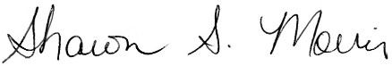

**Name / Title:** Rev. Sharon S. Morris

**Email:** morris@psec.org

**Phone:** 484-949-8774 ext 302

**Date:** May 17, 2017

This document is created through support to Our Church’s Wider Mission (OCWM) and is only possible through the covenantal relationships of all settings of the United Church of Christ.

*“Jesus answered them, ‘Have faith in God!’” – Mark 11:22*