LOCAL CHURCH PROFILE

Community Congregational Church of Manitou Springs
Manitou Springs, CO

Full-time Settled Minister

Rocky Mountain Conference, Southeastern Association

MARCH 2017

LOCAL CHURCH PROFILE CONTENTS
Position Posting
Who Is God Calling Us To Become?
Who Are We Now?
Who Is Our Neighbor?
References
Consent and Validation

“God is able to provide you with every blessing, so that
having all sufficiency in all things at all times,
you may abound in every good work.”
(2 Corinthians 9:8)

INSTRUCTIONS

The new Local Church Profile supports the calling and discernment of United Church of Christ congregations with their current or future pastoral leadership.

For many congregations, the interim time between ministers is an intentional season that is guided in part by the work of preparing a Local Church Profile. Through the Profile, the congregation can discover its data and express its story for the reliable discernment of a search committee and the beginning of a new pastorate. Searching ministers will want to see this document in its entirety.

The interim season is not the only time to give attention to questions and exploration of a congregation’s vocation, however. Three sections of the Local Church Profile – WHO ARE WE NOW, WHO IS OUR NEIGHBOR, and WHO IS GOD CALLING US TO BECOME – are meant to be updated every 3-5 years. Known as the “Discovery Document,” these three sections can be completed by a visioning group, a governing body, a transition team, or other entity in the church – not just by a search committee – in order to draw forward the gifts and imaginative possibilities of a congregation. The more participants, the better!

Some questions are easy to answer. Some are not so easy. Prompts are provided to stimulate narrative response if needed; these italicized prompts are merely examples from which to choose or to inspire your own. Efforts to answer the questions will prompt conversations and explorations and storytellings and many prayers, and as the Spirit moves throughout the process, congregations will shape a collective articulation of Christ’s leading (WHO IS GOD CALLING US TO BECOME). This last question to be answered becomes the first section to be read by searching ministers in the Local Church Profile, and it is the boldest and most actionable piece for faithful leadership into the future.

Your conference can provide materials referenced in the Local Church Profile, such as the 11-Year Report containing data as reported by your congregation annually to the UCC Data Hub and MissionInsite reports containing demographic information on your community. More information on types of pastorate in the United Church of Christ can be found in the Call Agreement Workbook. Be sure to use the Call Agreement Workbook’s Scope of Work to describe in this Local Church Profile the position being sought.

When it is time for ministerial search, the conference can counsel you on posting the Local Church Profile together with your public listing at UCC Ministry Opportunities (http://oppsearch.ucc.org).

The last page of the Local Church Profile contains a statement that parallels the consent statement signed by ministers in the UCC Ministerial Profile. In keeping with the covenantal relationship between a church and those it seeks to call, this statement encourages an open, honest exchange of information. On behalf of the United Church of Christ, and on the basis of the best knowledge available to them, your conference staff will validate your completed Local Church Profile when it is ready to be shared in relationship with prospective new leaders.

A. POSITION POSTING
A1. LISTING INFORMATION
A2. SCOPE OF WORK
A3. COMPENSATION & SUPPORT
A4. WHO IS GOD CALLING TO MINISTER WITH US?

A1. LISTING INFORMATION
A1.a.
Church name: Community Congregational Church of Manitou Springs
Address: 103 Pawnee Ave, Manitou Springs, CO 80829
Supplemental web links: http://www.manitouchurch.org/

Additional ecumenical affiliations:(e.g. denominations, communions, fellowships)

Conference: Rocky Mountain
Association: Southeastern
UCC Conference Minister: Reverend Sue Artt
Phone: 303-984-9118
Email: sue@rmcucc.org

A1. b. Summary Ministry Description:
In a short paragraph, reflect on where your church is going and what it might look like when you get there. What do you need to get there? Who are you seeking to join you on this part of your church’s faith journey?

We want to grow our congregation in Christian faith and practices. We want to reach out to families, individuals, and youth; those who can learn, live and flourish in God’s light and the practices He taught us. We are looking for a person who is strong in faith with the leadership skills to increase our church membership.

A1. c. Photographs:
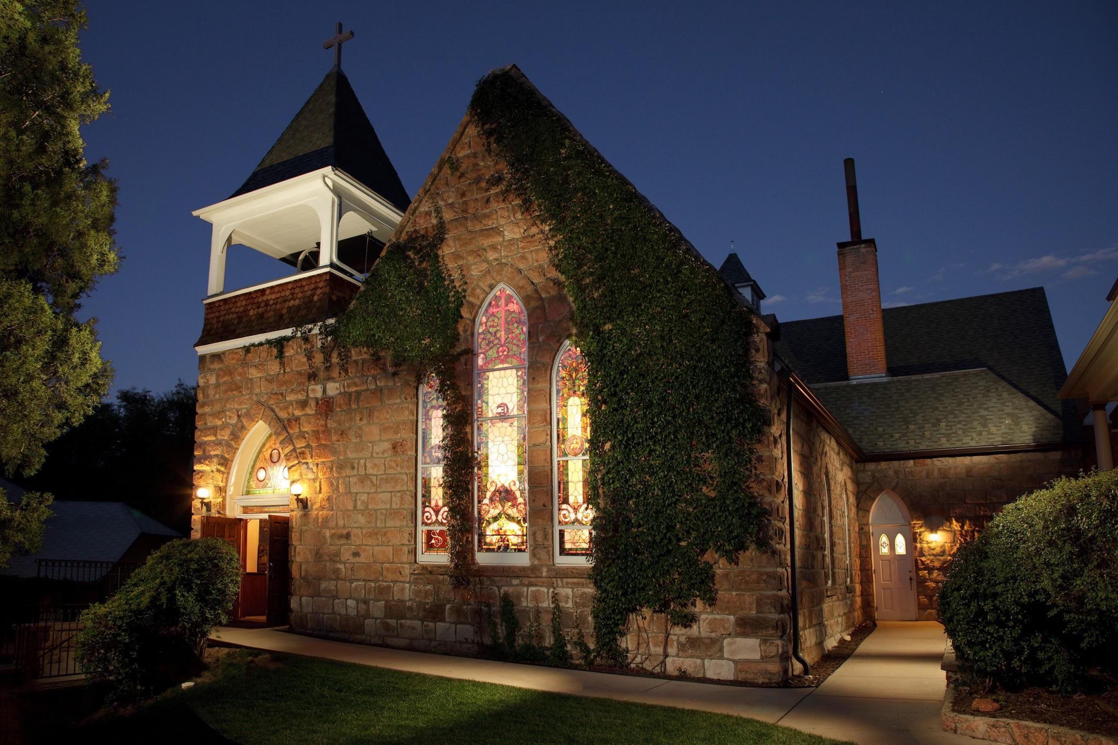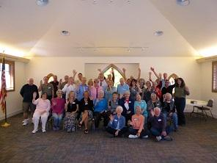

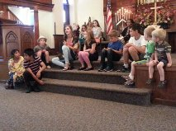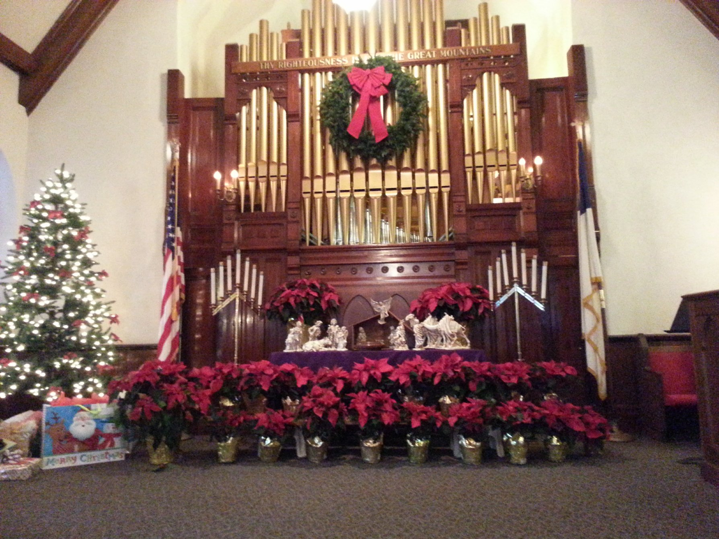
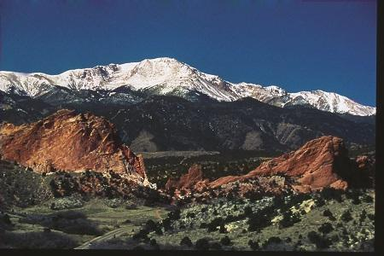

A1. d. What we value about living in our area (2 – 3 sentences):

Manitou Springs, Colorado (pop. approximately 5,000) is located at the foot of Pikes Peak just to the west of Colorado Springs (pop. approximately 500,000), which is home to the US Air Force Academy, the Olympic Training Center and several military bases. Manitou Springs is known for its mineral water springs and it’s small-town friendliness. There are numerous shops, art galleries, restaurants and motels, many of which are open year-round. The climate is moderate with over 300 days of sunshine a year. In addition to surrounding towns, Manitou Springs and Colorado Springs make up the greater Pikes Peak Region, which abounds in natural and manmade attractions.

A1. e. Current size of membership: 91

A1. f. Languages used in ministry (other than English): NA

A1. g. Position Title: Full-time Settled Minister

A1. h. Position Duration:
Settled – a called position intended for longer-term ministry in which the minister moves church membership to the congregation and moves standing to related association
A1. i. Compensation Level: Full Time

A1. j. Does the total support package meet conference compensation guidelines? Yes

A2. SCOPE OF WORK

Community Congregational Church of Manitou Springs, Colorado, is seeking a full-time settled minister, 40-50 hours per week, with responsibilities to include:

Preparation and leadership of Sunday worship, including scripture readings, crafting of liturgy, the weekly bulletin, sermon preparation, scheduling lay liturgists and guiding them as needed; planning of music in collaboration with the music director; preaching the message, offering prayers, and conducting the sacraments of Holy Communion and baptism.

Leadership development by working with congregants to create ministry offerings and programs.

Pastoral care, in collaboration with lay leaders, such as home and hospital visits.

Active participation in our community, leading the way for our church to be an ambassador of God’s love.
Performance of weddings, memorials, and funerals for church members and those in the community at large, when requested.

Faith formation through Bible study; identifying resources and opportunities for lay leaders to participate and take advantage of said resources.

Strategic planning for current and new directions in ministry, to include the re-energizing of our youth ministry.

Collaboration with lay leadership by attending Executive Council meetings, offering advice and leadership as needed.

Participation in wider church activities, such as Southeastern Association and Rocky Mountain Conference gatherings.

Faithful financial development and stewardship, in collaboration with the Membership and Stewardship Boards.

Responsibility for supervision of church employees, to include yearly performance reviews.

Availability for counseling, listening, and referrals to appropriate professional services when needed.

Willingness to participate in continuing education opportunities to deepen spiritual connections, improve skills, to lead, teach, and preach effectively.

Being the representative of our church in the wider community; participating in collaborative worship opportunities with other faith-based organizations.

A2. a. Core Competencies:

Compassionate
Communicative
Humble

A3. COMPENSATION AND SUPPORT

A3. a. Salary Basis:
$75,000

A3. b. Benefits: Salary with Benefits (housing allowance, health insurance, pension)

A3. c. What is the expected living situation for your next minister?
Living nearby with housing allowance

A3. d. Comment on the residential/commuting expectations for your next minister.
To be negotiated.

A3. e. State any incentives:
No Firm Policy.

A3. f. Describe peer and professional supports available for ministers in your association/conference:
We are part of the Southeastern Association Rocky Mountain Conference and have the opportunity to utilize their programs.

A3. g. If applicable, describe how your church will adopt part-time adjustments in the pastoral schedule to support a minister’s bi-vocational employment:
To be negotiated.

A4. WHO IS GOD CALLING TO MINISTER WITH US?

A4. a. Describe the ministry goals you envision your next minister co-collaborating with the congregation to achieve.

Reaching out to people who have left the church with the message that we are still viable and present.
Establishing a strong youth ministry.
Infusing congregation with new energy and attracting new members.
Helping others to meet the challenges of life.

A4. b. Describe how your vision of the minister you are now seeking will assist the congregation in making an impact beyond its walls.
Energetic
Leader
Vibrant
Confident
Congenial
Being part of the community (civic and social groups)
Exerting influence
Using the UCC programs

A4. c. Specify language requirements or culturally-specific capacities preferred in a next ministerial leader, and why they matter to the congregation’s sense of calling. N/A

A4. d. Based on what you have learned about who your church is, who your church’s neighbor is, and who God is calling the church to become, describe four areas of excellence from The Marks of Faithful & Effective Authorized Ministry that your next minister will display to further equip the congregation’s ministry in these areas.

Commitment to lifelong spiritual growth and practice, individually and in the wider community.

Articulate the UCC’s commitment to being a united and uniting, multiracial and multicultural, open and affirming, accessible to all and just peace church.

A sense of theological identity and authority, while being responsive to the opinions and values of others, including those whom the Minister will serve.

Understand the profound differences that physical, psychological, gender identity, sexual orientation, age, class, cultural, religious, racial, and ethnic factors make in the ways that human beings experience the world.

Preach the good news, lead worship and participate in the sacraments in a manner faithful to the broader Christian heritage and appropriate to the characteristics of a specific culture and setting.
B. WHO IS GOD CALLING US TO BECOME?

B.1. Who is God calling you to become as a congregation?

God is calling us to:
- be welcoming and accepting of any and all of His people
- be a mirror of His love
- listen to Him and be patient
- seek His will for us

B.2. Describe how God is calling you to reach out to address the emerging challenges and opportunities of your community and congregation.

CONNECT Community Auction and Dinner: The past year and a half we have experienced a falling attendance at Sunday Worship, and a shortfall in the Sunday offering. We reached out to the community with an auction and dinner as a fundraiser in October. After much planning, recruiting, ticket sales, and the usual headaches we filled the Fellowship Hall. The event raised over $9,000. We plan to repeat this event in 2017.

Youth Babysitting Project: We are working to strengthen our youth Program with a new volunteer leader and youth meetings once a month. The Youth Group offered a “Parent Timeout” with free babysitting at the church. Several dates were offered in December, but were poorly attended. We learned that at least this is a start and our focus on building the Youth Program will take more work.

Board/Committee Fair: In January of 2016, we put together a “Board Fair” in an effort to educate the congregation regarding each of the Boards and Committees that form the hub of the church. It was well attended and the congregation learned more about church operations and opportunities.

C. WHO ARE WE NOW?
C1. CONGREGATIONAL REFLECTIONS
C2. 11-YEAR REPORT
C3. CONGREGATIONAL DEMOGRAPHICS
C4. PARTICIPATION AND STAFFING
C5. CHURCH FINANCES
C6. HISTORICAL INFORMATION

C1. CONGREGATIONAL REFLECTIONS

C1. a. Describe your congregation’s life of faith.

God is often described in worship as a caring, giving, loving, all embracing presence. The Holy Spirit is with us as a guiding light, even when our outlook may dim or our faith be questioned. We see that regardless of challenges we have faced in recent years, our commitment to one another has strengthened and, if anything, has become more visible.

Theologians are discussed based on the message to be presented. We discuss teachings from the Bible, such as Peter, Paul, Luke, John, Timothy and compare them to today’s events. Both the men and the women of the church have study groups that meet weekly.

The Holy Spirit has been felt through prayer and meditation, as well as during church services (worship, funerals, weddings, community events) and committee meetings.

C1. b. Describe several strengths or positive qualities of your congregation.

The congregation is a supportive, community-focused, and committed group that seeks to grow in numbers, spiritual strength and knowledge.
Many of us participate in fundraising activities
Many community organizations use our facilities to hold events (for free or a nominal donation).
We run a food pantry every Friday that supports local residents.
Lastly, we support each other by helping when needed.

C1. c. Describe what worship is like when your congregation gathers.
For example, where does worship take place, and what is it based around? What was a recent baptism like? What are some words used to describe good preaching?

We have a standard one hour service every Sunday at 10:00 a.m. in the sanctuary followed by refreshments in Fellowship Hall. Community and sharing is paramount to the structure of the service and we value our music program: Sanctuary Choir and Bell Choir accompanied by our 100+ year old pipe organ.

Learning and engaging are the themes. Sometimes, the current interim pastor holds discussion immediately following the sermon and all are invited to comment.

Seeing our children participate in the “Children’s Message” is a high point of the service that reinforces our Christian faith and commitment to our youth.

Good preaching looks and sounds like:
· enthusiasm,
· words/ideas to take into the coming week,
· learning about our faith,
· practicing outreach as Christ demonstrated,
· asking questions without answering for us, and
· pastor sharing with us his/her spirituality, faith, and understanding in words that make sense.

C1. d. Describe the educational program and/or faith formation vision of your church. For example, how are young people in leadership? How do people continue to form their faith over a lifetime? Name a topic studied or curriculum used recently; what was the impact of this study on those who attended?

We have been continually focused on promoting the youth and Christian education in our church by including them in our church services. This is done by having a weekly children’s sermon and Sunday school. Our church also holds Vacation Bible School every summer.

The Youth Group performs sermons occasionally. For these sermons, the youth are expected to come together and decide on a theme for the sermon and prepare the entire service with the assistance of the minister. This gives them an excellent opportunity to study the Bible verses and discuss what they feel they mean and how it relates to today’s ever changing world.

Recently we have been studying and discussing the foundation of the church using the teachings of Jesus to his apostles about “building your house on a solid foundation”. This gave the congregation a lot to discuss about values and beliefs. It has been very thought-provoking and has given many the opportunity to carry these ideas out into the community.

C1. e. Describe how your congregation is organized for ministry and mission.
For example, how are decisions communicated in your church? How are teams or committees organized? Where does your church struggle for vision?

The church is structured with a Board of Trustees that oversees our church buildings and grounds, financial matters, and administrative operations. This Board meets once a month (or more often, if circumstances require) for about an hour before church service on the third Sunday of every month.

The Executive Council meets the third Sunday of each month after worship for about 2 hours and is chaired by the Moderator. All church Boards (9) are represented here. The pastor is a non-voting member.

The Boards and committees function throughout the year as necessary and information is shared at the Executive Council meeting each month. The committees and church leadership are renewed each year at the annual meeting.

C1.e.1. When it comes to decision-making, how many hours are spent in meetings per month?
  - Trustees: 1 hour
  - Executive Council: 2 hours
  - Minister’s meetings: 5 hours
C1.e.2. Think of a time when action had to be taken quickly, for example when a crisis or disaster occurred. How was that accomplished?
When Manitou Springs was experiencing flooding in both 2013 and 2014, we immediately opened our Fellowship Hall to the community. The Red Cross came in and offered their organization and support, our congregation volunteered to help operate it, and we were mentioned often in the local press as a place for citizens to go for help. Providing fast response to community needs is important.
C1.e.3. Can you provide the next minister with a copy of an organization structure, bylaws and/or annual report to further explain the patterns of the church’s activity and governance?

Yes

C2. 11-YEAR REPORT

We are working to update this report. It will be available soon.

CONGREGATIONAL DEMOGRAPHICS

Describe those who participate in your church.
 |  | Is this number an estimate? (check if yes)
Number of active members: | 91 | Yes
Number of active non-members: | 9 | Yes
Total of church participants (sum of the numbers above): | 100 | Yes

Percentage of total participants who have been in the church:
 |  | Is this percentage an estimate? (check if yes)
More than 10 years: | 70 | Yes
Less than 10, more than 5 years: | 20 | Yes
Less than 5 years: | 10 | Yes

Number of total participants by age:(80% of the membership is over 51 years of age)
0-11 | 12-17 | 18-24 | 25-34 | 35-44 | 45-54 | 55-64 | 65-74 | 75+ | Are these numbers an estimate?  (check if yes)
8 | 5 | 5 | 4 | 10 | 15 | 15 | 15 | 23 | Yes

Percentage of adults in various household types:
 |  | Is this percentage an estimate? (check if yes)
Single adults under 35: | 9 | Yes
Joint household with minors: | 7 | Yes
Single adults age 35-65: | 15 | Yes
Joint household with no minors: | 25 | Yes
Single adults over 65: | 25 | Yes

Education level of adult participants by percentage:
 |  | Is this percentage an estimate? (check if yes)
High school: | 90 | Yes
College: | Unknown | Yes
Graduate School: | Unknown | Yes
Specialty Training: | NA
Other (please specify): | NA

Percentage of adults in various employment types:
 |  | Is this number an estimate? (check if yes)
Adults who are employed: | 50 | Yes
Adults who are retired: | 45 | Yes
Adults who are not fully employed: | 5 | Yes

Describe the range of occupations of working adults in the congregation:
Accountant
Small business owner
Information Technology
Realtor
Custodian
Light manufacturing
Medical
Teachers
Artists
Government Employees

Describe the mix of ethnic heritages in your congregation, and the overall racial make-up. Most UCC congregations tend to describe themselves as “diverse.” Yet, the vast majority of UCC congregations are mono-cultural. What does diversity mean in your context?

Our church is primarily made up of Caucasian persons due to the fact that the community is primarily Caucasian. This does not mean to say that we are not inclusive of any race or culture. We do show diversity through economic, political and lifestyle differences.

List the date your congregation has had or will have a conversation using a resource such as the Welcoming Diversity Inventory. Comment on the results.

This is one of the things that we are looking to do in the near future.

PARTICIPATION AND STAFFING

Complete the following chart. Please leave blank any fields that are not applicable to your congregation.
Ways of Gathering | Estimated number of people involved in attendance | Who plans each of the listed gatherings? (list any and all worship planners, such as various lay leaders, pastors, musicians, other staff)
Adult Groups or Classes | 20 | Individual members, lay leaders
Baptisms (number last year) | 2 | Parents/Pastor
Children’s Groups or Classes | 8/4 | CE Director
Christmas Eve and Easter Worship | 160 | Pastor, Music Director, Diaconate
Church-wide Meals | 40 | Special Committee
Choirs and Music Groups | 25 | Music Director
Church-based Bible Study | 7 | Individual members, lay leaders
Communion (served how often?) | 50 | Pastor, Music Director, Diaconate
Community Meals | Varies | Special Committee
Confirmation (number confirmed last year) | 0 | NA
Drama or Dance Program | 0 | NA
Funerals (number last year) | 5 | Pastor and Family
Intergenerational Groups | 0 | NA
Outdoor Worship | 0 | NA
Prayer or Meditation Groups | 0 | NA
Public Advocacy Work | 0 | NA
Retreats | 0 | NA
Theology or Bible Programs in the Community | 0 | NA
Weddings (number last year) | 0 | NA
Worship (time slot: 10:00 am) | 50 | Pastor, Music Director, Diaconate
Worship (holidays) (time slot: Varies) | 50 | Pastor, Music Director, Diaconate
Young Adult Groups or Classes | 0 | NA
Youth Groups or Classes | 4 | Youth group director
Other

Additional comments:

List all members or regular participants in your congregation who are ordained, licensed, or commissioned ministers. Indicate those with current United Church of Christ Three-Way Covenants (i.e. serving in a congregation) or Four-Way Covenants (i.e. serving in a ministry beyond a congregation).
Name | Three-Way or Four-Way Covenant?  (3 or 4 or No) | Ministry Setting | Type of Ministry Role | Retired?  (Y or N)
Rev. David Hunting | No | Not attending/involved | Past Minister | Y
Crystal Karr | 3 | Occasional attendance | In UCC Seminary | N
Rev. Jim Reid | 3 | Current Interim Pastor | Interim | N

If one or more previous pastors or retired ministers currently hold membership in the church, describe their role(s) in the life of the congregation:

Reverend Hunting is a paid member, but does not attend or interact with the church as per UCC guidelines regarding retirement of previous ministers.

List all current staff, including ministers. Exclude the position you are seeking to fill. Indicate which staff person serves as head of staff.
Staff Position | Head of Staff? | Compensation (full time, part time, volunteer) | Supervised by | Length of Tenure for current person in this position
Interim Pastor | Yes | Full time | Executive Council and GOD | 15 months
Secretary | No | Part time | Interim Pastor | 37 years
Director of Music | No | Part time | Interim Pastor | 6 months
Organist | No | Part Time | Interim Pastor | 17 years
Custodian | No | Part time | Interim Pastor/Trustees | 3 years
Nursery Attendant | No | Part time | Interim Pastor | 12 years
Book keeper | No | Part time | Treasurer | 1 month

C4. e. REFLECTION
Reflection: After reviewing the congregational demographics and activities above, what does this information reflect about your congregation’s overall ministry?

We are an older congregation. We are working to grow and become more involved in the communities of Manitou Springs and Colorado Springs. We want to demonstrate our faith and include more of the community. We want to rebuild the membership. We are working in many areas to make a bigger impact, have a clearer focus, more youthful perspectives, and higher energy for our Christian Faith.

C5. CHURCH FINANCES

C5. a. Current annual income (dollars used during most recent fiscal year)
Source | Amount
Annual Offerings and Pledged Giving | $120,633
Endowment Proceeds (as permitted within spending policy, such as a cap of typically  4.5%-5% on total return) | $0
Endowment Draw (beyond what is permitted by spending policy, “drawing down the principal”) | $0
Fundraising Events | $9,670
Gifts Designated for a Specific Purpose | $47,699
Grants | $0
Rentals of Church Building | $3,715
Rentals of Church Parsonage | $0
Support from Related Organizations  (e.g. Women’s Group) | $2,000
Transfers from Special Accounts (SCRIP Sales) | $2,224
Other (specify): Bank interest and rewards | $293
Other (specify): Flowers | $585
TOTAL | $186,819

C5. b. Current annual expenses (dollars budgeted for most recent fiscal year):

This will be provided upon request

C5. c. Considering total budgeted expenses for the year, compare total ministerial support. What is the percentage? 55%

C5. d. Has the church ever failed to pay its financial obligations to a minister of the church? No
C5. e. Is your church 5-for-5, i.e. does it include each of the following contributions during the church year? (indicate those included during the most recent fiscal year)
_X_ Our Church’s Wider Mission (OCWM – Basic Support)
_X_ One Great Hour of Sharing
__ Strengthen the Church
_X_ Neighbors in Need
_X_ Christmas Fund

C5. f. In what way is OCWM (Basic Support) gathered? If calculated as a percentage of operating budget, what is that percentage? (recommended 10%)

Only by individuals giving designated donations.

C5. g. What is the church’s current indebtedness?
Total amount of loan debt: None
Reason for debt: N/A
Are capital and other payments current? Yes, only current operating bills are payable.

C5. h. If a building program is projected or underway, describe it, including the projected start/end date of the building project and the total project budget.

N/A

C5. i. If the church has had capital campaigns in the last ten years, describe:
Year(s) | Purpose | Goal | Result | Impact
2012-2013 | Replace carpet in Fellowship hall | $12,000 | $12,000
2014-2015 | Replace carpet in Sanctuary and lower hall | $18,000 | $18,000

C5. j. If a capital campaign is underway or anticipated, describe:
Year(s) | Purpose | Goal | Result | Impact
 | None | $ | $

C5. k. Describe the prominent mission component(s) involved in the most recent (or current) capital campaign.

N/A

C5. l. Does your church have an endowment?

Yes - a fund for providing college scholarships

What is the market value of the assets?

$627,136

Are funds drawn as needed, regularly, or under certain circumstances?

Regularly

What is the percentage rate of draw (last year, compared to 5 years ago)?

Determined by Bank Trust department.

Describe draw on endowment, if any, to meet operating budget expenses for the most recent year and the past five years:

Not used for Operating expenses.

At the current rate of draw, how long might the endowment last?

In perpetuity.

Please comment on the above calculations or estimates:

To be used only for scholarships until June of 2024. After that, the total value of the trust will be distributed to the church without restrictions.

C5. m. Other Assets

Reserves (savings): $12,000

Investments (other than endowment): $132,285

Does your church have a parsonage? No

Fair market rental value of the parsonage:
How is the parsonage used?
Street / City / State / Zip:
Finished square footage:
Number of Bedrooms, Number of Bathrooms:
Assessed real estate value:
Available for minister's residence:
Expected minister's residence:
Condition of structure, systems and appliances:
Entity in the church responsible for review and needed repairs:

Describe all buildings owned by the church:

Stone Sanctuary building built in 1880 which seats up to 150 people. It is cross-shaped with balconies on either side of the pulpit area. One balcony is seating for members and visitors and the other balcony is known as the choir loft as that is where the choir sits and performs most of the time.

There is an attached 2-story Fellowship Hall constructed in 1974 and remodeled in 2001. The upper level of the Fellowship Hall is about 3,800 square feet and has a large country kitchen and meeting space which can accommodate approximately 150 people. The lower level contains several classrooms, meeting rooms, and the nursery. There is an elevator to allow access from the sanctuary to Fellowship Hall.

Next door to the church is a 2-story house which once was the parsonage, but has only been used for offices and classrooms for many years now. Our food pantry is operated from this building and both the church secretary and the minister have offices on the ground floor.

Describe non-owned buildings or space used or rented by the church:

N/A.

Which spaces are accessible to wheelchairs?

All space in Sanctuary and Fellowship hall with the exception of the pulpit/altar area.

C5. n. Reflection: After reviewing the church’s finances and assets described above, what does this information reflect about your congregation’s mission and ministry?

Overall, the church is in good shape financially, but is experiencing a dwindling membership. We have concerns each year in meeting the proposed budget, but we manage to do it every year, even in years with deficit budgets. There is also concern about developing a future capital campaign to support staff development, outreach and program growth.

C6. HISTORICAL INFORMATION

C6. a. Name one to three significant happenings in the history of your church that have shaped the identity of your congregation. Add the most important event in the life of your church in the past 10 years.

- Three years ago, the community of Manitou had devastating floods as a result of the Waldo Canyon Fire the previous summer. We opened our Fellowship Hall as a Red Cross Temporary Shelter that was used several times that summer and the next.
- During the Waldo Canyon Fire in 2012, many Manitou residents were evacuated as the fire was posing a threat to the community. Our pastor played an instrumental role in communications for the community and the volunteer fire department.

- Twelve years ago, the congregation voted to allow same sex marriages. The vote passed by a small margin. About 30% of the congregation left as a result. We recovered from the disappointing departure of these members and raised the money necessary to meet and exceed the budget for that year. The fundraising events we held earned over $20,000.

C6. b. Describe a specific change your church has managed in the recent past.

Minister retires, 2015
The retirement of our last pastor after 23 years came as both a surprise and perhaps an opportunity to grow in new ways. While many members became inactive, many have participated in meetings and discussions as to our future and what we believe as a church; new people have become involved in this process. We have also grown in our transparency, started new fellowship activities, and strengthened our commitment to the church. The interim pastor, Rev. Dr. James Reid, has been instrumental in leadership through this adjustment and helpful as we look forward.

New Sound System
In December 2016, we were able to totally replace and update the sound system with money provided by a donation.

C6. c. Every church has conflict, some minor, some larger. “Where two or three are gathered, there will be disagreement….” Describe your congregation’s values and practices when it comes to conflict.

The retirement of our last pastor involved some controversy with some members of the congregation deciding to leave the church. We amped up the fellowship side of things and the members that stayed held no malice toward anyone who left. We put together our Transition Team, which has helped reinforce our bedrock beliefs and core values. The participation of all has increased, the worship service has been slightly redesigned.

C6. d. Ministerial History (include all ministerial staff past 30 years)
Staff member’s name | Years of service | UCC Standing (Y/No)
Rev. Merrill Lanker | 1980-1991 | Yes
Rev. Paul Feidler (Interim) | 1991-1992 | Yes
Rev. Dave Hunting | 1992-2015 | Yes
Rev. Jim Reid (Interim) | 2015-Present | Yes

C6. e. Comment on what your church has learned about itself and its relationship with persons who provided ministerial leadership:

We became very apathetic and passive under a long-standing ministry. We have come to an “awakening” of sorts and have developed into a congregation that wants to be active in the growth and participation of the church. Many members who just sat back and followed have stepped up to take a much more active role in the happenings of the current and future well-being of the church.

C6. f. Has any past leader left under pressure or by involuntary termination?

No

Has your church been involved in a Situational Support Consultation?

No

Has a past pastor been the subject of a Fitness Review while at your church?

No

D. WHO IS OUR NEIGHBOR?
D1. COMMUNITY VISION
D2. MISSIONINSITE

D1. COMMUNITY VISION
D1. a. How do the relationships and activities of your congregation extend outward in service and advocacy?

Since 1984, our food pantry has served families in need via Westside CARES (WSC). No one is turned away just because they don’t have the proper voucher. Also through WSC, we contribute goods to provide 600 backpacks to needy area children, children’s bags (coloring books, crayons, snacks, and juice pouches) that are distributed through our food pantry and, most recently, we donated 364 pairs of socks during their sock campaign. During the holiday seasons, we support WSC families with gifts and food baskets.

Handmade blankets and comforters created by Women’s Fellowship are distributed to the needy in the community. Our Missions Board also supports One Nation Walking Together, a Sioux Nation in South Dakota, and migrant workers in the San Luis Valley area of southern Colorado. As mentioned earlier, our church has also served the community during emergency situations.

Our Fellowship Hall is open for and used by many community organizations for a nominal fee, or even free. These groups include Boy Scouts, Girl Scouts, the Manitou Springs Garden Club, Restorative Justice, the Manitou Springs Library, and Manitou Springs schools. The Manitou Springs Kiwanis club has met at our church for over 60 years and their dinner each Monday evening is served by the Women’s Fellowship group.

D1. b. Describe your congregation’s participation in meetings, relationships and activities connecting the wider United Church of Christ (association / conference / national setting).

The Southeastern Association meetings are attended by our moderator and other interested congregants. We sent a husband and wife team to the 2016 Rocky Mountain conference in Utah.

D1. c. Check all of the following “statements of witness” that apply to your UCC faith community. (Find more information on these statements at ucc.org.) __ Accessible to All (A2A)
__ Creation Justice
__ Economic Justice
__ Faithful and Welcoming
__ God Is Still Speaking (GISS)
__ Immigrant Welcoming
__ Inter-cultural/Multi-racial (I’M)
__ Just Peace
__ Global Mission Church
__ Open and Affirming (ONA)
__ WISE Congregation for Mental Health
__ Other UCC designations:
__ Other similar designations in affiliated denominations
_X_ None

D1. d. Reflect on what the above statement(s) mean(s) to your community. Is your congregation interested in working toward any of the above statements of witness in the near future?

We would like to be involved in many, or preferably all, of the statements of witness. We feel it is important to the growth of our congregation and are committed to that growth. This is the direction we are planning to go with the leadership of our new minister.

D1. e. Describe your congregation’s participation in ecumenical and interfaith activities (with other denominations and religious groups, local & regional).

We belong to Westside CARES (WSC), an ecumenical and interfaith nonprofit collaboration of 22 religious groups of the west side of Colorado Springs that is committed to care and compassion for those in need. One of our church members has served on the Westside CARES Board in the past and one of our members is the current liaison. We support this organization with our weekly food pantry, clothing and holiday donations, and the Children’s area at the WSC facility. We also supported their capital building campaign with a $6,000 donation over a 3 year period that was completed in 2016.

D1. f. If your congregation has a mission statement, how does that mission statement compare to the actual time spent engaging in different activities? Think of the range of activities from time spent gathering, to governance, to time spent going out.

At this time, we do not have a Church Vision or Mission Statement. Our Transition Team, with the help of consultant Tom Bandy, has led the congregation in saying who we are as a church in terms of Values - positive patterns of behavior, and Bedrock Beliefs - faith convictions that give strength in times of trouble. We will invite the next called pastor to go with us on the next step - developing a Vision Statement.

D1. g. Reflect on the scope of work assigned to your pastor(s). How is their community ministry and their ministry in and on behalf of the wider church accounted for in the congregation’s expectations on their time?

The minister and church are a welcome and obvious presence within the community. The current minister is in interim standing and therefore is not focused on community involvement.

Our past minister took on a volunteer role as Chaplain in the Manitou Springs Fire Department and in the AdAmAn club, a local group that climbs Pikes Peak every New Year’s Eve to light fireworks as part of the celebration.

D2. MissionInSite

D2. a. Comment on your congregation’s MissionInsite report with data for your neighborhood(s) or area. What trends and opportunities are shown?

Our 3 largest demographic groups are:
Rooted Flower Power 20.8%
Aging Aquarius 14.3%
Bohemian 10.4%

Significant trends:
- Households with children at home represent about 23% of the population, which is projected to remain stable over the next 10 years.
- Singles and childless households will decline about 3% over the next 10 years.
- Seniors over 65 will increase by 4.8% over the next 10 years.

The largest family lifestyle segments (together representing 13,000 households) in our demographic are:
- Family Troopers (military families) at 5.6%
- Family Funtastic at 2.3%
- Diapers and Debit Cards at 1.2%

Late wave baby boomers are much more alienated from the institutional church than first wave baby boomers. As they retire, the motivation for church participation is based on big congregational vision, credible spiritual leadership, and quantifiably effective outreach.

D2. b. How do your congregation’s internal demographics compare or contrast to a) the neighborhoods adjacent to your church, and b) other neighborhoods with which your church connects?

Our congregation is 50% baby boomers compared to 30% of the community. Over 30% of the congregation is 66+ years old. 27% are retired and presumably on fixed income. 80% of the congregation is over 51. About 6.5% of the current congregation are households with families and children. Over 1/3rd of our members have a college degree or better.

Church members and about 30% of the community prefer a fairly traditional pastor. One who (in MissionInSite terms) is an Enabler, a CEO, and a Faith Tutor. Typical traits of this type of pastor are preaching, organizing committees, facilitating volunteers, caregiving and adult faith formation.

The community and about 5%+ of the congregation prefer a non-traditional pastor who is a Visionary, Mentor and Pilgrim. One who casts a bold vision of personal and/or social change, excels at one-to-one consulting and small group communication, and encourages multicultural and interfaith worship.

The conflict in expectations of leadership between church and community is significant. Therefore, a new pastor will need to have certain gifts and skills to help the church bridge this gap.
D2. c. How are the demographics of the community currently shaping ministry, or not?

This was answered in the above question.

D2. d. What do you hear when you talk to community leaders and ask them what your church is known for?

We hear that our church is supportive of the community and open to all who are in need, those who have children and need a safe, free, welcoming environment. We have a presence in the Manitou Springs community, but, as a congregation, we look to grow this.

D2. e. What do new people in the church say when asked what got them involved?

Recently we had a discussion that involved people who were new to the congregation. During this discussion, it was said that the thing that impressed them the most was how welcomed and included they felt. This makes them much more willing to participate. The feeling that their opinion matters, even as a new person to the congregation, is important.

E: REFERENCES
Name up to three people who have agreed to serve as phone and written references. Make sure they are not members of your church but are persons who know your church well enough to be helpful to candidates seeking more information. Request a letter from each reference in answer to the four prompts below. Attach the letters (up to three) as desired.

REFERENCE 1
Name: Steve Brown
Position: Executive Director, Westside Cares
Telephone: 719-389-0759
Email: stephen.brown@westsidecares.org

REFERENCE 2
Name: Margaret Morris
Position: Manager, Manitou Springs Public Library
Telephone: 719-685-5206
Email: mmorris@ppld.org

REFERENCE 3
Name: Martin Leopard
Position: President, Kiwanis Club of Manitou Springs
Telephone: 719-482-4324
Email: maleopard@hotmail.com

PROMPTS FOR REFERENCES
Describe some areas of strength in this church’s ministry.
Describe some areas for improvement in this church’s ministry.
Describe a significant experience you have had with this church’s ministry.
Anything else you wish to share

F. CLOSING THOUGHTS
F1. CLOSING PRAYER
F2. STATEMENT OF CONSENT
F3. CONFERENCE/ASSOCIATION VALIDATION

F1. CLOSING PRAYER

Gracious God,
You have brought us together, as a group, and tasked us with representing our church family, to help move Community Congregational Church forward into this unknown future that lies ahead. We have devoted our time to describing our church and our community in a way that will speak to the heart of the one that you have chosen to lead us. As we move forward, grant us the patience to imagine the future you have in store for us, plans for a future filled with hope. Give us the courage to be open to new possibilities. Lord, steer us in the right direction, at the right time. While we all may have ideas of whom or what we want our next pastor to be like, we know that You already know who will be that person. May not our will, but Thy will be done. We ask this in the name of your Son Jesus Christ. Amen

Jeremiah 29:11
“For I know the plans I have for you, says the Lord, plans for good, and not for evil, to give you a future and a hope..”

F2. STATEMENT OF CONSENT

The covenantal relationship between a church and those called by that church to serve as pastors and teachers and in other ministerial positions is strengthened when vital information is openly shared by covenantal partners. To that end, we attest that, to the best of our abilities, we have provided information in this profile that accurately represents our church. We have not knowingly withheld any information that would be helpful to candidates.
As the committee charged with the responsibility for identifying and recommending a suitable new minister for our church, we have been authorized to share the information herein with potential candidates. We understand that a candidate may wish to secure further knowledge, information, and opinions about our church. We encourage a candidate to do so, recognizing that an open exchange of relevant information builds the foundation for continuing and healthy relationships between calling bodies and persons seeking a ministry position.
- Which individuals and groups in the church contributed to the contents of this Local Church Profile?
Search Committee (Deb Bornholdt, Jean Gabardi, Terry Rich, Bob
Alexander, Mary Henson, Darold Jones, Tawnya Winters, Julie Wells)
Rev. James Reid, Interim Pastor
Patsy Adams, Secretary
Rich Baker, Treasurer
Transition Team
- Additional comments for interpreting the profile: Call with questions to Rev. Sue Artt, Rocky Mountain Conference Minister
Signed:

Julie Wells / Chair, MSCCC Search Committee / Date: 2/14/2017
F3. VALIDATION BY CONFERENCE/ASSOCIATION

The congregation is currently in good standing with the association / conference named.
Staff Comment: YES

To the best of my knowledge, ministerial history information is complete.
Staff Comment: YES

To the best of my knowledge, available church financial information is presented thoroughly.
Staff Comment: YES

My signature below attests to the above three items.

Signature: REV. SUE ARTT
Name / Title: CONFERENCE MINISTER
Email: SUE@RMCUCC.ORG
Phone: 303.984.9118
Date: MARCH 2017

This document is created through support to Our Church’s Wider Mission (OCWM) and is only possible through the covenantal relationships of all settings of the United Church of Christ.

“Jesus answered them, ‘Have faith in God!’” – Mark 11:22

