FOR LOCAL CHURCHES SEEKING LEADERSHIP IN AN INTERIM TIME

The covenantal relationship between a church and those called by that church to serve as pastors and teachers and in other ministerial positions is strengthened when vital information is openly shared by covenantal partners. To that end, we attest that, to the best of our abilities, we have provided information in this document that accurately represents our church. We have not knowingly withheld any information that would be helpful to candidates. As the committee charged with the responsibility for identifying and recommending a suitable leader for the interim time for our church, we have been authorized to share the information herein with potential candidates.

We understand that the interim pastor cannot be considered for the settled position. We understand that a candidate may wish to secure further knowledge, information, and opinions about our church. We encourage a candidate to do so, recognizing that an open exchange of relevant information builds the foundation for continuing and healthy relationships between calling bodies and persons seeking a ministry position.

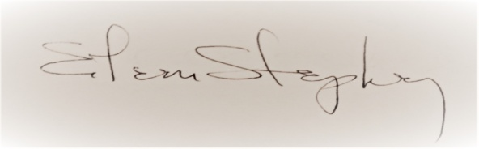
_________________________________ ______12/27/2016______
Signature of Search Committee Chairperson Date
or Consistory/Council President

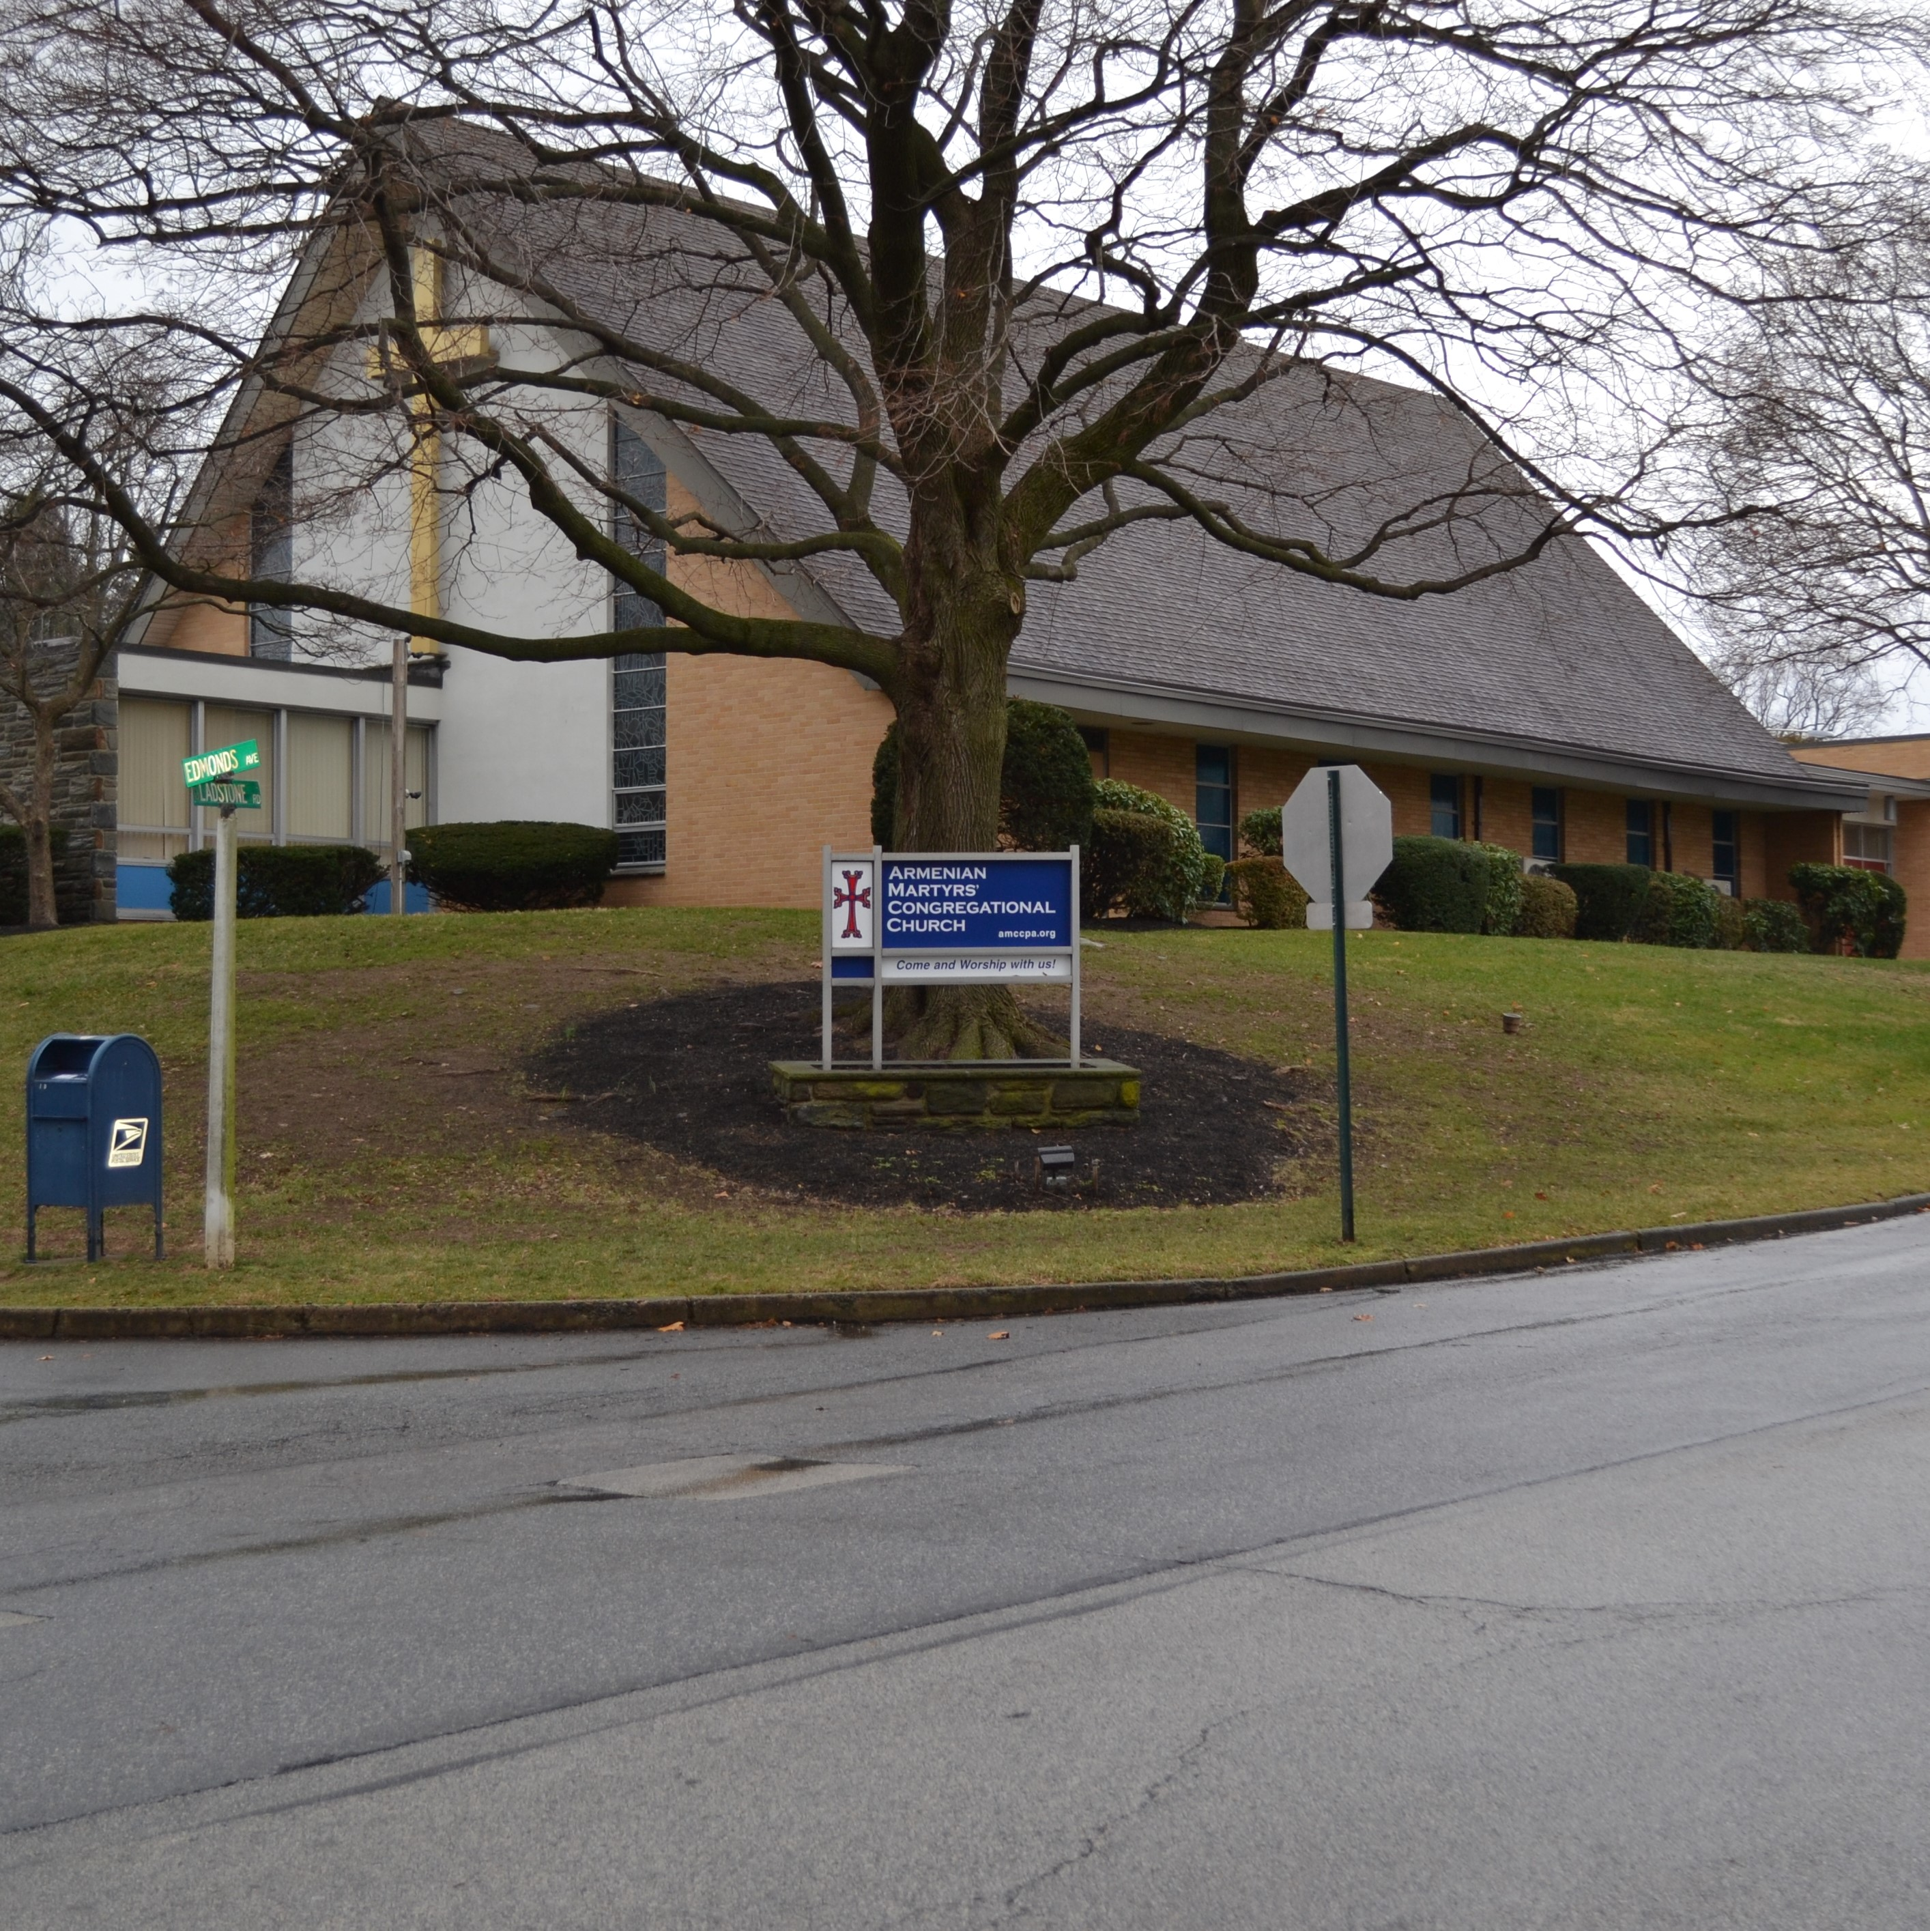
Church Name: Armenian Martyrs'
Congregational Church
Address: 100 N. Edmonds Ave.
Havertown, PA 19083
Telephone: 610-446-3330
Fax: 610-446-3963

Email: office@amccpa.org

Website: www.amccpa.org

Date of vacancy: January 16, 2017

Contact Person and information: Don Uber,
Moderator (c) 610-574-8230

Ministry flows from mission. The interim time in the life of a congregation is an opportunity to gain clarity on the church’s mission.

What is your local church’s mission? (Please share your church’s mission statement here or name that one needs to be developed): The Search Committee believes that our mission statement is a combination of both the Church Covenant (Article II of the church Bylaws) and our Vision Statement.
Church Covenant: "We are a worshipping fellowship of Christians, called together to teach and preach the gospel of Jesus Christ by word and deed; to administer the holy sacraments of baptism and communion; to render loving service to humanity utilizing lawful means; to promote the righteous, justice, peace and sovereignty of God; and to strive for unity within this church and the church universal."
Vision Statement (March 15, 2003): Armenian Martyrs' Congregational Church will be a church community that is Christ-centered, spiritually alive, growing in worship attendance, Armenian-and community based, inclusive and diverse."

The following questions can shape a time of transition in our churches. To test or develop a church’s mission, the interim time can be guided by three questions:
- Who are we now (our skills, assets, character, gifts, and historical trends and DNA)?

We have a rich Armenian history with the majority of members either Armenian or married to an Armenian. This ethnic history also provides for diverse theological views within the congregation. Our congregation has been accepting of many pastoral styles and encourages focus on the local community or youth group. Our current pastor has created an active youth group with many attendees outside our church.
We view ourselves as warm and welcoming and strive to welcome all who step through the doors of the church building.

- Who is our neighbor (around the community and commuter radius and around the world)? What are their burdens, dreams, longings and strivings, spiritual needs, challenges, fears, struggles?

Our neighbors, exhibited by the time spent with them, are primarily the Armenian community, but with significant support to non-Armenian needs. This is represented by involvement the vibrant Armenian Intercommunal Committee which consists of 4 other Armenian churches (3 Apostolic, 1 Catholic) and the Armenian Sisters Academy, serving all churches. We are also connected with the Armenian Evangelical Union of North America, as well as globally via the Armenian Missionary Association of America. We provide mission funds for many more non-Armenian efforts, but do not provide a lot of time or service to them. Over 40% of our mission giving is to non-Armenian missions such as: missionaries in Mexico and Romania (Wycliffe), United Church of Christ, Global Mosaic International, local food banks, etc.
We currently have a deficit for our operations but have not pulled back on our missions efforts and freely use funds from our endowment investments to support our missions.

- And given the answer to the first two questions; What is God Calling us to become and to do in this current time and place?

We think God is calling us to continue to grow as a spiritually vibrant church family that is
reflected with more focus on our faith journeys beyond the Sunday service. We think God
is also challenging us to decide on whether we can do more to engage Armenians not
active in a church (our inactive members or others) and whether we can do more to grow as
a community church outside the Armenian focus. Our evangelical history is steeped in
sharing the gospel message of Christ in action and words By being more energized and
Christ focused, we seek to manifest that faith with actions, and to be generous with our
resources such as time, talents and to serve others by showing love and respect for one
another.

In addition to asking and responding to the three questions above during the time of transition, what are your Expectations/Primary Goals/Needs for the interim time: (Push yourselves to be precise…this is crucial for your work and ongoing conversation of the assessment/evaluation of the interim time)

1. Development of our youth - To serve our youth by delivering a weekly children's
sermon during the church service, and to lead the weekly Sunday evening Youth Group
meetings. We also need the Interim pastor to help in a search for a youth group leader.

2. Engage the congregation - Help to develop small groups sessions by offering more
programs. Attend the monthly Senior Fellowship lunch meetings. Reach out, visit and
help provide assistance to our elderly as needed. Represent AMCC at Armenian cultural
events and attend Haverford Township Ministerium meetings. Members will maintain
church operations while the Deacons work with the interim pastor.

3. Cultivating members spiritual lives - In addition to leading an inspiring Sunday worship
service, challenge and help us become more clear about our mission as a church.
Show us where and how we can grow in our faith, where we do well and how we can
improve as we search for a full-time pastor.

In a paragraph or two for each item, please provide the following:

Brief History: See attached

Church Strengths:
- Connections with other churches and missions

- The theological diversity of our members (from biblical inerrancy to the Bible as an allegory and everything in between). AMCC pastors have always accepted and respected this diversity by preaching to the center.

- A strong financial endowment with the funds managed by lay people from the congregation.

- Majority of the service is in English

- Fellowship hour following the church service offers opportunity for connection.

- Our being Armenian gives us the opportunity to witness to fellow Armenians, as shown in our
Youth Group, Men's Christian Group (Bible study), Women's Spiritual Mornings (book/Bible study),
and Senior Wednesdays (secular programs). In each of these, about half of the attendees are not members of our church, but are fellow Armenians. We also support our sister church in Berd, Armenia.

Significant Events:
Within the past few years, we have developed the Youth Group, Vacation Bible School, Men's Christian group, Women's Spiritual Group, and Senior Fellowship.

Our Challenges:
- Stewardship - we need to expand parishioners involvement in serving and giving financially to the church.

- Outreach - we need to stay connected with parishioners and reach out to those who cannot or do not attend through phone calls and letters.

- Theology - we need a high level of sensitivity to address our members' theological diversity and strive to avoid becoming divisive.

- Community engagement - we need to find ways to reach out to the community.
Is there unresolved Conflict in Church? _____ Yes _X__ No

Level of Conflict in Your Church (Low 1, 2, 3, 4, 5 High): 1
(As identified by Speed Leas, in a Leadership Magazine article in 1989:
- “We have problems to solve, but we can do it!”
- “We’re not communicating. There seems to be a low level of trust…but we are talking!
- The focus has changed to “winners/losers!” At this level it is wise to seek outside help!
- The goal is “divorce,” and getting people to quit.
- Not only wanting others to leave, but seeking revenge!

Was the previous leader a contributor to the conflict? _____ Yes ___X__ No

If yes, please explain:

BASIC STATISTICS:
#Church Members | Average Worship Attendance | CE Participation | Adult Ed Participation
95 active | 65 | 13 | 9

2015 Income | 2015 Budget | 2015 UCC Mission Giving | Reserves & Endowments | Compensation being offered
$197,606 | 151,530 | 26,166 | 1,447,321 | 105,400

Generally, the starting place of negotiation for the Compensation Package offered to the Interim Pastor is the same as that of the most recent pastor or what you anticipate offering your new Called Pastor.

Total Compensation package offered: $ salary, housing allowance, health benefits, pastoral travel reimbursement
Conference Compensation Guidelines (salary and housing allowance range): $45,000 - 65,000

Depending on experience

One-time Criminal Background Check ($160) reimbursement: __X___ Yes _____ No

Renewable Covenant/Contract will be for: ______ 12 months _____ 18 months _____ 24 months

Is this full time or part time? Full Time

Interim Pastor will be selected by: Search Committee

How much notice must be given by church or Interim Pastor to terminate the contract: 30 days

Once an Interim Pastor has been chosen, please contact Brea Rarick (brea@psec.org, 484-949-8774 ext. 311) to arrange a Call Agreement between the church and interim.

Suggested Supplemental Materials to send to a candidate:
- Newsletter
- Worship bulletin
- Annual Report

